Name: Waqar Ahmed

Roll No: 20P-0750

Lab-task: subnetting

## Task 1: Determine Network Address of the following IP Address

IP address: 10.128.240.50/30. Also, determine broadcast and range of host addresses.

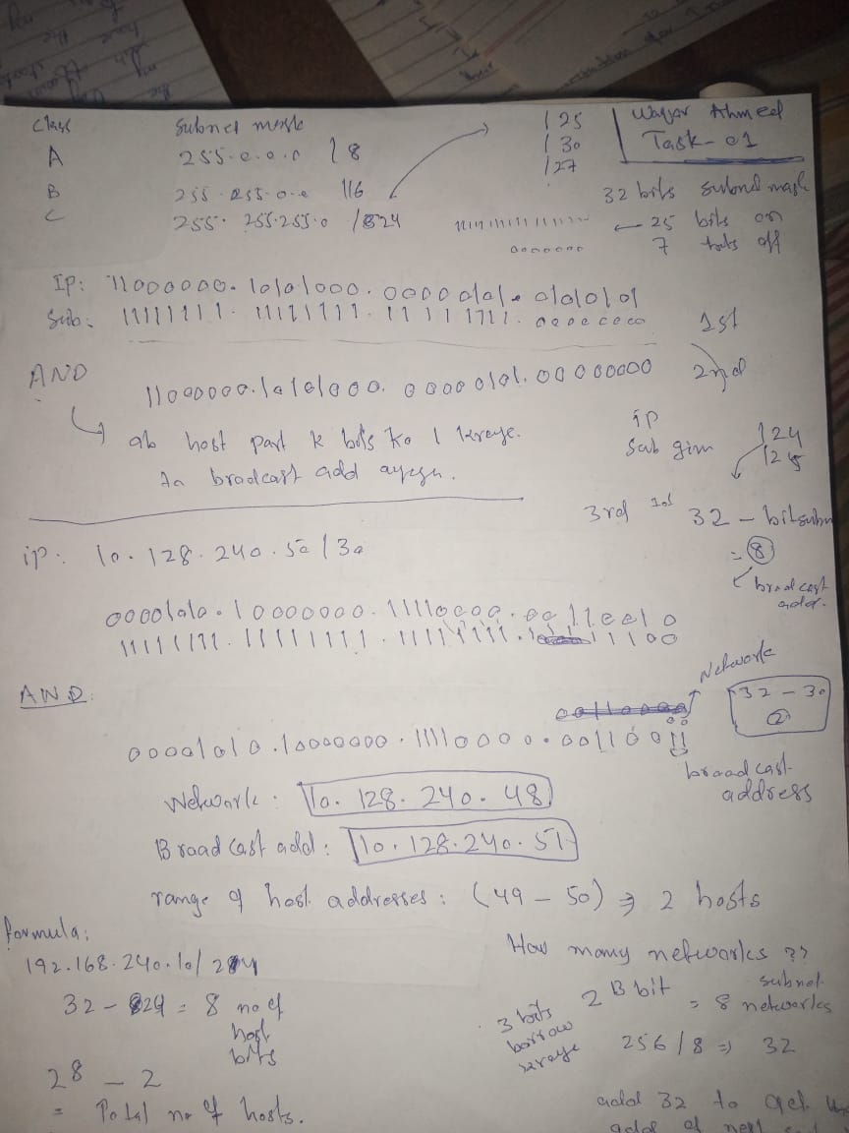

## 

## 

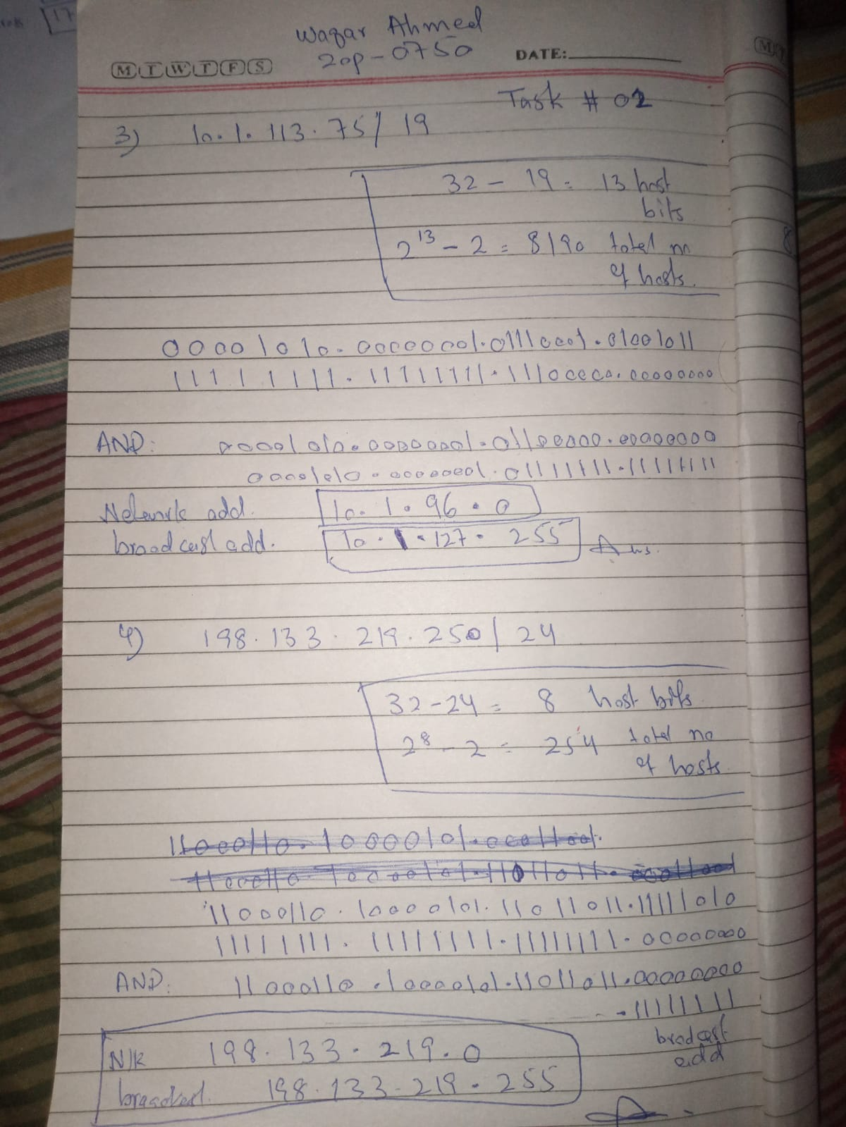

**Task 3: Network Topology A**

**In Part 1, you have been given the 192.168.10.0/24 network address to subnet, with the following**

**topology. Determine the number of networks needed and then design an appropriate addressing**

**Scheme.**

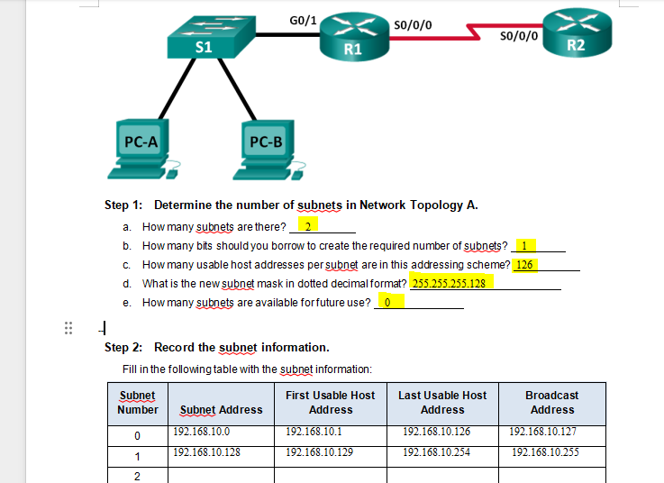

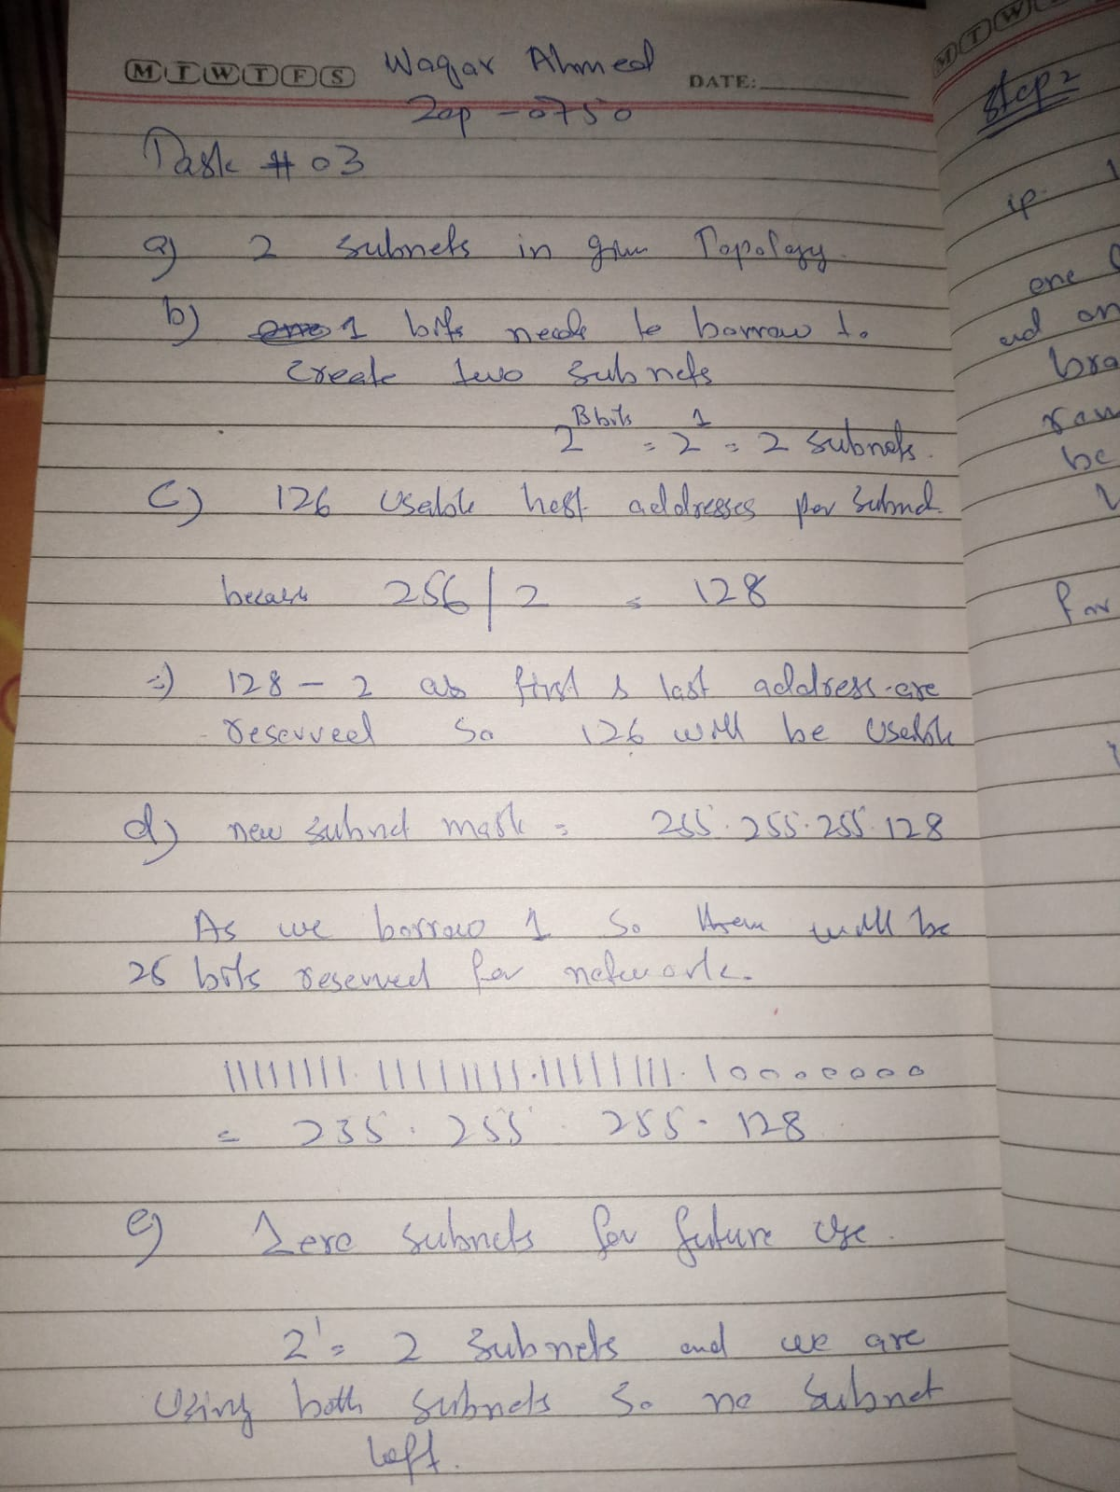

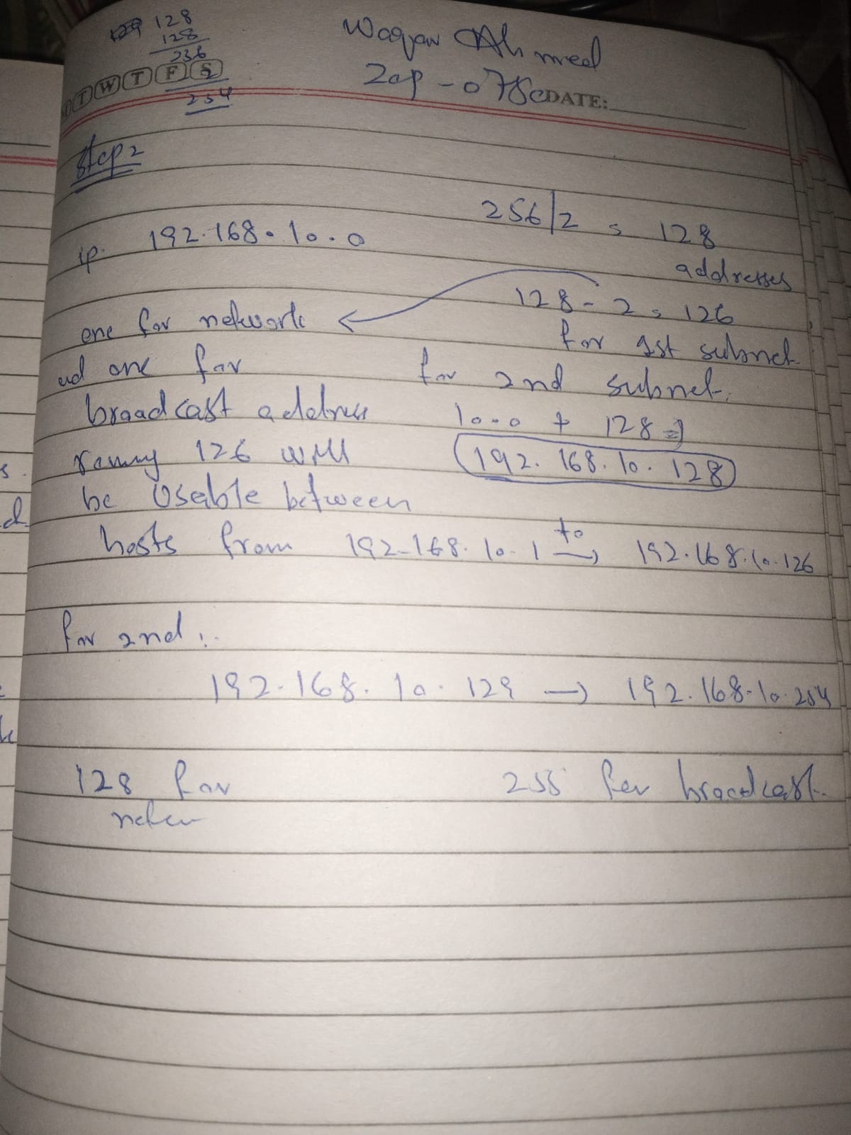

## Task 4: Network Topology B

The topology has changed again with a new LAN added to R2 and a redundant link between R1 and R3. Use the 192.168.10.0/24 network address to provide addresses to the network devices. Also provide an IP address scheme that will accommodate these additional devices. For this topology, assign a subnet to each network.

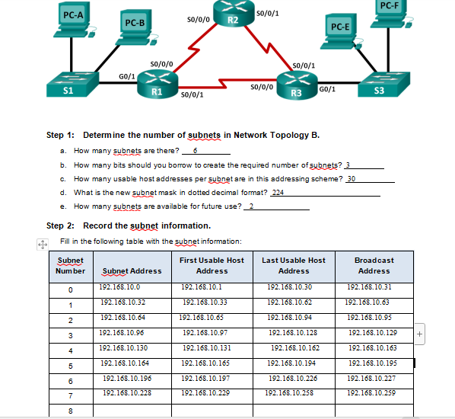

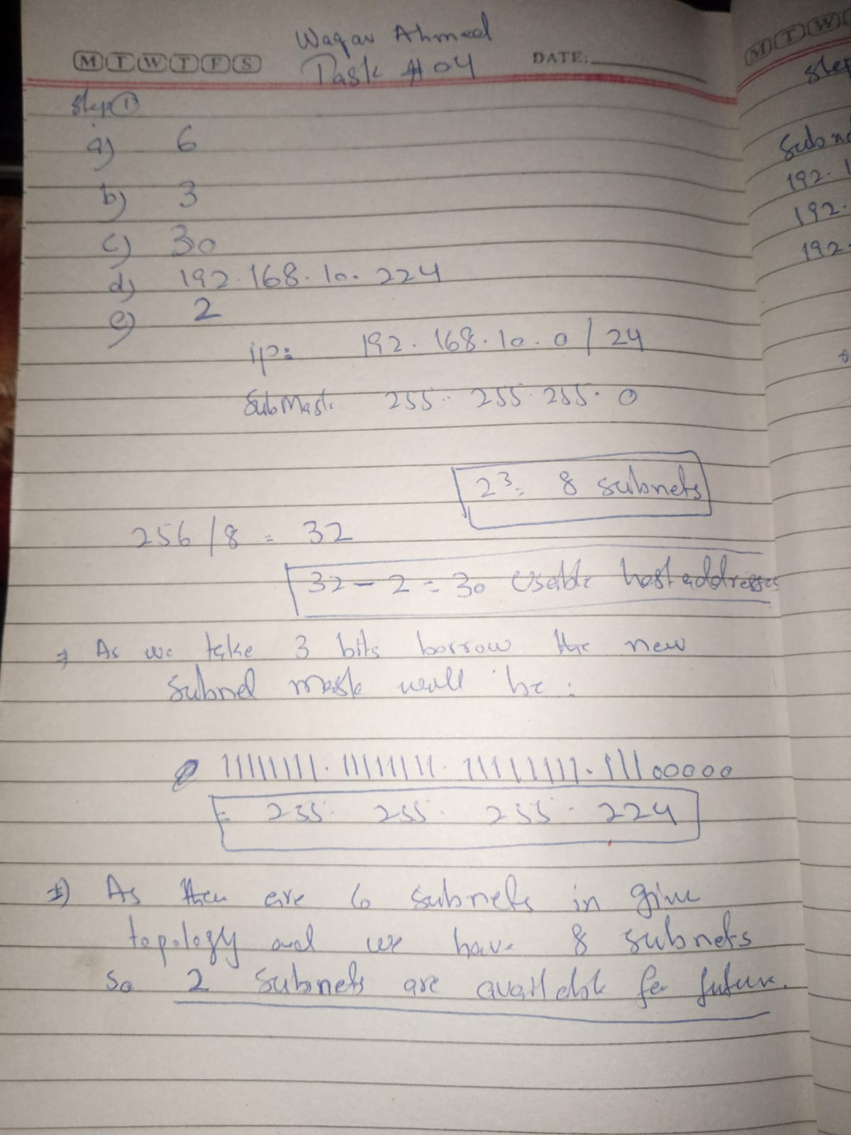

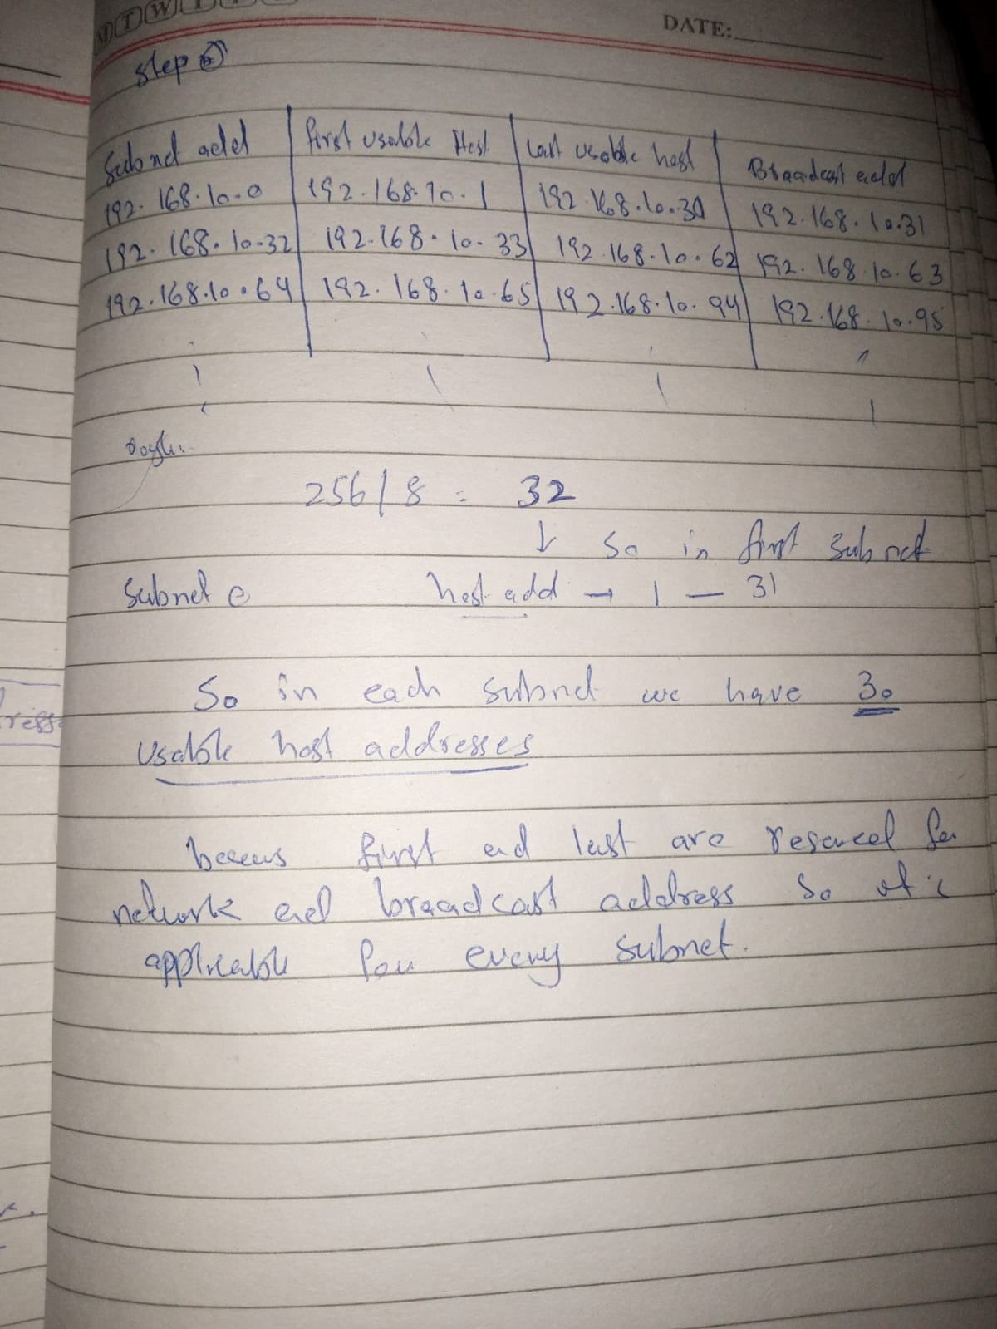

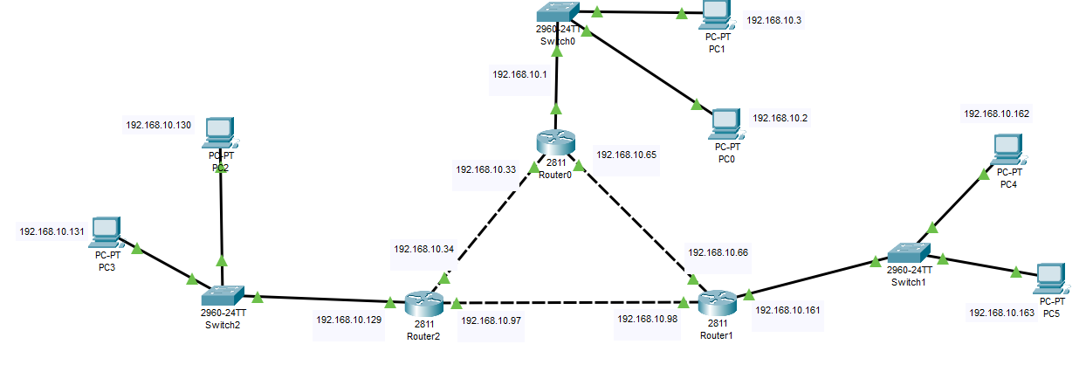

**Step 3: Assign addresses to network devices in the subnets.**

1. **Fill in the following table with IP addresses and subnet masks for the router interfaces:**

