#### IMG_256

#### Waqar Ahmed

#### 20P-0750

#### Lab Task 01

**Experiment 1:**

**ipconfig** is a command-line utility in Windows operating systems that provides information about the computer's network configuration. When I run the **ipconfig** command, it displays details such as the IP address, subnet mask, default gateway, and other network-related settings.

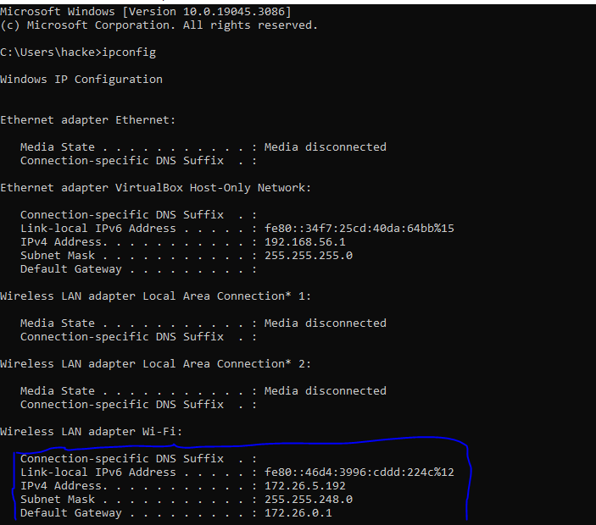

**Experiment 2:**

1. **View DNS Cache**

**ipconfig /displaydns**

**This command will list all the currently cached IP addresses on your computer also referred to as**

**the DNS resolver cache).**

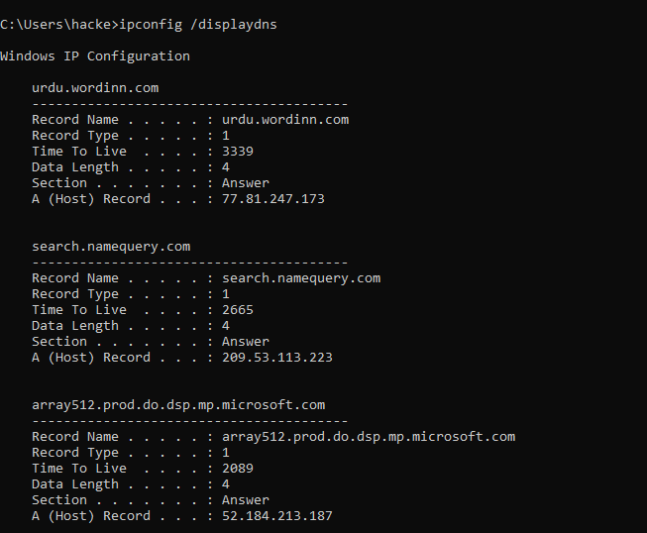

1. **Display MAC Address of Only Physical Connected Network Adapters**

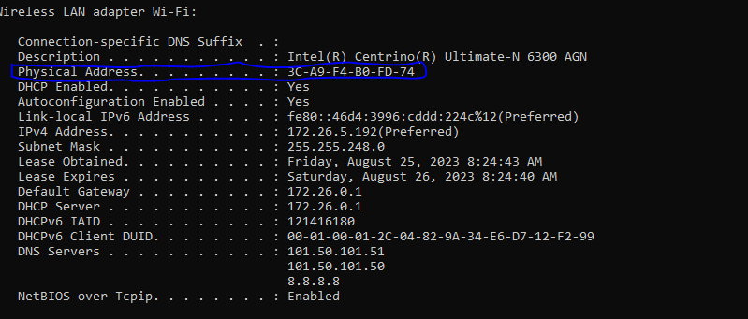

**Experiment 3: Retrieving All TCP/IP Network Information using the ipconfig /all Command**

**and redirect it to a text file.**

**Instead of displaying the results on the screen, we can have the results saved automatically to a text file on our computer. To do this, simply use the ">" symbol followed by the folder path and**

**file name of your choice. in the command window then press Enter: ipconfig /all >C:\ipconfig-results.txt**

**This will create a file named ipconfig-results.txt in the folder path c:\ that will have my**

**result.**

