Name : Waqar Ahmed Roll No: 20P-0750

Lab Task : 05

Task 1: Configure DHCP server on a Router

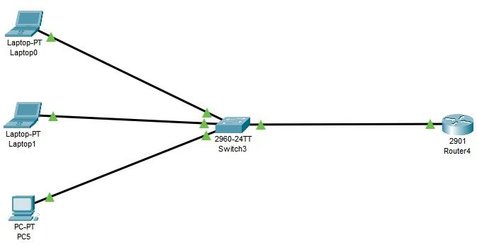

2: Configure DHCP server on a Generic server

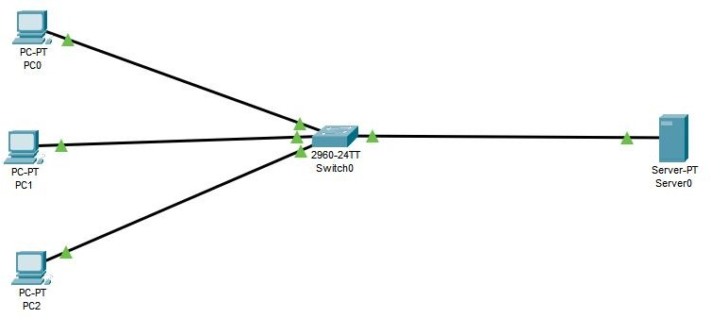

Configure static path and centralized DHCP server

