Name : Waqar Ahmed Roll No : 20P_0750 LabTask : 09

Instructor : Maa’m Hurmat

Task1 : By looking at the information in the HTTP GET and response messages,

**answer the following questions**

1. **Is your browser running HTTP version 1.0, 1.1, or 2?**
2. **What version of HTTP is the server running?**
3. **What languages (if any) does your browser indicate that it can accept to the server?**
4. **What is the IP address of your computer? What is the IP address of the gaia.cs.umass.edu server?**
5. **What is the status code returned from the server to your browser?**
6. **When was the HTML file that you are retrieving last modified at the server?**
7. **How many bytes of content are being returned to your browser?**
8. **Is your browser running HTTP version 1.0, 1.1, or 2?**

To see that what version your browser is running select line one in which GET request is made.

Then Go to the Hypertext Transfer Protocol -> Select Get -> Request Version My browser is running on HTTP version 1.1.

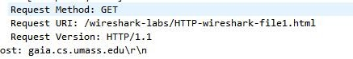

1. What version of HTTP is the server running?

To see that what version of HTTP server is running select second line in which 200 response is coming.

Then Go to the Hypertext Transfer Protocol -> Select HTTP/1.1 200 OK

/r/n -> Response Version Server has a HTTP Version 1.1.

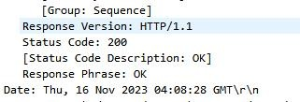

1. What languages (if any) does your browser indicate that it can accept to the server?

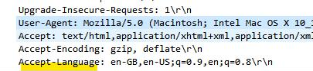

1. What is the IP address of your computer? What is the IP address of the gaia.cs.umass.edu server?

IP address of my computer: 172.26.7.47

IP address of the gaia.cs.umass.edu server = 128.119.245.12



1. What is the status code returned from the server to your browser? The status code returned from the server is 200 that mean OK. That means the page is successfully retrieved without any error.

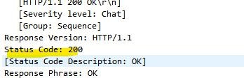

1. When was the HTML file that you are retrieving last modified at the server?

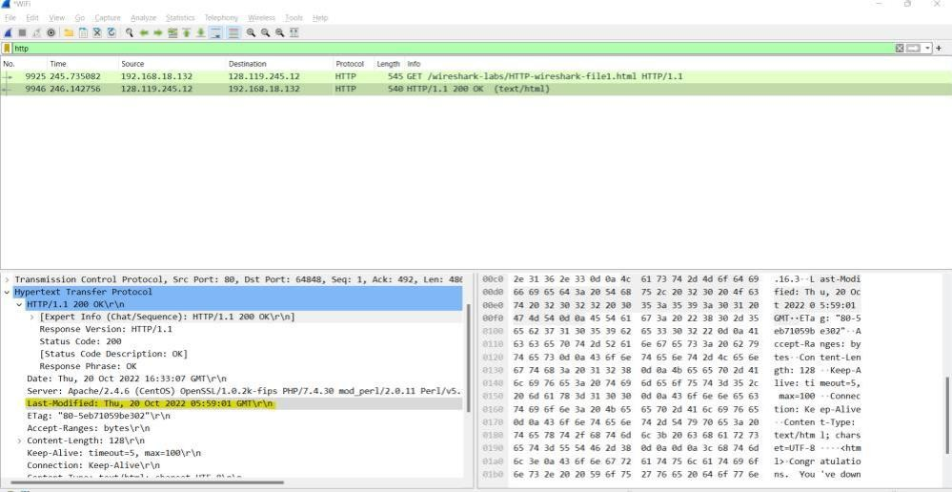

1. How many bytes of content are being returned to your browser?



Task2: Answer the following questions:

1. Inspect the contents of the first HTTP GET request from your browser to the server. Do you see an

“IF-MODIFIED-SINCE” line in the HTTP GET?

1. Inspect the contents of the server response. Did the server explicitly return the contents of the file? How can you tell?
2. Now inspect the contents of the second HTTP GET request from your browser to the server. Do you see an “IF-MODIFIED-SINCE:” line in the HTTP GET6? If so, what information follows the “IF

MODIFIED-SINCE:” header?

1. What is the HTTP status code and phrase returned from the server in response to this second HTTP

GET? Did the server explicitly return the contents of the file? Explain

* 1. Inspect the contents of the first HTTP GET request from your browser to the server. Do you see an “IF-MODIFIED-SINCE” line in the HTTP GET?

Ans: I inspected the first HTTP GET request from the browser but IF- MODIFIED-SINCE is not found. This is due to this because that is our first time, we are fetching the page so IF-MODIFIED-SINCE is not checked.

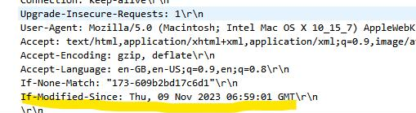

* 1. Inspect the contents of the server response. Did the server explicitly return the contents of the file? How can you tell?

Ans : I inspected the contents of the server response. Server is explicitly returning the contents of the file in

the option Line-based text data: text/html (10 lines)

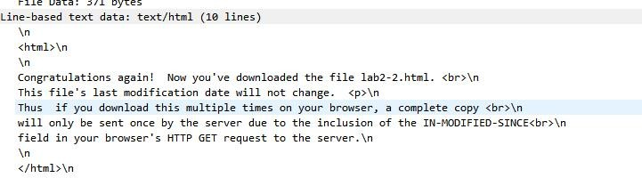

* 1. Now inspect the contents of the second HTTP GET request from your browser to the server. Do you

see an “IF-MODIFIED-SINCE:” line in the HTTP GET? If so, what information follows the “IF-MODIFIED SINCE:” header?

Ans: I inspected the second HTTP GET request. This time IF-MODIFIED- SINCE found. Reason for this is that because we are fetching the page second time page is already present in cache and if page is not modified then it will not fetch complete page from server rather it will pick page from cache and show to the user.



* 1. What is the HTTP status code and phrase returned from the server in response to this second HTTP GET? Did the server explicitly return the contents of the file? Explain.

Ans: 304 status code returned from the server in response to this second HTTP Get. No, Server did not explicitly return the contents of the file.

