University of Texas at San Antonio

Network Traffic Analysis with NetworkMiner and Wireshark

Daniella Carbuccia
IS 3513: Information Assurance and Security
Prof. John Newsom
25 Oct. 2024

In today’s digital landscape, cybersecurity is crucial for protecting sensitive information and maintaining the integrity of networks. As cyber threats become more sophisticated, security professionals must be equipped with effective tools to analyze network traffic and identify vulnerabilities. In this lab, we will explore two powerful tools: NetworkMiner and Wireshark. We will use NetworkMiner to conduct host and endpoint analysis, reconstruct files, and examine sessions to gather valuable insights. Simultaneously, Wireshark will help us capture and analyze real-time network traffic, allowing us to visualize the data as we investigate. Through this hands-on experience, we aim to deepen our understanding of network traffic analysis and enhance our skills in identifying security issues.
To start off the lab we had to install Wireshark and NetworkMiner onto our host machine. I already had Wireshark installed on my system because I have fiddled around with it to get practice, but I just made sure it was up to date. I downloaded NetworkMiner and followed the steps and had no issues and just made sure it operates properly and went into the right path in my C: drive. For the first part of the lab, we were instructed to create three packet captures. The first one was a short PCAP, and I did this by choosing the network interface with the most traffic, which for me was Wi-Fi. I double clicked it and let it start running and we were told to let it capture packets for 20 minutes. Once the time passed, I saved the file as ShortPCAP and created a folder for all of my PCAPS. We were also told to make a long packet capture, and I did it for the minimum amount of time which was two hours and saved it as LongPCAP. Lastly, we were told to make a packet capture of our Ubuntu virtual machine from the second lab. I signed into my ubuntu WS machine and then started the packet capture on the NAT VM adapter. I used the command hostname -l and got the IP address of my machine and searched it on Google Chrome using HTTP first. Then we were told to use HTTPS, which is a secure connection and then end the packet capture. I saved this PCAP as WebPCAP and now these three PCAPS will be used to observe different components of Wireshark and NetworkMiner. The last thing we needed to do in this section of the lab was to make sure we could open the PCAPS in NetworkMiner. At first, I had an issue finding the PCAPS in NetworkMiner, but it was because I had them saved as pcapng which isn’t compatible with NetworkMiner. So, I went back into each PCAP and saved them as a simple pcap and from there I could open them in NetworkMiner. Now that everything was set up, I was ready to start analyzing network traffic on Wireshark in the next part.
After setup, we moved onto the portion where we analyze network traffic with Wireshark. Throughout the lab we got brief explanations on how to better analyze packets and see the information we want to see. On Wireshark depending on how long your packet capture is, you could get very long results, and it is very hard to sift through it all to detect any abnormalities. However, in this lab we were taught we could filter by protocol type, IP address, port, and you can combine the filters to see a protocol used with a certain IP address for example. This is all done on the filter bar at the top. You would just enter the protocol name, or ip.addr == (enter IP address), and if you combine them, you could use logical operators. Wireshark also makes it very user friendly by giving suggestions for the filter in case the user isn’t sure what they are looking for. I tested it out by picking a random IP address I noticed in my capture and when I started typing it, it started to fill in the possible IP address I was looking for. I thought this was a really great feature for analyzing.
We were then instructed to enter different protocols into the filter bar and see what results we get on each of the PCAPS we created at the beginning of the lab. The first protocol used was ARP. According to an article from TechTarget, “Address Resolution Protocol (ARP) is a protocol that maps dynamic IP addresses to permanent physical machine addresses in a local area network (LAN). The physical machine address is also known as a media access control (MAC) address.” (Zydyk). So, ARP pretty much helps devices find each other in a local network to send data where it needs to go. It is not safe however, because it is vulnerable to spoofing. ARP only looks for the recipient’s MAC address, but it doesn’t verify that the response to the request is from an authorized device. There is a more secure option through Neighbor Discovery Protocol (NDP) because it uses cryptographic keys to verify the device is authorized, but it is only used in IPv6 networks and unfortunately the internet mainly uses IPv4. When I filtered my packets for the ARP protocol, I did get results in each one and I think it is because it is common with ARP to refresh to keep the address mappings current. It operates in the data-link layer (which is why there is no port used because the ports are usually assigned on the transport layer) so it is essential for network communications. That is why it will show as packet captures even if the user has no activity. I wasn’t surprised to find it on my network because after researching this protocol, I realized it will show up in all PCAPS because it is the translator for IP addresses to MAC addresses.
The next protocol we filtered with was Transmission Control Protocol (TCP). TCP ensures that data that is sent is accurate through what is called a 3-way handshake. This establishes a secure connection with the receiver. The client sends out a SYN (synchronization packet) to the server. Once the server receives it, it acknowledges the request by sending back a SYN-ACK and the client will send out an ACK packet which then establishes a connection. This protocol is usually safe but does have some vulnerabilities such as spoofing and something called SYN Flooding. SYN flooding is where an attacker will open a bunch of TCP connections that are incomplete, and it floods the server. Overall, this protocol is very common and usually safe but there is an alternative which is UDP. I will go over this protocol in the next section. I filtered my PCAPS with TCP and I got many results in each. I knew I would get these results because when I have worked with Wireshark before, I would commonly see the SYN, SYN-ACK, and ACK packets being sent back and forth. I think it showed on my PCAPs this time because while I was running the sessions, I was using my computer to do research, and TCP is essential for a secure connection to the server. A good example is when we looked up our VM’s IP address using HTTP and HTTPS in Google Chrome. It used port 80 for HTTP to establish a connection and 443 for HTTPS. Overall, this is a very common protocol, and I know I will always run across it in packet captures.
Remember when I said the other alternative was UDP? Well, that was the next protocol we used in this portion of the lab. User Datagram Protocol (UDP) is a connectionless protocol that will allow data to travel quickly by getting it from sender to receiver. Due to this UDP does not work on any specific port because it allows the applications to use whatever port number for the transfer. This protocol could be a better alternative than TCP only when the data needs to be sent fast, and reliability isn’t a big concern. Reliability is a concern with this protocol because since it is connectionless, it doesn’t care to verify who the recipient is, it will send the data anyway if speed is needed. This does cause a concern for safety because it doesn’t verify the identity of the recipient like TCP does with a 3-way handshake, therefore, TCP is the safer alternative to UDP. These two protocols go hand in hand and have their own benefits over the other. Now when I searched for it in my PCAPS, I was a little confused because I thought I wasn’t getting results because I would see protocols such as mDNS. After some research I found out it is because multicast DNS (mDNS) relies on UDP as it resolves hostnames to IP addresses without needing a DNS server. So this started to make more sense to me and I realized that I did have UDP in my captures. I also noticed that it shows on the bottom where it has the layers and it clearly shows User Datagram Protocol and the port used.
We also checked for HTTP and HTTPS. Hypertext Transfer Protocol (HTTP) is a protocol that facilitates the transfer of resources between a client and a server. It will usually be related to web pages, and you will usually see this when you type in a URL to access a website for example: http://www.google.com/. It works on a request-response cycle where you request a certain webpage by typing in the URL, then an HTTP request is sent asking for the webpage from the server. The server will then respond with a HTTP response to the browser with all the information and then it will be displayed to you. HTTP typically operates over TCP using port 80 but it is generally not safe because it lacks encryption. Since it isn’t encrypted, it can be intercepted so any passwords or other sensitive information is susceptible to being compromised. However, there is a better alternative that usually you hear about that goes hand in hand with which is HTTPS. Hypertext Transfer Protocol Secure (HTTPS) has the same purpose as HTTP but it has security in mind. You see this more commonly in URL’s because it is the preferred way of looking up websites due to the built in encryption that HTTP lacks. The way HTTPS does this is by using HTTP over a SSL/TLS connection which is encrypted. SSL stands for Secure Socket Layer and TLS stands for Transport Layer Security. These are just protocols that protect data as it travels over the internet. So, HTTPS is generally the best alternative when it comes to safety because it does a great job at preventing interception. It also will verify the server’s authenticity which prevents phishing incidents. This protocol works on port 443 as opposed to port 80. The main difference I noticed when doing this lab was when we worked on the WebPCAP. We had to look up our Ubuntu IP address with both protocols and when I typed in HTTP, it gave me a warning that the connection wasn’t secure, whereas HTTPS let me go right through to the webpage. So, I knew for sure that both would be on that packet capture, but I also saw both protocols on the other two PCAPS as well. I wasn’t surprised by seeing HTTPS because I was using my laptop during the capture for homework assignments, and I was accessing webpages, but I was surprised to see HTTP. However, after a bit of research I found out that some elements on a webpage may still use HTTP such as images or ads so that is why my packets were capturing that kind of traffic.
The next protocol which is also pretty common is FTP. File Transfer Protocol (FTP) transfers files between a client and a server over the internet. The way this is done is by the client requesting to upload files or download files from the server by connecting through FTP. FTP will use two different ports to achieve this. The first port is 21, which is a control channel that sends commands and responses. The second port is 20, which is a data channel, and it is what moves the data between the client and server. This protocol is generally not safe because it is unencrypted and is susceptible to interception so the safer option to use would be Secure FTP (SFTP) as it has built in encryption. Now FTP was another protocol I didn’t have any results for when I filtered for it in my captures. I think the reason I didn’t have it is because I didn’t do any file transfers while running the capture, so it is really dependent on the client to initiate a download or upload of files.
We were also instructed to look for Internet Control Message Protocol (ICMP). According to this blog post from FS,
ICMP (Internet Control Message Protocol), a crucial network layer protocol in the TCP/IP suite, facilitates control message exchange for host and router communication. It assesses reachability and route availability, playing a key role in network diagnostics and fault resolution, despite not transmitting user data directly (Howard).
So essentially it is a way devices ping each other to see if they are reachable and how long it will take for messages to get through. It also doesn’t use any ports like other protocols and works on the IP layer. ICMP does have its own uses but there are some risks with it such as ping flooding that I discussed earlier, and it doesn’t have built-in encryption. However, there aren’t any real replacements for ICMP because it has its own functionality. You can however replace some functionalities such as using TCP SYN packets to check for open ports but there are still other functions that are specific to ICMP. I didn’t have any results with ICMP, and I think it is because ICMP usually communicates things like errors and status updates which might have not happened while the capture was happening.
Another protocol we looked at was Domain Name System (DNS). DNS is a translator, and it converts URLs into an IP address that computers can use to identify each other. So, when you type your URL into a web browser, the computer needs to find the corresponding IP address. The computer will then send a request to the DNS server asking for that IP address associated with the domain name. The DNS server will look until it finds the IP address and send it back to your computer and then load the webpage. DNS typically uses port 53 and uses UDP for fast queries and TCP for certain tasks.

PCAP’s saved to my file:
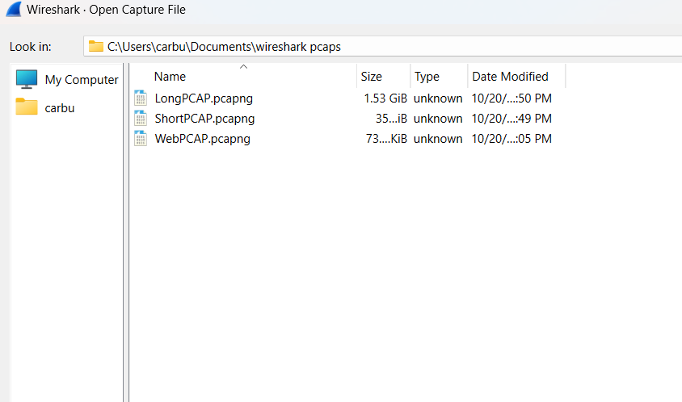
ARP on one PCAP:
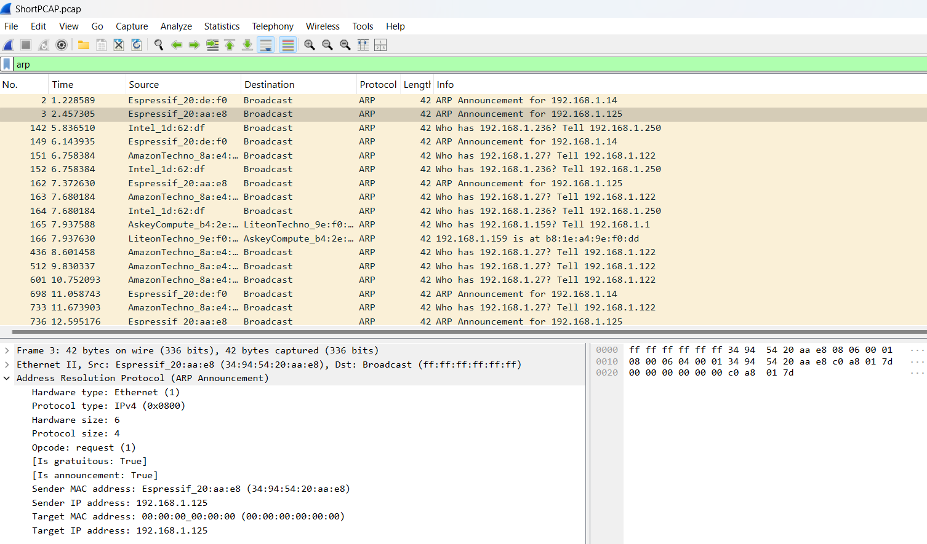
TCP on PCAP:
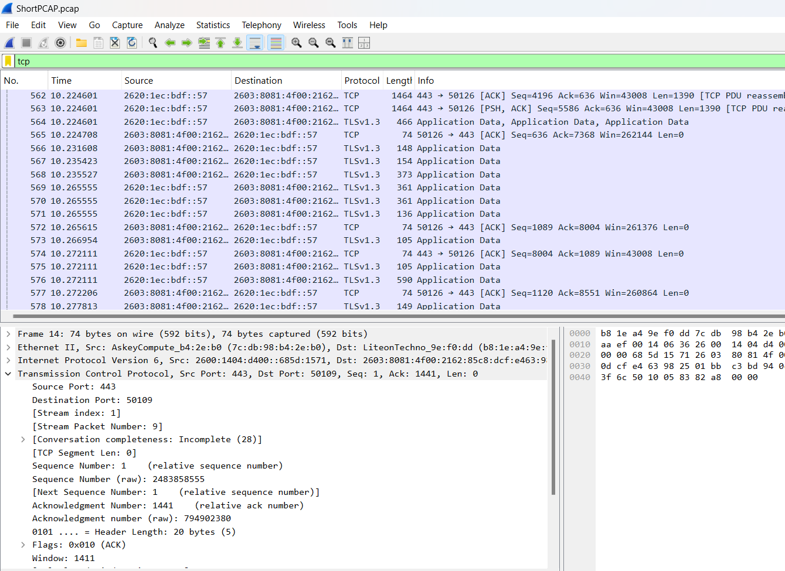
TCP with port 80:
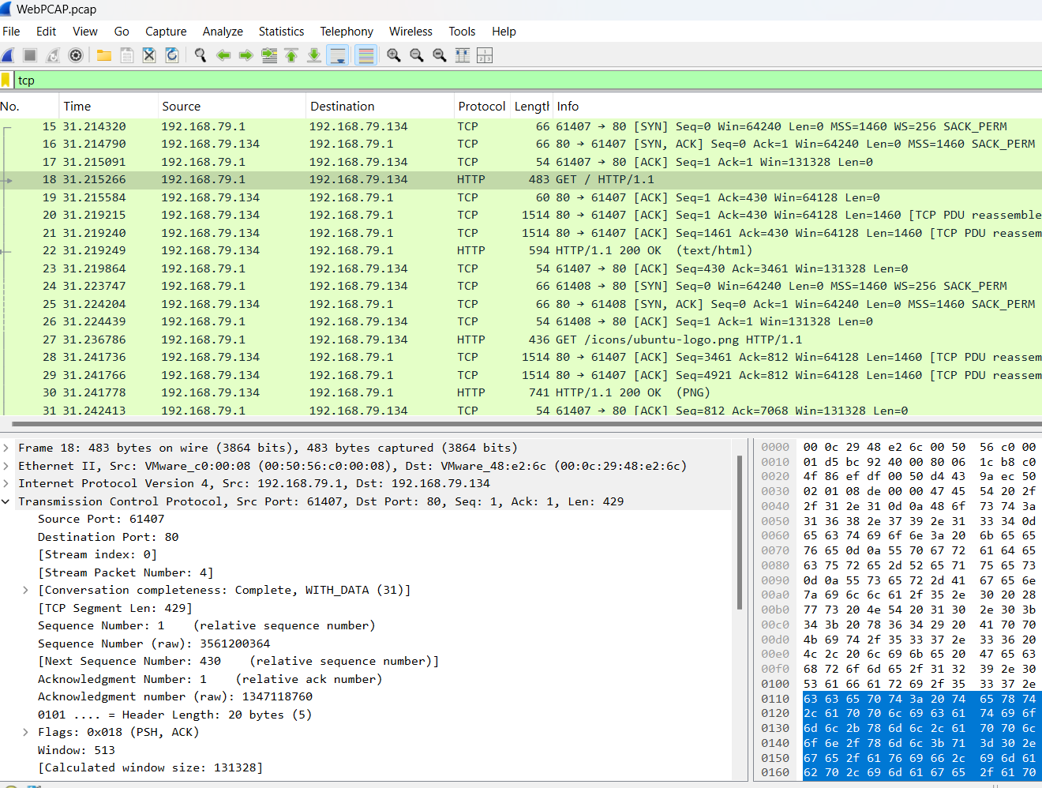

UDP on PCAP:
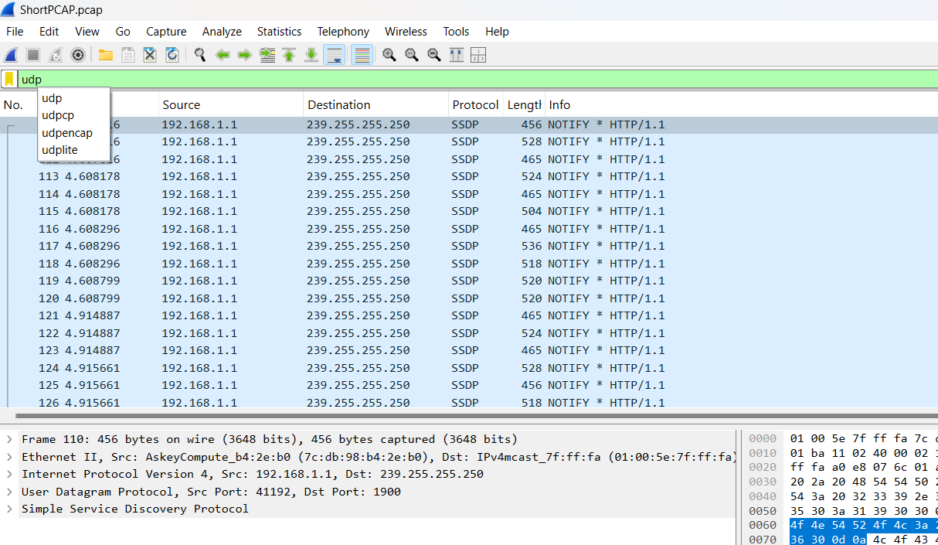
HTTP and port:
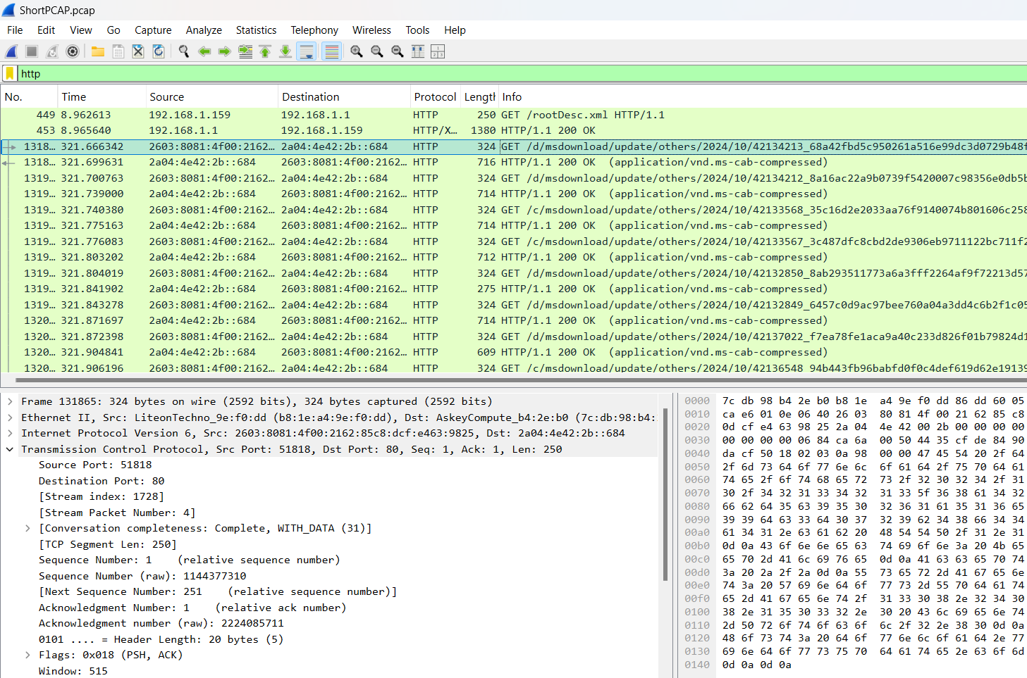
HTTPS results:
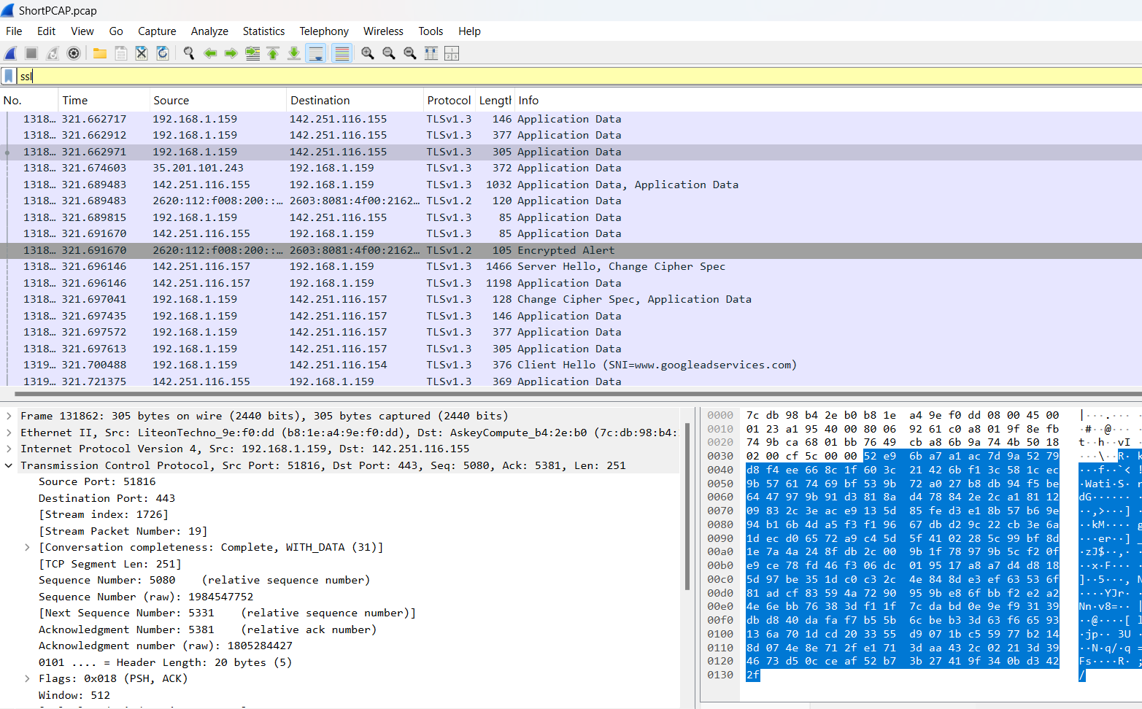
FTP:
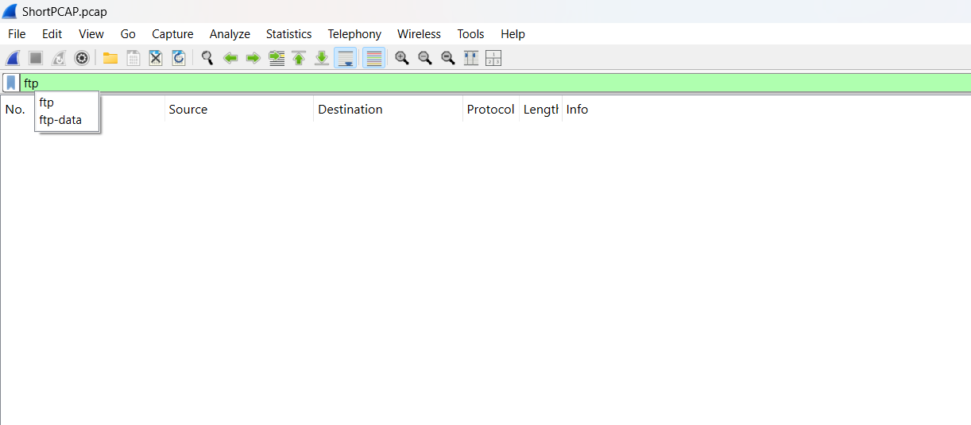
ICMP (did not have any results on WebPCAP):
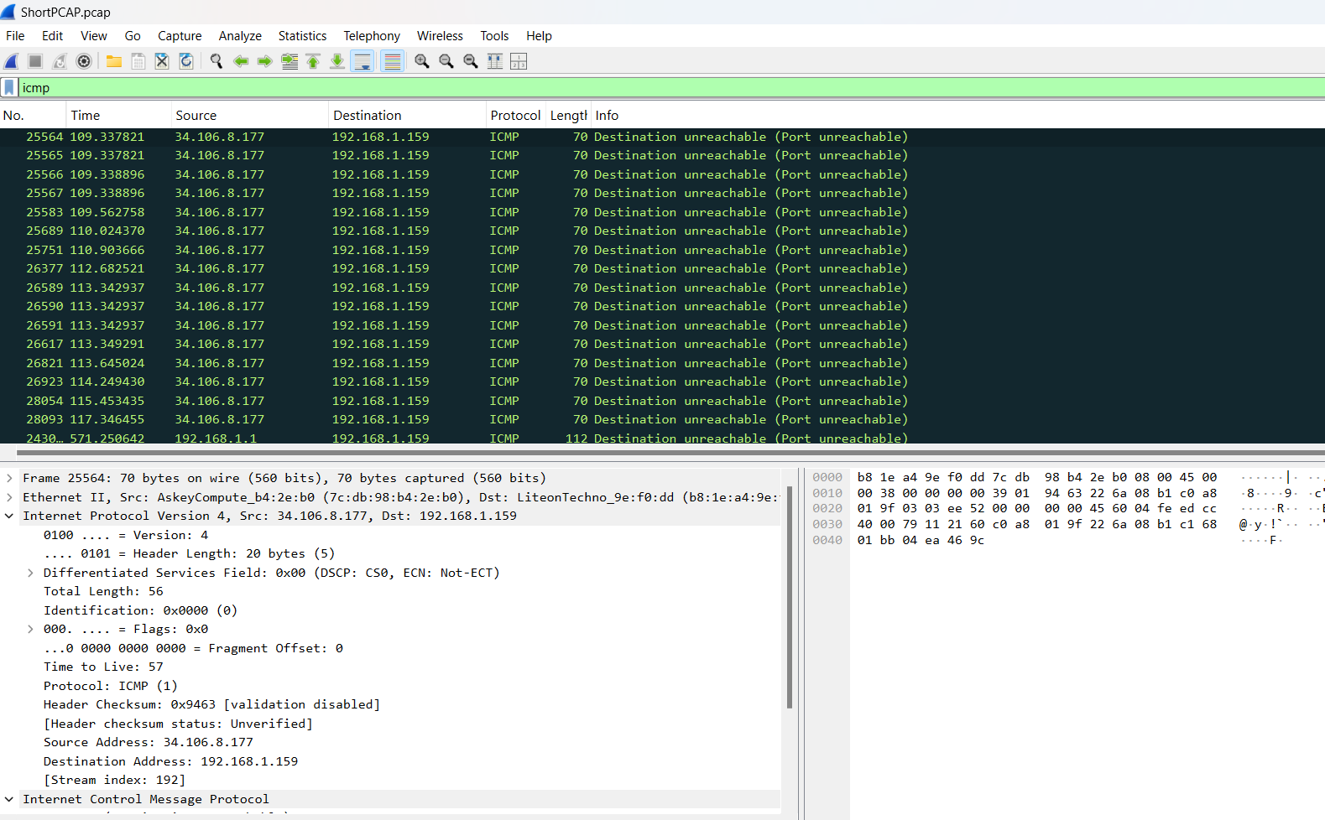
DNS (no results on WebPCAP):
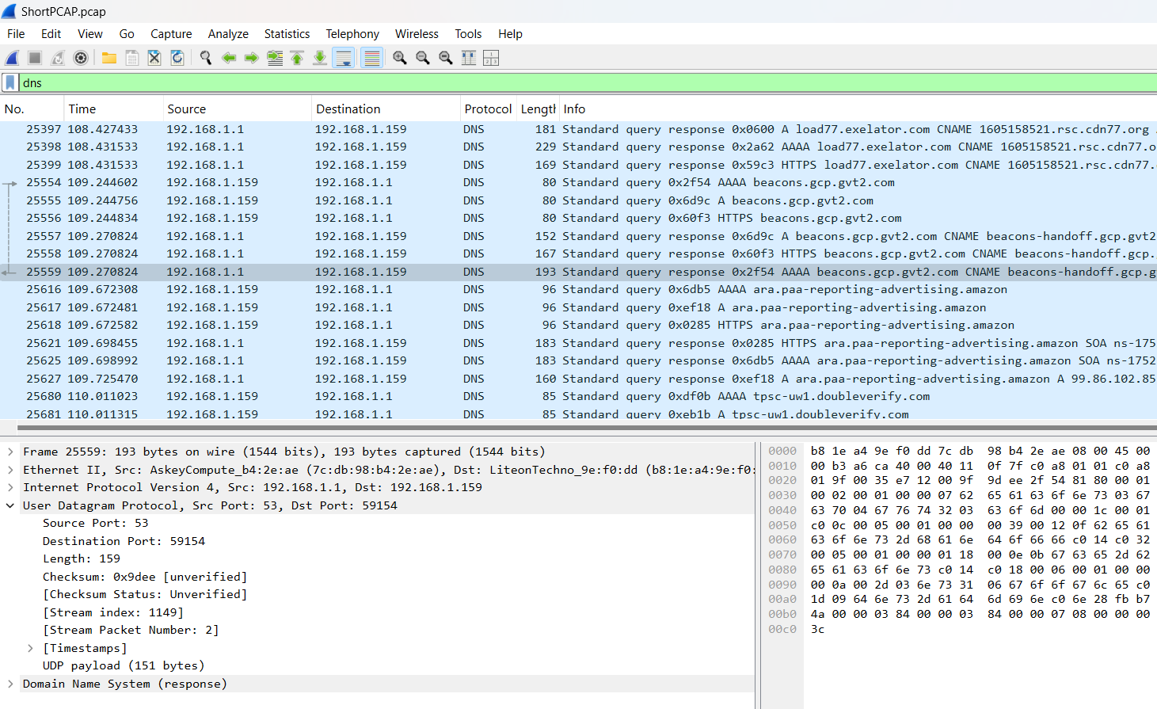
DHCP(no results on LongPCAP or WebPCAP):
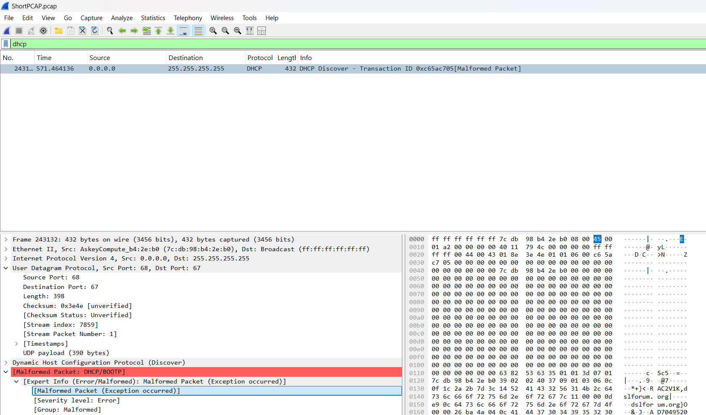
SMTP:
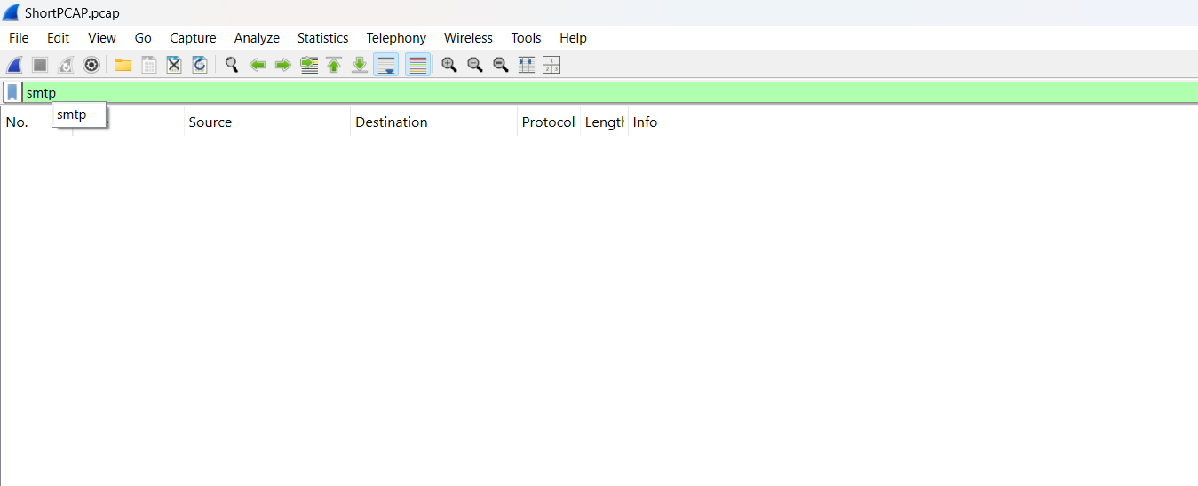
Ssh:
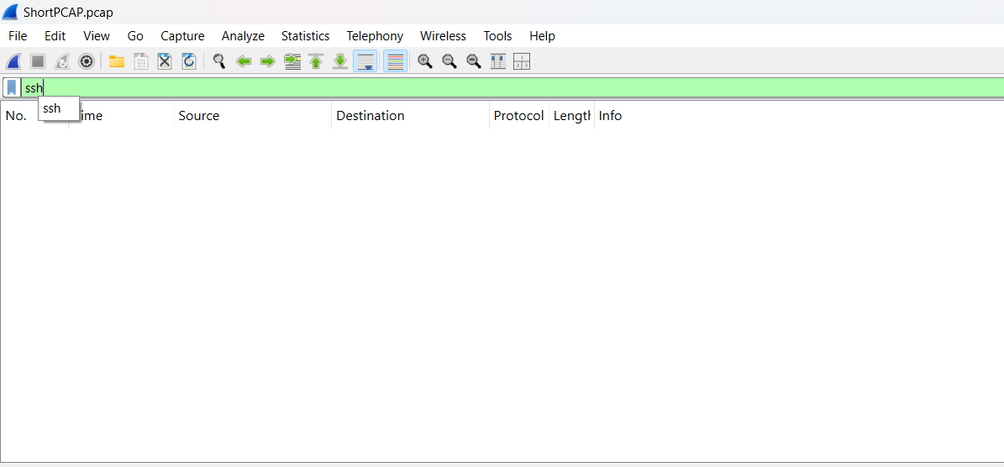
Smb:
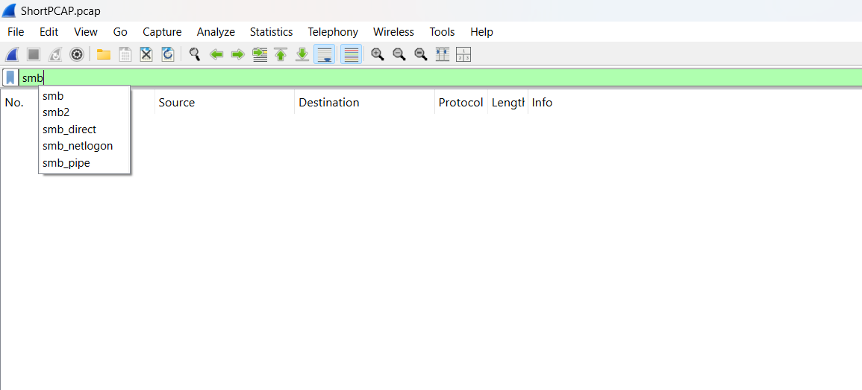

Following a tcp stream:
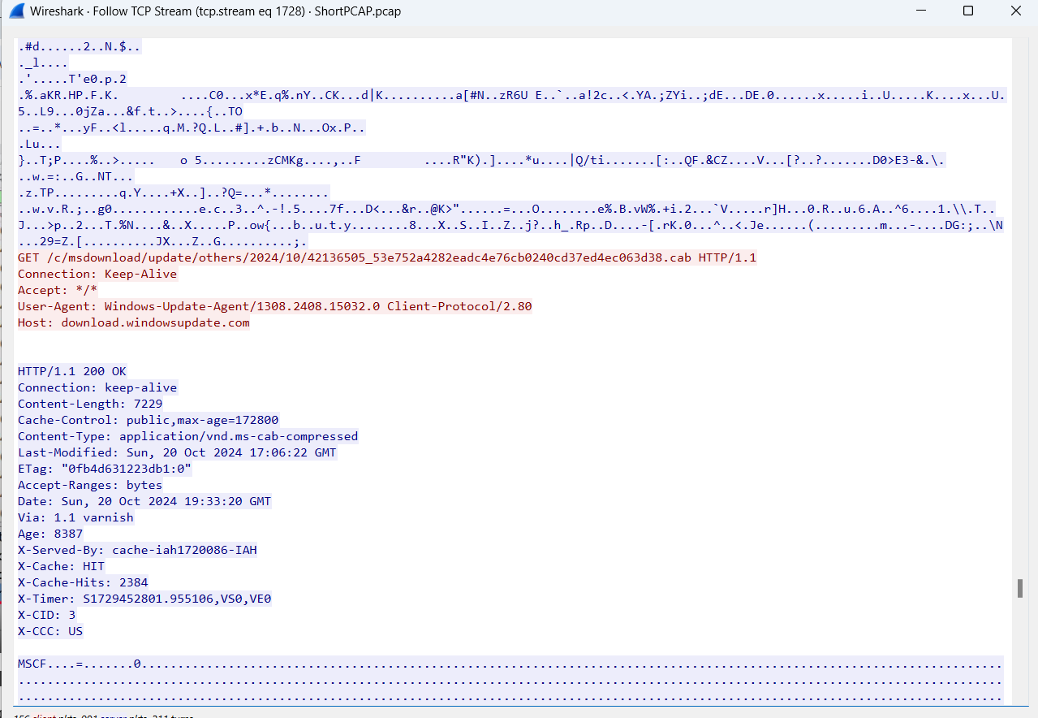
ShortPCAP hierarchy:
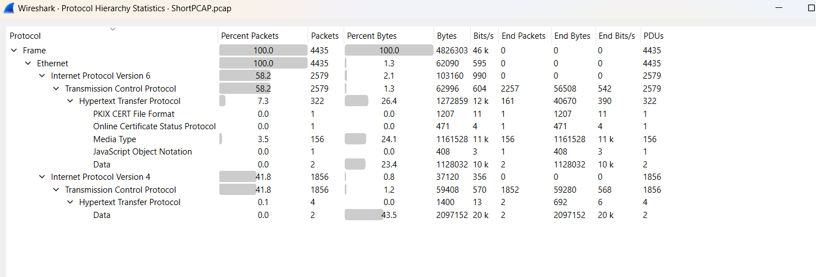
LongPCAP hierarchy:
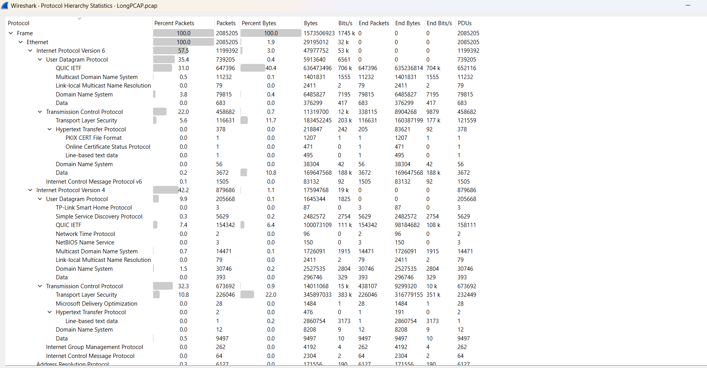
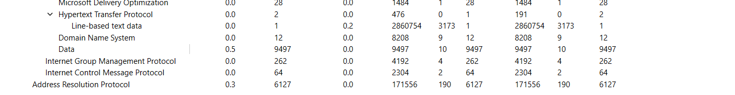
WebPCAP hierarchy:
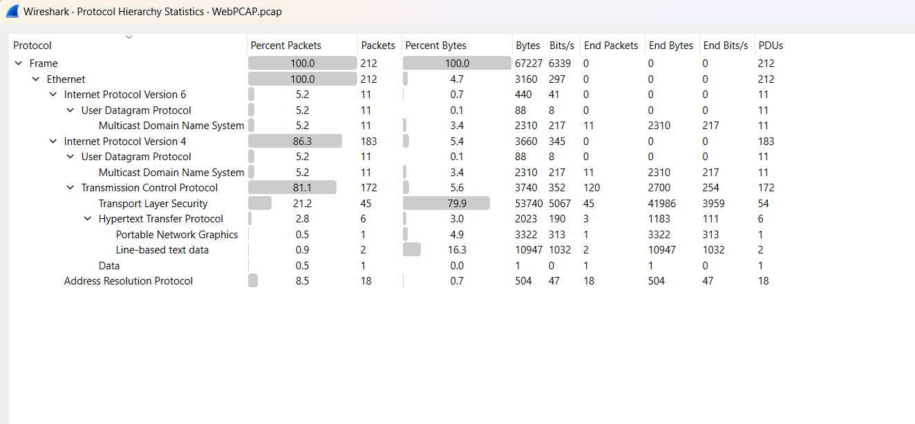
ShortPCAP conversations:
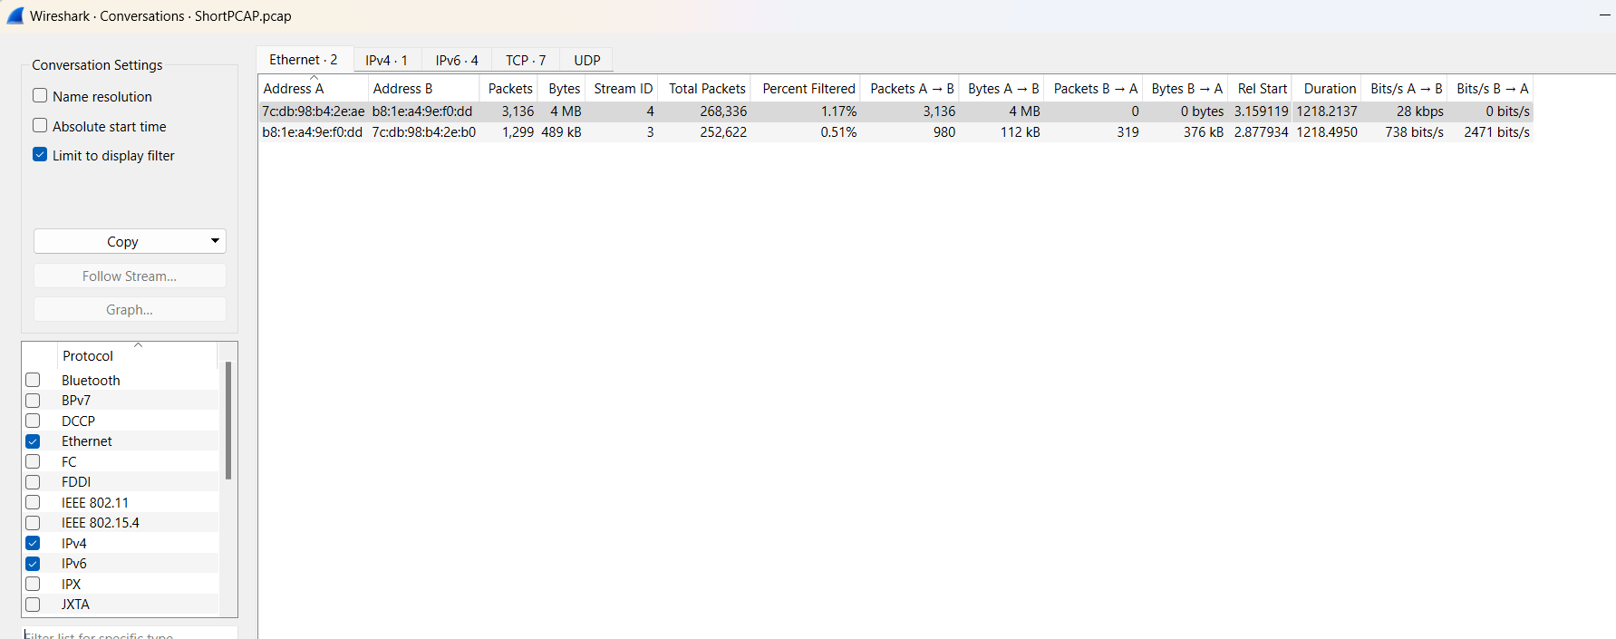
LongPCAP conversations:
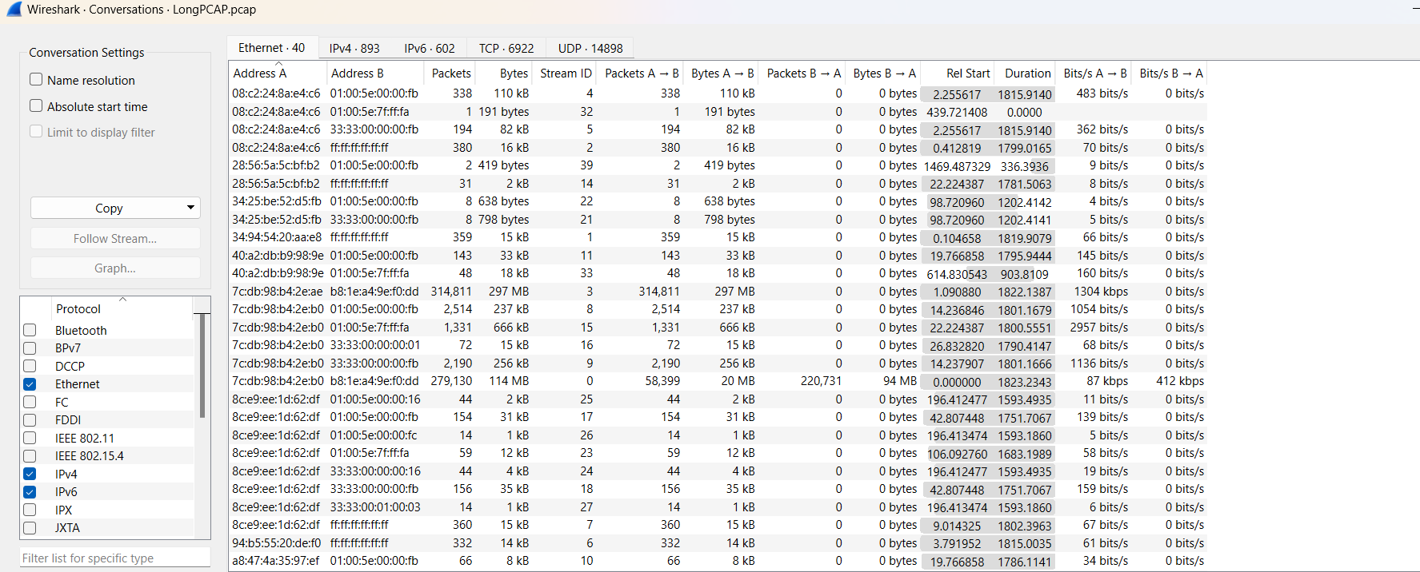
WebPCAP conversations:
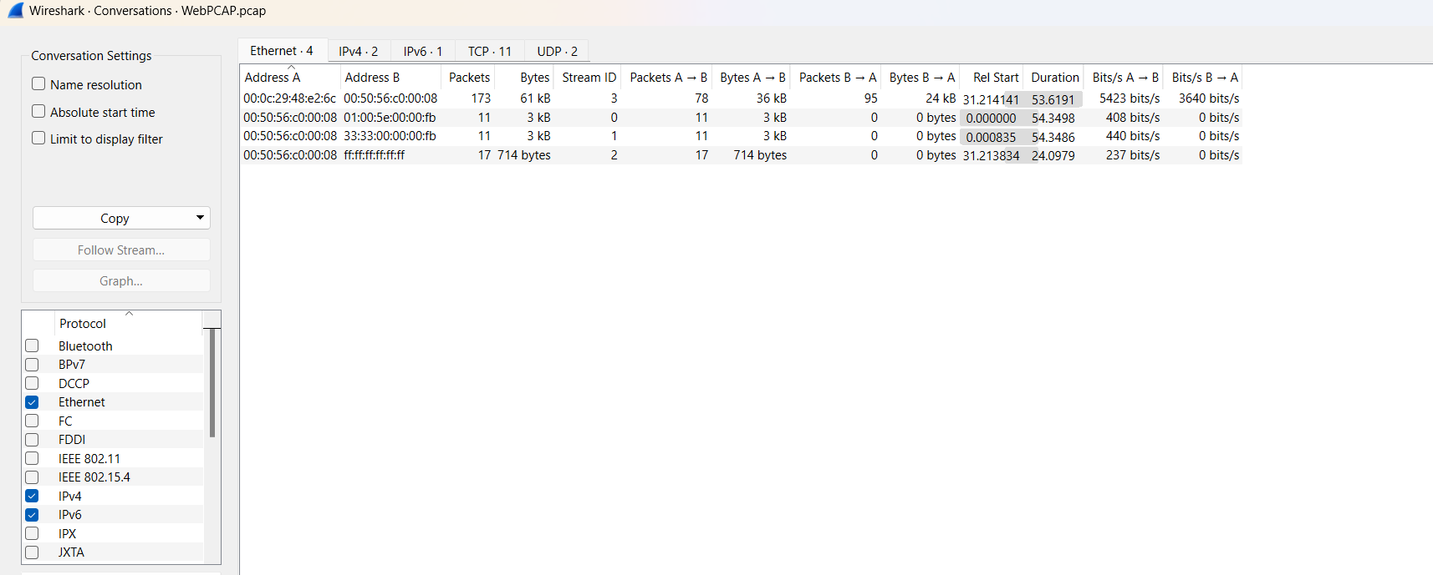
ShortPCAP endpoints:
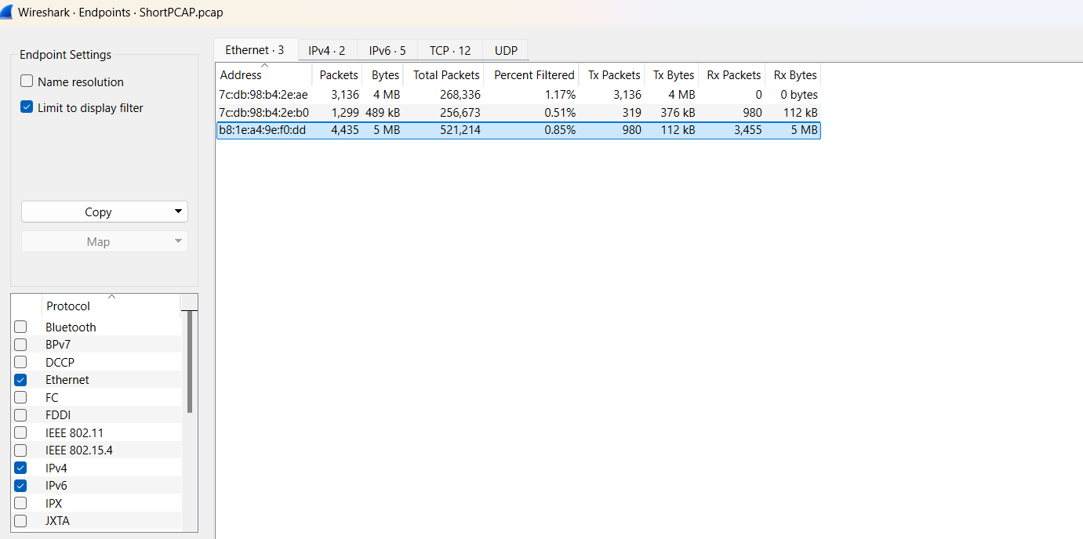
LongPCAP endpoints:
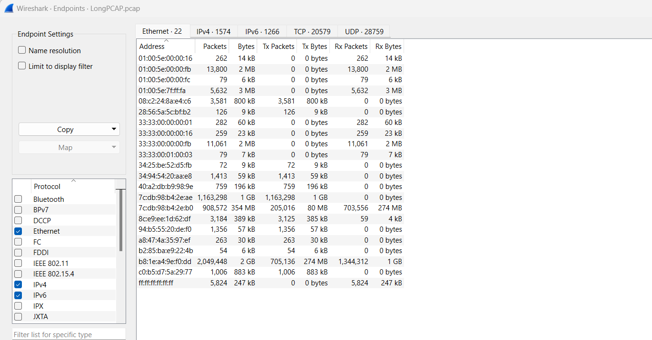
WebPCAP endpoints:
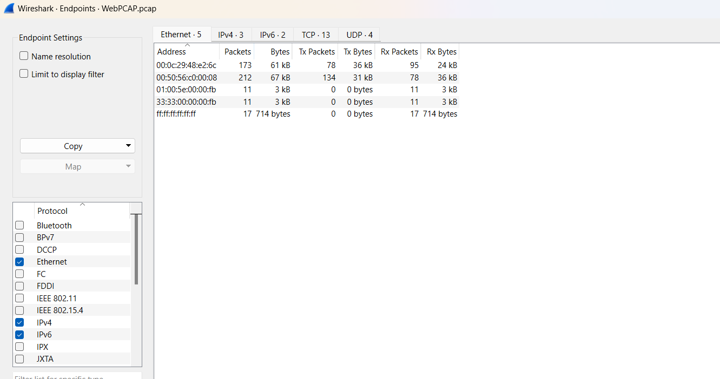
ShortPCAP I/O graph:
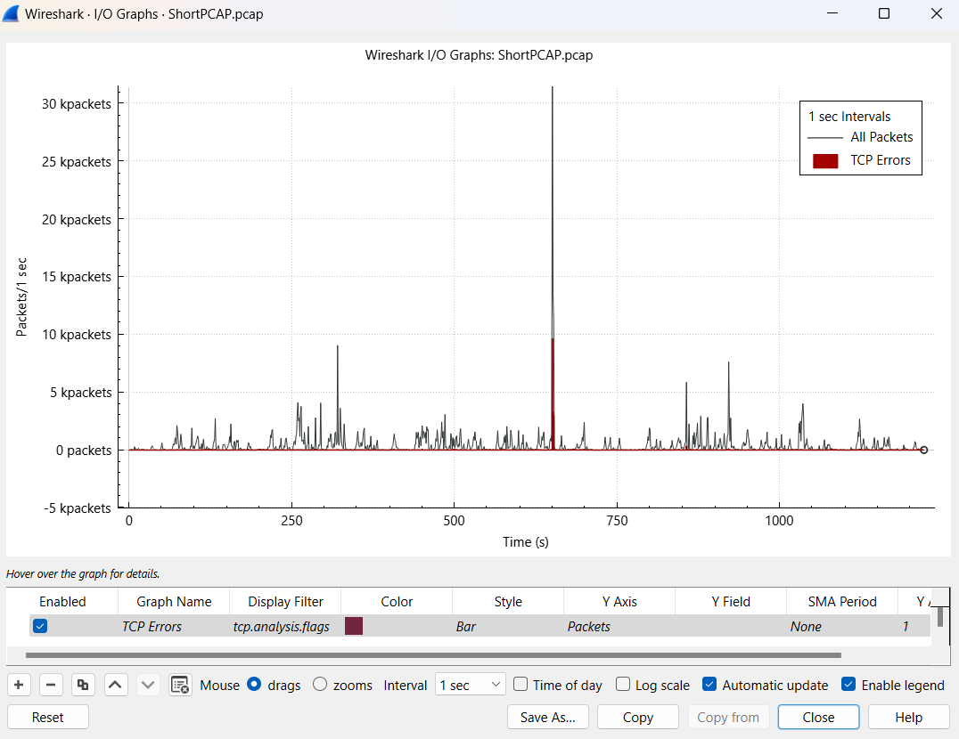
LongPCAP I/O graph:
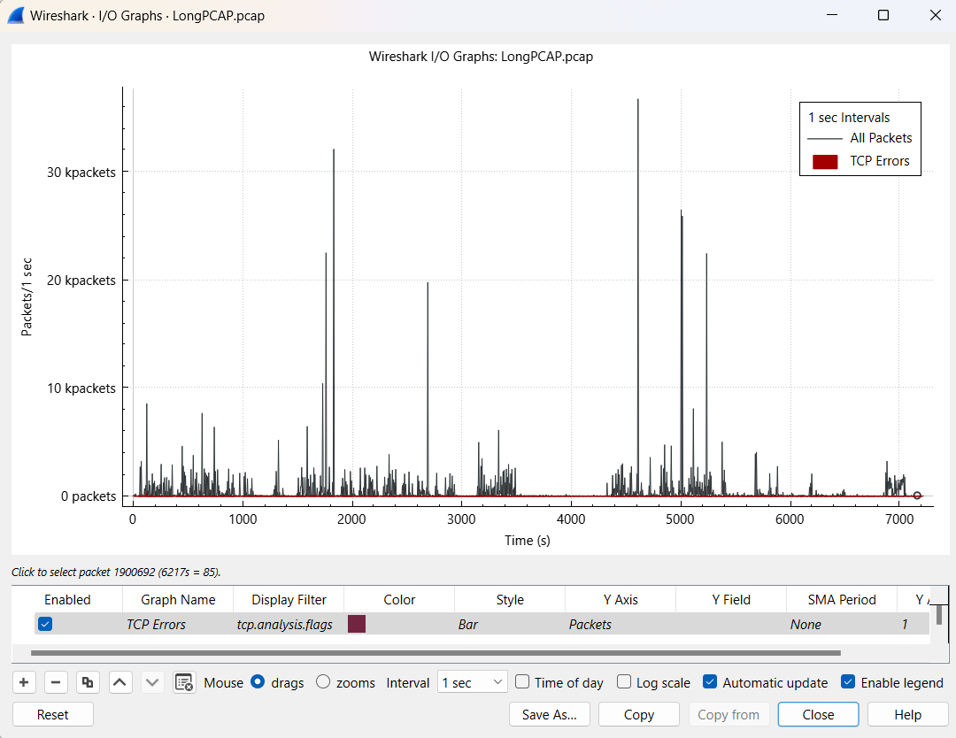
WebPCAP I/O graph:
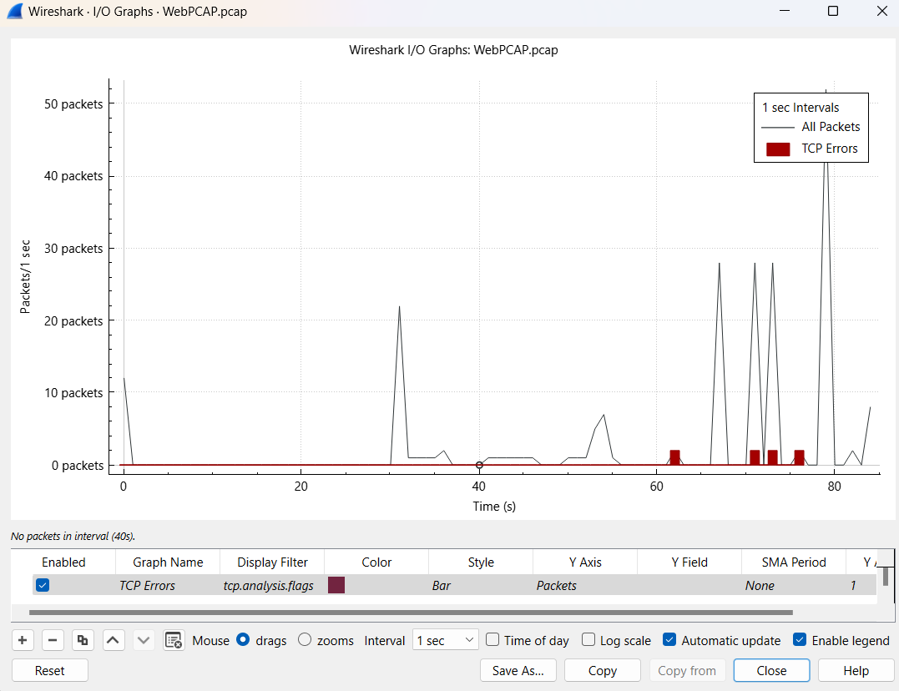
ShortPCAP flow graph (viewed TCP streams):
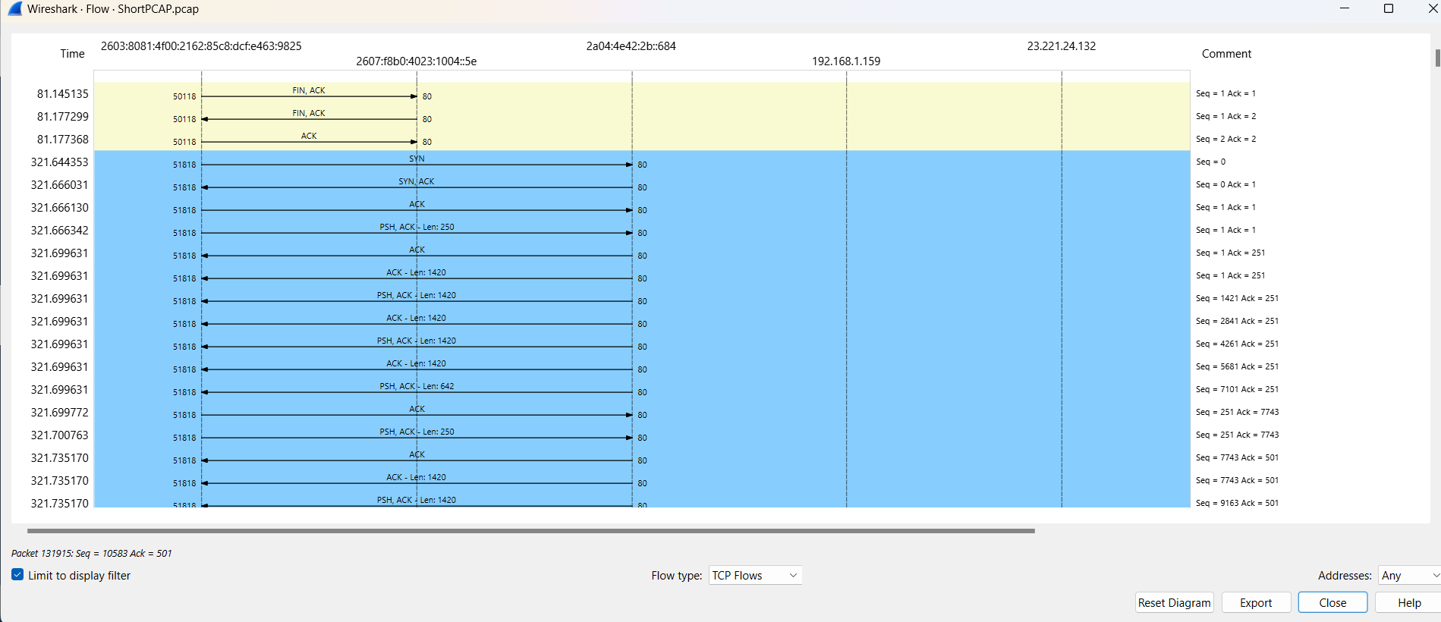
LongPCAP flow graph (viewed TCP streams):
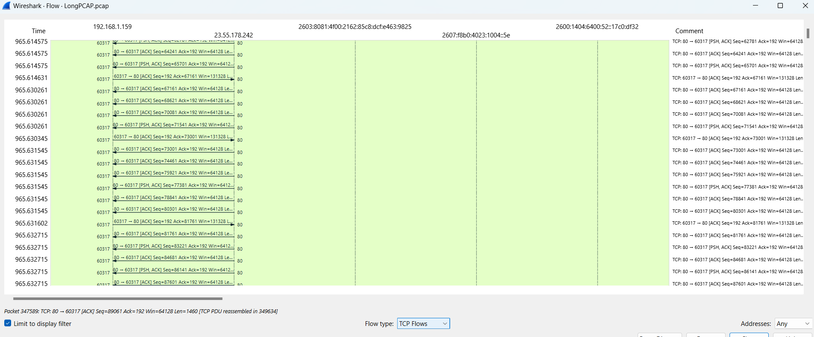
WebPCAP flow graph (viewed TCP streams):
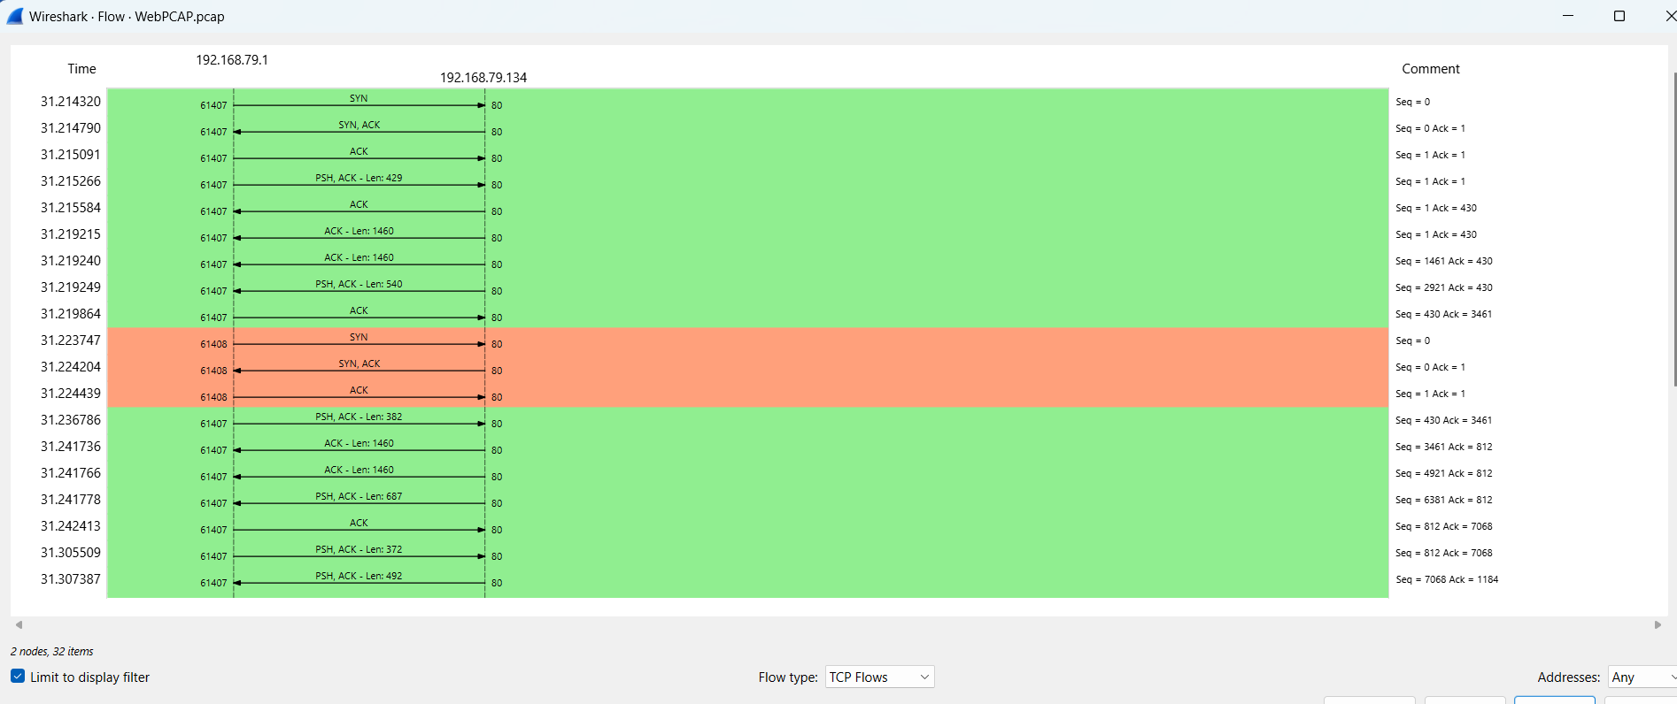
ShortPCAP opened on Network Miner (I filtered my sessions tab by a specific host that I saw in the hosts tab I wasn’t familiar with to see the endpoint sessions):
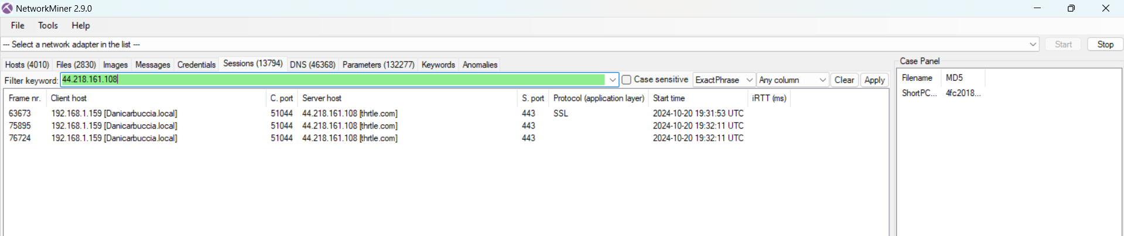
LongPCAP credentials (I had no results and I checked all PCAPS):
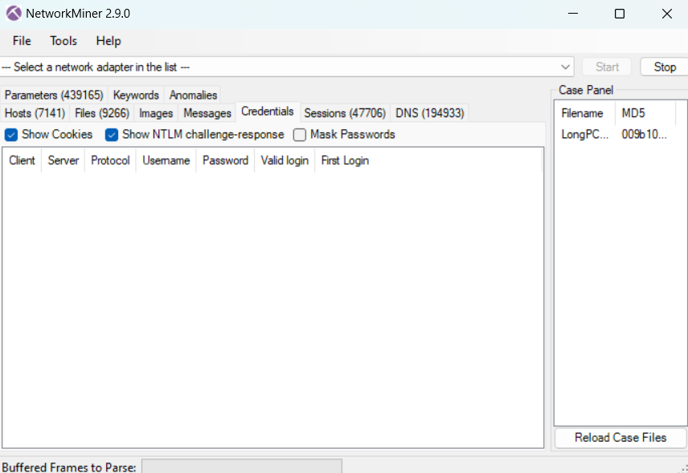
LongPCAP DNS tab:
