University of Szeged

Department of Computational Optimization

Embedded network structures of transaction graphs

Master Thesis

|  |  |  |  |  |
| --- | --- | --- | --- | --- |
|  | Written by: |  | Advisor: |  |
|  | Daniella Nikov |  | András Pluhár |  |
|  |  |  | Associate Professor |  |

Szeged

2022

Table of contents

1 Description of topic 2

2 Abstract 3

3 Introduction 4

4 Used Technologies 5

4.1 Python, PyEnv, PyCharm 5

4.2 Git 6

4.3 NetworkX 6

4.4 Sixtep software 8

4.5 Graph Databases 10

5 Graphs, Data sources 13

5.1 Social 13

5.1.1 IWIW 13

5.1.2 Facebook 14

5.1.3 Zachary 15

5.2 Transaction 16

5.2.1 OTP graph 16

5.2.2 Word-Graph 17

6 Algorithms, experiences 18

6.1 Community detection algorithms 18

6.1.1 Newman-Girvan 18

6.1.2 Maximized modularity 19

6.1.3 Cliques 21

6.2 Clustering algorithms on transaction networks 22

6.2.1 Markov-chain 23

6.2.2 H-avoiding coloring 23

6.3 Other algorithms 25

6.3.1 Condensation 25

6.3.2 Small-worldness 27

6.3.3 Colormap 28

7 Measuring, results 30

7.1 Modularities, used colors 31

7.1.1 Network: Facebook, 0.edges dataset 31

7.1.2 Network: transaction graphs of the OTP database 32

7.1.3 Wordgraph 36

7.2 Patterns 39

7.2.1 Supplier – Customer 39

7.2.2 Embedded 45

7.3 Efficiency 47

8 Further studies 47

9 References 48

10 Acknowledgements 49

# Description of topic

Study and analyze graph structures, implement clustering and community detecting algorithms. The application has to be able to handle directed and undirected graphs as well. The edges can carry weight information as attributes. The application should be covered with unit tests.

# Abstract

A prototype console application has been implemented to detect communities in social networks and clusters in transactional graphs. Several algorithms have been implemented to run against the given databases, such as Girvan-Newman, Markov chain, etc. The application is able to map a graph (also known as network) with any given delimiter, in any text format furthermore there is an option to connect to database if necessary. The results of the algorithms are plotted and displayed after the run. The coloring logic has been implemented in a fairly naive and greedy colormap. The application is scalable and modularized.

# Introduction

World Wide Web, blogging platforms, instant messaging and Facebook can be characterized by the interplay between rich information content, the millions of individuals and organizations who create and use it, and the technology that supports it. This thesis will cover the processing of recent research on the structure and analysis of large social and transaction networks and on models and algorithms that abstract their basic properties. Unusual ways have been explored how to practically analyze large scale network data and how to reason about it through models for network structure. Topics include methods for network community detection and their connection with transactional graphs. [1]

Community detection and analysis is an important methodology for understanding the organization of various real-world networks and has applications in problems as diverse as consensus formation in social communities. Currently used algorithms that identify the community structures in large-scale real-world networks require a priori information such as the number and sizes of communities or are computationally expensive. I intend to rely more on algorithms, which use the network structure as their guide instead of this priori information. Finding community structures in networks is another step towards understanding the complex systems they represent [2]. Social networks are represented by people as nodes and their relationships by edges therefore they contain more triangles than a random graph with similar edge density or degree properties. In contrast technological or transaction graphs contain fewer triangles and often display tree-like structures [15].

I gained knowledge about some of the prerequisites of social graph studies, for example algorithms of community detection have been used, along with the extracted data from an earlier implemented software, the Sixtep program, as well.

Based on the research written in article [15] and some earlier studies I intend to give an explanation about the implementation of algorithms for generalized coloring of transactional graphs. As the study goes, I follow the heuristics and possible suggested solutions for the clustering algorithm. With this information and techniques, I attempted to detect the embedded pattern in the provided transaction-like graphs and color it with the implemented algorithm. The article suggest several subgraphs, however I paid special attention to the 2K2 structure in the bipartite graphs.

# Used Technologies

The applied technologies are not sensitive for versioning (the versions are not depended on each other), the developer can easily go with the latest stable versions of them.

* Python: 3.9.4
* PyEnv,
* PyCharm: 2021.1.3 community edition
* NetworkX: 2.5.1
* Sixtep software
* Git
* Graph Databases

## Python, PyEnv, PyCharm

Python is a programming language that makes possible to work more quickly and integrate the designed system more effectively. Perfect choice to develop proof of concepts, make prototypes. It can be easy to pick up whether the developer makes a first time project or has experience with other languages. The well documented packages help the programmer along the learning way and the gains in productivity can be seen almost immediately. It also reduces maintenance costs of the targeted application. The packages used in this thesis are developed under open source license, making it freely usable and distributable not only educational purposes but even for commercial use. [16]

PyEnv makes it possible to switch between multiple versions of Python. It is unobstructive and follows the UNIX tradition of single-purpose tools. PyEnv-virtualenv is a PyEnv plugin that provides features to manage virtualenvs for Python on UNIX-like systems.

PyCharm is a Python IDE with intelligent code completion, on-the-fly error checking, quick fixes, built in support for Numpy, Matplotlib and other scientific libraries while offering graphs, array viewers and much more.

These tools have been chosen for thesis purposes not only because they are open source, but the documentations and tutorials are in good quality. The tools have wide range of support layer and make the development ready to start. Perfect choice when the scope is widely changes during the development and each feature has to be prototyped at first.

## Git

Git is a free and open source distributed version control system designed to handle everything from small to very large project with speed and efficiency. It has wide range of supported features, like branching and merging strategy, distribution, data assurance, staging area, however during the app development for the thesis, it has only been used for version control.

## NetworkX

NetworkX is a Python package for the creation, manipulation, and study of the structure, dynamics, and functions of complex networks. It supports a variety of features, provides classes for graph objects, generators to create standard graphs, IO routines for reading in existing datasets, algorithms to analyze the resulting networks and some basic drawing tools.

Most of the NetworkX API is provided by functions which take a graph object as an argument. Methods of the graph object are limited to basic manipulation and reporting. This provides modularity of code and documentation. It also makes it easier to learn about the package in stages.

In NetworkX, a graph is represented by a collection of edges that are pairs of nodes. Attributes are often associated with nodes and/or edges. NetworkX graph objects come in different flavors depending on the properties of the network, like is the graph directed, or are multiple edges allowed. Based on that, the basic graph classes are Graph, Directed Graph, Multi Graph, Multi-Directed Graph. Graph objects can be created by importing data from pre-existing (usually file) sources. In this thesis, graph algorithms provided by NetworkX include shortest path and breadth first search and clustering algorithm. While NetworkX in not designed as a network drawing tool, it provides a simple interface to drawing packages and some simple layout algorithms. In the application drawing has been done using this package and the Matplotlib Python package. The basic drawing functions essentially place the nodes on a scatterplot using the positions which have been provided via a dictionary or the positions are computed with a layout function. The edges are represented as lines between the dots. NetworkX uses dictionaries as the basic network data structure. This allows fast lookup with reasonable storage for large sparse networks. [4]

* Data structures for graphs, digraphs, and multigraphs
* Many standard graph algorithms
* Network structure and analysis measures
* Generators for classic graphs, random graphs, and synthetic networks
* Nodes can be "anything" (e.g., text, images, XML records)
* Edges can hold arbitrary data (e.g., weights, time-series)
* Open source 3-clause BSD license
* Well tested with over 90% code coverage
* Additional benefits from Python include fast prototyping, easy to teach, and multi-platform

### Algorithms

Algorithms in the Bipartition module

The module provides functions and operations for Graph and DiGraph classes. The algorithms are not imported into the NetworkX namespace at the top level, so it has to be added manually. The convention is to use a node attribute with value 0 or 1 to identify the sets each node belongs to. The functions in this package do not check that the node set is actually correct nor that the input graph is actually bipartite. For bipartition computing, the **Kernighan-Lin bipartition** algorithm is a good choice. This algorithm partitions a network into two sets by iteratively swapping pairs of nodes to reduce the edge cut between the two sets.

Cliques

Finding the largest clique in a graph is NP- complete problem, so the **find_cliques()** function probably has an exponential running time, however it returns all maximal cliques in an undirected graph.

**K-Clique**. A k-clique community is the union of all cliques of size k that can be reached through adjacent k-cliques.

Modularity-based communities

Greedy modularity maximization is implemented in a function, named **greedy_modularity_communities()**. It begins with each node in its own community and repeatedly joins the pair of communities that lead to the largest modularity until no further increase in modularity is possible.

### Colormap helper tools

spring_layout

Position nodes using Fruchterman-Reingold force-directed algorithm. The algorithm simulates a force-directed representation of the network treating edges as springs holding nodes close, while treating nodes as repelling objects, sometimes called an anti-gravity force. Simulation continues until the positions are close to an equilibrium. [3]

get_cmap

This function is located in the pyplot namespace in the Matplotlib package. It gets a colormap instance as parameter.

draw_networkx_nodes

This function draws the graph given as parameter with extra possible features, like axis labes, title, etc.

## Sixtep software

The software has been released in 2007 by network theory researchers and CRM advisors. In this study, a demo version of the software has been used. It is able to load a graph and visualize it. After adding a graph, an attribute file can be attached to it, provide information about the nodes with it. For example, if the nodes are representing people, such information like name, age, city can be added.

Several algorithms are implemented to clusterize or detect communities such as the Newman-Girvan algorithm or the Markov chain model. The UI representation of the graph is user friendly; the location of the nodes can be easily modified by clicking one by one or select a targeted area. Several built-in functions help to make the graph more interpretable. The user can select unique modules like clusters or communities and display only the selected ones.

3 algorithms have been used in this thesis to classify the nodes:

* Markov chain clustering
* Maximized modularity
* Community detection

The source code of the software cannot be accessed; therefore, the software is not expandable, cannot be further developed. However, it is possible to get the calculated cluster and community data with the export function. The exported data needed further processing, since the data structure was not in the right format to manufacture the NetworkX Graph object. An import function processes the data from the export then a factory function provides the Graph object that is needed. After that, a colormap is assigned to the nodes by the exported labels. The result can be compared with the built in NetworkX functions via modularity and/or the number of the used colors.

Sadly, there is no information provided in the software about the edges between the clusters, however valuable data can be found while exploring that area. See more at graph condensation.

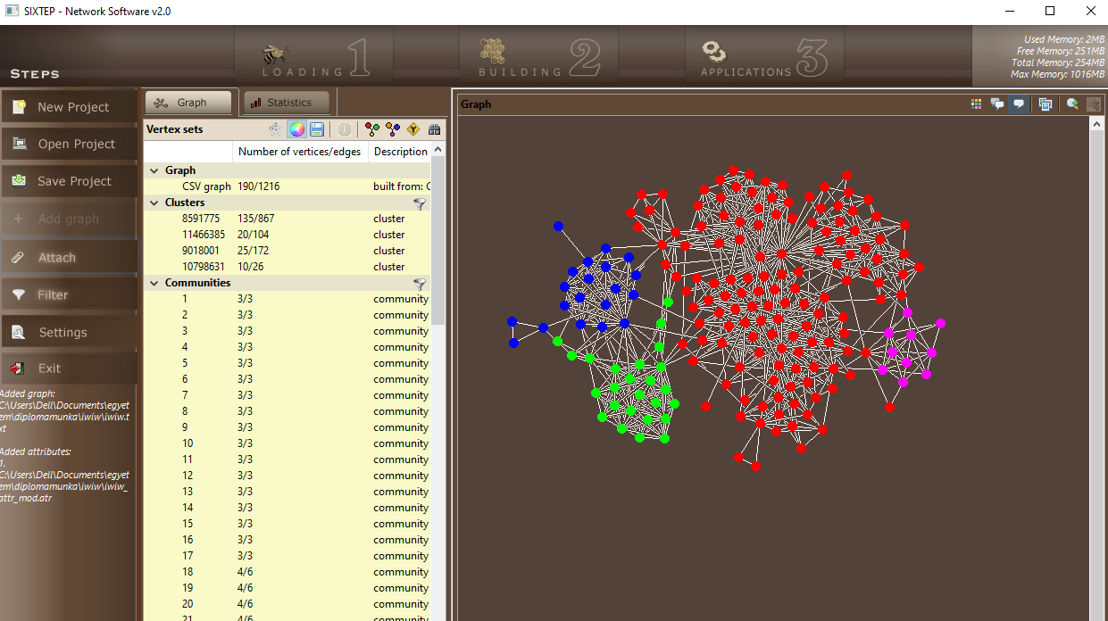

Figure 4.1 Clustering result in Sixtep software

Detecting communities with Sixtep

N++ algorithm

It is a generic algorithm with two arbitrary functions and where represents the strength of the connection between the A community and the x vertex. If , x shall be connected to A. The algorithm has tow main parts. The Build subroutine builds from bottom to top and gives the first approximation of the K communities.

The pseudo code for Build

Begin(Build)  
Input G, k, c  
Let   
for i = 1 to k  
if   
then put into K.  
delete all , where and   
print K  
end(Build)

After executing the Build, the other subroutine, Merge shall be used to merge the almost identical communities.

Let C be a graph, where and   
if is large enough*  
replace K with   
then the elements of c shall be the communities

* Based on experimental results, it represents the 60% of the item number of the smaller set. The value of the function depends on the number of the 1 and 2 lengths of paths between x and A. Therefore, should we get the communities that include x, it is sufficient to search it in set, so among the secondary neighbours.[22]

Further developments about the algorithm have been implemented by Csizmadia. [21]

## Graph Databases

A graph database is defined as a specialized, single-purpose platform for creating and manipulating graphs. Graphs contain nodes, edges and properties, all of which are used to represent and store data in a way that relational databases are not equipped to do. Graph analytics is another commonly used term and it refers specially to the process of analyzing data in a graph format using data points as nodes and relationships as edges. Graph analytics requires a database that can support graph formats. This could be a dedicated database, or a converged database that supports multiple data models, including graphs.

There are two popular models of graph databases: property graphs and RDF graphs. The property graph focuses on analytics and querying, while the RDF graph emphasizes data integration. Both types of graphs consist of a collection of points (nodes) and the connection between those points (edges). But there are differences as well.

Property Graphs.

These types of graphs are used to model relationships among data and they enable query and data analytics based on these relationships. A property graph has nodes that can contain detailed information about a subject and edges that denote the relationship between nodes. The nodes and edges can have attributes, called properties, with which they are associated. Because they are so versatile, property graphs are used in a broad range of industries and sectors, such as finance, manufacturing, public safety, retail and many others.

RDF graphs.

RDF stand for Resource Description Framework. These graphs conform to a set of W3C standard designed to represent statements and are best for representing complex metadata and master data. They are often used for linked data, data integration and knowledge graphs. They can represent complex concepts in a domain, or provide rich semantics and inferencing on data. In the RDF model a statement is represented by three elements: two nodes connected by an edge reflecting the subject, predicate and object of a sentence – this is known as an RDF triple. Every node and edge is identified by a unique URI, or Unique resource Identifier. The RDF model provides a way to publish data in a standard format with well-defined semantics, enabling information exchange. Government statistics agencies, pharmaceutical companies and healthcare organizations have adopted RDF graphs widely.

How graph databases work.

Graphs and graph databases provide graph models to represent relationships in data. They allow users to perform “traversal queries” based on connections and apply graph algorithms to find patterns, paths, communities, influencers, single points of failure, and other relationships, which enable more efficient analysis at scale against massive amounts of data. The power of graphs is in analytics, the insights they provide, and their ability to link disparate data sources.

When it comes to analyzing graphs, algorithms explore the paths and distance between the vertices, the importance of the vertices, and clustering of the vertices. For example, to determine importance algorithms will often look at incoming edges, importance of neighboring vertices, and other indicators.

Graph algorithms—operations specifically designed to analyze relationships and behaviors among data in graphs—make it possible to understand things that are difficult to see with other methods. When it comes to analyzing graphs, algorithms explore the paths and distance between the vertices, the importance of the vertices, and clustering of the vertices. The algorithms will often look at incoming edges, importance of neighboring vertices, and other indicators to help determine importance. For example, graph algorithms can identify what individual or item is most connected to others in social networks or business processes. The algorithms can identify communities, anomalies, common patterns, and paths that connect individuals or related transactions.

Advantages of graph databases.

The graph format provides a more flexible platform for finding distant connections or analyzing data based on things like strength or quality of relationship. Graphs let you explore and discover connections and patterns in social networks, IoT, big data, data warehouses, and also complex transaction data for multiple business use cases including fraud detection in banking, discovering connections in social networks, and customer 360. Today, graph databases are increasingly being used as a part of data science as a way to make connections in relationships clearer.

Because graph databases explicitly store the relationships, queries and algorithms utilizing the connectivity between vertices can be run in subseconds rather than hours or days. Users don’t need to execute countless joins and the data can more easily be used for analysis and machine learning to discover more about the world around us.

Graph databases are an extremely flexible, extremely powerful tool. Because of the graph format, complex relationships can be determined for deeper insights with much less effort. Graph databases generally run queries in languages such as Property Graph Query Language (PGQL). The example below shows the same query in PGQL and SQL.

Because graphs emphasize relationships between data, they are ideal for several different types of analyses. In particular, graph databases excel at:

* Finding the shortest path between two nodes
* Determining the nodes that create the most activity/influence
* Analyzing connectivity to identify the weakest points of a network
* Analyzing the state of the network or community based on connection distance/density in a group

# Graphs, Data sources

## Social

### IWIW

Number of nodes: 190

Number of edges: 1216

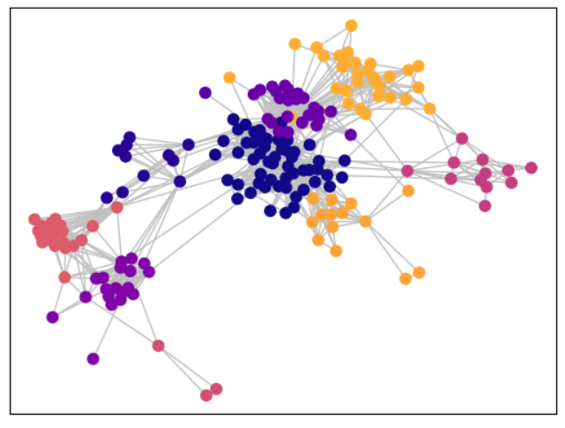

Figure 5.1 IWIW social connection graph

The graph above represents the connections of a person on the IWIW social platform. This is the only data which has not been anonymized. The nodes represent people and the edges the friendships. An attribute file is available for this graph, holding information about names, locations and other valuable information. With this data, a possibility was given to check the efficiency of the implemented community detector algorithms. The results showed that the communities appeared in certain period of time.

### Facebook

This dataset is collected from the website of Stanford University. Despite the data is anonymized, this source opened a possibility to handle large social type of graphs and examine the structure of them. Based on what is known about the IWIW graph, the same patterns can be deduced in other anonymized graphs like the ones collected from Facebook or Twitter.

The datasets from Stanford are using a wide range of delimiters to separate the nodes of the edges, so most of them are not eligible to open with the Sixtep software that has been provided to use during the research. The application had to be implemented that way to be able to use any delimiter given by the user. This parameter comes from outside, and not depends on the implementation.

Number of nodes: 128

Number of edges: 100

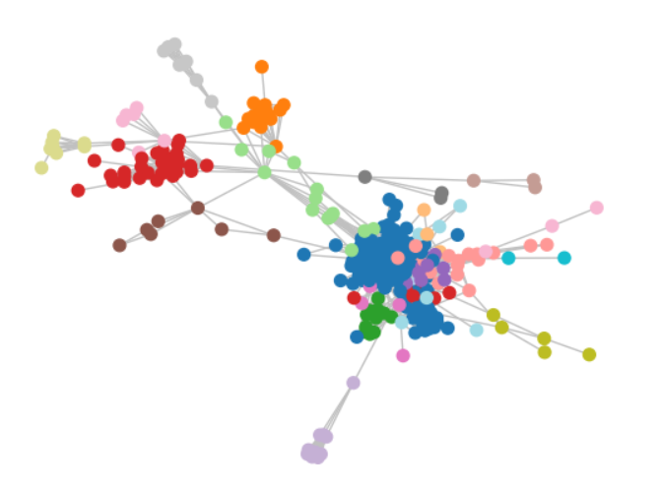

Figure 5.2 Newman-Girvan run on the slice of a FB graph

### Zachary

A social network of a karate club was studied by Wayne W. Zachary. The network became a popular example of community structure in networks after its use by Michelle Girvan and Mark Newman. It captures 34 members of a karate club, documenting links between pairs of members who interacted outside the club. During the study a conflict arose between the administrator and instructor, which led to the split of the club into two. Half of the members formed a new club around the instructor; members from the other part found a new instructor or gave up karate. Based on collected data Zachary correctly assigned all but one member of the club to the groups they actually joined after the split. The coloring of the graph represents the two new community. [5]

Number of nodes: 34

Number of edges: 78

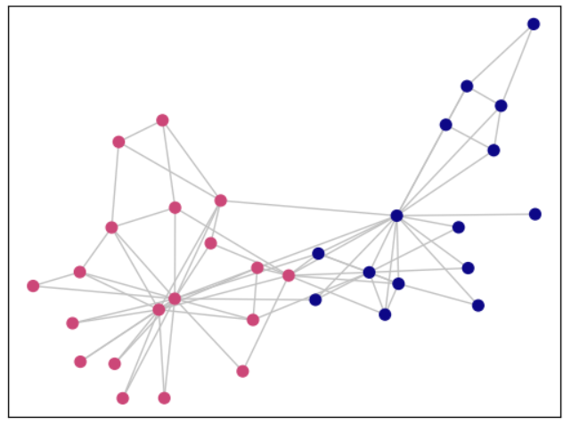

Figure 5.3: The well-known karate club community is divided into 2 main part due to a conflict of interest.

## Transaction

### OTP graph

This graph has been provided by the agreement of the OTP Bank (represented by Csernenszky) and the Sixtep company (represented by A. Pluhár). Despite the data is covered with a total anonymization, it is strictly confidential. The graph originally has been cut into 3 pieces and even smaller slices were made from the main partitions to make the detection easier even to the naked eye. It is not possible to decide obviously whether the graph is social or transactional type, there are areas with each kind. See layers after condensation.

Main partitions:

Relevant first quarter year:

* Nodes: 34992
* Edges: 72440

Relevant second quarter year:

* Nodes: 37008
* Edges: 79098

Relevant third quarter year:

* Nodes: 39155
* Edges: 86110

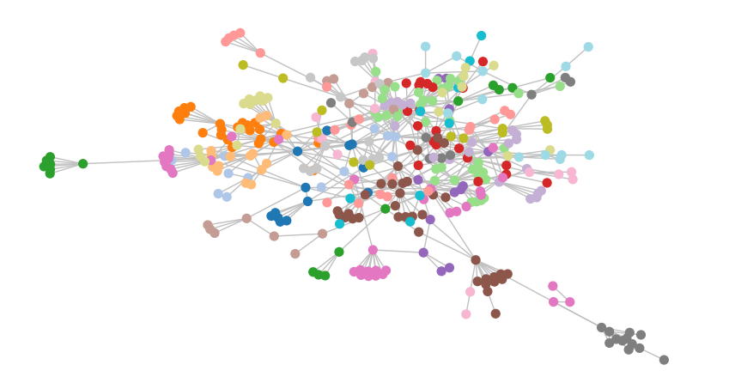

Figure 5.4 Largest connected components clustered by MCL in a slice of OTP first quarter graph

### Word-Graph

The graph based on a word association game: People have been asked what comes to mind about the given words. It is a fairly large graph with a wide range of network structures. It is similar to random graphs, however both social and transaction patterns can be detected while observing the structures of inner layers.

# Algorithms, experiences

## Community detection algorithms

### Newman-Girvan

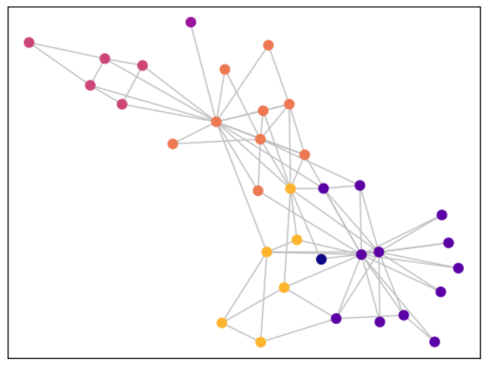

Figure 6.1 NG communities in zachary-graph

The Girvan-Newman algorithm for the detection and analysis of community structure relies on the iterative elimination of edges that have the highest number of shortest paths between nodes passing through them. By removing edges from the graph one-by-one, the network breaks down into smaller pieces, so-called communities. The algorithm was introduced by Michelle Girvan and Mark Newman. The idea was to find which edges in a network occur most frequently between other pairs of nodes by finding edges betweenness centrality. The edges joining communities are then expected to have a high edge betweenness. The underlying community structure of the network will be much more fine-grained once the edges with the highest betweenness are eliminated which means that communities will be much easier to spot. [3]

In the NetworkX implementation the Girvan-Newman algorithm can be divided into four main steps:

1. For every edge in a graph, calculate the edge betweenness centrality.
2. Remove the edge with the highest betweenness centrality.
3. Calculate the betweenness centrality for every remaining edge.
4. Repeat steps 2-4 until there are no more edges left.

### Maximized modularity

Figure 6.2 Maximized modularity in zachary-graph

This algorithm finds communities in graph using Clauset-Newman-Moore greedy modularity maximization. This method currently does not consider edge weights. Greedy modularity maximization begins with each node in its own community and joins the pair of communities that most increases modularity until no such pair exists. [3]

Source code:

<https://networkx.org/documentation/stable/_modules/networkx/algorithms/community/modularity_max.html>

Modularity

One of the most sensitive detection methods is optimization of the quality function known as modularity over the possible divisions of a network, but direct application of this method using, for instance, simulated annealing is computationally costly. A community structure in a network corresponds to a statistically surprising arrangement of edges, can be quantified using the measure known as modularity [9]. The modularity is, up to a multiplicative constant, the number of edges falling within groups minus the expected number in an equivalent network with edges placed at random. The modularity can be either positive or negative, with positive values indicating the possible presence of community structure [10].

Modularity is defined in [11] as

Where m is the number of edges, A is the adjacency matrix of G, is the degree of i, γ is the resolution parameter, and is 1 if i and j are in the same community, else 0.

According to [12] (and verified some algebra) this can be reduced to

Where the sum iterates over all communities c, m is the number of edges, is the number of intra-community links for community c, is the sum of degrees of the nodes in community c, and γ is the resolution parameter.

The resolution parameter sets an arbitrary tradeoff between intra-group edges and inter-group edges. More complex grouping patterns can be discovered by analyzing the same network with multiple values of gamma and then combining the results [13]. That said, it is very common to simply use gamma=1. More on the choice of gamma is in [14].

This NetworkX version has been used in the community detector repository. The parameters are the following: G represent the NetworkX graph. Communities are a list or iterable of set of nodes. These node sets must represent a partition of G’s nodes. Weight is an edge attribute that holds the numerical value used as a weight. It is an optional parameter, if the value is None or an edge does not have that attribute, then that edge has weight 1. Resolution is an optional parameter as well. If resolution is less than 1, modularity favors larger communities. Greater than 1 favors smaller communities. The function returns Q, the modularity of the partition. In case of the communities are not a partition of G, the function raises NotAPartition exception.

The second formula is the one actually used in calculation of the modularity. For directed graphs the second formula replaces with .

### Cliques

Clique problem.

In computer science, the clique problem is the computational problem of finding cliques (subsets of vertices, all adjacent to each other, also called complete subgraphs) in a graph. It has several different formulations depending on which cliques, and what information about the cliques should be found. Common formulations of the clique problem include finding a maximum clique (a clique with the largest possible number of vertices), finding a maximum weight clique in a weighted graph, listing all maximal cliques (cliques that cannot be enlarged) and solving the decision problem of testing whether a graph contains a clique larger than a given size.

The clique problem arises in the following real-world setting. Consider a social network, where the graph's vertices represent people, and the graph's edges represent mutual acquaintance. Then a clique represents a subset of people who all know each other, and algorithms for finding cliques can be used to discover these groups of mutual friends. Along with its applications in social networks, the clique problem also has many applications in bioinformatics, and computational chemistry.

Most versions of the clique problem are hard. The clique decision problem is NP-complete (one of Karp's 21 NP-complete problems). The problem of finding the maximum clique is both fixed-parameter intractable and hard to approximate. Listing all maximal cliques may require exponential time as there exist graphs with exponentially many maximal cliques. Therefore, much of the theory about the clique problem is devoted to identifying special types of graphs that admit more efficient algorithms, or to establishing the computational difficulty of the general problem in various models of computation.

To find a maximum clique, one can systematically inspect all subsets, but this sort of brute-force search is too time-consuming to be practical for networks comprising more than a few dozen vertices. Although no polynomial time algorithm is known for this problem, more efficient algorithms than the brute-force search are known. For instance, the Bron–Kerbosch algorithm can be used to list all maximal cliques in worst-case optimal time, and it is also possible to list them in polynomial time per clique. [19]

Clique maximization:

For each node n, a maximal clique for n is a largest complete subgraph containing n. The largest maximal clique is sometimes called the maximum clique. This function returns an iterator over cliques, each of which is a list of nodes. It is an iterative implementation, so should not suffer from recursion depth issues. A list of nodes has been accepted as parameters and only the maximal cliques containing all of these nodes are returned. It can considerably speed up the running time if some specific cliques are desired.

A list output of the function find_cliques(G) has been used to obtain all maximal cliques. However, in the worst-case scenario, the length of this list can be exponential in the number of nodes in the graph. This function avoids storing all cliques in memory by only keeping current candidate node lists in memory during its search.

This implementation is based on the algorithm published by Bron and Kerbosch (1973) [6], as adapted by Tomita, Tanaka and Takahashi (2006) [7] and discussed in Cazals and Karande (2008) [8].

This algorithm ignores self-loops and parallel edges, since cliques are not conventionally defined with such edges.

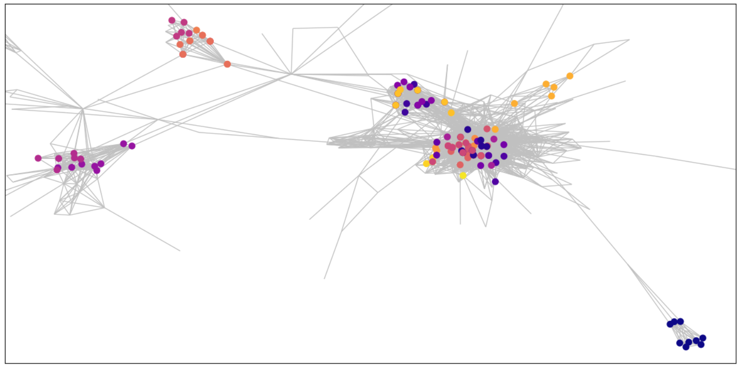

Figure 6.3 It is important to determine the size of the cliques should be detected. For example, a clique with size 3 has lower importance than 5 or above.

## Clustering algorithms on transaction networks

### Markov-chain

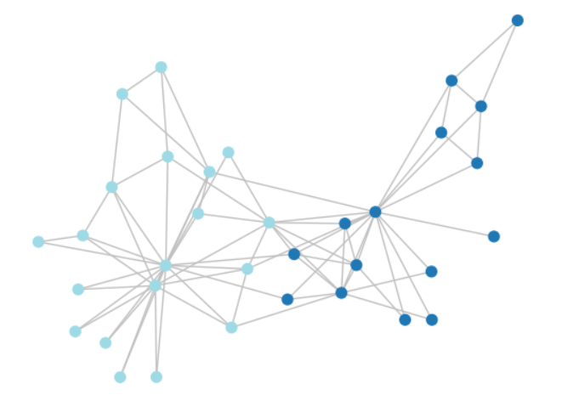

Figure 6.4 MCL in zachary-graph

The MCL algorithm is short for the Markov Cluster Algorithm, a fast and scalable unsupervised cluster algorithm for graphs (also known as networks) based on simulation of (stochastic) flow in graphs. The algorithm was invented/discovered by Stijn van Dongen at the Centre for Mathematics and Computer Science (also known as CWI) in the Netherlands. [4]

### Induced H-avoiding coloring

(Induced H-avoiding coloring is called from now on H-avoiding coloring)

Embeddedness of bipartite subgraphs in transaction networks

Certain bipartite graphs, for example pollinator networks or trade networks suggest the presence of different structures, like the notion of embeddedness. The vertices of each color class can be ordered, and the smaller ranked vertex neighbourhood contains the neighbourhood of any higher ranked one. A binary matrix *A* is fully nested if its rows and columns can be reordered such that the ones are in echelon form. Let be the bipartite graph whose adjacency matrix is A. Then A being fully nested is equivalent to satisfying embeddedness.

Let X (the columns) and Y (the rows) be the bipartition of . The matrix A and the graph are each said to be k-nested with respect to X if X can be partitioned as such that all subgraphs spanned by are fully nested for . The quantity of interest for any is smallest k for which is k-nested.

Given a “forbidden graph” H and an integer k, an H-avoiding k-coloring of a graph G is a k-coloring of the vertices of G such that no maximal H-free subgraph of G is monochromatic.

A monochromatic graph is a colored graph (either vertex-colored or edge-colored, depending on the context) in which each of the vertices or edges is assigned the same color.

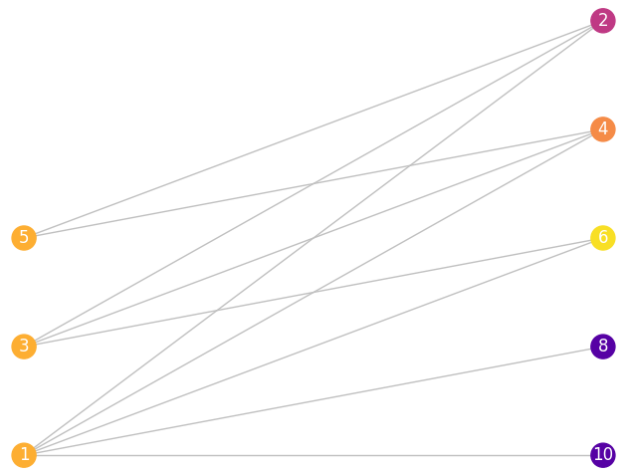

Figure 6.5. Proper 2K2 avoiding coloring of a bipartite graph

*Colormap: {'1': 0.82, '2': 0.44999999999999996, '4': 0.72, '6': 0.94, '8': 0.15000000000000002, '10': 0.15000000000000002, '3': 0.82, '5': 0.82}*

A new kind of clustering of general (that is, not necessarily bipartite) transaction graphs has been presented via a certain class of proper colorings. The clusters are the color classes, since no edges are desired inside a cluster. The structure of the edges is restricted between the pairs of classes. The above examples suggest that in some cases there should be a fully nested or, equivalently, embeddedness relation among any two-color classes. This notion is generalized to an arbitrary host graph G and a forbidden bipartite subgraph H as follows.

Definition 1. Fix a bipartite graph H. A proper coloring of a graph G is an H-avoiding coloring if the union of any two-color classes spans an induced H-free graph. Let be the minimum number of colors in an H-avoiding coloring of G.

Observation 2. For any graphs H and G, . If G is H-free, then

The computation of is NP-hard for some graphs and polynomially computable for others. The most interesting case is, when , gives back embeddedness as described above. For these generalized chromatic numbers some theoretical extremal results have been derived as well as results on complexity.

## Other algorithms

### Condensation

Condensed graphs

Each community/cluster has been contracted to single node. If there is a path between the modules, the algorithm puts an edge between the nodes. The algorithm works well, if the source graph is strongly connected. The condensation algorithm has been tested on the IWIW graph with the NG community detector. If the condensation logic runs against the result clusters of the MCL algorithm, it most likely is going to be fail. The reason behind this is that the MCL algorithm, implemented in the NetworkX package, renames the nodes, thus the condensation logic cannot map the old names of the nodes with the new ones. The algorithm is not going to crush, but rather will present a false result with no vertices displayed. In general, the condensation algorithm provides a reliable result, if the detector algorithm does not rename the vertices.

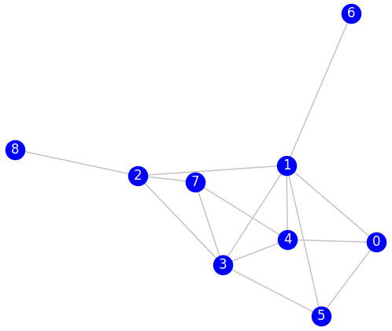

Figure 6.6 Condensed form of the IWIW graph

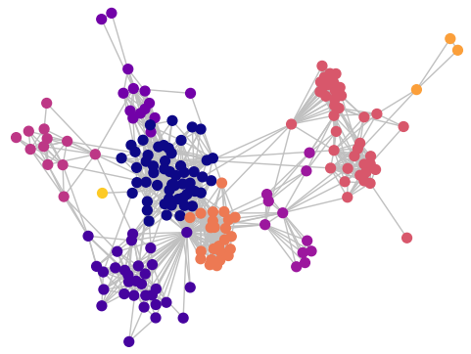

Figure 6.7 Communities in IWIW graph clustered by girvan

### Condensation with heuristics

If the communities are large enough (many vertices belong to them), there is a high probability that edges are going to exist among them. Therefore, the information is more valuable if the number of edges is considered based on the size of the communities. In the case of small communities, a much lesser value of edges can represent a connection between the two groups. If the size of the communities is large enough, a small number of edges between the node groups are not representative.

Further investigation can be done to study the position of the edges. If the information is fetchable, which nodes are connected, some value can be provided about the centralization of the nodes. An edge can be put in the new graph, if the degrees of the two centralized nodes in the groups are high enough.

### Small-worldness

The fundamental properties of social graphs have been studied in the 60s, and based on their nature, the name Small-world graph has been assigned to them. According to experimental results, the structure of these types of graphs has the following ruleset.

1. The structure of the social type of graph G is rare, the number of edges, e(G), is a lot smaller, than .
2. There are dense areas in the G graph, the distribution of the edges is far from homogeneous
3. The average diameter of G (the distance of a pair of vertices) is fairly small, almost constant

These observations have been confirmed by later studies, the definition has been specified, refined by the explanations. Despite the definition has not been fully validated, these observations are widely accepted. Studies show that the distribution of the degree of such graph follows the power-law relation, such as , vertices with k number of degree, , where . The diam(G) average diameter is commensurable with the logarithm of the number of vertices in G, so . However, this distribution should be used carefully. It is safer to assume that the degree of every vertex is at least , so truncated distribution should be used. These observations clarify the presence of the large number of vertices with high degree, and the diameter that looks constant. According to the measuring results of Albert, Jeoung and Barabási, the diameter of the Internet-graph is 19, next to the one and a half billion webpage. The average link of the pages is smaller though, compare to the number of a person’s regular cellphone partners, so estimating with the formula above, the value of the average diameter is significantly under 10.

Small-world functions in NetworkX

Small-world functions are used for estimating the small-worldness of graphs. A small world network is characterized by a small average shortest path length and a large clustering coefficient. Small-worldness is commonly measured with a coefficient, which compares the average clustering coefficient and shortest path length of a given graph against the same quantities for an equivalent random or lattice graph.

The coefficient is defined as:

Where C and L are respectively the average clustering coefficient and average shortest path length of the graph. [3]

The graph is commonly classified as small-world if .

### Colormap

NetworkX draw() function needs a dictionary that describes which node to be colored by which color. There are predefined palettes provided by the MatPlotLib Python package.

Classes of colormaps:

Colormaps are often split into several categories based on their function (see, e.g., [Moreland]):

* Sequential: change in lightness and often saturation of color incrementally, often using a single hue; should be used for representing information that has ordering.
* Diverging: change in lightness and possibly saturation of two different colors that meet in the middle at an unsaturated color; should be used when the information being plotted has a critical middle value, such as topography or when the data deviates around zero.
* Cyclic: change in lightness of two different colors that meet in the middle and beginning/end at an unsaturated color; should be used for values that wrap around at the endpoints, such as phase angle, wind direction, or time of day.
* Qualitative: often are miscellaneous colors; should be used to represent information which does not have ordering or relationships.

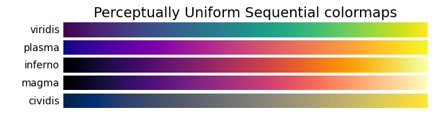

Figure 6.8 source: https://matplotlib.org/stable/gallery/color/colormap_reference.html

Sequential:

For the Sequential plots, the lightness value increases monotonically through the colormaps. Some of the values in the colormaps span from 0 to 100 (binary and the other grayscale), and others start around . Those that have a smaller range of will accordingly have a smaller perceptual range. Note also that the function varies amongst the colormaps: some are approximately linear in and others are more curved. [20]

Implemented colormapper fuction

The implemented algorithm applies a naïve way to order colors to the node groups. The colors are randomly picked from the colormap of the NetworkX package. The position of the nodes is calculated by the spring_layout function.

## Helper tools

### edgenumber

It calculates the number of edges between the clusters of a given graph and prints it out in a logfile.

Parameters:

* list of clusters
* graph
* name of the output logfile (path: project_directory/outputs/{logfile.txt})

### get_edges

It is a getter function to access the edge list between two clusters.

Parameters:

* cluster1, cluter2
* graph

### nodegroups2cluster

Convert any classification result to Cluster object, so the nodes of the clusters can be accessed by the getter function of the Cluster class and the clusters can be identified with UUIDs.

### write2file

As the name suggests, this function writes the results into an output logfile. The generated file can be found in the output folder in the project directory.

# Measuring, results

The clustering and community detector algorithms were run against the graphs with various strategies to get the best results overlapping the real-life groups.

To get the communities of a social graph, the console application’s first job is to identify the number of the colors to reach the maximum of modularity. The rate of these two numbers determines the parameters of the NG algorithm, to get the best quality to approximate the real communities. The parameter set is correct if the value of the modularity is high enough (it is a value between zero and one), while the least color has been used. With this strategy, the communities() function is able to detect the groups of people who form the communities, without using any hardcoded value, or requesting any parameters from the user, except the path of the graph. The algorithm only relies on the local structures of the strongly connected subgraph.

Usually, it is not decidable at first that the graph has social structures, or rather shows transactional patterns. To identify the nature of the graph, the measure() function runs the MCL and greedy_modularity algorithms to check which one performs better.

If the user wants to condensate the graph, a clusterization shall be provided to the algorithm. However, the logic itself has been implemented in many lines of code. To modularize the application as it supposed, the logic of these two features should be separated in different functions. The detect_and_condense API function calls these two implementations. This layer of abstraction provides the user a friendly and failsafe operation of the algorithms.

The algorithms in the Sixtep software have been performed well, however there were difficulties to export the results and parse the information into the console application. For these features, the API function is the sixtep_modularity(). It imports the data from the output file and measure the modularity value for the detection.

## Modularities, used colors

The data of the following tables represent the measured values of modularities, and the number of colors used by the algorithms. Based on these two parameters an efficiency can be calculated or deduced. Usually, the examined graphs are large enough to contain both social-like subgraphs and transactional networks as well.

### Facebook, 0.edges dataset

|  |  |  |  |  |
| --- | --- | --- | --- | --- |
| Application | Community detector app | | | |
| Algo | NG | NG-comm* | Markov | Maximized modularity |
| Nr. of colors | 2 | 30 | 24 | 8 |
| Modularity | 0.3615 | (6) 0.2523 | -0.8080 | **0.4429** |
| (20) 0.3729 |
| (30) 0.4136 |
| (35) 0.4129 |
| (40) 0.4111 |
| (50) 0.4043 |

|  |  |  |  |
| --- | --- | --- | --- |
| Application | Sixtep | | |
| Algo | communities | Markov | Maximized modularity |
| Nr. of colors | 208 | 7 | 8 |
| Modularity | Cannot be calculated** | 0.3306 | **0.3891** |

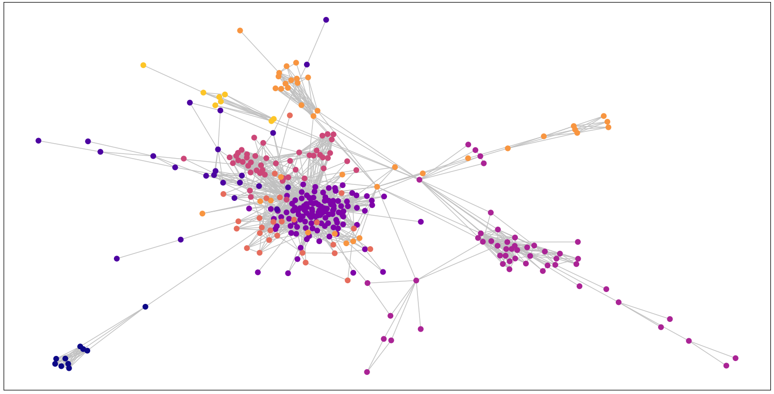

Figure 7.1: Facebook communities detected by greedy modularity algorithm

Number of nodes: 324

Number of edges: 2514

The value of the number of edges is different from the value given by the Sixtep software. The reason behind this is that the edges are represented in both direction in the text file. In conclusion, the value is double.

* The numbers before the modularity values represent the number of communities the algorithm took.

** The communities that has been provided by the Sixtep software are not a valid partition of the graph, therefore the NetworkX modularity function cannot be run against the data.

### Transaction graphs of the OTP database

|  |  |  |  |  |  |  |
| --- | --- | --- | --- | --- | --- | --- |
| Application | Community detector app | | | | | |
|  | Newman-Girvan | | Markov | | Greedy modularity | |
|  | # colors | Modularity | # colors | Modularity | # colors | Modularity |
| OTP 100 | 10 | 0.6981 | 14 | 0.5413 | 9 | 0.7042 |
| First 600 edges of first quarter year largest cc | 19 | **0.7570** | 80 | 0.5725 | 15 | 0.7632 |
| First quarter year 1k | 19 | 0.7977 | 113 | 0.6182 | 20 | 0.7981 |
| Middle slice | - | - | 3810 | 0.5509 | 92 | 0.8227 |
| total | - | - | 0.3900 | | - | |
| Second quarter year | - | - | 0.3794 | | - | |
| Third quarter year | - | - | 0.3690 | | - | |

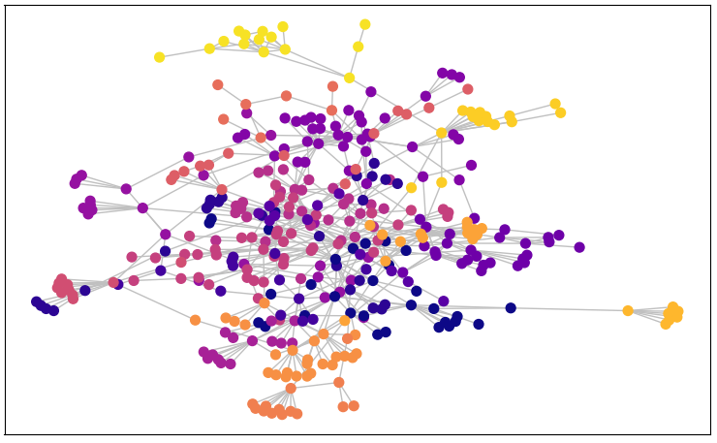

Figure 7.2 First 600 edges of first quarter year largest cc, 19 with 0.7570 mod

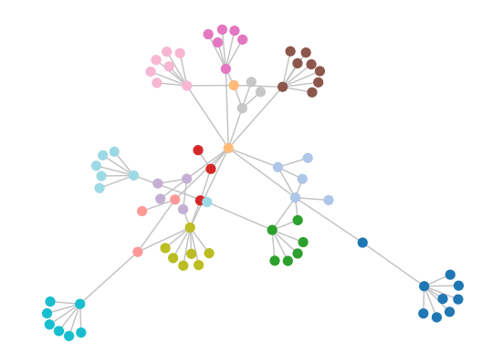

|  |  |  |  |  |  |
| --- | --- | --- | --- | --- | --- |
| Application | Sixtep | | | | |
|  | communities | Markov | | Greedy modularity | |
|  | # colors | # colors | Modularity | # colors | Modularity |
| OTP 100 | 2 | 9 | 0.6128 | 12 | 0.7580 |
| First 600 edges of first quarter year largest cc | 39 | 25 | 0.7346 | 19 | 0.7697 |
| First quarter year 1k | 56 | 39 | 0.7751 | 25 | 0.7965 |
| Middle slice | 862 | 1587 | 0.7632 | 879 | 0.8349 |
| First quarter year | 3583 | 1688 | 0.5792 | - | |
| Second quarter year | 3814 | 1587 | 0.5764 | - | |
| Third quarter year | 4303 | 1738 | 0.5707 | - | |

First quarter year:

* Number of nodes: 34992
* Number of edges: 72440, 76668 in Sixtep

Second quarter year:

* Number of nodes: 37008
* Number of edges: 79098, 83926 in Sixtep

Third quarter year:

* Number of nodes: 39155
* Number of edges: 86110, 91862 in Sixtep

OTP midslice of a first quarter year:

* Number of nodes:18032
* Number of edges: 25686

First 1K edges of first quarter year largest cc:

* Number of nodes:675
* Number of edges: 1000

First 600 edges of first quarter year largest cc:

* Number of nodes: 398
* Number of edges: 600 in Sixtep

First 100 edges of first quarter year largest cc:

* Number of nodes: 96
* Number of edges: 100

The information is known that the OTP graph is directed. Usually, the difference between the number of the edges in the same graph in Sixtep software and the console application represents the direction of the graph. and show that the nodes are mutually connected to one another.

The difference between the modularity that has been measured in Sixtep and the application can be caused by the data, that the algorithms were run against the exact graph or the largest connected component of the graph.

The smaller graphs are a subset of the graph from the first quarter year. These subgraphs are better for studying the structure and measure the algorithms. The most figure is captured by running the algorithms on these smaller datasets. The algorithms usually cannot run against the whole dataset, and at this size, there is not much sense to visualize the graphs in 2D either. No information can be gained with naked eyes or manual clustering.

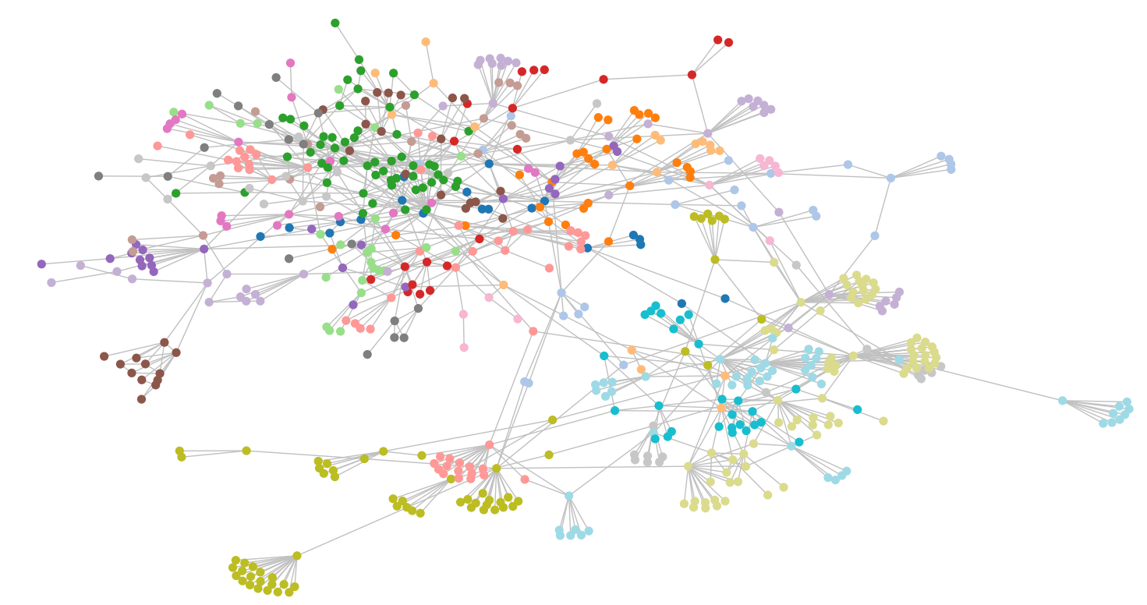

Figure 7.3. First quarter year of the OTP transactions clustered by Markov chain algorithm. 675 nodes have been colorized.

### Wordgraph

|  |  |  |  |  |  |  |
| --- | --- | --- | --- | --- | --- | --- |
| Application | Community detector app | | | | | |
|  | Newman-Girvan | | Markov | | Greedy modularity | |
|  | # colors | Modularity | # colors | Modularity | # colors | Modularity |
| wordgraph | - | - | 3786 | 0.2241 | 106 | 0.5349 |
| 1200 | 17 | **0.8663** | 52 | 0.7264 | 19 | 0.8661 |

|  |  |  |  |  |  |
| --- | --- | --- | --- | --- | --- |
| Application | Sixtep | | | | |
|  | communities | Markov | | Greedy modularity | |
|  | # colors | # colors | Modularity | # colors | Modularity |
| wordgraph | null | 236 | 0.4303 | 114 | 0.5303 |

* Number of nodes: 11381
* Number of edges: 31784

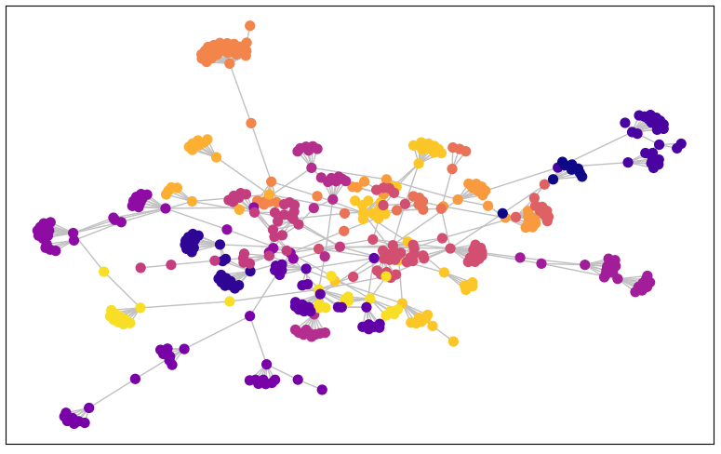

Figure 7.4 slice of wordgraph, colored by NG

### OTP transaction leveling by condensation

This result has been provided by iterating the community detector, and the condensation algorithm after each other on the OTP graph. The valuable information in this direction is that some clique-like structures can be detected amongst the levels, against other cases, where a tree-like pattern can be found. We know from the Wordgraph that this architecture suggests strong connection among the nodes, and in social graphs like Facebook, it means a friendship circle. Based on that information, some cooperation can be supposed among the detected vertices, however the expected result would be the opposite meaning (We do not expect to see cooperation among competitors).

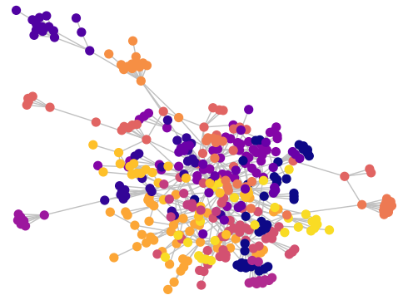

Figure 7.5 Community detection in OTP slice

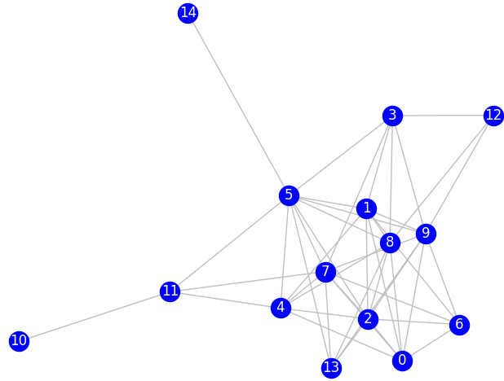

Figure 7.6 Condensed graph

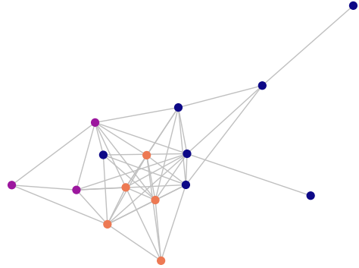

Figure 7.7 Modularity value: 0.7632

## Patterns

The following patterns are present in the word association graph.

### Supplier – Customer

In this structure only a few nodes are present with a high edge number originated from them and many nodes are displayed with low degree number. In the word association graph, the meaning of the pattern is that there are words that cover a wide range of topic, for example: TOOL. It can represent basically anything like an IT tool, Neo4J Aura (graph database in cloud), or a mechanical tool like hammer. In a transactional environment, it could represent a classic transactional pattern with a supplier – customer relationship, however since the OTP graph is anonymized, the necessary information is not provided to resolve the exact meaning.

Figure 7.8

The following pattern has been unable to be identified, however it is quite common both in social and in transaction networks as well.

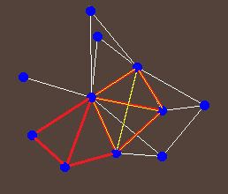

Figure 7.9

If the structure is extended, it appears that the so-called supplier vertices are connected with edges. As I looked through the graph, a circular, tree-like structure appeared.

Figure 7.10

If we consider one supplier and the customers as one cluster, we can observe smaller communities among them. In the previous image we can see several triangles, but I discovered larger ones as I increased the number of layers I observed at the same time. Since the graph I am working with is anonymized, we do not have the necessary information to resolve the graph, thus I am still not sure what this structure represent.

Figure 7.11 WA graph

The idea of complementary coloring

Another way to test the coloring cluster’s efficiency is to run on a complementary of a social graph. Using the color dictionary in the original graph, a subset of cliques shall be colored, if the intermediate edge-structure is acceptable. This kind of embeddedness is self-complementary, only the orientation of the relations should change. There are a lot of edges in a dense structure in the sets of a social type of graph, so nothing common with the transactional set at first sight. If we delete these edges, the ones among the communities remain. By the intermediate edges, the complementary function keeps the original structure, only the location of the vertices going to be different. Therefore it makes sense to run the algorithm against a social graph complementary.

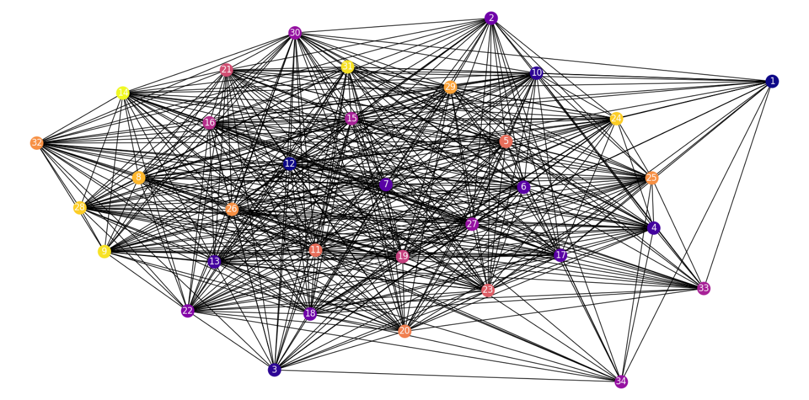

Figure 7.12 Complementary Coloring

Figure 7.13 transactional and community pattern in the same cluster in OTP graph MCL

### Embedded

Figure 7.14 pattern in WA graph

This pattern shows up, when there is a deeper connection among the meanings of the words. Usually, one is the subset of the other, creating the embedded structure mentioned above. In the transaction networks, this structure often suggests competitive areas between the nodes with high degree. The presence of an edge between these nodes is not necessarily forbidden, see below.

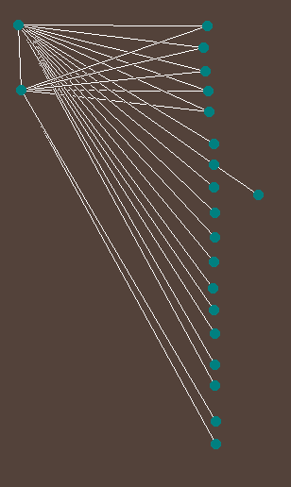

Figure 7.15 OTP

Figure 7.16: 2 supplier with a common customer set

Nodes: 15473275, 15473718

cluster: 15473275

community: 3468

## Efficiency

It is not easy to measure the efficiency of a clustering algorithm. Since the graphs, that provided to the research, are anonymized, no reference data can be accessed, and by default, it is hard to define, what can be accepted as a community or a cluster. Due to these reasons, the task requires to investigate the problem from more different point of view.

One of the best tools to quantifying the efficiency is calculating the modularity. The experimental result showed that the value decreases, when the largest connected component has been used as input parameter. This case seems reasonable, since the standalone subsets define clear groups for the algorithms.

The other well-defined value to compare the efficiency is the number of the colors the algorithm used. This method is a good choice if transactional graphs has been measured, since the modularity is not defined there.

One of the most important parameters, when an algorithm is being used, is the runtime. It is not a good sign, if the user must wait for the application to execute the algorithm. Even if a loading bar displayed, we do not know how much time we have to wait, or that if the algorithm has already crashed. Therefore, calculating the runtime of the algorithm is highly suggested.

# Further studies

* Implement a user interface to provide easy access to the algorithms for non-IT users.
* the application should provide opportunity to manually color graph nodes, modify the location of the nodes.
* The functions should be covered with unit tests
* Import the datasets into a graph db.
* Measuring tools for non-perfect coloring heuristics

This solution is scalable and modularized which makes further implementation easier. The code can be found in the github repository liked below:

<https://github.com/daniellanikov/Community-detector>

# References

[1] <https://snap.stanford.edu/>

[2] Usha Nandini Raghavan, Réka Albert and Soundar Kumara, 2007, Near linear time algorithm to detect community structures in large-scale networks

[3] NetworkX documentation: <https://networkx.org/>

[4] <https://github.com/guyallard/markov_clustering>

[5] Zachary, W. W., 1977, An Information Flow Model for Conflict and Fission in Small Groups

[6] Bron, C. and Kerbosch, J, 1973, Algorithm 457: finding all cliques of an undirected graph

[7] Etsuji Tomita, Akira Tanaka, Haruhisa Takahashi, 2006, The worst-case time complexity for generating all maximal cliques and computational experiments

[8] F. Cazals, C. Karande, 2008, A note on the problem of reporting maximal cliques

[9] M. E. J. Newman and M. Girvan, Finding and evaluating community structure in networks. Phys. Rev. E 69, 026113 (2004).

[10] M. E. J. Newman, 2006, Modularity and community structure in networks

[11] M. E. J. Newman “Networks: An Introduction”, page 224. Oxford University Press, 2011.

[12] Clauset, Aaron, Mark EJ Newman, and Cristopher Moore. “Finding community structure in very large networks.” Phys. Rev. E 70.6 (2004). <<https://arxiv.org/abs/cond-mat/0408187>>

[13] Reichardt and Bornholdt “Statistical Mechanics of Community Detection” Phys. Rev. E 74, 016110, 2006. <https://doi.org/10.1103/PhysRevE.74.016110>

[14] M. E. J. Newman, “Equivalence between modularity optimization and maximum likelihood methods for community detection” Phys. Rev. E 94, 052315, 2016. https://doi.org/10.1103/PhysRevE.94.052315

[15] A London, Ryan R. Martin, A. Pluhár, 2021, Graph clustering via generalized colorings

[16] <https://www.python.org>

[17] <https://git-scm.com>

[18] <https://github.com/pyenv/pyenv-virtualenv>

[19] <https://wikipedia.org>

* Cliques
* Small-world graphs

[20] [https://matplotlib.org/stable/tutorials/colors/colormaps.html](https://www.reddit.com/r/Catculations/comments/ug3kyb/who_put_this_swimming_pool_in_front_of_my_food/?utm_medium=android_app&utm_source=share)

[21] Master Thesis by László Csizmadia, 2003

[22] Bartalos István, Pluhár András, Communities in small-world graphs

# Acknowledgements

Many thanks to all the scientists and colleagues, who contributed to this very old but rather fascinating topic of graph clustering in network theory and special thanks to my advisor, András Pluhár, who provided the help with patience and understanding through my learning path.

Tartalmi összefoglaló Magyar nyelven

A diplomamunka keretein belül egy prototípusnak megfelelő konzol alkalmazás került lefejlesztésre Python nyelven. Az applikáció tartalmazza a már felfedezett közösség detektáló és klaszterező algoritmusokat a NetworkX framework által behúzva. Ilyenek például a Newman-Girvan algoritmus, vagy pedig a Markov-lánc. Ezen felül számos saját fejlesztésű helper függvény segíti a felhasználókat az eredményes kutatás érdekében.

A diplomamunka témájának elődjéhez tartozik a kutatók és szoftverfejlesztők által közösen elkészített Sixtep szoftver. Az alkalmazás beépített funkciói közé tartozik a tanszék által fejlesztett közösség detektáló, a Markov-lánc és a maximum Modularitás algoritmus. Nem utolsó sorban az app rendelkezik grafikus kezelőfelülettel, ami nagyban megkönnyíti a dolgát a felhasználóknak. A felület meglehetősen felhasználóbarát, intuíciók alapján könnyen kitalálható a program működéséhez szükséges gombok használata. Az alkalmazás lehetővé teszi a gráfok betöltését fájlból, és még azt is, hogy a pontok helyzete szabadon testreszabható legyen a felhasználó által: a pontok mozdítása az egér bal gombát nyomva tartva történik. Ez az aprónak nem nevezhető funkció nagy jelentőséggel bír a gráfok szabad szemmel való vizsgálatánál.

Van lehetőség továbbá a klaszterek és közösségek kiexportálására. Ez azonban nem olyan zökkenőmentes, mint elsőre tűnik, ugyanis az adat nem a megfelelő formában van rendezve, így ez későbbi átalakításokat igényelt. Miután a konzol app megfelelő szerkezetbe rendezte a pontokat, már létre lehetett hozni a Python által használt Gráf objektumot.

Mivel a Sixtep szoftverben implementált közösségdetektáló algoritmus eltér a konzol app által behasznált Newman-Girvan algoritmustól, ezért nagy jelentősége van az exportálási lehetőségnek, további irányokat biztosítva a közösségek közti élek tanulmányozására. Nem csak a közösségek, de a klaszterek modularitása is eltér alkalmazásonként, habár az eltérés mértéke nem olyan drasztikus. Az eltérést az okozza, hogy a klaszterező algoritmusok a pythonos konzol appban jórészt a legnagyobb összefüggő komponensre vannak futtatva a sikeres futás érdekében. Ez a jelenség okozza a modularitás kis mértékű csökkenését a Sixtep szoftverben működő algoritmusokhoz képest. Még egy további oka is van a jelenségnek. Ugyanazt a gráfot vizsgálva a két programban az élek száma eltér, aminek a másik oka az, hogy az irányítottságot különböző mértékben kezelik. X -> Y és Y -> X él a Sixtep programban 2 élnek számít, míg a konzolos applikáció egy élt rendel hozzá.

A Python nyelv választásának okai

A script nyelvek általánosságban jó lehetőséget biztosítanak a prototípusok, Proof of Concept (POC) projektek kivitelezésére. Lehetővé teszik a programok gyors fejlesztését, cserébe a teljesítményből kell kis mértékben feladnia a programozónak. Ellentétben például a c++ nyelv adta lehetőségekkel, itt nincs mód a memória precíziós kezelésére, viszont így a hibák lehetősége is csökken, nagyobb kapacitást biztosítva így az algoritmusok tervezésére, kivitelezésére. Amennyiben egy heurisztika eredményesnek bizonyul, és a projekt váza kezd összeállni, úgy érdemes lehet áttérni a hatékonyabb programozási nyelvekre.

Ezen kívül a Python széles közben elterjedt, nagy támogatottságú könyvtárai is nagyban könnyítik a fejlesztő életét. Amennyiben mégis elakadna a fejlesztés valamilyen hiba folytán, rengeteg segítség érhető el online, tutorial cikkek és példa kódok formájában. A diplomamunkában felhasznált könyvtárak dokumentációjára sem lehet panasz. Rendkívül érthető és hatékonyan kereshető formában szolgáltatják az információt, az igényesen megfogalmazott API dokumentáció tehát megtérül, rengeteg mérnök órát spórolva.

A virtualizációs környezet lehetővé teszi, hogy különböző Python verziók ne ütközzenek egymással, illetve biztosítja, hogy minden függőség feltelepül a program sikeres futásához.

A PyCharm fejlesztői környezet rengeteg hasznos funkcióval segítséget nyújt, könnyebbé és gyorsabbá téve a fejlesztést, gördülékenyebbé a hibakeresést. Általában ezen környezetek ingyenesen hozzáférhetőek közösségi használatra, így a diplomamunka készítése során is lehetőség van a használatukra.

Az így készült konzol alkalmazás objektum orientált, modularizált ezáltal könnyen bővíthető. Karbantartása és továbbfejlesztése nem igényel sok munkaórát.

A diplomamunka során felhasznált könyvtárak egyike a NetworkX Python modul, amit gráfok tanulmányozására, közösség detektálók és klaszterezők alkalmazására fejlesztettek ki. Széles körben használt és rendkívül nagy támogatottsággal bír. A gráfok megjelenítésére a MatPlotLib függvénykönyvtár lett felhasználva, továbbá egyéb kisegítő célokra a SciPy függvényeket alkalmaztam. Ezen csomagok verziószáma a requirements.txt fájlban található, tételenként felsorolva. A megfelelő verzió letöltéséről és telepítéséről a fejlesztői környezet gondoskodik, amint megadtuk számára az előre definiált Python környezetet. Ennek szerkesztését a PyEnv modullal lehet elvégezni.

Rendelkezésre álló gráfok

Több forrásból is elérhetővé váltak nagyobb méretű, valós adatokból felépülő gráfok, nemcsak szociális struktúrával, de tranzakciós jelleggel is. Az IWIW közösségi oldalról legyűjtött adatokat, a szó-asszociációs gráfot, valamint az OTP negyedéves kimutatásainak anonimizált gráfját az Informatikai Intézet Számítógépes Optimalizálás Tanszéke biztosította a kutatáshoz. Ezen kívül még érdemes megemlíteni, hogy a Stanford Egyetem honlapján szép számban elérhetőek szociális jellegű gráfok Facebookról, Twitterről és egyéb neves helyről legyűjtve, természetesen szintén anonimizált formában. Ezeknek az adatoknak a linkje elérhető a felsorolt referenciák között. A Zachary-féle közismert szociális gráf is fel lett használva a dolgozatban példagráfként illusztrálva az algoritmusok helyes működését. A karate klubot ábrázoló kisebb gráf illusztrációként szolgált, az algoritmusok teljesítményét igyekeztem a többi nagyobb gráfon mérni.

Az applikációban elérhető funkciók

Newman-Girvan algoritmus

A közösségi szerkezet felderítésére és elemzésére szolgáló Girvan-Newman algoritmus azon élek iteratív kiküszöbölésére támaszkodik, amelyeknél a legtöbb a legrövidebb út a rajtuk áthaladó csomópontok között. A gráf éleinek egyenkénti eltávolításával a hálózat kisebb darabokra, úgynevezett közösségekre bomlik. Az algoritmust Michelle Girvan és Mark Newman vezette be. Az ötlet az volt, hogy megkeressük, hogy a hálózat mely élei fordulnak elő leggyakrabban más csomópontpárok között, azáltal, hogy megtaláljuk a központi elemek közötti éleket. A közösségeket összekötő élek ekkor várhatóan magas edge-betweenness értékkel rendelkeznek. Így a hálózatot felépítő közösségi struktúra sokkal finomabb lesz. Mivel megszűnnek az összekötő élek, a közösségek sokkal könnyebben detektálhatóvá válnak. [3]

Maximum Modularitás

Ez az algoritmus a Clauset-Newman-Moore mohó modularitás maximalizálásával talál közösségeket a gráfban. A módszer jelenleg nem veszi figyelembe az élsúlyokat. A mohó modularitás-maximalizálás minden egyes közösségében a saját csomóponttal kezdődik, és csatlakozik ahhoz a közösségpárhoz, amely leginkább növeli a modularitást, amíg ilyen pár nem létezik. [3]

Klikk kereső

Minden n csomópont esetében az n maximális klikk egy legnagyobb teljes részgráf, amely n-t tartalmazza. Az alkalmazott függvény egy iterátort ad vissza a klikkek felett definiálva, amely élek listájából áll. A megoldás egy iteratív megvalósítást alkalmaz, ezért nem szenvedhet rekurziós mélységproblémáktól. A függvény egy pontok által definiált listát vár paraméterként és a maximális klikkel tér vissza. Ha egy specifikus klikket keresünk, akkor ez jelentősen lerövidítheti az algoritmus futási idejét.

A find_cliques(G) függvény visszatérési listájában az összes maximum-klikk megtalálható, de legrosszabb esetben a lista hossza exponenciálisan megnőhet. A függvény csak az akluális pontlistát tárolja el a cache memóriában, és nem számol az összes már megtalált klikkel egyszerre.

Ez a megvalósítás a Bron és Kerbosch (1973) [6] által közzétett algoritmuson alapul, amelyet Tomita, Tanaka és Takahashi (2006) [7] adaptált, és Cazals és Karande (2008) [8] használt fel.

Az algoritmus figyelmen kívül hagyja a hurkokat és a párhuzamos éleket, mivel a klikkeket hagyományosan nem ilyen élekkel határozzák meg. [3]

Markov-lánc

Az MCL algoritmus a Markov Cluster Algorithm rövidítése, amely egy gyors és méretezhető, nem felügyelt klaszter-algoritmust valósít meg gráfokon, amely a gráfok (sztochasztikus) áramlásának szimulációján alapul. Az algoritmust Stijn van Dongen találta fel a Hollandiában található Matematikai és Számítástechnikai Központban (más néven CWI). [4]

H-elkerülő színezés

Az általános (vagyis nem feltétlenül irányított) tranzakciós gráfok újfajta klaszterezését végző algoritmus a megfelelő színezések bizonyos osztályán belül. A klasztereket a színosztályok képzik, mivel a klaszteren belül el szeretnénk kerülni az élek jelenlétét. Az élek szerkezete az osztálypárok között korlátozott szerkezetet vesz fel. A fenti példák arra utalnak, hogy bizonyos esetekben teljesen beágyazott vagy ezzel egyenértékű beágyazottsági relációnak kell lennie bármely két színosztály között. Ez a fogalom lett általánosítva egy tetszőleges G gráfra és egy tiltott páros H részgráfra a felhasznált cikk szerint. [15]

Kondenzáció

Minden közösséget vagy éppen klasztert egy pontra tömörít az algoritmus. Az élek jelenléte az új pontok között bizonyos heurisztikákhoz kötött. Minél nagyobb a közösségben lévő pontok száma, annál biztosabb, hogy húzódni fog él a két közösség között. Ezért az új él behúzásánál figyelembe kell venni az eredeti osztály méretét, az élsűrűséget, az osztály szerkezetét. Az algoritmus akkor működik jól, ha az input gráf összefüggő.

Kis-világ tulajdonság

Ez a függvény a gráfokban való kis-világ tulajdonság jelenlétének becslésére szolgál. Egy kis-világ hálózatot kis átlagos legrövidebb úthossz és nagy klaszterezési együttható jellemez. A kis-világ tulajdonságot általában a szigma vagy omega együtthatóval mérik. Mindkét együttható összehasonlítja egy adott gráf átlagos klaszterezési együtthatóját és legrövidebb úthosszát ugyanazokkal a mennyiségekkel egy ekvivalens véletlenszerű vagy rácsos gráf esetében. Egy gráfot általában kisvilágúnak minősítenek, ha a szigma>1 vagy omega nullához közeli értéket vesz fel. Az algoritmus időigényes, nagy gráfok esetén használhatatlan.

Színezős stratégiák

Egyedi implementációt igényelt a detektáló algoritmusok által visszaadott osztályok pontjainak színskálákhoz való rendelése. A megvalósított logika meglehetősen naiv, cserébe működik. Erre a célra lett létrehozva a Cluster nevű helper class, ami egy uuid-t rendel a csoportokhoz. A függvény mohó logika alapján választ egy színt a skáláról és a csoportokhoz rendeli, lehetőleg úgy, hogy a színek távol essenek egymástól, így a csoportok a megjelenítés után szabad szemmel is könnyebben megkülönböztethetőek lesznek. Természetesen minél több az osztály, annál nehezebb ezt az igényt megvalósítani. A skála választása sem triviális feladat annak ellenére, hogy a MatPlotLib függvénykönyvtár remek lehetőségeket biztosít. Az átmeneti skálák nem ideálisak a precíz megkülönböztetésre, a jól elhatárolt színek meg beleolvadnak a háttérbe, ezért a kettő között érdemes színskálát választani. Például az egyik sokat használt színskála a dolgozatban a „Plazma” nevet viseli, az ábrája megtekinthető a dolgozat Colormap című fejezetében.

Mérések, eredmények, minták

Az algoritmusok jóságának meghatározása nem egyszerű feladat, elvégre honnan tudjuk, hogy mi számít jó detektálásnak. A gráfok nagy része anonimizált, és még referencia adatok sem állnak rendelkezésre, ezért a probléma összetettsége megkívánja, hogy több oldalról legyen mérve a hatékonyság.

Az egyik módszer az algoritmusok hatékonyságának számszerűsítése a modularitás számítása. Az algoritmus nem csak hatékonyságot tud mérni, de egyben maga is megad egy lehetséges osztályozást.

„Egy hálózat közösségi struktúrája az élek statisztikailag meglepő elrendeződésének felel meg, számszerűsíthető a modularitásként ismert mértékkel [9]. A modularitás egy multiplikatív állandóként annyit tesz, hogy a csoportokba eső élek száma mínusz a várt szám, egy ekvivalens hálózatban, ahol az élek véletlenszerűen vannak elhelyezve. A modularitás lehet pozitív vagy negatív, a pozitív értékek a közösségi struktúra lehetséges jelenlétét jelzik.” [3]

A kísérleti eredmények a modularitás vizsgálatára több érdekességet is mutattak. Például minél nagyobb a gráf, a modularitás az algoritmusok jóságától függetlenül kúszik lefele. Persze az is igaz, hogy minél nagyobb egy gráf, annál nehezebb értelmes osztályokat adni. Megfigyelhető továbbá, hogy ha nem összefüggő gráfnak vesszük a legnagyobb összefüggő komponensét, akkor is esik a modularitás. Ez is könnyen belátható, értelemszerűen a leszakadt darabok jól definiált osztályokat alkotnak, így növelik a modularitást. Az eredmények összehasonlításánál érdemes tehát figyelembe venni, hogy a Sixtep szoftver a gráf egészén futtat algoritmusokat, míg a dolgozat keretein belül fejlesztett konzol alkalmazás a gráf legnagyobb összefüggő komponensén, ezáltal az értékek megtévesztőek lehetnek.

A létrehozott színosztályok száma

Egy egyszerű, ám meglehetősen hasznos paraméter, hogy az algoritmus hány színt használt el az osztályozás során. Különösen igaz ez a tranzakciós gráfokon végzett klaszterezések esetében, ahol a modularitás nem annyira számottevő. (Bár sokkal jelentősebb, mint azt az ember elsőre gondolná)

Az algoritmus futási ideje

Cseppet sem elhanyagolható tényező, hogy mennyit kell várnunk egy-egy klaszterezési eredményre.

Egy szoftverfejlesztő szemszögéből meglehetősen bináris az ügylet: Ha lefut az algoritmus, ameddig utántöltődik a kávé, akkor teljesen rendben van. Egyébként pedig vissza kell térni és csiszolni kell még a hatékonyságot. (Egy applikációban nem mutat jól, ha várnunk kell. A felhasználó könnyen elbizonytalanodik, hogy az alkalmazás hibás, de nem jelez, vagy pedig az algoritmus lassú, akkor is, ha egyébként az információ jelezve van.)

Ha elérkezik az a pont, hogy feltehetjük, hogy az algoritmus jól működik és az adatokban sincs semmi hiba, akkor érvényt szerez magának az ügy tudományos megközelítése, az algoritmus futási idejének tudományos számítása. Például a Stanford Egyetem által legyűjtött óriás gráfokon hasznos, ha meg tudjuk becsülni, hogy a pontok és az élek ismeretében mennyi lesz a futási idő.

E kritikus paraméter csökkentésére rengeteg megoldási irány keletkezett, többek között az adatok feldolgozásának a többszálúsításának a gondolata. Numerikus műveleteknél célravezető, ha nem egymásra épülő számításokat nem lineárisan, hanem párhuzamosan végeztetjük el. Erre a legalkalmasabb hardver a grafikus kártya (GPU).

Minták a gráfokban

Ez talán az egyik legszubjektívebb és legabsztraktabb része a dolgozat keretein belül elért eredményeknek. Az, hogy mit tekintünk gyakori mintának és hogy különböző gráfokban az adott struktúrát hogyan értelmezzük, meglehetősen kreatív gondolkozásmódot igényel és koránt sem biztos, hogy mindig ugyanazt jelenti.

Például egy tranzakciós gráfban a termelő – fogyasztó szerkezet egy központi egységhez sok kapcsolódó pontot mutat. Szociális viszonylatban pedig lehet egy összekötő ember, vagy főnök. A szó-asszociációs gráfban ez a minta egy általános szót takar, mint például az „eszköz”. A szó beleillik rengeteg témakörbe, így számos él fut be az őt reprezentáló pontba. Ha a mintából kiindulva további mélységig vizsgáljuk a gráfot, akkor egy fa-jellegű struktúra rajzolódik ki, jellemzően tranzakciós adatokon, vagy pedig a szó-asszociációs gráfon.

Jelen van továbbá egyfajta beágyazottság is bizonyos osztályok között. A szó-asszociációs környezetben főként akkor jelenik meg, amikor a szavak jelentése meglehetősen eltér, de a téma viszont szorosan kapcsolódik egymáshoz. Gyakori jelenség, hogy egyik téma egy részhalmaza a másiknak, létrehozva ezzel a beágyazott szerkezetet. A tranzakciós gráfoknál viszont a piaci viszonyok egyik jele lehet és versenyzést mutathat a beszállításra alkalmas területek között. Ennek ellenére nem ritka az sem, hogy a versenyző felek között is kapcsolat van.

A fent említett mintákról készült ábrákat a dolgozat Patterns fejezetében lehet megtekinteni. Az egyetlen nagy méretű gráf, ahol valamilyen formában elérhetőek voltak nem anonimizált adatok, az a szó-asszociációs gráf, így a minták vizsgálata, összehasonlítása különböző gráfokban meglehetősen fapados eredményeket produkált.

A téma tanulmányozásának további lehetséges irányai

Nem minden ember barátkozik meg a konzolos lehetőségekkel, illetve ma már széles körben vannak támogatva a felhasználókat segítő grafikus interfészek, így a jelen alkalmazáshoz is célszerű lenne egy grafikus felület, ami megkönnyíti a program használatát. Ha az alkalmazás rendelkezik grafikus megjelenítéssel az további lehetőségeket is hordoz magában. Például a gráf pontjainak egérrel való mozgatását, illetve manuális színezését lehetővé tevő funkciók hasznos részei lehetnek a programnak.

A szoftver minőségének egyik ismérve, hogy mennyi a unit tesztekkel való lefedettsége. Ez nem csak a regresszió ellen nagyon hasznos, de valamilyen mértékig garantálja a program megfelelő működését. Biztosítékot ad továbbá a robusztusságra is, amennyiben nem csak a happy path-t teszteltük le.

Nagyméretű gráfoknál kifejezetten sokat számíthat a teljesítményen a gráf adatbázisok használata. Egy kommunális célokra ingyenesen hozzáférhető, felhő alapú adatbázis mindig rendelkezésre áll és nem komplikált az adatok importja sem. További érv a használata mellett, hogy az alkalmazás mostani állapotában alkalmas a gráf adatbázishoz való csatlakozásra.

Abban az esetben, ha nem egyértelműen eldönthető, hogy egy pont hova is tartozik igazán, érdemes megengedni bizonyos hibákat az algoritmus futása során és egy határt, hogy mennyire engedjük meg.

Az alkalmazás fejlesztése közben igyekeztem figyelmet szentelni az objektum-orientáltságra és a megfelelő mértékű modularizációra, hogy egy esetleges refaktor, vagy éppen továbbfejlesztés során a ráfordított idő gazdaságos legyen.

A forráskód a következő github linken érhető el:

<https://github.com/daniellanikov/Community-detector>

Nyilatkozat

Alulírott Nikov Daniella programtervező informatikus MSc szakos hallgató, kijelentem, hogy a dolgozatomat a Szegedi Tudományegyetem, Informatikai Intézet Számítógépes Optimalizálás Tanszékén készítettem, programtervező informatikus MSc diploma megszerzése érdekében. Kijelentem, hogy a dolgozatot más szakon korábban nem védtem meg, saját munkám eredménye, és csak a hivatkozott forrásokat (szakirodalom, eszközök, stb.) használtam fel. Tudomásul veszem, hogy diplomamunkámat a Szegedi Tudományegyetem Informatikai Intézet könyvtárában, a helyben olvasható könyvek között helyezik el.