#1.a

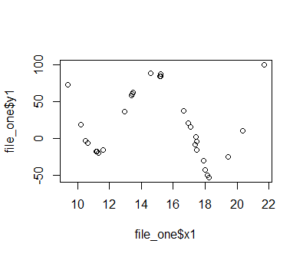

#1.b

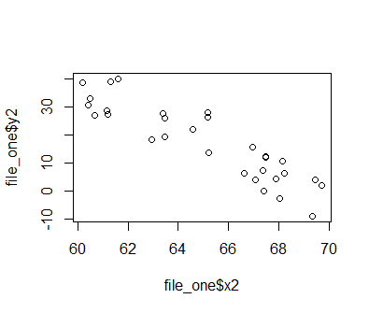

#1.c

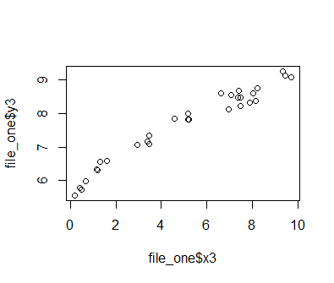 y = x^1/2 maybe y = -bx^2

#3

#a

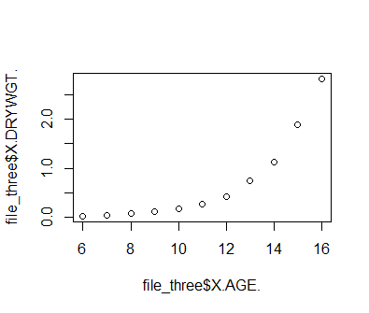y^ = ^b0+^b1exp(x) + E

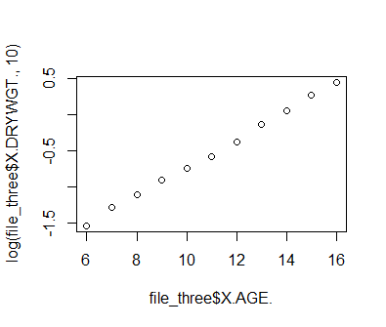 z^ = ^b0+^b1X + E

Dry weight vs age is exponential , and log(dry weight) vs age is linear

#b > y.hat

(Intercept) file_three$X.AGE.

-1.8845273 0.2350727

y.hat = -1.8845 + .2351x

> z.hat

(Intercept) file_three$X.AGE.

-2.6891985 0.2350727

z.hat = -2.6892 + .2351x

#c > SSE.y

[1] 2.089602

> SSE.z

[1] 0.007054059

#d

As the age increase by one unit (presumably year), the dry weight will increase by .2351, and the log dry weight increases by .2351

#e 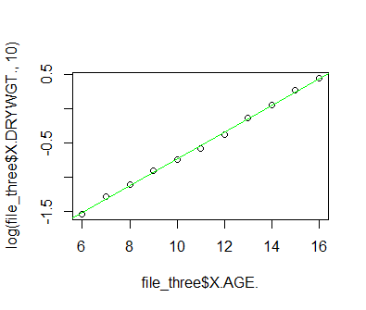

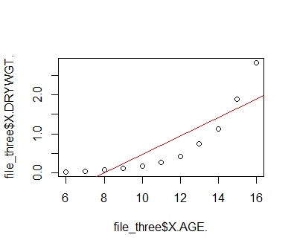

4.

#a 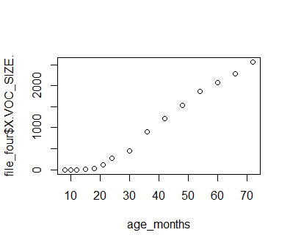no looks logistic function

#b y^ = b0^ + b1^(L/(1+exp(-kx)) + E

#c [1] 285024.9

SSE = sum((y – y^)^2)