plot(y~x)

* 1. Y^ = 70.576 + 21.492x

Coefficients:

Estimate Std. Error t value Pr(>|t|)

(Intercept) 70.576 12.322 5.728 2.99e-06 ***

one_file$X.QUET. 21.492 3.545 6.062 1.17e-06 ***

* 1. H0 : B1 = 0, HA: B1 != 0
     1. Reject the null as the pvalue = 0. 1.171656e-06 < 0.05 and the test statistic +- 6.06 is in the critical region, therefore there is sufficient evidence to reject the null with alpha of 0.5

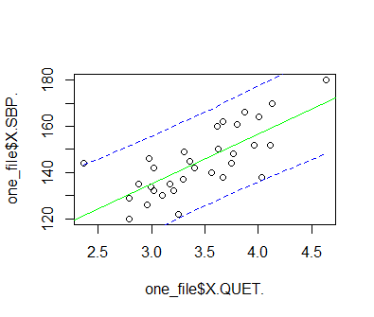

* 1. [136.1362, 151.1600 ], at QUET = 3.4 the SBP of a person is predicted to be 143.6481
  2. 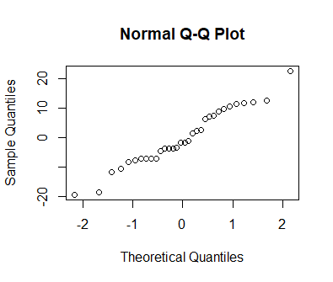

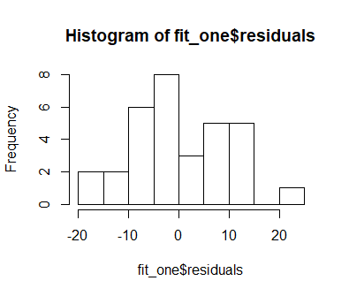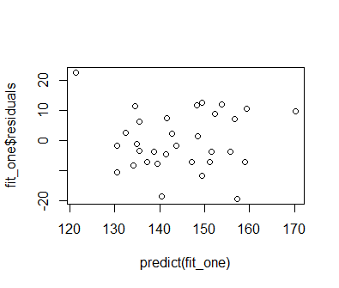

No as the scatter plot looks centered around (145, 0) , and the histogram looks centered at 0 and not skewed. Therefore the model does not violate the normality and linearity tests

1. * DISTANCE = y and MPH = x
   1. 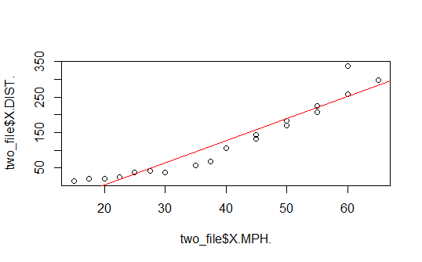
   2. y^ = -122.344588 + 6.227082 x
   3. 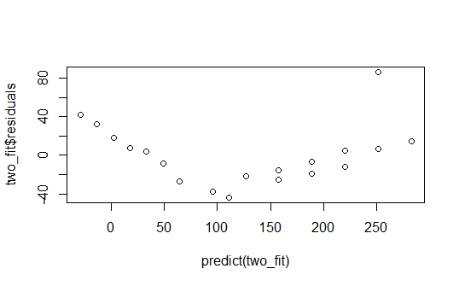

The model does not follow the assumptions of linearity as there is a linear like pattern of the residuals; there is a pattern therefore fails linearity

1. * DISTANCE = y and MPH = x
   1. 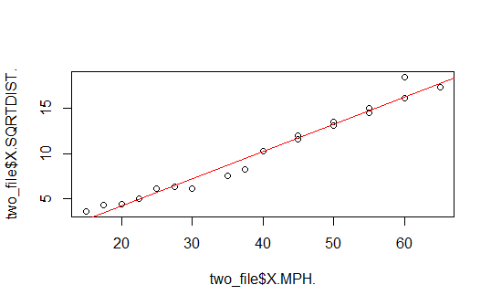
   2. y^ = -1.6971235 + 0.2987753x
   3. 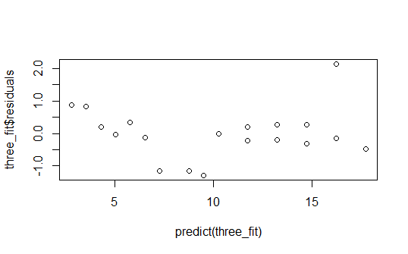fails linearity because the model appears is quadratic
   4. [.2676520, .3298986]
   5. About 0 (R returned 5.81x10^-21) Reject the null hypothesis, there is sufficient evidence as p value = 2.579126e-05 < 0.01
   6. 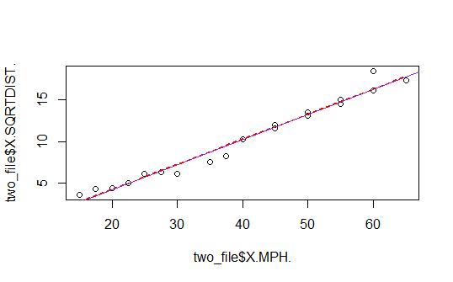
   7. Prediction of SQRTDIST for X = 45 is 11.74776, and the 95% confidence band for population mean at X = 45 is [11.33279, 12.16274]. Therefore, we are 95% confident the population mean at x = 45 lies within the given confidence interval.
2. .
   1. Y^ = 435.9236 + 3630.5613x
   2. 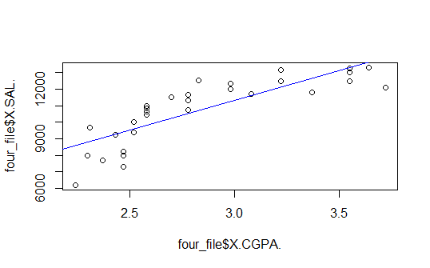
   3. 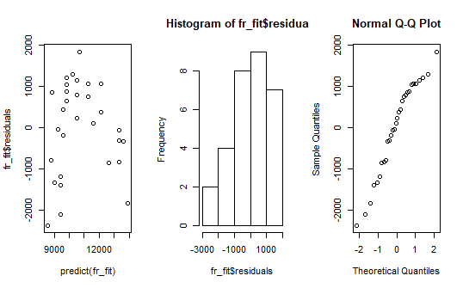 The histogram is left skewed and the residual plot looks about quadratic. Therefore, the model fails the normality and linearity tests.
3. 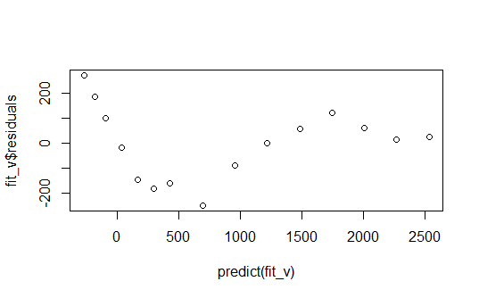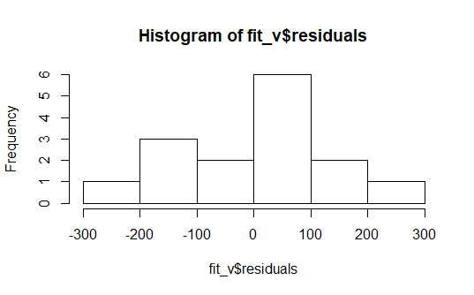 The model fails linearity as the points have a pattern
4. #Check if x = dynamiclift and y = armstrength
   1. 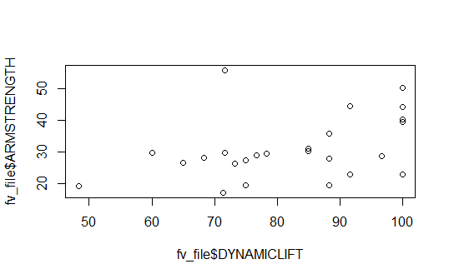 I expect a small value for the correlation coefficient because the values seem to be in a pattern
   2. r = 0.1542^2= 0.02377764 Therefore The Dynamic life and armstregth are weakly correlated
   3. Note the Hypothesis test of B1 and population correlation coefficient return equivalent values; Critical region = +- 2.06865761, test statistic = 2.04771726, p value = 0.05217377; As the test statistic is in the acceptance region and pvalue > 0.5 alpha; there is insufficient evident to reject the null, therefore do not reject the null
   4. SSR = 360.31 , SSY = SSE + SSR = 2336, SSE = 1976.37, TSS = SSE + SSR = 2336.68 , R^2 = SSR/TSS = 0.1542

|  |
| --- |
| Analysis of Variance Table  Response: fv_file$ARMSTRENGTH  Df Sum Sq Mean Sq F value Pr(>F)  fv_file$DYNAMICLIFT 1 360.31 360.31 4.1931 0.05217 .  Residuals 23 1976.37 85.93  ---  Signif. codes: 0 ‘***’ 0.001 ‘**’ 0.01 ‘*’ 0.05 ‘.’ 0.1 ‘ ’ 1 |

* 1. About 15% of variation in y can be explained by using x to predict y
  2. I would use this model as demonstrating a trend as it has a large SSE, small r and r^2 values.