 |  |  | TECHNICAL SPECIFICATION |  |  |  |  | N°: | I-PT-4880.00-7109-200-CZ1-001
 |  |  | CLIENT: | LOG/TM/ON |  |  |  |  |  |  |  |  | sheet: |  | 1 of 25
 |  |  | Job: | TP 25 – PRODUCT CARRIERS 15600 DWT |  |  |  |  |  |  |  |  | -
 |  |  | aREA: | PETROBRAS FLEET |  |  |  |  |  |  |  |  | IN-4880-23-001
 |  |  | Title: | TECHNICAL PROPOSAL FOR SWITCHBOARDS |  |  |  |  |  |  |  |  | LOG/PL/EGE
 |  |  | Title: |  |  |  |  |  |  |  |  |  | INTERNAL
 |  |  | BUILDER:  CONSORCIO ECOVIX / MACLAREN |  |  |  |  |  |  |  | CONTRACT NUMBER:  7000.0130000.25.2
 |  |  | TECHNICAL RESPONSIBLE:  marcelo delano |  |  | CREA NUMBER:  2006118561 |  |  |  |  | kongsberg number:  N/A
index of revision
REV. | description and/or revised sheets
0 | original issue
 |  | Rev. 0 |  |  | Rev. A |  | Rev. B |  |  | Rev. C |  | Rev. D |  | Rev. E
Date |  | 22/10/2025
EXECUtion |  | daniel laranjo
check |  | davi pegado
APproval |  | marcelo delano
IN ACCORDANCE WITH STANDARD PE-1TP-00365, the information contained in this document is transpetro property and may not be used for
purposes other than thosespecifically indicated herein. this form is part of petrobras’ n-381-rev.m.

1. Revision History 4
2. Comments to Quotation 5
2.1 Deviations 5
3. Energy System description 6
3.1 Kongsberg AC Solution 6
3.2 System Topology 7
3.2.1 Power System Topology 7
3.2.2 Hight Voltage Shore Connection system (OPTION) 7
4. Scope of Supply 8
4.1 Kongsberg Low Voltage Switchboards 8
4.1.1 General Specification 8
4.1.1.1 Recommended Swtchigear installation 8
4.1.2 General incomer W. digital Layer – ACB and touchscreen functions 8
4.1.3 General incomer W. digital Layer – HW instruments and functions 9
4.1.4 General incomer W. digital Layer – Protection functions 10
4.1.5 Bus tie W. digital Layer – ACB and touchscreen functions 11
4.1.6 Bus tie W. digital Layer – HW instruments and functions 12
4.1.7 Bus tie W. digital Layer – protection functions 12
4.2 450V Main Switchboards 13
4.2.1 General Specification 13
4.2.2 Mechanical Specification 13
4.2.3 Electrical Specification 14
4.3 450V Emergency Switchboards 16
4.3.1 General Specification 16
4.3.2 Mechanical Specification 16
4.3.3 Electrical Specification 16
4.4 220V Main Switchboards 17
4.4.1 General Specification 17
4.4.2 Mechanical Specification 17
4.4.3 Electrical Specification 17
4.5 220V Emergency Distribution Board 18
4.5.1 General Specification 18
4.5.2 Mechanical Specification 18
4.5.3 Electrical Specification 19
4.6 Main Transformes 19
4.6.1 General Specification 19
4.6.2 Electrical Specification 20
4.6.3 Mechanical Specification 20
4.7 Low Voltage Shore Connection Cabinet 21
4.7.1 General Specification 21
4.7.2 Mechanical Specification 21
4.7.3 Electrical Specification 21
4.8 Hight Voltage Shore Connection Switchboard (OPTION) 22
4.8.1 General Specification 22
4.8.2 Mechanical Specification 22
4.8.3 Electrical Specification 22
4.9 Hight Voltage Shore Connection Transformer (OPTION) 23
4.9.1 General Specification 23
4.9.2 Electrical Specification 23
4.9.3 Mechanical Specification 24
4.10 Electrical Studies 24
4.10.1 Deliverables 24
5. Spare Parts 25
6. Commissioning 25
7. Training 25
Not included 25
8. CLASS 25
9. Factory Acceptance Tests 25
10. Documentation 25
11. List of Attachments 26

Revision History

Rev. | Date | Description of Change | By whom
0 | Aug 23, 2024 | First issue | RMCF
2 | Jun 02, 2025 | Updated according to Building specification (9) | ERO
3 | Jun 19, 2025 | Updated according to Building specification (9) and after tech meetings with yard. Small cleaning and info. | LBR
4 | July 2, 2025 | Updated class notation | LBR
5 | Sept 16, 2025 | Updated voltage level, added future HVSC description | ERO
6 | Sept 22, 2025 | Added system studies | ERO
7 | Oct 09, 2025 | Added deviation list | ERO

Comments to Quotation
09.10.2025
Added a deviation list in chapter 2.1

22.09.2025
Added description of system studies that will be delivered.

16.09.2025
Updated voltage levels to 450V, 220V. Added description for HVSC system, not included in the delivery.
09.09.2025
Updated voltage levels to 450V/220V.

02.07.2025
Updated class notation.

Deviations
No. | Customer technical requirement | Description of Deviation
01 | The MSB shall be equipped with optical arc detection sensors to trip the busbar's power  circuit breakers. | Not included, typically not used for this vessel type. Can be included on request, at additional  cost.
02 | The automatic and manual controls shall be located in the MSB synchronization column | Manual control of sync and load is performed in each generator panel via the HMI touch panel.
03 | The front and rear doors of electrical panels shall be fitted with handrails made of insulating material along the entire length of  the panel | This type of switchboard has rear mounted busbars, hence there are no doors on the rear side.
04 | Power quality monitoring shall be included for the main busbars | Not included, typically not used for this vessel type. Can be included on request, at additional cost.
05 | The switchboards shall be designed for free standing mounting on a common base frame. Each cubicle shall consist of a framework built  up of zinc plated squared tubes | The frame of the switchboard is built up of painted steel profiles.
06 | The main busbar should preferably be located at the top of the panel, without splices, silver plated at the contact points | The contact points are not silver plated. The switchboard uses a purpose specific paste at the connection points
07 | The busbars shall be made of electrolytic copper, insulated (sheathed) and fitted with  silver plated contacts/terminations. | Busbars are not sheathed; they are located in a separate busbar compartment in the rear  part of the switchboard.
08 | In front of panel shall be mounted control equipment for the generator breaker, etc.: | Manual control of sync and load is performed in each generator panel via the HMI touch  panel.
09 | Main bus instrument. Mimic diagram in front including:  - Running indicator emergency diesel  - Emergency switchboard supplied from  emergency generator  - Emergency switchboard supplied from main  switchboard | There is no mimic diagram in one section, information is available from the relevant section. Overall mimic is available from PMS operator station.

Energy System description

Kongsberg AC Solution
The AC Solution is an integrated power electric system in which the main power generation is carried out by means of synchronous AC generators connected directly to an AC switchboard.

The AC Solution comprises generators, switchgear, variable speed drives and motors for propulsion, all controlled by Kongsberg power- and energy management systems.
Integration between the different main elements of the power system is based on standardized interfaces developed through extensive operational experience, focusing on safety, efficiency and flexibility.

A high level of flexibility is achieved by utilizing the main elements of the power system in various combinations. Pre-defined power system modes can be defined to meet operational requirements in different vessel operating modes.
Power Management System functions are described in further detail in “Section 3 – Instrument
System”

System Topology

3.2.1 Power System Topology
Electric power generation consists of three generator sets connected to a 450V main switchboard. The rated system frequency is 60Hz. Power is distributed to main consumers and transformers from the main switchboard.
A bus-tie breaker is installed and is normally closed. A low volage shore connection system is included, the connection is synchronized towards the generators for transfer of load without going through black-out.
Power is distributed from main switchboard to large consumer groups like HVAC and Cargo, and to smaller power consumers through transformers.

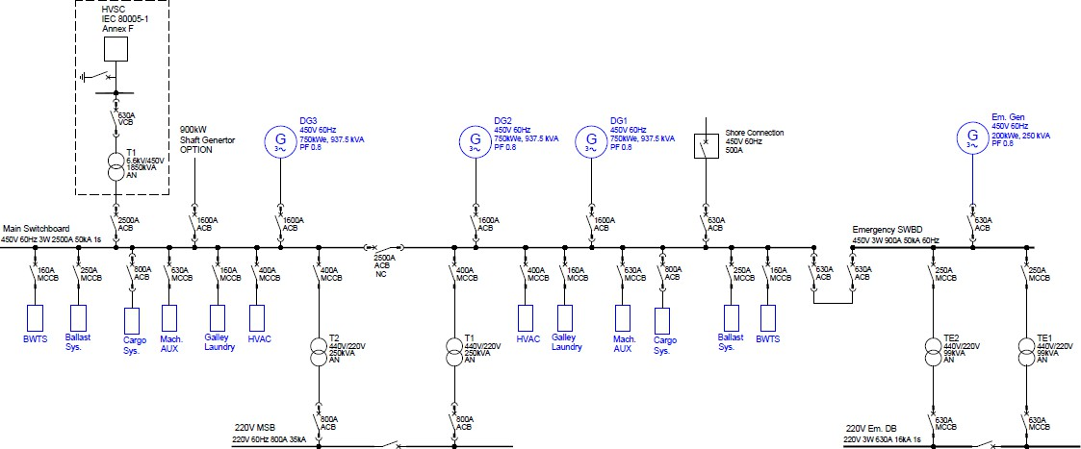

There are spare breakers for future installation of High voltage shore connection and shaft generator system in the main switchboard.
An emergency generator connects to an emergency switchboard to power all consumers defined for emergency operation. Under normal operation conditions, the emergency switchboard is powered from the main switchboard.

3.2.2 Hight Voltage Shore Connection system (OPTION)
The high voltage shore connection system is designed to comply with IEC 80005-1, Annex F For tankers is applied for this application. See sketch below for general connection system. The sketch below illustrates the system topology.
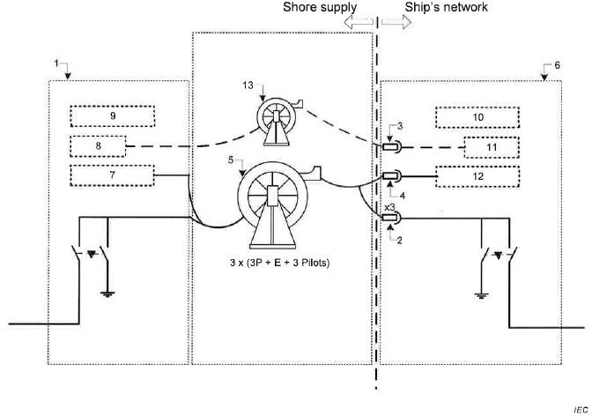

Scope of Supply

Kongsberg Low Voltage Switchboards

4.1.1 General Specification

The low voltage switchgear and control gear assembly is designed by Kongsberg Maritime. It’s a unique enclosure solution, where a range of different cubicles can be assembled based on few standard components, joined together. This gives high flexibility, and a robust design tailor made for the marine industry. The switchboard has been designed according to 61439-1/2 and IEC60092-302.

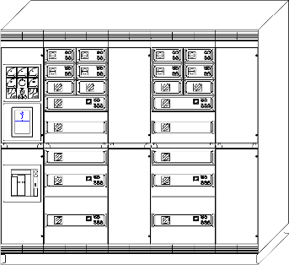

4.1.1.1 Recommended Swtchigear installation
Front: Minimum 1200 mm free space in front is required to have escape route with doors open. Side: Minimum 250 mm free space on each side to open door more than 90 degrees.
Rear: Minimum 500 mm free space to have access for easy installation and maintenance. Top: Minimum 100 mm and minimum 300 mm where ARC flaps on top are required.
Environment: Switchgears must be placed in clean and well-ventilated locations. Cable entry: Bottom.

4.1.2 General incomer W. digital Layer – ACB and touchscreen functions

Included is Kongsberg K-Power Digital Layer with fast measurement, protection, and functions. The plug-and-play interface to K-Chief PMS/EMS is done by Modbus TCP. Therefore, no additional transducers are installed or required.
The air circuit breaker(s) (ACB) can be operated locally or remotely.
Included as described in the Switchgear incomer | Functions:  - Breaker Close / Open  - Breaker Synchronize  - Auto  - Semi Auto  - Prime Mover  - Start / Stop  - Speed Increase  - Speed Decrease | Generator(s) incomer local breaker display (LBD)  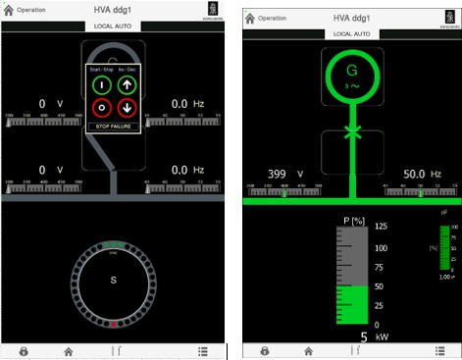

 | Measurement/alarms:  - Gen & Bus Voltage  - Gen & Bus Freq.  - Current  - Power  - Power factor  - Status Indication  - Instrument Indication  - Alarm Acknowledge  - Trip Reset | Generator(s) incomer on the local breaker display (LBD)  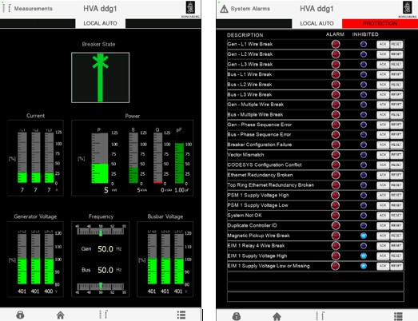

4.1.3 General incomer W. digital Layer – HW instruments and functions
Item | Qty | Description | Scale | Accuracy | HW components
1 | 3 | Ampere meter | 130 % of rated current | 2.5 % or higher | 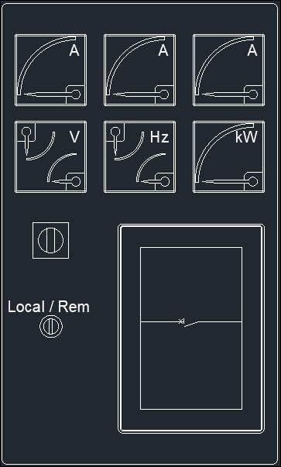
2 | 1 | Voltmeter w. phase selector switch (for the incomer and busbar) | 120 % of nominal voltage | 2.5 % or higher
3 | 1 | Frequency meter for the incomer and busbar) | 8 % above and below nominal frequency | 2.5 % or higher
4 | 1 | Active power meter (kW) | 130 % of rated current
5 | 1 | Local/remote selector switch

4.1.4 General incomer W. digital Layer – Protection functions

The local synchronizing and protection (LSP) unit is a highly configurable controller designed for marine use. The controller contains the functions required to protect and control a generator and its breaker or bus tie breakers. Each controller includes processors and high-speed internal communication  with fast protection. |  |  |  |  |  |  | 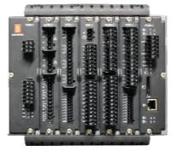
ANSI code | IEC | Description | Latch | IAS  alarms | Circuit breaker trip | AVR  de-excitation trip | Protection
27 | U<, U<< | Under-voltage |  | X | X |  | Voltage
32 | P>, P>> | Overload |  | X1 |  |  | Power
32R | P<, P<< | Reverse power |  | X | X |  | Power
40O | Q>, Q>> | Reactive power  export |  | X |  |  | AVR
40U | Q<, Q<< | Reactive power import |  | X |  |  | AVR
50TD | 3I>, 3I>> | Overcurrent |  | X | X |  | Current
50/50TD | 3I>>> | Fast overcurrent | X |  | X | X | Current
50BF |  | Breaker failure | X | X | X |  | Breaker
51 | It> | Inverse time  overcurrent | X | X | X |  | Current
59 | U>, U>> | Overvoltage |  | X | X2 |  | Voltage
67 | I0φ | Directional  overcurrent | X | X | X3 |  | Current
81U | f<, f<< | Under-frequency |  | X |  |  | Frequency
81O | f>, f>> | Over-frequency |  | X |  |  | Frequency
87G | Id>> | Differential  protection | X | x | X | X | ≥1500 kVA (DNV
¹ Preferential trip output on the LSP, overload protection 1 and 2 as the source. Need to implement a DO in the LSP.
² The generator must have a time delay due to coordination/selectivity and the bus tie to have the first trip.

4.1.5 Bus tie W. digital Layer – ACB and touchscreen functions

Included is Kongsberg K-Power Digital Layer with fast measurement, protection, and functions. The plug-and-play interface to K-Chief PMS/EMS is done by Modbus TCP. Therefore, no additional transducers are installed or needed.
Air circuit breaker(s) (ACB) can be operated locally or remotely.
Included as described in the Switchgear incomer and feeders chapter. | Functions:  - Breaker Close / Open  - Breaker Synch check | Bus tie local breaker display (LBD)  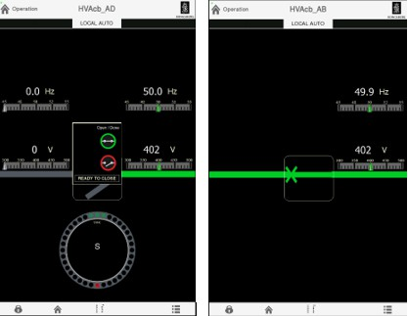
 | Measurement/alarms:  - Bus 1 & Bus 2 Voltage  - Bus 1 & Bus 2 Freq.  - Power  - Power factor  - Status Indication  - Instrument Indication  - Alarm Acknowledge  - Trip Reset | Generator(s) incomer local breaker display (LBD)

4.1.6 Bus tie W. digital Layer – HW instruments and functions

Item | Qty | Description | Scale | Accuracy | HW components
1 | 0 |  |  |  | 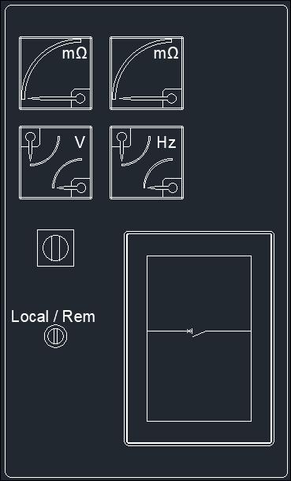
2 | 1 | Voltmeter w. phase | 120 % of | 2.5 % or
 |  | selector switch | nominal | higher
 |  | (busbar 1 and | voltage
 |  | busbar 2)
3 | 1 | Frequency meter | 8 % above | 2.5 % or
 |  | for incomer and | and below | higher
 |  | busbar | nominal
 |  |  | frequency
4 | 1 | Local/remote
 |  | selector switch
5 | 2 | Insulation guard
 |  | (one on each
 |  | busbar)

4.1.7 Bus tie W. digital Layer – protection functions

The local synchronizing and protection (LSP) unit is a highly configurable controller designed for marine use. The controller contains the functions required to protect and control a generator and its breaker or bus-tie breakers. Each controller includes processors and high-speed internal communication with fast protection.
Alternatively, the protection may be a Micrologic that is integrated into the ACB.
ANSI  code | IEC | Description | Latch | IAS  alarms | Circuit breaker trip | AVR  de-excitation trip | Protection
27 | U<, U<< | Under-voltage |  | X |  |  | Voltage
32 | P>, P>> | Overload |  |  |  |  | Power
32R | P<, P<< | Reverse power |  |  |  |  | Power
40O | Q>, Q>> | Reactive power  export |  |  |  |  | AVR
40U | Q<, Q<< | Reactive power  import |  |  |  |  | AVR
50TD | 3I>, 3I>> | Overcurrent |  | X | X |  | Current
50/50TD | 3I>>> | Fast overcurrent | X |  | X |  | Current
50BF |  | Breaker failure | X | X | X |  | Breaker
51 | It> | Inverse time  overcurrent | X | X | X |  | Current
59 | U>, U>> | Overvoltage |  | X | X2 |  | Voltage
67 | I0φ | Directional  overcurrent |  |  |  |  | Current
81U | f<, f<< | Under-frequency |  | X |  |  | Frequency
81O | f>, f>> | Over-frequency |  | X |  |  | Frequency
87G | Id>> | Differential  protection |  |  |  |  | Current
¹ Preferential trip output on the LSP, overload protection 1 and 2 as the source. Must implement a DO in the LSP.
² The generator must have a time delay due to coordination/selectivity and the bus tie to have the first trip.

450V Main Switchboards

4.2.1 General Specification
Quantity 1

4.2.2 Mechanical Specification
Main dimensions
Estimated Size (W x D x H) 6250 x 600 x 2200 mm
Estimated Weight 4924 kg
Cooling system
Cooling Method Air
Estimated Heat Load to Air 6017 W
Terminals and protection
Ingress Protection P23
Access Front & rear
Cable Entry Bottom
Painting RAL9005 (Jet Black) / RAL9006 (White Aluminum)
Environmental conditions
Air temperature range (room) 0 – 45°C
. condensation, splash water and ice formation not permitted
Construction standards
LV Air circuit breakers (ACB). Form according to EC 61439
Withdrawable Form 3a
LV Molded-case circuit breakers (MCCB). Form according to EC 61439
Fixed/ Plug-In Form 1

4.2.3 Electrical Specification
Bus-bar nominal voltage V
Bus-bar nominal frequency 60 Hz
Bus-bar nominal rating 2865 A
Short circuit level (Icw) 50 kA, 1 s.
Distribution system IT
+01 Feeders (MCCB)
TYPE Plug-In
Feeder NS 800 A 0
Feeder NSX 630 A 0
Feeder NSX 400 A 4
Feeder NSX 250 A 4
Feeder NSX 160 A 0
Feeder NSX 100 A 2
Feeder NSXm 160 A 0
Feeder NSXm 63 A 0
+02 Feeder (ACB)
Name CARGO1
Generator Rated Active Power 600 kVA
ACB Rated Current 800 A
MicroLogic 5
+03 HVSC Incomer (ACB)
Name HVSC
Generator Apparent Power 1850 kVA
ACB Rated Current 2900 A
LBD Yes
LSP Yes
+04 Shaft Generator Incomer (ACB)
Name SG
Generator Apparent Power 688 kVA
ACB Rated Current 1000 A
Form Factor 4b Selected No
LBD Yes
LSP Yes
+05 Generator Incomer (ACB)
Name G3
Generator Apparent Power 938 kVA
ACB Rated Current 1250 A
LBD Yes
LSP Yes
+06 Bus-Tie (ACB)
Name Bus-Tie
Rated Apparent Power 1750 kVA
ACB Rated Current 2900 A
MicroLogic Included 5
LBD Yes
LSP Yes

+07 Generator Incomer (ACB)
Name G2
Generator Apparent Power 938 kVA
ACB Rated Current 1250 A
LBD Yes
LSP Yes
+08 Generator Incomer (ACB)
Name G1
Generator Apparent Power 938 kVA
ACB Rated Current 1250 A
LBD Yes
LSP Yes
+09 Shore Power Incomer (ACB)
Name LVSC
Generator Apparent Power 380 kVA
ACB Rated Current 630 A
Form Factor 4b Selected No
LBD Yes
LSP Yes
+10 Feeder (ACB)
Name CARGO2
Generator Rated Active Power 600 kVA
ACB Rated Current 800 A
MicroLogic 5
+11 Feeder (ACB)
Name EMG
Generator Rated Active Power 250 kVA
ACB Rated Current 630 A
MicroLogic 5
+12 Feeders (MCCB)
TYPE Plug-In
Feeder NS 800 A 0
Feeder NSX 630 A 0
Feeder NSX 400 A 4
Feeder NSX 250 A 4
Feeder NSX 160 A 0
Feeder NSX 100 A 2
Feeder NSXm 160 A 0
Feeder NSXm 63 A 0

450V Emergency Switchboards

4.3.1 General Specification
Quantity 1

4.3.2 Mechanical Specification
Main dimensions
Estimated Size (W x D x H) 2050 x 600 x 2200 mm
Estimated Weight 1830 kg
Cooling system
Cooling Method Air
Estimated Heat Load to Air 2596 W

Terminals and protection
Ingress Protection P23
Access Front & rear
Cable Entry Bottom
Painting RAL9005 (Jet Black) / RAL9006 (White Aluminum)
Environmental conditions
Air temperature range (room) 0 – 45°C
. condensation, splash water and ice formation not permitted
Construction standards
LV Air circuit breakers (ACB). Form according to EC 61439
Withdrawable Form 3a
LV Molded-case circuit breakers (MCCB). Form according to EC 61439
Fixed/ Plug-In Form 1

4.3.3 Electrical Specification
Bus-bar nominal voltage V
Bus-bar nominal frequency 60 Hz
Bus-bar nominal rating 950 A
Short circuit level (Icw) 42 kA, 1 s.
Distribution system IT
+01Generator Incomer (ACB)
Name EG
Generator Apparent Power kVA
ACB Rated Current 630 A
Form Factor 4b Selected No
LBD No
LSP No
+02 Incomer (ACB)
Name MSB
Generator Apparent Power 250 kVA
ACB Rated Current 630 A
Form Factor 4b Selected No
LSP No

+03 Feeders (MCCB)
TYPE PlugIn
Feeder NS 800 A 0
Feeder NSX 630 A 4
Feeder NSX 400 A 0
Feeder NSX 250 A 12
Feeder NSX 160 A 0
Feeder NSX 100 A 4

220V Main Switchboards

4.4.1 General Specification
Quantity 1

4.4.2 Mechanical Specification
Main dimensions
Estimated Size (W x D x H) 2850 x 600 x 2200 mm
Estimated Weight 1575 kg
Cooling system
Cooling Method Air
Estimated Heat Load to Air 2356 W
Terminals and protection
Ingress Protection P23
Access Front & rear
Cable Entry Bottom
Painting RAL9005 (Jet Black) / RAL9006 (White Aluminum)
Environmental conditions
Air temperature range (room) 0 – 45°C
. condensation, splash water and ice formation not permitted
Construction standards
LV Air circuit breakers (ACB). Form according to EC 61439
Withdrawable Form 3a
LV Molded-case circuit breakers (MCCB). Form according to EC 61439
Fixed/ Plug-In Form 1

4.4.3 Electrical Specification
Bus-bar nominal voltage V
Bus-bar nominal frequency 60 Hz
Bus-bar nominal rating 950 A
Short circuit level (Icw) 42 kA, 1 s.
Distribution system IT

+01 Feeders (MCCB)
TYPE Fixed
Feeder NS 800 A 0
Feeder NSX 630 A 2
Feeder NSX 400 A 0
Feeder NSX 250 A 6
Feeder NSX 160 A 0
Feeder NSX 100 A 2
Feeder NSXm 160 A 0
Feeder NSXm 63 A 0
+02 Transformer Incomer (ACB)
Name T1
Generator Apparent Power 250 kVA
ACB Rated Current 630 A
+03 Tranaformer Incomer (ACB)
Name T2
Generator Apparent Power 250 kVA
ACB Rated Current 630 A
+04 Bus-Tie (ACB)
Name BT
Rated Apparent Power 250 kVA
ACB Rated Current 800 A
+05 Feeders (MCCB)
TYPE Fixed
Feeder NS 800 A 0
Feeder NSX 630 A 2
Feeder NSX 400 A 0
Feeder NSX 250 A 6
Feeder NSX 160 A 0
Feeder NSX 100 A 2
Feeder NSXm 160 A 0
Feeder NSXm 63 A 0

220V Emergency Distribution Board

4.5.1 General Specification
Quantity 1

4.5.2 Mechanical Specification
Main dimensions
Estimated Size (W x D x H) 1450 x 600 x 2200 mm
Estimated Weight 768 kg

Cooling system
Cooling Method Air
Estimated Heat Load to Air 1623 W

Terminals and protection
Ingress Protection P23
Access Front & rear
Cable Entry Bottom
Painting RAL9005 (Jet Black) / RAL9006 (White Aluminum)

Environmental conditions
Air temperature range (room) 0 – 45°C
. condensation, splash water and ice formation not permitted

Construction standards
LV Air circuit breakers (ACB). Form according to EC 61439
Withdrawable Form 3a
LV Molded-case circuit breakers (MCCB). Form according to EC 61439
Fixed/ Plug-In Form 1

4.5.3 Electrical Specification
Bus-bar nominal voltage V
Bus-bar nominal frequency 60 Hz
Bus-bar nominal rating 950 A
Short circuit level (Icw) 42 kA, 1 s.
Distribution system IT

+01Feeders (MCCB)
TYPE Fixed
Feeder NS 800 A 0
Feeder NSX 630 A 5
Feeder NSX 400 A 0
Feeder NSX 250 A 11
Feeder NSX 160 A 0
Feeder NSX 100 A 4
Feeder NSXm 160 A 0
Feeder NSXm 63 A 0

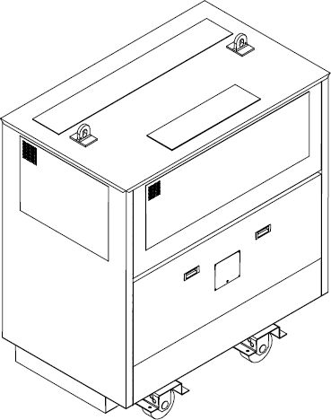
Main Transformes

4.6.1 General Specification
Qty 2
Application / Environment Distribution
Transformer Type Dry transformer

4.6.2 Electrical Specification
Rated Apparent power 250 kVA
Duty Continuous
Load type Distribution THD 8 %
Number of phases 3
Connection Dy11
Primary voltage V
Secondary voltage V
Rated frequency 60 Hz
Insulation class H
Temperature rise class F
Cu screen Not Included
Pre-magnetization Included

4.6.3 Mechanical Specification
Ingress Protection P23
Cable entry primary side Bottom
Cable entry secondary side Bottom
Power cable terminals (No. of cables) Manufacturer’s standard
Windings Aluminium
Enclosure Steel
Terminals Cu
Environment / Climatic / Fire class E1 / C1 / F0
Colour RAL 7035
MCT frame Included
Cooling system
Cooling method AN
Estimated heat load to air 5.0kW
Main dimensions
Estimated Size (W x D x H) 1200 x 1000 x 1300 mm
Estimated Weight 900 kg

Terminals and protection
Winding temperature monitoring .................................................................................... PT-100

Environmental conditions
Air temperature range (room) 0 – 45 °C

Low Voltage Shore Connection Cabinet
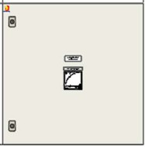

The CSCC panel is a conventional shore connection panel with a circuit breaker and connection point for shore power cables. The cable entry is through a hatch and the cables are connected by lugs and bolts.
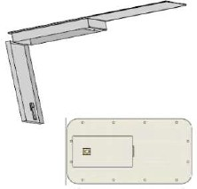

4.7.1 General Specification
Qty 1
Panel type CSCC4-8V

4.7.2 Mechanical Specification
Estimated Size TBC (W x D x H) 760 x 300 x 760 mm
Ingress Protection P 44
Cable entry Hatch

4.7.3 Electrical Specification
Rated Voltage V
Rated Frequency 60 Hz
Rated Current 500A
Number of phases 3 ph. + 1 P.E

Hight Voltage Shore Connection Switchboard (OPTION)

4.8.1 General Specification
Quantity 1 pcs.
Type Kongsberg High Voltage Switchboard

4.8.2 Mechanical Specification
Main dimensions
Estimated Size (W x D x H) 1280 x 1320 x 2750 mm
Estimated Weight 1660 kg
Cooling system
Cooling Method Air Natural
Estimated Heat Load to Air 0.5 kW
Air flow TBC m³/h
Terminals and protection
Ingress Protection IP 42 (Open bottom)
Access Requirement Front & Back
Cable Entry Bottom
Painting RAL9005 (Jet Black) / RAL9006 (White Aluminum)

Environmental conditions
Air temperature range (room) 0 – 45°C
Degree of pollution...................................................................................... 2 (IEC/EN 61800-5-1)
Air humidity ... 5-95 %rh
. Condensation, splash water and ice formation not permitted
Air pressure equivalence ≤ 2000 masl
Displacement limit (vibration) 1.0 mm at 2 - 13.2 Hz
Acceleration limit (vibration) ................................................................... 0.7 g at >13.2 100 Hz
Radio interference special power distribution zone (IEC 60533)

Construction standards
Design EC 62271-200
Vacuum circuit breakers (VCB) EC62271-100
Withdrawable Form Factor 3b

4.8.3 Electrical Specification
Bus nominal voltage kV
Bus rated voltage kV
Bus nominal frequency 60 Hz
Bus nominal current 1250 A
Short circuit level (Icw) 25 kA, 1 s.
Distribution system IT
+01 Auxiliary Panel (Riser panel)
Name BUSMEASURE
VCB Rated Current N.A
Protection Device N.A
Grounding Switch Yes (Bus Grounding)

+02 Switchboard Feeder
Name MS1
VCB Rated Current 630A
Protection Device P3F30
Grounding Switch Yes (Cable Side)

Hight Voltage Shore Connection Transformer (OPTION)

4.9.1 General Specification
Qty 1
Application / Environment Shore Connection
Transformer Type Dry transformer

4.9.2 Electrical Specification
Rated Apparent power 1850 kVA
Duty Continuous
Load type Distribution THD 8 %
Number of phases 3
Connection Dy11
Primary voltage ..................................................................................................................6600 V
Secondary voltage V
Rated frequency 60 Hz
Insulation class H
Temperature rise class F
Cu screen Not Included
Pre-magnetization Included

4.9.3 Mechanical Specification
Ingress Protection P44
Cable entry primary side Bottom
Cable entry secondary side Bottom
Power cable terminals (No. of cables) Manufacturer’s standard
Windings Aluminium
Enclosure Steel
Terminals Cu
Environment / Climatic / Fire class E1 / C1 / F0
Colour RAL 7035
MCT frame Included
Cooling system
Cooling method AFWF
Estimated heat load to air TBC
Coolant inlet temperature range (ship side) 38 °C
Secondary Cooling Freshwater w/glycol
Cooling fan 450 V, 60 Hz

Main dimensions
Estimated Size (W x D x H) 2700 x 1800 x 2000 mm
Estimated Weight 5000 kg

Terminals and protection
Winding temperature monitoring .................................................................................... PT-100
Leakage detector Yes

Environmental conditions
Air temperature range (room) 0 – 45 °C

Electrical Studies
A model of the electrical system is made based on information about loads and power supply. The vessel load list is needed as input to the model.

The results of the simulations will be delivered as documents according to the Supplier master document lists (SMDL). Information from client related to systems and items outside of
Kongsberg’s scope of supply must be in hand within due time to perform the analysis and deliver the documents according to the documentation plan.

4.10.1 Deliverables
The Following documents will be supplied:
- Short Circuit Calculation (for defined operational modes)
- Voltage-drop analysis
- Protection coordination (for KM delivered switchboards)
- Load flow study

An arc flash test of Kongsberg Low Voltage switchboard has been perfomed, test report will be submitted.

Spare Parts
Operational spare parts for two years are not required but can be added upon request.

Commissioning
Ref. to Kongsberg Maritime General Terms and Conditions for Commissioning Services
Commissioning:
40 days (at 10 hours per day)
Waiting time is not included and will be invoiced. Living and lodging expenses for the period are included
Additional assistance:
Additional assistance will be charged in accordance with Kongsberg standard rates

Training

Not included

CLASS
The equipment and system will be delivered in accordance with BV (Bureau Veritas)

The following notations will be applicable:
I, OIL TANKER, ESP, METHANOLFUEL-PREPARED (S, T, H, P, ME-DF, AE, B), CPS(WBT), COMF-VIB 3, COMF-NOISE 3, AUT-UMS, AVM, SYS-NEQ-1, CARGOCONTROL, LI-S3, VCS-TRANSFER, IG, SPM, CYBER SECURE, SMART (EnE2), ETA, BWT, CLEANSHIP, SOX-x%, GREENPASSPORT, INWATERSURVEY, MON-SHAFT, ALM

Factory Acceptance Tests
For equipment with project specific certification requirement a standard workshop test in the presence of class surveyor and customer (if required) will be performed.

The following equipment is subject to project specific certification:
- 450V Main Switchboard
- 450/220V Emergency Switchboard
- 220V Main Switchboard
- Main Transformers
For equipment without project specific certification requirement a standard workshop test will be performed or following suppliers QA system

Documentation
A project specific SMDL (Supplier Master Document List) will be provided soon after project is established. It will contain all documents related to the products and systems specified in this technical quotation. The SMDL also contains information about when each document will be ready, and who shall receive it.

List of Attachments
Main Single Line Diagram
450V Main Switchboard – General Arrangement 220V Main Switchboard – General Arrangement
450V/220V Emergency Switchboard – General Arrangement

