Supervised machine learning for predicting and explaining macrophage cytokine responses to hydrogels
Yanbing Liuª, Yaxi Chen^{a,b}, Hongyi Chen^{c}, Lan Wang^{d}, Jie Huang^{a,*}
ª Department of Mechanical Engineering, University College London, London, UK
^{b} Hawkes Institute, University College London, London, UK
^{c} Department of Computer Science, University College London, London, UK
^{d} Aier Eye Institute, AIER Eye Hospital Group, Changsha, PR China
*Corresponding author: Jie Huang (jie.huang@ucl.ac.uk)
Supplementary materials | revised 20 October 2026
Feature | Type | Unit or coding | Definition
hydrogel composition | Categorical | A–C | Origin of structural network-forming constituents: natural polymer, synthetic polymer, or natural–synthetic hybrid. Modified natural backbones remain natural; cargo alone does not determine origin.
modulus | Numerical | kPa | Recorded mechanical modulus, converted to kPa; includes storage, compressive and other reported modulus types.
pore size | Numerical | µm | Characteristic hydrogel pore size, as reported or digitised from the source.
bioactive cue | Categorical | A–F | Material-associated immune or pro-regenerative signalling cue; distinct from external activation. Categories describe supported roles, not cytokine magnitude or literal growth-factor cargo.
crosslink method | Categorical | A–D | Harmonised network-formation mechanism. Temperature-triggered physical gelation is included in physical self-assembly; other chemical or mixed routes remain in the residual category.
crosslink level | Categorical | A–C | Qualitative network classification using the criteria in Table S2.
macrophage model | Categorical | A–E | Macrophage cell model or primary/tissue context used for the cytokine measurement.
activation stimulus | Categorical | A–F | Externally applied stimulation context, including unstimulated or basal conditions.
exposure mode | Categorical | A–F | Hydrogel–cell interaction or assay geometry, including porous scaffold residence, indirect exposure and in vivo endpoints.
exposure time | Numerical | h | Recorded duration of culture or material exposure; distinct from material preparation or prior LPS priming.
Table S1a. Definitions of the model features.

Feature | Categorical coding
hydrogel composition | A, natural polymer; B, natural–synthetic hybrid; C, synthetic polymer
bioactive cue | A, none; B, anti-inflammatory cue; C, anti-inflammatory + pro-regenerative signalling cues; D, pro-regenerative signalling cue; E, pro- and anti-inflammatory cues; F, pro-inflammatory cue
crosslink method | A, photo-crosslinking; B, physical self-assembly; C, enzymatic crosslinking; D, other / mixed
crosslink level | A, medium; B, high; C, low
macrophage model | A, RAW264.7; B, murine primary or in vivo context; C, THP-1; D, human monocyte-derived macrophages; E, bone-marrow-derived macrophages
activation stimulus | A, LPS; B, unstimulated or basal; C, IL-4/IL-13; D, LPS + IFN-γ; E, other stimulation; F, unclear
exposure mode | A, direct surface contact; B, hydrogel extract or eluate; C, 3D encapsulation / scaffold residence; D, in vivo tissue or systemic; E, Transwell or indirect; F, unclear
Table S1b. Categorical codes used in the dataset tables. Letters are nominal labels fixed in the 19 October 2026 codebook; they are not numerical or ordinal inputs to the models.

Scoring dimension | Score = 0 | Score = 1 | Score = 2
Network complexity | Single weak physical network | Single stable network or single chemical network | Double network, multiple crosslinking mechanisms, or combined physical and chemical crosslinking
Crosslink-density clues | Clearly low crosslink density | Conventional or moderate crosslink density | Clearly high crosslink density
Mechanical/structural stability clues | Soft, loose, weakly stable, or rapidly swelling/degrading | Intermediate mechanical strength or stability | Reinforced, highly stable, dense, or low-swelling network
Source-author wording | Terms such as loosely crosslinked, soft, or weak | No clear tendency reported | Terms such as dense, reinforced, robust, or strong
Table S2. Scoring criteria for crosslink level classification.
Scores are summed across the four dimensions: 0–2, low; 3–5, medium; 6–8, high. In the revised IL-10 data, 61 records are medium (A), 64 high (B), and 8 low (C).
Feature | TNF-α available  n (%) | TNF-α missing  n (%) | IL-10 available  n (%) | IL-10 missing  n (%)
hydrogel composition | 139 (100.0%) | 0 (0.0%) | 133 (100.0%) | 0 (0.0%)
modulus | 105 (75.5%) | 34 (24.5%) | 97 (72.9%) | 36 (27.1%)
pore size | 112 (80.6%) | 27 (19.4%) | 104 (78.2%) | 29 (21.8%)
bioactive cue | 139 (100.0%) | 0 (0.0%) | 133 (100.0%) | 0 (0.0%)
crosslink method | 139 (100.0%) | 0 (0.0%) | 133 (100.0%) | 0 (0.0%)
crosslink level | 139 (100.0%) | 0 (0.0%) | 133 (100.0%) | 0 (0.0%)
macrophage model | 139 (100.0%) | 0 (0.0%) | 133 (100.0%) | 0 (0.0%)
activation stimulus | 139 (100.0%) | 0 (0.0%) | 133 (100.0%) | 0 (0.0%)
exposure mode | 139 (100.0%) | 0 (0.0%) | 133 (100.0%) | 0 (0.0%)
exposure time | 133 (95.7%) | 6 (4.3%) | 129 (97.0%) | 4 (3.0%)
Table S3a. Availability of the ten model features before imputation.

Excluded feature | TNF-α reporting evidence | IL-10 reporting evidence | Exclusion reason
swelling ratio | 14/41 studies (34.1%) | 16/36 studies (44.4%) | Reference mass, medium and equilibration time differ; a common numerical swelling descriptor is not established.
porosity | 3/41 studies (7.3%) | 6/36 studies (16.7%) | Void fraction, section area fraction and pore dimensions must remain distinct; comparable row-level values are incompletely resolved.
quantitative bioactive-cue loading | 15/41 studies (36.6%) | 10/36 studies (27.8%) | Feed amount, carrier loading, retained payload and delivered exposure dose use different denominators; they cannot be pooled without assumptions.
stress-relaxation measurements | 1/41 studies (2.4%) | 1/36 studies (2.8%) | One study reported relaxation curves; no common relaxation-time scalar was available.
degradation kinetics or time | 19/41 studies (46.3%) | 16/36 studies (44.4%) | Reported measures included mass loss, erosion, imaging retention and complete degradation time under different media and endpoints; no common kinetic descriptor was available.
mesh size (theoretical) | 2/41 studies (4.9%) | 2/36 studies (5.6%) | Available values were theory-derived network lengths rather than imaged pores, with insufficient comparable row-level measurements.
Table S3b. Study-level reporting of descriptors not included in the models.

No. | Cytokine | Imputation method | Model | R² | RMSE (pg/mL) | MAE (pg/mL)
1 | TNF-α | Median | LightGBM | 0.700 | 259.68 | 177.14
2 | TNF-α | Median | Gradient boosting regression | 0.718 | 251.75 | 171.88
3 | TNF-α | Median | XGBoost | 0.700 | 259.71 | 176.81
4 | TNF-α | Median | Random forest | 0.656 | 278.32 | 185.45
5 | TNF-α | Mean | LightGBM | 0.518 | 329.05 | 218.87
6 | TNF-α | Mean | Gradient boosting regression | 0.582 | 306.59 | 208.68
7 | TNF-α | Mean | XGBoost | 0.573 | 310.00 | 215.77
8 | TNF-α | Mean | Random forest | 0.655 | 278.62 | 191.79
9 | TNF-α | Iterative Bayesian ridge | LightGBM | 0.454 | 350.25 | 224.15
10 | TNF-α | Iterative Bayesian ridge | Gradient boosting regression | 0.527 | 325.98 | 210.33
11 | TNF-α | Iterative Bayesian ridge | XGBoost | 0.556 | 316.19 | 213.35
12 | TNF-α | Iterative Bayesian ridge | Random forest | 0.588 | 304.50 | 201.25
13 | TNF-α | Scaled KNN (k = 3) | LightGBM | 0.586 | 305.29 | 203.01
14 | TNF-α | Scaled KNN (k = 3) | Gradient boosting regression | 0.620 | 292.40 | 198.64
15 | TNF-α | Scaled KNN (k = 3) | XGBoost | 0.624 | 290.78 | 195.67
16 | TNF-α | Scaled KNN (k = 3) | Random forest | 0.592 | 303.06 | 199.95
17 | TNF-α | Scaled KNN (k = 5) | LightGBM | 0.589 | 303.92 | 206.30
18 | TNF-α | Scaled KNN (k = 5) | Gradient boosting regression | 0.602 | 299.32 | 201.14
19 | TNF-α | Scaled KNN (k = 5) | XGBoost | 0.605 | 298.00 | 204.45
20 | TNF-α | Scaled KNN (k = 5) | Random forest | 0.596 | 301.41 | 198.22
Table S4a. Comparison of numerical imputation methods for TNF-α prediction.

No. | Cytokine | Imputation method | Model | R² | RMSE (pg/mL) | MAE (pg/mL)
1 | IL-10 | Median | LightGBM | 0.719 | 204.41 | 121.47
2 | IL-10 | Median | Gradient boosting regression | 0.736 | 197.96 | 121.95
3 | IL-10 | Median | XGBoost | 0.753 | 191.51 | 120.25
4 | IL-10 | Median | Random forest | 0.778 | 181.34 | 112.30
5 | IL-10 | Mean | LightGBM | 0.701 | 210.55 | 126.88
6 | IL-10 | Mean | Gradient boosting regression | 0.746 | 194.08 | 117.08
7 | IL-10 | Mean | XGBoost | 0.777 | 182.00 | 117.10
8 | IL-10 | Mean | Random forest | 0.778 | 181.59 | 108.87
9 | IL-10 | Iterative Bayesian ridge | LightGBM | 0.710 | 207.61 | 128.19
10 | IL-10 | Iterative Bayesian ridge | Gradient boosting regression | 0.744 | 194.98 | 116.63
11 | IL-10 | Iterative Bayesian ridge | XGBoost | 0.776 | 182.27 | 115.37
12 | IL-10 | Iterative Bayesian ridge | Random forest | 0.720 | 203.85 | 115.65
13 | IL-10 | Scaled KNN (k = 3) | LightGBM | 0.623 | 236.44 | 131.49
14 | IL-10 | Scaled KNN (k = 3) | Gradient boosting regression | 0.743 | 195.32 | 114.26
15 | IL-10 | Scaled KNN (k = 3) | XGBoost | 0.730 | 200.35 | 124.25
16 | IL-10 | Scaled KNN (k = 3) | Random forest | 0.685 | 216.13 | 126.91
17 | IL-10 | Scaled KNN (k = 5) | LightGBM | 0.681 | 217.59 | 119.50
18 | IL-10 | Scaled KNN (k = 5) | Gradient boosting regression | 0.741 | 196.25 | 114.94
19 | IL-10 | Scaled KNN (k = 5) | XGBoost | 0.734 | 198.52 | 122.03
20 | IL-10 | Scaled KNN (k = 5) | Random forest | 0.696 | 212.49 | 119.75
Table S4b. Comparison of numerical imputation methods for IL-10 prediction.

Cytokine | Model | Training observations | Mean ± SD R² | Mean ± SD RMSE (pg/mL) | Mean ± SD MAE (pg/mL)
TNF-α | Gradient boosting regression | 111 | 0.718 ± 0.007 | 251.75 ± 3.19 | 171.88 ± 3.68
IL-10 | Random forest | 106 | 0.778 ± 0.004 | 181.34 ± 1.71 | 112.30 ± 0.48
Table S4c. Pooled ten-fold out-of-fold validation of the selected models. Values are mean ± sample SD across three realisations, not across ten folds.
For IL-10, imputation and model family were selected by mean Validation R² across the same three realisations. Among the evaluated panels satisfying the Validation, Test and direction criteria, the selected panel minimised mean individual C4 MAE. The evaluated 442-realisation pool does not establish a full-range optimum. TNF-α retains the earlier per-realisation Validation-winner rule. Test and C4 data contributed to panel screening and are not independent estimates of performance after selection.

Parameter | TNF-α model | IL-10 model
Regression model | GradientBoostingRegressor | RandomForestRegressor
Numerical imputation | Median | Median
Categorical imputation | Constant: __missing__ | Constant: **missing**
Categorical encoding | Dense one-hot; unknown categories ignored | Dense one-hot; unknown categories ignored
Loss/objective | Squared error | Squared error
Tree split criterion | friedman_mse | squared_error
Number of estimators | 1000 | 250
Learning rate | 0.08 | —
Maximum tree depth | 3 | 8
Maximum leaves per tree | Unrestricted | Unrestricted
Minimum observations per leaf | 8 | 1
Minimum observations to split | 2 | 2
Boosting row subsampling | 0.7 | —
Bootstrap sampling | — | False
Feature sampling per split | All features | 0.7
Minimum impurity decrease | 0 | 0
Cost-complexity pruning (ccp_alpha) | 0 | 0
Model realisations | 3 | 3
Training / Test observations | 111 / 28 | 106 / 27
Train/Test partition | Fixed 80:20 membership | Fixed 80:20 membership
Validation folds | 10 shuffled folds | 10 shuffled folds
Validation partition | Shared Training folds | Shared Training folds
Numerical imputer strategy | Median | Median
Imputer statistics | Training rows only | Training rows only
Validation selection | Best model–imputer pair in each realisation | Best model–imputer pair by three-realisation mean
Implementation | scikit-learn 1.7.2 | scikit-learn 1.7.2
Model version | Accepted Training-80 TNF release | Crosslink-7 RF median, 20 October 2026
Predictive numerical standardisation | None | None
Parallel jobs | — | 1
Table S5. Settings of the selected TNF-α and IL-10 models.

No. | Representative | hydrogel  composition | modulus  (kPa) | pore size  (µm) | bioactive cue | crosslink  method | crosslink  level | Predicted TNF-α  (pg/mL) | Predicted IL-10  (pg/mL)
1 | P1 | natural polymer | 0.280058 | 5.40947 | anti-inflammatory + pro-regenerative signalling cues | physical self-assembly | medium | 17.99 ± 14.38 | 1017.63 ± 6.86
2 | — | natural polymer | 0.3 | 5.40947 | anti-inflammatory + pro-regenerative signalling cues | physical self-assembly | medium | 17.99 ± 14.38 | 1017.63 ± 6.86
3 | — | natural polymer | 2.64817 | 3 | none | enzymatic crosslinking | medium | 64.49 ± 14.59 | 1137.62 ± 14.85
4 | — | natural–synthetic hybrid | 19.2166 | 84.437 | anti-inflammatory + pro-regenerative signalling cues | other / mixed | high | 95.06 ± 70.55 | 1261.13 ± 29.14
5 | — | natural polymer | 0.426277 | 84.437 | anti-inflammatory + pro-regenerative signalling cues | other / mixed | high | 120.96 ± 94.31 | 1365.66 ± 56.15
6 | — | natural polymer | 0.426277 | 84.437 | anti-inflammatory + pro-regenerative signalling cues | other / mixed | high | 177.50 ± 88.93 | 1454.99 ± 48.06
7 | — | natural polymer | 14.343 | 84.437 | anti-inflammatory + pro-regenerative signalling cues | other / mixed | high | 235.34 ± 104.69 | 1465.77 ± 34.69
8 | — | natural polymer | 14.343 | 84.437 | anti-inflammatory + pro-regenerative signalling cues | other / mixed | high | 266.28 ± 99.52 | 1469.26 ± 34.76
9 | — | natural polymer | 14.343 | 84.437 | anti-inflammatory + pro-regenerative signalling cues | photo-crosslinking | high | 407.05 ± 96.48 | 1480.01 ± 38.89
10 | — | natural polymer | 14.343 | 84.437 | anti-inflammatory + pro-regenerative signalling cues | photo-crosslinking | high | 444.79 ± 93.37 | 1483.50 ± 38.70
11 | P2 | natural polymer | 0.426277 | 84.437 | anti-inflammatory + pro-regenerative signalling cues | other / mixed | high | 675.48 ± 86.87 | 1609.49 ± 31.65
12 | — | natural polymer | 2.64817 | 84.437 | anti-inflammatory + pro-regenerative signalling cues | other / mixed | high | 924.82 ± 19.80 | 1630.70 ± 29.00
13 | — | natural polymer | 11.2329 | 84.437 | anti-inflammatory + pro-regenerative signalling cues | other / mixed | high | 958.53 ± 83.23 | 1641.83 ± 22.04
14 | — | natural polymer | 14.343 | 84.437 | anti-inflammatory + pro-regenerative signalling cues | photo-crosslinking | high | 1204.83 ± 73.62 | 1706.13 ± 29.59
15 | — | natural polymer | 11.2329 | 84.437 | anti-inflammatory + pro-regenerative signalling cues | photo-crosslinking | high | 1292.22 ± 83.28 | 1759.65 ± 3.72
16 | — | natural polymer | 9.31507 | 84.437 | anti-inflammatory + pro-regenerative signalling cues | photo-crosslinking | high | 1425.41 ± 49.77 | 1765.41 ± 4.29
17 | — | natural polymer | 3.99216 | 84.437 | anti-inflammatory + pro-regenerative signalling cues | photo-crosslinking | high | 1555.44 ± 46.35 | 1770.20 ± 3.85
18 | P3 | natural polymer | 3.004 | 84.437 | anti-inflammatory + pro-regenerative signalling cues | photo-crosslinking | high | 2130.14 ± 2.29 | 1776.19 ± 3.82
Table S6a. Material descriptors and predicted cytokine concentrations for the 18 Pareto profiles shown in Fig. 10. P1–P3 denote the representative designs. Values are mean ± sample SD across three models.

Profile No. | Macrophage model | Activation stimulus | Exposure mode | Exposure time (h)
1 | RAW264.7 | LPS | hydrogel extract or eluate | 24
2 | RAW264.7 | LPS | hydrogel extract or eluate | 24
3 | Murine primary or in vivo context | LPS + IFN-γ | direct surface contact | 36
4 | RAW264.7 | Unstimulated or basal | direct surface contact | 120
5 | Murine primary or in vivo context | Unstimulated or basal | direct surface contact | 24
6 | Murine primary or in vivo context | Other stimulation | direct surface contact | 36
7 | Murine primary or in vivo context | Other stimulation | direct surface contact | 36
8 | Murine primary or in vivo context | Other stimulation | direct surface contact | 24
9 | Murine primary or in vivo context | Other stimulation | direct surface contact | 36
10 | Murine primary or in vivo context | Other stimulation | direct surface contact | 24
11 | RAW264.7 | LPS | hydrogel extract or eluate | 12
12 | RAW264.7 | LPS | hydrogel extract or eluate | 12
13 | RAW264.7 | LPS | hydrogel extract or eluate | 48
14 | RAW264.7 | LPS | hydrogel extract or eluate | 24
15 | RAW264.7 | LPS | hydrogel extract or eluate | 24
16 | RAW264.7 | LPS | hydrogel extract or eluate | 24
17 | RAW264.7 | LPS | hydrogel extract or eluate | 24
18 | RAW264.7 | LPS | hydrogel extract or eluate | 24
Table S6a (continued). Experimental descriptors for the same profiles.

Profile No. | TNF-α domain ratio | IL-10 domain ratio | Non-dominance frequency
1 | 0.666 | 0.574 | 6/9
2 | 0.666 | 0.574 | 6/9
3 | 0.377 | 0.334 | 6/9
4 | 0.845 | 0.854 | 6/9
5 | 0.905 | 0.900 | 6/9
6 | 0.846 | 0.851 | 8/9
7 | 0.998 | 0.851 | 6/9
8 | 0.992 | 0.860 | 6/9
9 | 0.927 | 0.711 | 8/9
Table S6b. Applicability-domain ratios and non-dominance frequency for the profiles in Table S6a.

Profile No. | TNF-α domain ratio | IL-10 domain ratio | Non-dominance frequency
10 | 0.921 | 0.706 | 7/9
11 | 0.638 | 0.622 | 9/9
12 | 0.627 | 0.622 | 6/9
13 | 0.753 | 0.615 | 7/9
14 | 0.668 | 0.422 | 6/9
15 | 0.601 | 0.420 | 9/9
16 | 0.553 | 0.420 | 9/9
17 | 0.430 | 0.417 | 9/9
18 | 0.416 | 0.417 | 6/9
Table S6b (continued). Profiles 10–18.

Feature | PEG microgel scaffold | PEG microgel scaffold with tethered IL-10 | HPA@SIN-GM | HPA@SIN-GM@DR
hydrogel composition | synthetic polymer | synthetic polymer | natural polymer | natural polymer
modulus (kPa) | — | — | 10.0 | 10.0
pore size (µm) | 90.0 | 90.0 | 7.5 | 7.5
bioactive cue | none | anti-inflammatory cue | anti-inflammatory cue | anti-inflammatory + pro-regenerative signalling cues
crosslink method | other / mixed | other / mixed | physical self-assembly | physical self-assembly
crosslink level | medium | medium | high | high
macrophage model | THP-1 | THP-1 | RAW264.7 | RAW264.7
activation stimulus | unstimulated or basal | unstimulated or basal | LPS | LPS
exposure mode | 3D encapsulation / scaffold residence | 3D encapsulation / scaffold residence | hydrogel extract or eluate | hydrogel extract or eluate
exposure time (h) | 72.0 | 72.0 | 24.0 | 24.0
Table S7a. Formulation features in the case studies.

Formulation | Experimental TNF-α | Predicted TNF-α | Experimental IL-10 | Predicted IL-10
PEG microgel scaffold | 704.545 | 422.555 ± 67.820 | 208.522 | 624.815 ± 13.173
PEG microgel scaffold with tethered IL-10 | 428.030 | 190.882 ± 92.441 | 552.807 | 716.929 ± 2.649
HPA@SIN-GM | 612.000 [474.434, 749.566] | 590.973 ± 17.052 | 155.000 [128.525, 181.475] | 167.050 ± 2.368
HPA@SIN-GM@DR | 488.963 [369.010, 668.273] | 487.348 ± 9.696 | 188.060 [166.418, 206.716] | 183.802 ± 2.055
Table S7b. Experimental and predicted cytokine concentrations (pg/mL).
Predictions are mean ± sample SD across three realisations. PEG microgel predictions use separate whole-study-excluded models; HPA formulations use the primary Training-only models. C4 selection error is the mean of each model’s two absolute concentration errors; it is distinct from the absolute error in the paired concentration change.
DOI | No. | Hydrogel  composition | Modulus  (kPa) | Pore size  (µm) | Bioactive  cue | Crosslink  method | Crosslink  level | Macrophage  model | Activation  stimulus | Exposure  mode | Exposure  time (h) | Measured  TNF-α  (pg/mL)
10.1016/j.bioactmat.2024.07.015 | 1 | A | — | 182.8023 | A | D | A | A | F | A | 48.0 | 500.822
10.1016/j.bioactmat.2024.07.015 | 2 | A | — | 182.8023 | A | D | A | A | F | A | 96.0 | 502.583
10.1016/j.mtbio.2025.101686 | 3 | A | 19.1869 | 40.011 | A | A | A | A | A | B | 48.0 | 681.006
10.1016/j.mtbio.2025.101686 | 4 | A | 16.8094 | 50.25 | C | A | A | A | A | B | 48.0 | 675.825
10.1016/j.mtbio.2025.101686 | 5 | A | 13.1193 | 97.387 | C | A | A | A | A | B | 48.0 | 206.09
10.1038/s41467-024-50072-y | 6 | A | — | — | A | A | C | B | B | A | 24.0 | 66.2712
10.1038/s41467-024-50072-y | 7 | A | — | — | A | A | C | B | D | A | 24.0 | 274.539
10.1038/s41467-024-50072-y | 8 | A | — | — | A | A | C | B | E | A | 24.0 | 135.318
10.1038/s41467-024-50072-y | 9 | A | — | — | A | A | B | B | B | A | 24.0 | 66.2943
10.1038/s41467-024-50072-y | 10 | A | — | — | A | A | B | B | D | A | 24.0 | 613.67
10.1038/s41467-024-50072-y | 11 | A | — | — | A | A | B | B | E | A | 24.0 | 531.629
10.1186/s12951-024-02996-2 | 12 | A | 12.263 | 142.614 | B | A | B | B | C | A | 24.0 | 9.45985
10.1186/s12951-024-02996-2 | 13 | A | 16.1507 | 139.205 | B | A | B | B | C | A | 24.0 | 7.39738
10.1186/s12951-024-02996-2 | 14 | A | 29.6548 | 117.045 | C | A | B | B | C | A | 24.0 | 2.28207
10.1002/smll.202203680 | 15 | A | 0.0841 | — | A | B | C | B | E | C | 72.0 | 204.7
10.1002/smll.202203680 | 16 | A | 0.4281 | — | A | D | B | B | E | C | 72.0 | 190.5
10.1002/smll.202203680 | 17 | A | 0.4434 | — | A | D | B | B | E | C | 72.0 | 193.6
10.1002/smll.202203680 | 18 | A | 0.438 | — | A | D | B | B | E | C | 72.0 | 196.1
10.34133/bmr.0029 | 19 | A | 26.67 | 60.0 | A | D | A | A | F | F | — | 253.053
10.34133/bmr.0029 | 20 | A | 36.67 | 60.0 | A | D | A | A | F | F | — | 191.66
10.1021/acsami.2c08593 | 21 | A | 3.008 | 158.438 | A | B | C | B | E | D | 96.0 | 87.3506
10.1021/acsami.2c08593 | 22 | A | 2.265 | 44.628 | B | B | C | B | E | D | 96.0 | 54.1627
10.3389/fimmu.2023.1170153 | 23 | A | 0.752 | — | A | C | C | B | E | D | 72.0 | 632.568
10.1016/j.biomaterials.2024.122706 | 24 | B | 0.319 | 30.3213 | A | B | A | A | A | A | 48.0 | 641.249
10.1016/j.biomaterials.2024.122706 | 25 | B | 0.638 | 48.5321 | B | B | A | A | A | A | 48.0 | 529.351
10.1039/d4bm01623h | 26 | C | 10.9 | — | B | A | B | C | F | A | 144.0 | 18.4211
10.1016/j.actbio.2025.03.015 | 27 | B | 5.593 | 250.31 | A | A | B | A | A | A | 24.0 | 591.268
10.1016/j.actbio.2025.03.015 | 28 | B | 4.123 | 116.52 | B | A | B | A | A | A | 24.0 | 364.241
10.1016/j.mtbio.2025.101690 | 29 | B | 0.227 | 44.177 | A | B | A | A | A | E | 96.0 | 1851.27
10.1016/j.mtbio.2025.101690 | 30 | B | 0.227 | 56.5916 | B | B | A | A | A | E | 96.0 | 1481.01
10.1016/j.mtbio.2025.101690 | 31 | B | 0.227 | 58.795 | B | B | A | A | A | E | 96.0 | 1063.29
10.1016/j.mtbio.2025.101690 | 32 | B | 0.227 | 68.073 | B | B | A | A | A | E | 96.0 | 669.304
10.1002/advs.202206771 | 33 | A | 0.8201 | 13.1805 | A | A | A | A | A | A | 24.0 | 775.76
10.1002/advs.202206771 | 34 | A | 0.9985 | 6.593 | B | A | A | A | A | A | 24.0 | 476.648
10.1002/btm2.10217 | 35 | C | — | 90.0 | A | D | A | C | B | C | 72.0 | 704.545
10.1002/btm2.10217 | 36 | C | — | 90.0 | B | D | A | C | B | C | 72.0 | 428.03
10.1002/btm2.10217 | 37 | C | — | 90.0 | A | D | A | C | D | C | 72.0 | 875.0
10.1002/btm2.10217 | 38 | C | — | 90.0 | B | D | A | C | D | C | 72.0 | 590.909
10.1002/btm2.10217 | 39 | C | — | 90.0 | A | D | A | C | C | C | 72.0 | 583.333
10.1002/btm2.10217 | 40 | C | — | 90.0 | B | D | A | C | C | C | 72.0 | 212.121
10.1021/acsami.4c18945 | 41 | A | — | 59.081 | A | A | B | A | A | A | 24.0 | 373.937
10.1021/acsami.4c18945 | 42 | A | 1.3 | 79.5045 | C | A | B | A | A | A | 24.0 | 248.824
10.1021/acsami.4c18945 | 43 | A | 1.3 | 80.389 | C | A | B | A | A | A | 24.0 | 162.299
10.1016/j.mtbio.2024.101340 | 44 | A | 0.42377 | 295.976 | B | A | B | A | A | A | 48.0 | 494.064
10.1016/j.mtbio.2024.101340 | 45 | A | 0.42377 | 295.976 | E | A | B | A | A | A | 48.0 | 383.374
10.1002/smll.202405236 | 46 | A | — | — | A | A | B | A | A | A | 48.0 | 69.9588
10.1002/smll.202405236 | 47 | A | — | — | B | A | B | A | A | A | 48.0 | 59.6367
10.1002/smll.202405236 | 48 | A | — | — | A | A | B | A | A | A | 48.0 | 64.9004
10.1002/smll.202405236 | 49 | A | — | — | B | A | B | A | A | A | 48.0 | 56.563
10.1002/adma.202108430 | 50 | B | 10.0 | 10.411 | A | D | B | B | E | F | — | 597.329
10.1002/adma.202108430 | 51 | B | 10.0 | 10.411 | B | D | B | B | E | F | — | 285.0
10.1002/adma.202108430 | 52 | B | 10.0 | 10.411 | D | D | B | B | E | F | — | 602.925
10.1002/adma.202108430 | 53 | B | 10.0 | 10.411 | C | D | B | B | E | F | — | 263.706
10.1016/j.colsurfb.2024.114466 | 54 | A | 3.5015 | 142.607 | B | A | A | C | A | A | 24.0 | 1096.31
10.1016/j.colsurfb.2024.114466 | 55 | A | 1.1265 | 142.607 | B | A | A | C | A | A | 24.0 | 1396.74
10.1007/s13770-022-00437-5 | 56 | B | 14.343 | 70.7182 | A | B | A | A | A | B | 24.0 | 0.182773
10.1007/s13770-022-00437-5 | 57 | B | 14.343 | 70.7182 | C | B | A | A | A | B | 24.0 | 0.0453782
10.1016/j.biomaterials.2025.123414 | 58 | A | 1.1178 | 133.677 | A | D | A | A | A | B | 24.0 | 237.242
10.1016/j.biomaterials.2025.123414 | 59 | A | 1.0371 | 189.967 | C | D | A | A | A | B | 24.0 | 42.9847
10.1016/j.biomaterials.2025.123376 | 60 | B | — | 123.179 | A | D | A | A | F | A | 24.0 | 229.627
10.1016/j.biomaterials.2025.123376 | 61 | B | — | — | B | D | A | A | F | A | 24.0 | 258.859
10.1016/j.biomaterials.2025.123376 | 62 | B | 1.3477 | 336.94 | E | D | A | A | F | A | 24.0 | 413.19
10.1016/j.jconrel.2025.113893 | 63 | A | 3.004 | 84.437 | A | A | B | A | A | B | 24.0 | 2627.21
10.1016/j.jconrel.2025.113893 | 64 | A | 3.004 | 84.437 | D | A | B | A | A | B | 24.0 | 2547.12
10.1016/j.jconrel.2025.113893 | 65 | A | 3.004 | 84.437 | D | A | B | A | A | B | 24.0 | 2379.86
10.1016/j.jconrel.2025.113893 | 66 | A | 3.004 | 84.437 | C | A | B | A | A | B | 24.0 | 2060.62
10.1038/s41467-026-68318-2 | 67 | A | 0.087 | 27.8 | C | B | A | A | E | F | 24.0 | 73.5981
10.1038/s41467-026-68318-2 | 68 | A | 0.2542 | 28.6 | F | B | A | A | E | F | 24.0 | 124.065
10.1038/s41467-026-68318-2 | 69 | A | 0.9287 | 19.8 | E | B | B | A | E | F | 24.0 | 206.075
10.1016/j.mtbio.2026.102863 | 70 | A | — | — | A | A | C | A | A | B | 24.0 | 50.2006
10.1016/j.mtbio.2026.102863 | 71 | A | — | 16.1591 | A | A | C | A | A | B | 24.0 | 47.6791
10.1016/j.mtbio.2026.102863 | 72 | A | — | 4.5605 | C | A | B | A | A | B | 24.0 | 24.0688
10.1186/s13018-025-06631-0 | 73 | A | 2.6997 | — | B | A | A | A | A | A | 24.0 | 70.4354
10.1186/s13018-025-06631-0 | 74 | A | 2.6997 | — | B | A | A | A | A | A | 24.0 | 147.016
10.1186/s12951-024-02810-z | 75 | A | — | 130.1491 | A | A | A | A | A | B | 24.0 | 642.424
10.1186/s12951-024-02810-z | 76 | A | 1.0 | 177.823 | B | A | A | A | A | B | 24.0 | 565.657
10.1093/burnst/tkaf024 | 77 | C | 1.0 | 88.58 | A | D | A | B | E | D | 192.0 | 506.456
10.1093/burnst/tkaf024 | 78 | C | — | 87.94 | C | D | A | B | E | D | 192.0 | 367.334
10.1093/burnst/tkaf024 | 79 | C | — | 87.94 | C | D | A | B | E | D | 192.0 | 215.074
10.1093/burnst/tkaf024 | 80 | C | — | 87.94 | C | D | A | B | E | D | 192.0 | 167.923
10.1021/acsnano.5c10123 | 81 | A | 1.59979 | 156.933 | C | A | A | A | A | A | 48.0 | 1803.7
10.1021/acsnano.5c10123 | 82 | A | 1.65229 | 200.938 | C | A | A | A | A | A | 48.0 | 1768.45
10.1016/j.mtbio.2026.102988 | 83 | A | 2.5039 | 84.4927 | A | A | A | B | E | D | 168.0 | 55.5102
10.1016/j.mtbio.2026.102988 | 84 | A | 5.4922 | 84.4927 | A | A | B | B | E | D | 168.0 | 41.4505
10.1016/j.mtbio.2026.102988 | 85 | A | 5.4922 | 84.4927 | C | A | B | B | E | D | 168.0 | 35.8554
10.1016/j.mtbio.2026.102988 | 86 | A | 5.4922 | 84.4927 | C | A | B | B | E | D | 168.0 | 33.8331
10.1016/j.mtbio.2025.102521 | 87 | A | 0.6287 | 10.0 | B | B | A | A | A | A | 18.0 | 142.697
10.1016/j.mtbio.2025.102521 | 88 | A | 0.6287 | 15.2632 | B | B | A | A | A | A | 18.0 | 110.451
10.1016/j.mtbio.2025.102521 | 89 | A | 0.6287 | 15.2632 | C | B | A | A | A | A | 18.0 | 108.078
10.1016/j.mtbio.2025.102519 | 90 | A | — | — | A | A | C | A | A | B | 8.0 | 191.547
10.1016/j.mtbio.2025.102519 | 91 | A | 0.0472 | 242.3805 | C | A | A | A | A | B | 8.0 | 125.485
10.1016/j.mtbio.2025.102519 | 92 | A | 0.097 | 159.96 | C | A | C | A | A | B | 8.0 | 181.02
10.1016/j.mtbio.2025.102519 | 93 | A | — | — | C | A | A | A | A | B | 8.0 | 103.18
10.1016/j.mtbio.2025.102556 | 94 | C | 0.883 | 18.98 | A | D | A | A | F | A | 12.0 | 304.806
10.1016/j.mtbio.2025.102556 | 95 | C | 0.883 | 16.783 | B | D | B | A | F | A | 12.0 | 284.309
10.1016/j.mtbio.2025.102556 | 96 | C | 0.883 | 10.043 | B | D | B | A | F | A | 12.0 | 236.606
10.1016/j.mtbio.2025.101810 | 97 | A | 0.8718 | 22.0221 | A | A | A | A | A | B | 24.0 | 112.421
10.1016/j.mtbio.2025.101810 | 98 | A | — | — | C | A | A | A | A | B | 24.0 | 100.105
10.1016/j.mtbio.2025.101810 | 99 | A | — | — | C | A | A | A | A | B | 24.0 | 87.4737
10.1016/j.mtbio.2025.101810 | 100 | A | 0.7565 | 22.1846 | C | A | A | A | A | B | 24.0 | 81.48
10.1016/j.mtbio.2024.100960 | 101 | A | 0.539 | 148.83 | A | D | A | A | A | B | 24.0 | 712.695
10.1016/j.mtbio.2024.100960 | 102 | A | — | 100.0 | A | D | B | A | A | B | 24.0 | 627.877
10.1016/j.mtbio.2024.100960 | 103 | A | — | 148.83 | B | D | A | A | A | B | 24.0 | 288.561
10.1016/j.mtbio.2024.100960 | 104 | A | 2.962 | 100.0 | B | D | B | A | A | B | 24.0 | 289.782
10.1016/j.mtbio.2023.100753 | 105 | B | 8.4838 | 100.0 | A | A | A | A | B | A | 48.0 | 283.688
10.1016/j.mtbio.2023.100753 | 106 | B | 7.2986 | 100.0 | A | A | B | A | B | A | 48.0 | 319.149
10.1016/j.mtbio.2023.100753 | 107 | B | 3.5545 | 100.0 | B | A | B | A | B | A | 48.0 | 215.603
10.1016/j.mtbio.2022.100392 | 108 | B | 19.2166 | 20.0 | A | A | B | A | B | A | 24.0 | 151.154
10.1016/j.mtbio.2022.100392 | 109 | B | 19.2166 | 20.0 | A | A | B | A | B | A | 24.0 | 140.769
10.1016/j.mtbio.2022.100392 | 110 | B | 19.2166 | 20.0 | B | A | B | A | B | A | 24.0 | 155.769
10.1016/j.mtbio.2022.100392 | 111 | B | 19.2166 | 20.0 | B | A | B | A | B | A | 24.0 | 148.846
10.1016/j.mtbio.2022.100392 | 112 | B | 19.2166 | 20.0 | B | A | B | A | B | A | 24.0 | 176.538
10.1016/j.mtbio.2022.100392 | 113 | B | 19.2166 | 20.0 | A | A | B | A | B | A | 72.0 | 180.0
10.1016/j.mtbio.2022.100392 | 114 | B | 19.2166 | 20.0 | A | A | B | A | B | A | 72.0 | 153.462
10.1016/j.mtbio.2022.100392 | 115 | B | 19.2166 | 20.0 | B | A | B | A | B | A | 72.0 | 158.077
10.1016/j.mtbio.2022.100392 | 116 | B | 19.2166 | 20.0 | B | A | B | A | B | A | 72.0 | 168.462
10.1016/j.mtbio.2022.100392 | 117 | B | 19.2166 | 20.0 | B | A | B | A | B | A | 72.0 | 184.615
10.1016/j.mtbio.2022.100392 | 118 | B | 19.2166 | 20.0 | A | A | B | A | B | A | 120.0 | 214.615
10.1016/j.mtbio.2022.100392 | 119 | B | 19.2166 | 20.0 | A | A | B | A | B | A | 120.0 | 191.538
10.1016/j.mtbio.2022.100392 | 120 | B | 19.2166 | 20.0 | B | A | B | A | B | A | 120.0 | 185.769
10.1016/j.mtbio.2022.100392 | 121 | B | 19.2166 | 20.0 | B | A | B | A | B | A | 120.0 | 208.846
10.1016/j.mtbio.2022.100392 | 122 | B | 19.2166 | 20.0 | B | A | B | A | B | A | 120.0 | 207.692
10.1016/j.actbio.2016.09.024 | 123 | A | 0.3 | 3.0 | A | C | A | B | B | A | 36.0 | 144.082
10.1016/j.actbio.2016.09.024 | 124 | A | 0.3 | 3.0 | A | C | A | B | B | A | 36.0 | 130.749
10.1016/j.actbio.2016.09.024 | 125 | A | 0.3 | 3.0 | A | C | A | B | D | A | 36.0 | 129.855
10.1016/j.actbio.2016.09.024 | 126 | A | 0.3 | 3.0 | A | C | A | B | D | A | 36.0 | 138.41
10.1016/j.actbio.2016.09.024 | 127 | A | 0.3 | 3.0 | A | C | A | B | C | A | 36.0 | 137.53
10.1016/j.actbio.2016.09.024 | 128 | A | 0.3 | 3.0 | A | C | A | B | C | A | 36.0 | 106.674
10.1016/j.actbio.2016.09.024 | 129 | A | 0.3 | 3.0 | A | C | A | B | E | A | 36.0 | 127.667
10.1016/j.actbio.2016.09.024 | 130 | A | 0.3 | 3.0 | A | C | A | B | E | A | 36.0 | 118.704
10.1016/j.mtbio.2025.102080 | 131 | B | 36.883 | 2.95 | B | B | B | A | A | B | 24.0 | 461.686
10.1016/j.mtbio.2025.102080 | 132 | B | 22.857 | 4.9 | B | B | B | A | A | B | 24.0 | 599.954
10.1016/j.mtbio.2025.102080 | 133 | B | 9.62045 | 8.54 | B | B | A | A | A | B | 24.0 | 647.617
10.1016/j.mtbio.2025.102080 | 134 | B | 7.0 | 26.3 | B | B | C | A | A | B | 24.0 | 934.435
10.1016/j.mtbio.2026.102989 | 135 | B | 8.659 | 40.55 | F | D | A | E | A | A | 24.0 | 980.0
10.1016/j.mtbio.2026.102989 | 136 | B | 8.659 | 40.55 | F | D | A | A | A | A | 24.0 | 403.196
10.1039/D5BM01187F | 137 | A | 0.2579 | — | A | A | C | D | F | A | 144.0 | 361.674
10.1039/D5BM01187F | 138 | A | 1.1957 | — | A | A | A | D | F | A | 144.0 | 354.176
10.1039/D5BM01187F | 139 | A | 4.4266 | — | A | A | B | D | F | A | 144.0 | 702.217
Table S8. Complete TNF-α dataset before imputation (n = 139).

DOI | No. | Hydrogel  composition | Modulus  (kPa) | Pore size  (µm) | Bioactive  cue | Crosslink  method | Crosslink  level | Macrophage  model | Activation  stimulus | Exposure  mode | Exposure  time (h) | Measured  IL-10  (pg/mL)
10.1016/j.bioactmat.2024.07.015 | 1 | A | — | 182.8023 | A | D | A | A | F | A | 48.0 | 53.7037
10.1016/j.bioactmat.2024.07.015 | 2 | A | — | 182.8023 | A | D | A | A | F | A | 96.0 | 82.0988
10.1016/j.mtbio.2025.101686 | 3 | A | 19.1869 | 40.011 | A | A | A | A | A | B | 48.0 | 64.8354
10.1016/j.mtbio.2025.101686 | 4 | A | 16.8094 | 50.25 | C | A | A | A | A | B | 48.0 | 92.6978
10.1016/j.mtbio.2025.101686 | 5 | A | 13.1193 | 97.387 | C | A | A | A | A | B | 48.0 | 140.56
10.1038/s41467-024-50072-y | 6 | A | — | — | A | A | C | B | B | A | 24.0 | 63.7474
10.1038/s41467-024-50072-y | 7 | A | — | — | A | A | C | B | D | A | 24.0 | 205.237
10.1038/s41467-024-50072-y | 8 | A | — | — | A | A | C | B | E | A | 24.0 | 940.15
10.1038/s41467-024-50072-y | 9 | A | — | — | A | A | B | B | B | A | 24.0 | 49.9637
10.1038/s41467-024-50072-y | 10 | A | — | — | A | A | B | B | D | A | 24.0 | 61.7613
10.1038/s41467-024-50072-y | 11 | A | — | — | A | A | B | B | E | A | 24.0 | 784.833
10.1186/s12951-024-02996-2 | 12 | A | 12.263 | 142.614 | B | A | B | B | C | A | 24.0 | 396.255
10.1186/s12951-024-02996-2 | 13 | A | 16.1507 | 139.205 | B | A | B | B | C | A | 24.0 | 308.821
10.1186/s12951-024-02996-2 | 14 | A | 29.6548 | 117.045 | C | A | B | B | C | A | 24.0 | 760.713
10.1002/smll.202203680 | 15 | A | 0.0841 | — | A | B | C | B | E | C | 72.0 | 81.6
10.1002/smll.202203680 | 16 | A | 0.4281 | — | A | D | B | B | E | C | 72.0 | 108.8
10.1002/smll.202203680 | 17 | A | 0.4434 | — | A | D | B | B | E | C | 72.0 | 248.8
10.1002/smll.202203680 | 18 | A | 0.438 | — | A | D | B | B | E | C | 72.0 | 189.2
10.34133/bmr.0029 | 19 | A | 26.67 | 60.0 | A | D | A | A | F | F | — | 1.55869
10.34133/bmr.0029 | 20 | A | 36.67 | 60.0 | A | D | A | A | F | F | — | 2.02817
10.3389/fimmu.2023.1170153 | 21 | A | 0.752 | — | A | C | C | B | E | D | 72.0 | 60.9211
10.1016/j.actbio.2025.03.015 | 22 | B | 5.593 | 250.31 | A | A | B | A | A | A | 24.0 | 398.683
10.1016/j.actbio.2025.03.015 | 23 | B | 4.123 | 116.52 | B | A | B | A | A | A | 24.0 | 269.747
10.1016/j.mtbio.2025.101690 | 24 | B | 0.227 | 44.177 | A | B | A | A | A | E | 96.0 | 22.5485
10.1016/j.mtbio.2025.101690 | 25 | B | 0.227 | 56.5916 | B | B | A | A | A | E | 96.0 | 40.3391
10.1016/j.mtbio.2025.101690 | 26 | B | 0.227 | 58.795 | B | B | A | A | A | E | 96.0 | 92.9093
10.1016/j.mtbio.2025.101690 | 27 | B | 0.227 | 68.073 | B | B | A | A | A | E | 96.0 | 130.337
10.1002/btm2.10217 | 28 | C | — | 90.0 | A | D | A | C | B | C | 72.0 | 208.522
10.1002/btm2.10217 | 29 | C | — | 90.0 | B | D | A | C | B | C | 72.0 | 552.807
10.1002/btm2.10217 | 30 | C | — | 90.0 | B | D | A | C | D | C | 72.0 | 340.714
10.1002/btm2.10217 | 31 | C | — | 90.0 | A | D | A | C | C | C | 72.0 | 537.73
10.1002/btm2.10217 | 32 | C | — | 90.0 | B | D | A | C | C | C | 72.0 | 844.182
10.1021/acsami.4c18945 | 33 | A | — | 59.081 | A | A | B | A | A | A | 24.0 | 33.4879
10.1021/acsami.4c18945 | 34 | A | 1.3 | 79.5045 | C | A | B | A | A | A | 24.0 | 45.2363
10.1021/acsami.4c18945 | 35 | A | 1.3 | 80.389 | C | A | B | A | A | A | 24.0 | 78.7929
10.1016/j.mtbio.2024.101340 | 36 | A | 0.42377 | 295.976 | B | A | B | A | A | A | 48.0 | 451.811
10.1016/j.mtbio.2024.101340 | 37 | A | 0.42377 | 295.976 | E | A | B | A | A | A | 48.0 | 629.613
10.1002/smll.202405236 | 38 | A | — | — | A | A | B | A | A | A | 48.0 | 39.6917
10.1002/smll.202405236 | 39 | A | — | — | B | A | B | A | A | A | 48.0 | 47.687
10.1002/smll.202405236 | 40 | A | — | — | A | A | B | A | A | A | 48.0 | 40.5419
10.1002/smll.202405236 | 41 | A | — | — | B | A | B | A | A | A | 48.0 | 59.6115
10.1002/adma.202200521 | 42 | A | 507.772 | 45.107 | A | A | A | B | E | D | 168.0 | 53.4483
10.1002/adma.202200521 | 43 | A | 1139.9 | 27.228 | B | A | A | B | E | D | 168.0 | 66.8966
10.1002/adma.202200521 | 44 | A | 1523.32 | 17.8496 | B | A | B | B | E | D | 168.0 | 73.1034
10.1016/j.msec.2022.112721 | 45 | B | — | 0.8375 | D | D | B | A | E | C | 24.0 | 32.6525
10.1016/j.msec.2022.112721 | 46 | B | — | 0.8375 | D | D | B | A | E | C | 96.0 | 108.468
10.1016/j.msec.2022.112721 | 47 | B | — | 0.8375 | D | D | B | A | E | C | 168.0 | 150.226
10.1016/j.msec.2022.112721 | 48 | B | — | 0.8375 | D | D | B | A | E | C | 240.0 | 129.534
10.1016/j.msec.2022.112721 | 49 | B | — | — | D | D | B | A | E | C | 312.0 | 152.284
10.1016/j.msec.2022.112721 | 50 | B | — | — | A | D | B | A | E | C | 24.0 | 46.875
10.1016/j.msec.2022.112721 | 51 | B | — | — | A | D | B | A | E | C | 96.0 | 72.8059
10.1016/j.msec.2022.112721 | 52 | B | — | — | A | D | B | A | E | C | 168.0 | 74.2021
10.1016/j.msec.2022.112721 | 53 | B | — | — | A | D | B | A | E | C | 240.0 | 78.391
10.1016/j.msec.2022.112721 | 54 | B | — | — | A | D | B | A | E | C | 312.0 | 106.915
10.1016/j.ijbiomac.2024.129682 | 55 | A | 2.077 | 352.56 | A | D | A | A | A | B | 52.0 | 58.5145
10.1016/j.ijbiomac.2024.129682 | 56 | A | 1.595 | 295.68 | C | D | B | A | A | B | 52.0 | 250.082
10.1016/j.ijbiomac.2024.129682 | 57 | A | 1.105 | 283.45 | C | D | B | A | A | B | 52.0 | 369.809
10.1016/j.ijbiomac.2024.129682 | 58 | A | 1.052 | 161.559 | C | D | B | A | A | B | 52.0 | 414.666
10.1016/j.colsurfb.2024.114466 | 59 | A | 3.5015 | 142.607 | B | A | A | C | A | A | 24.0 | 146.873
10.1016/j.colsurfb.2024.114466 | 60 | A | 1.1265 | 142.607 | B | A | A | C | A | A | 24.0 | 101.321
10.1007/s13770-022-00437-5 | 61 | B | 14.343 | 70.7182 | A | B | A | A | A | B | 24.0 | 0.0544743
10.1007/s13770-022-00437-5 | 62 | B | 14.343 | 70.7182 | C | B | A | A | A | B | 24.0 | 0.141685
10.1016/j.biomaterials.2025.123414 | 63 | A | 1.1178 | 133.677 | A | D | A | A | A | B | 24.0 | 7.07635
10.1016/j.biomaterials.2025.123414 | 64 | A | 1.0371 | 189.967 | C | D | A | A | A | B | 24.0 | 16.0521
10.1016/j.biomaterials.2025.123376 | 65 | B | — | 123.179 | A | D | A | A | F | A | 24.0 | 94.4699
10.1016/j.biomaterials.2025.123376 | 66 | B | — | — | B | D | A | A | F | A | 24.0 | 109.133
10.1016/j.biomaterials.2025.123376 | 67 | B | 1.3477 | 336.94 | E | D | A | A | F | A | 24.0 | 101.031
10.1016/j.jconrel.2025.113893 | 68 | A | 3.004 | 84.437 | A | A | B | A | A | B | 24.0 | 1251.61
10.1016/j.jconrel.2025.113893 | 69 | A | 3.004 | 84.437 | D | A | B | A | A | B | 24.0 | 1600.0
10.1016/j.jconrel.2025.113893 | 70 | A | 3.004 | 84.437 | D | A | B | A | A | B | 24.0 | 1458.06
10.1016/j.jconrel.2025.113893 | 71 | A | 3.004 | 84.437 | C | A | B | A | A | B | 24.0 | 1780.65
10.1038/s41467-026-68318-2 | 72 | A | 0.087 | 27.8 | C | B | A | A | E | F | 24.0 | 68.8742
10.1038/s41467-026-68318-2 | 73 | A | 0.2542 | 28.6 | F | B | A | A | E | F | 24.0 | 49.647
10.1038/s41467-026-68318-2 | 74 | A | 0.9287 | 19.8 | E | B | B | A | E | F | 24.0 | 31.8951
10.1016/j.mtbio.2026.102863 | 75 | A | — | — | A | A | C | A | A | B | 24.0 | 10.5823
10.1016/j.mtbio.2026.102863 | 76 | A | — | 16.1591 | A | A | C | A | A | B | 24.0 | 11.6035
10.1016/j.mtbio.2026.102863 | 77 | A | — | 4.5605 | C | A | B | A | A | B | 24.0 | 15.1096
10.1186/s13018-025-06631-0 | 78 | A | 2.6997 | — | B | A | A | A | A | A | 24.0 | 36.8228
10.1186/s13018-025-06631-0 | 79 | A | 2.6997 | — | B | A | A | A | A | A | 24.0 | 26.0622
10.1186/s12951-024-02810-z | 80 | A | — | 130.1491 | A | A | A | A | A | B | 24.0 | 44.7558
10.1186/s12951-024-02810-z | 81 | A | 1.0 | 177.823 | B | A | A | A | A | B | 24.0 | 48.5897
10.1021/acsnano.5c10123 | 82 | A | 1.59979 | 156.933 | C | A | A | A | A | A | 48.0 | 112.587
10.1021/acsnano.5c10123 | 83 | A | 1.65229 | 200.938 | C | A | A | A | A | A | 48.0 | 124.476
10.1016/j.mtbio.2025.102521 | 84 | A | 0.6287 | 10.0 | B | B | A | A | A | A | 18.0 | 109.393
10.1016/j.mtbio.2025.102521 | 85 | A | 0.6287 | 15.2632 | B | B | A | A | A | A | 18.0 | 127.944
10.1016/j.mtbio.2025.102521 | 86 | A | 0.6287 | 15.2632 | C | B | A | A | A | A | 18.0 | 125.051
10.1016/j.mtbio.2025.102556 | 87 | C | 0.883 | 18.98 | A | D | A | A | F | A | 12.0 | 11.9538
10.1016/j.mtbio.2025.102556 | 88 | C | 0.883 | 16.783 | B | D | B | A | F | A | 12.0 | 15.6916
10.1016/j.mtbio.2025.102556 | 89 | C | 0.883 | 10.043 | B | D | B | A | F | A | 12.0 | 72.8542
10.1016/j.mtbio.2025.102174 | 90 | B | 0.3384 | 53.392 | B | D | B | A | A | A | — | 52.5753
10.1016/j.mtbio.2025.102174 | 91 | B | 0.5233 | 34.971 | B | D | B | A | A | A | — | 53.1773
10.1016/j.mtbio.2024.100960 | 92 | A | 0.539 | 148.83 | A | D | A | A | A | B | 24.0 | 277.026
10.1016/j.mtbio.2024.100960 | 93 | A | — | 100.0 | A | D | B | A | A | B | 24.0 | 261.927
10.1016/j.mtbio.2024.100960 | 94 | A | — | 148.83 | B | D | A | A | A | B | 24.0 | 459.479
10.1016/j.mtbio.2024.100960 | 95 | A | 2.962 | 100.0 | B | D | B | A | A | B | 24.0 | 509.658
10.1016/j.mtbio.2023.100753 | 96 | B | 8.4838 | 100.0 | A | A | A | A | B | A | 48.0 | 357.007
10.1016/j.mtbio.2023.100753 | 97 | B | 7.2986 | 100.0 | A | A | B | A | B | A | 48.0 | 382.434
10.1016/j.mtbio.2023.100753 | 98 | B | 3.5545 | 100.0 | B | A | B | A | B | A | 48.0 | 445.205
10.1016/j.mtbio.2022.100392 | 99 | B | 19.2166 | 20.0 | A | A | B | A | B | A | 24.0 | 109.944
10.1016/j.mtbio.2022.100392 | 100 | B | 19.2166 | 20.0 | A | A | B | A | B | A | 24.0 | 98.1033
10.1016/j.mtbio.2022.100392 | 101 | B | 19.2166 | 20.0 | B | A | B | A | B | A | 24.0 | 92.9424
10.1016/j.mtbio.2022.100392 | 102 | B | 19.2166 | 20.0 | B | A | B | A | B | A | 24.0 | 87.0424
10.1016/j.mtbio.2022.100392 | 103 | B | 19.2166 | 20.0 | B | A | B | A | B | A | 24.0 | 81.885
10.1016/j.mtbio.2022.100392 | 104 | B | 19.2166 | 20.0 | A | A | B | A | B | A | 72.0 | 84.2009
10.1016/j.mtbio.2022.100392 | 105 | B | 19.2166 | 20.0 | A | A | B | A | B | A | 72.0 | 96.1225
10.1016/j.mtbio.2022.100392 | 106 | B | 19.2166 | 20.0 | B | A | B | A | B | A | 72.0 | 88.7339
10.1016/j.mtbio.2022.100392 | 107 | B | 19.2166 | 20.0 | B | A | B | A | B | A | 72.0 | 89.5171
10.1016/j.mtbio.2022.100392 | 108 | B | 19.2166 | 20.0 | B | A | B | A | B | A | 72.0 | 99.2092
10.1016/j.mtbio.2022.100392 | 109 | B | 19.2166 | 20.0 | A | A | B | A | B | A | 120.0 | 105.238
10.1016/j.mtbio.2022.100392 | 110 | B | 19.2166 | 20.0 | A | A | B | A | B | A | 120.0 | 106.762
10.1016/j.mtbio.2022.100392 | 111 | B | 19.2166 | 20.0 | B | A | B | A | B | A | 120.0 | 121.656
10.1016/j.mtbio.2022.100392 | 112 | B | 19.2166 | 20.0 | B | A | B | A | B | A | 120.0 | 117.983
10.1016/j.mtbio.2022.100392 | 113 | B | 19.2166 | 20.0 | B | A | B | A | B | A | 120.0 | 121.733
10.1016/j.mtbio.2025.102276 | 114 | A | 11.2329 | 5.3 | E | A | A | A | A | B | 6.0 | 632.062
10.1016/j.mtbio.2025.102276 | 115 | A | 9.31507 | 6.34 | C | A | A | A | A | B | 6.0 | 1090.91
10.1016/j.mtbio.2025.102276 | 116 | A | 11.2329 | 5.3 | E | A | A | A | A | B | 12.0 | 630.176
10.1016/j.mtbio.2025.102276 | 117 | A | 9.31507 | 6.34 | C | A | A | A | A | B | 12.0 | 1100.43
10.1016/j.mtbio.2025.102276 | 118 | A | 11.2329 | 5.3 | E | A | A | A | A | B | 24.0 | 656.982
10.1016/j.mtbio.2025.102276 | 119 | A | 9.31507 | 6.34 | C | A | A | A | A | B | 24.0 | 1178.78
10.1016/j.actbio.2016.09.024 | 120 | A | 0.3 | 3.0 | A | C | A | B | B | A | 36.0 | 1216.58
10.1016/j.actbio.2016.09.024 | 121 | A | 0.3 | 3.0 | A | C | A | B | B | A | 36.0 | 1132.42
10.1016/j.actbio.2016.09.024 | 122 | A | 0.3 | 3.0 | A | C | A | B | D | A | 36.0 | 1163.72
10.1016/j.actbio.2016.09.024 | 123 | A | 0.3 | 3.0 | A | C | A | B | D | A | 36.0 | 1221.7
10.1016/j.actbio.2016.09.024 | 124 | A | 0.3 | 3.0 | A | C | A | B | C | A | 36.0 | 1096.3
10.1016/j.actbio.2016.09.024 | 125 | A | 0.3 | 3.0 | A | C | A | B | C | A | 36.0 | 1117.83
10.1016/j.actbio.2016.09.024 | 126 | A | 0.3 | 3.0 | A | C | A | B | E | A | 36.0 | 1101.77
10.1016/j.actbio.2016.09.024 | 127 | A | 0.3 | 3.0 | A | C | A | B | E | A | 36.0 | 1159.74
10.1039/D4BM01062K | 128 | A | 6.7 | — | A | A | A | B | A | A | 48.0 | 12.5
10.1039/D4BM01062K | 129 | A | 6.4 | 16.0 | A | A | A | B | A | A | 48.0 | 52.9762
10.1039/D4BM01062K | 130 | A | 6.5 | 9.0 | A | A | A | B | A | A | 48.0 | 45.8333
10.1039/D5BM01187F | 131 | A | 0.2579 | — | A | A | C | D | F | A | 144.0 | 224.622
10.1039/D5BM01187F | 132 | A | 1.1957 | — | A | A | A | D | F | A | 144.0 | 60.3054
10.1039/D5BM01187F | 133 | A | 4.4266 | — | A | A | B | D | F | A | 144.0 | 104.154
Table S9. Complete IL-10 dataset before imputation (n = 133).
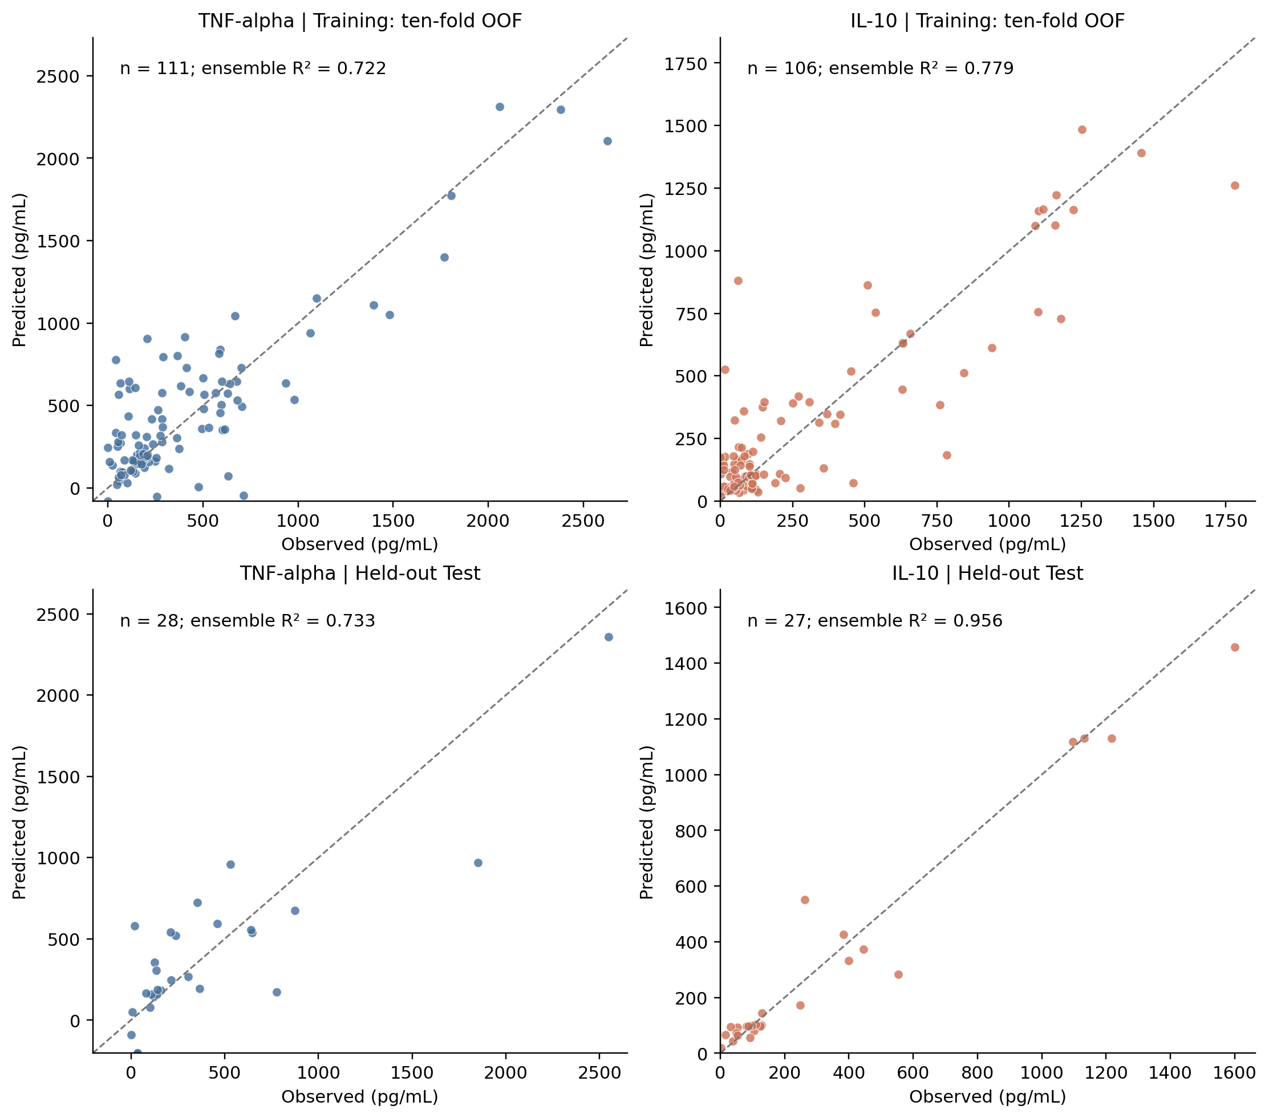
Figure S1. Measured versus predicted TNF-α (left) and IL-10 (right) concentrations. The upper row shows pooled ten-fold out-of-fold predictions; the lower row shows Test predictions from Training-only models. Each point is the mean of three predictions. The displayed R² is calculated from these mean predictions (ensemble R²), whereas Table S4c reports the mean and sample SD of the three individual R² values.
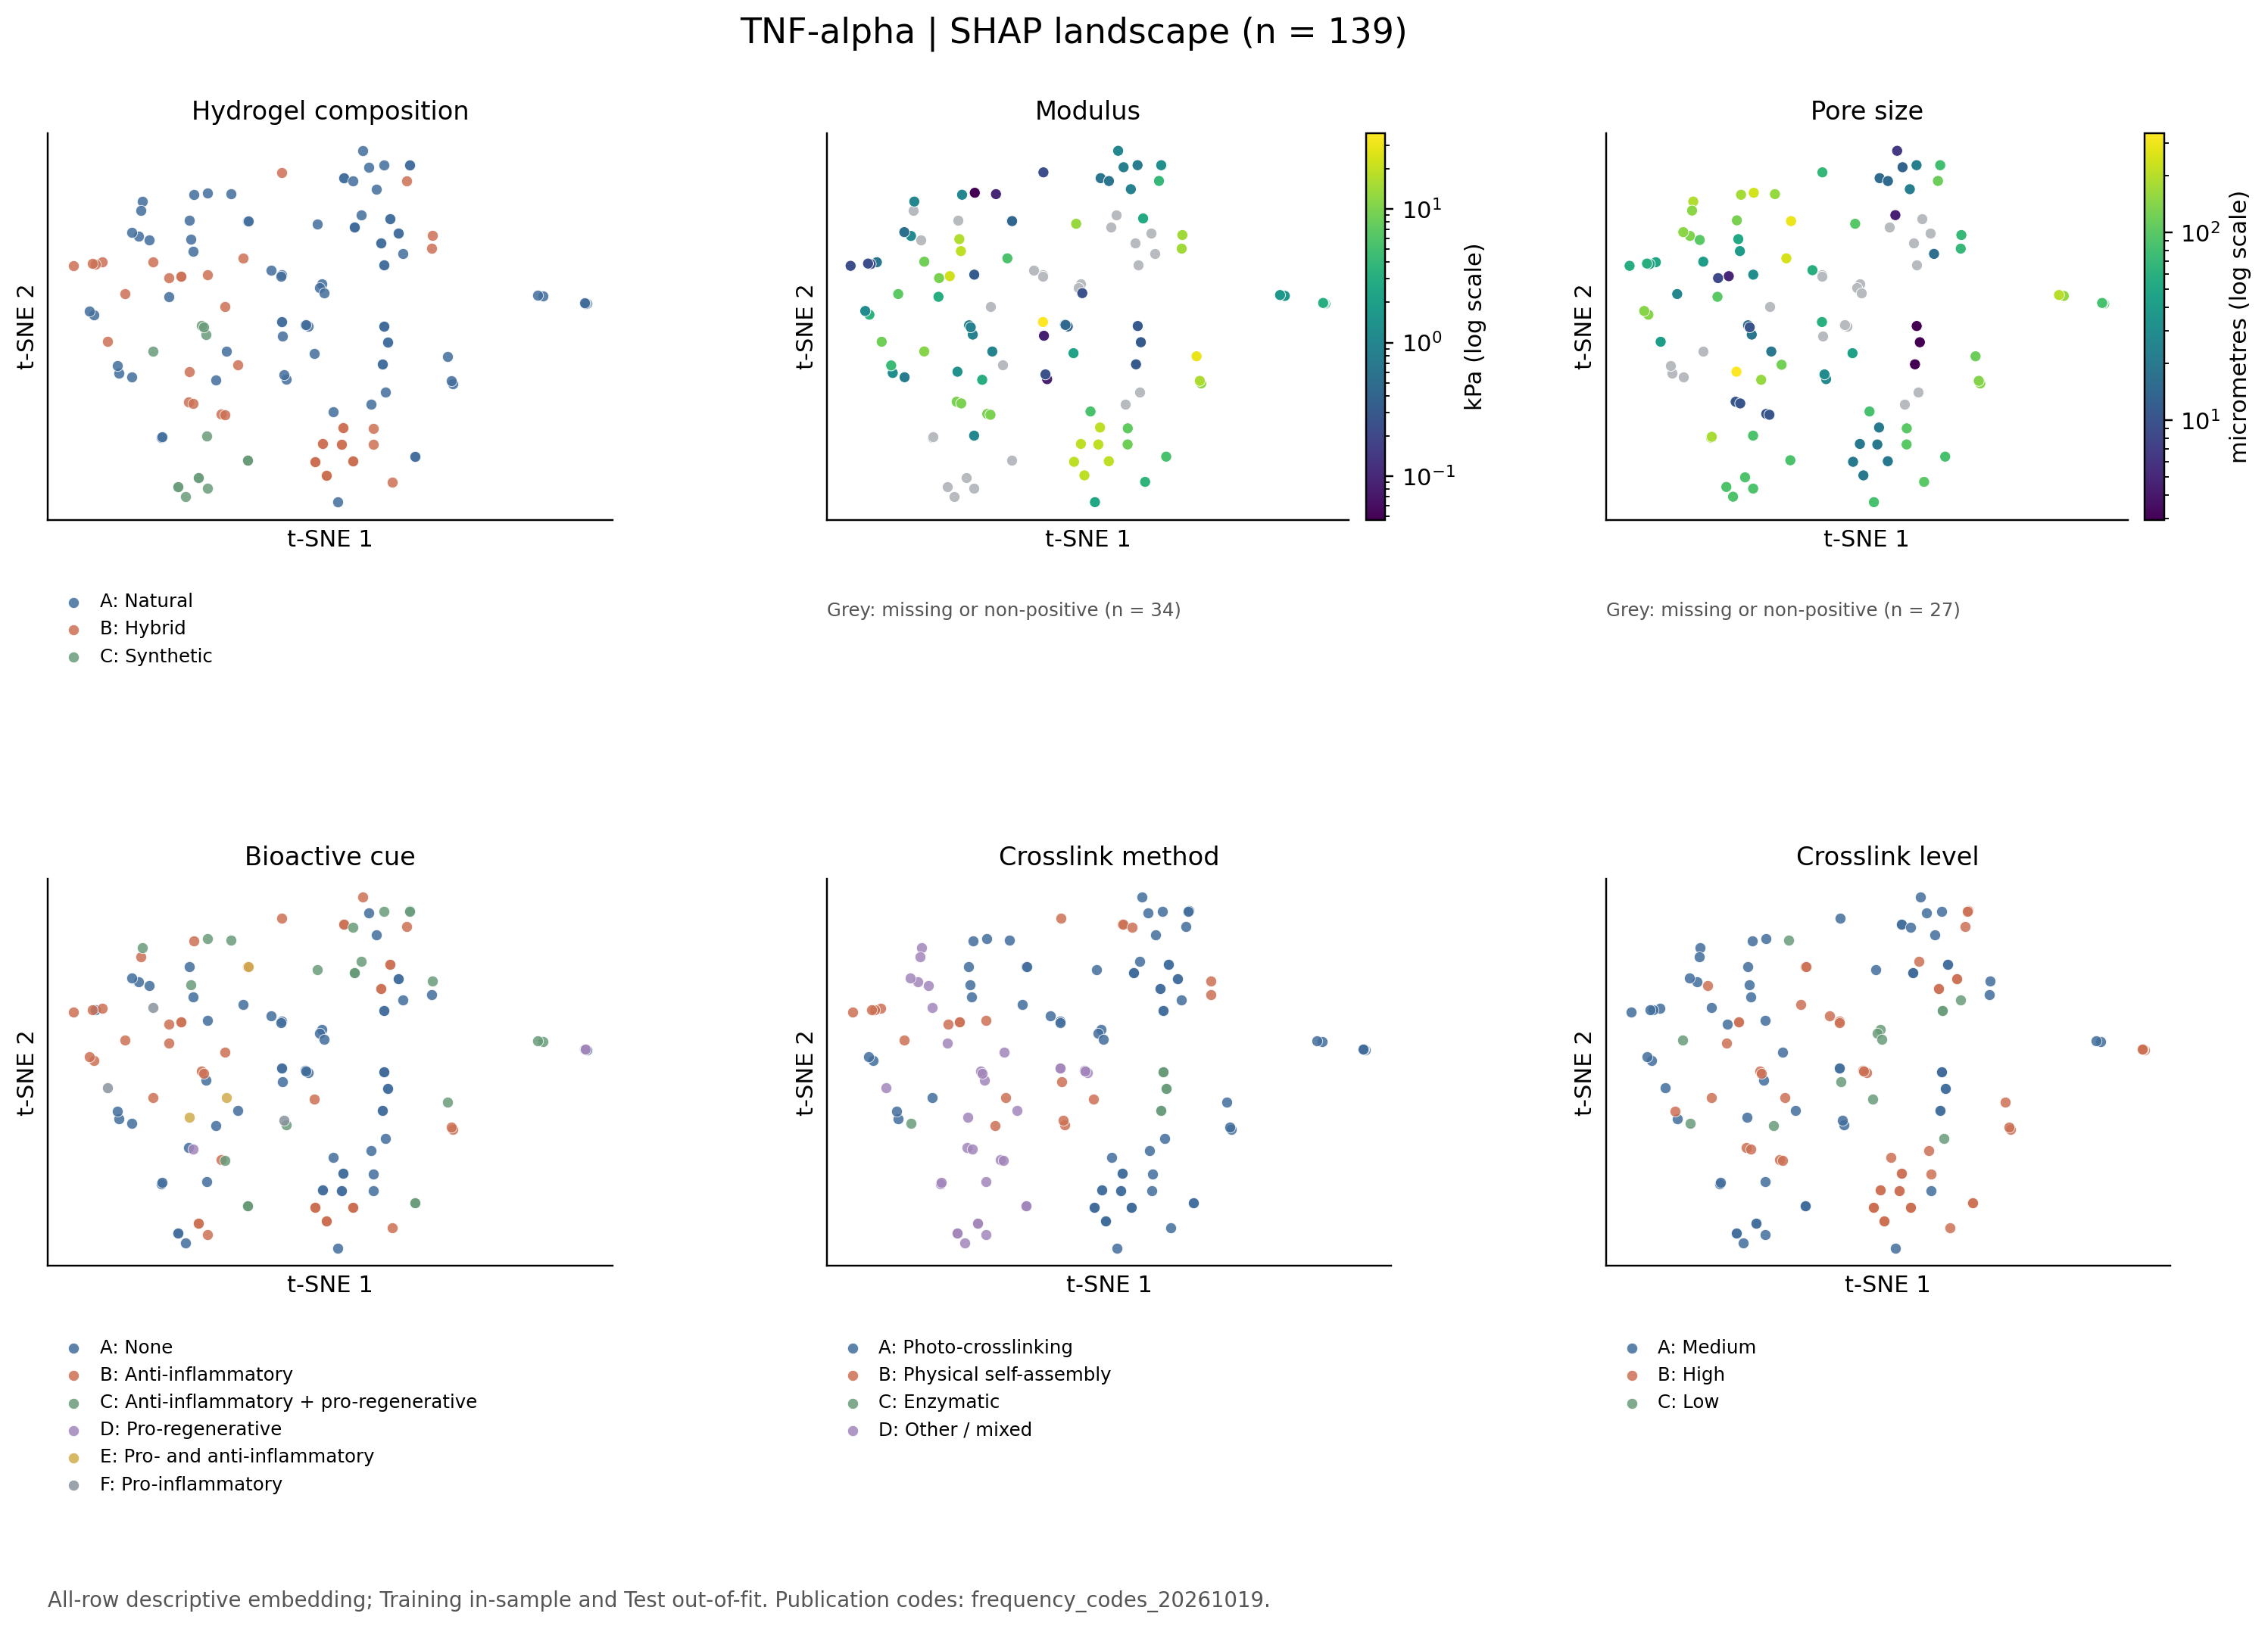
Figure S2. TNF-α SHAP landscapes coloured, from left to right and top to bottom, by hydrogel composition, modulus, pore size, bioactive cue, crosslink method and crosslink level. Ten-neighbour trustworthiness is 0.924. Numerical colour scales are logarithmic; grey denotes missing or non-positive values. The embedding uses all endpoint records and is descriptive; it is not an independent validation analysis.
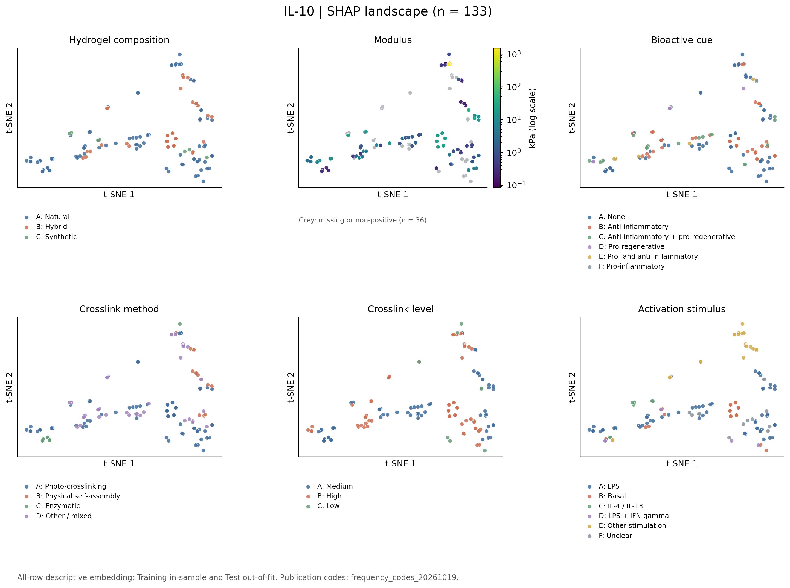
Figure S3. IL-10 SHAP landscapes coloured, from left to right and top to bottom, by hydrogel composition, modulus, bioactive cue, crosslink method, crosslink level and activation stimulus. Ten-neighbour trustworthiness is 0.980. Modulus uses a logarithmic colour scale; grey denotes missing or non-positive values. The embedding uses all endpoint records and is descriptive; it is not an independent validation analysis.
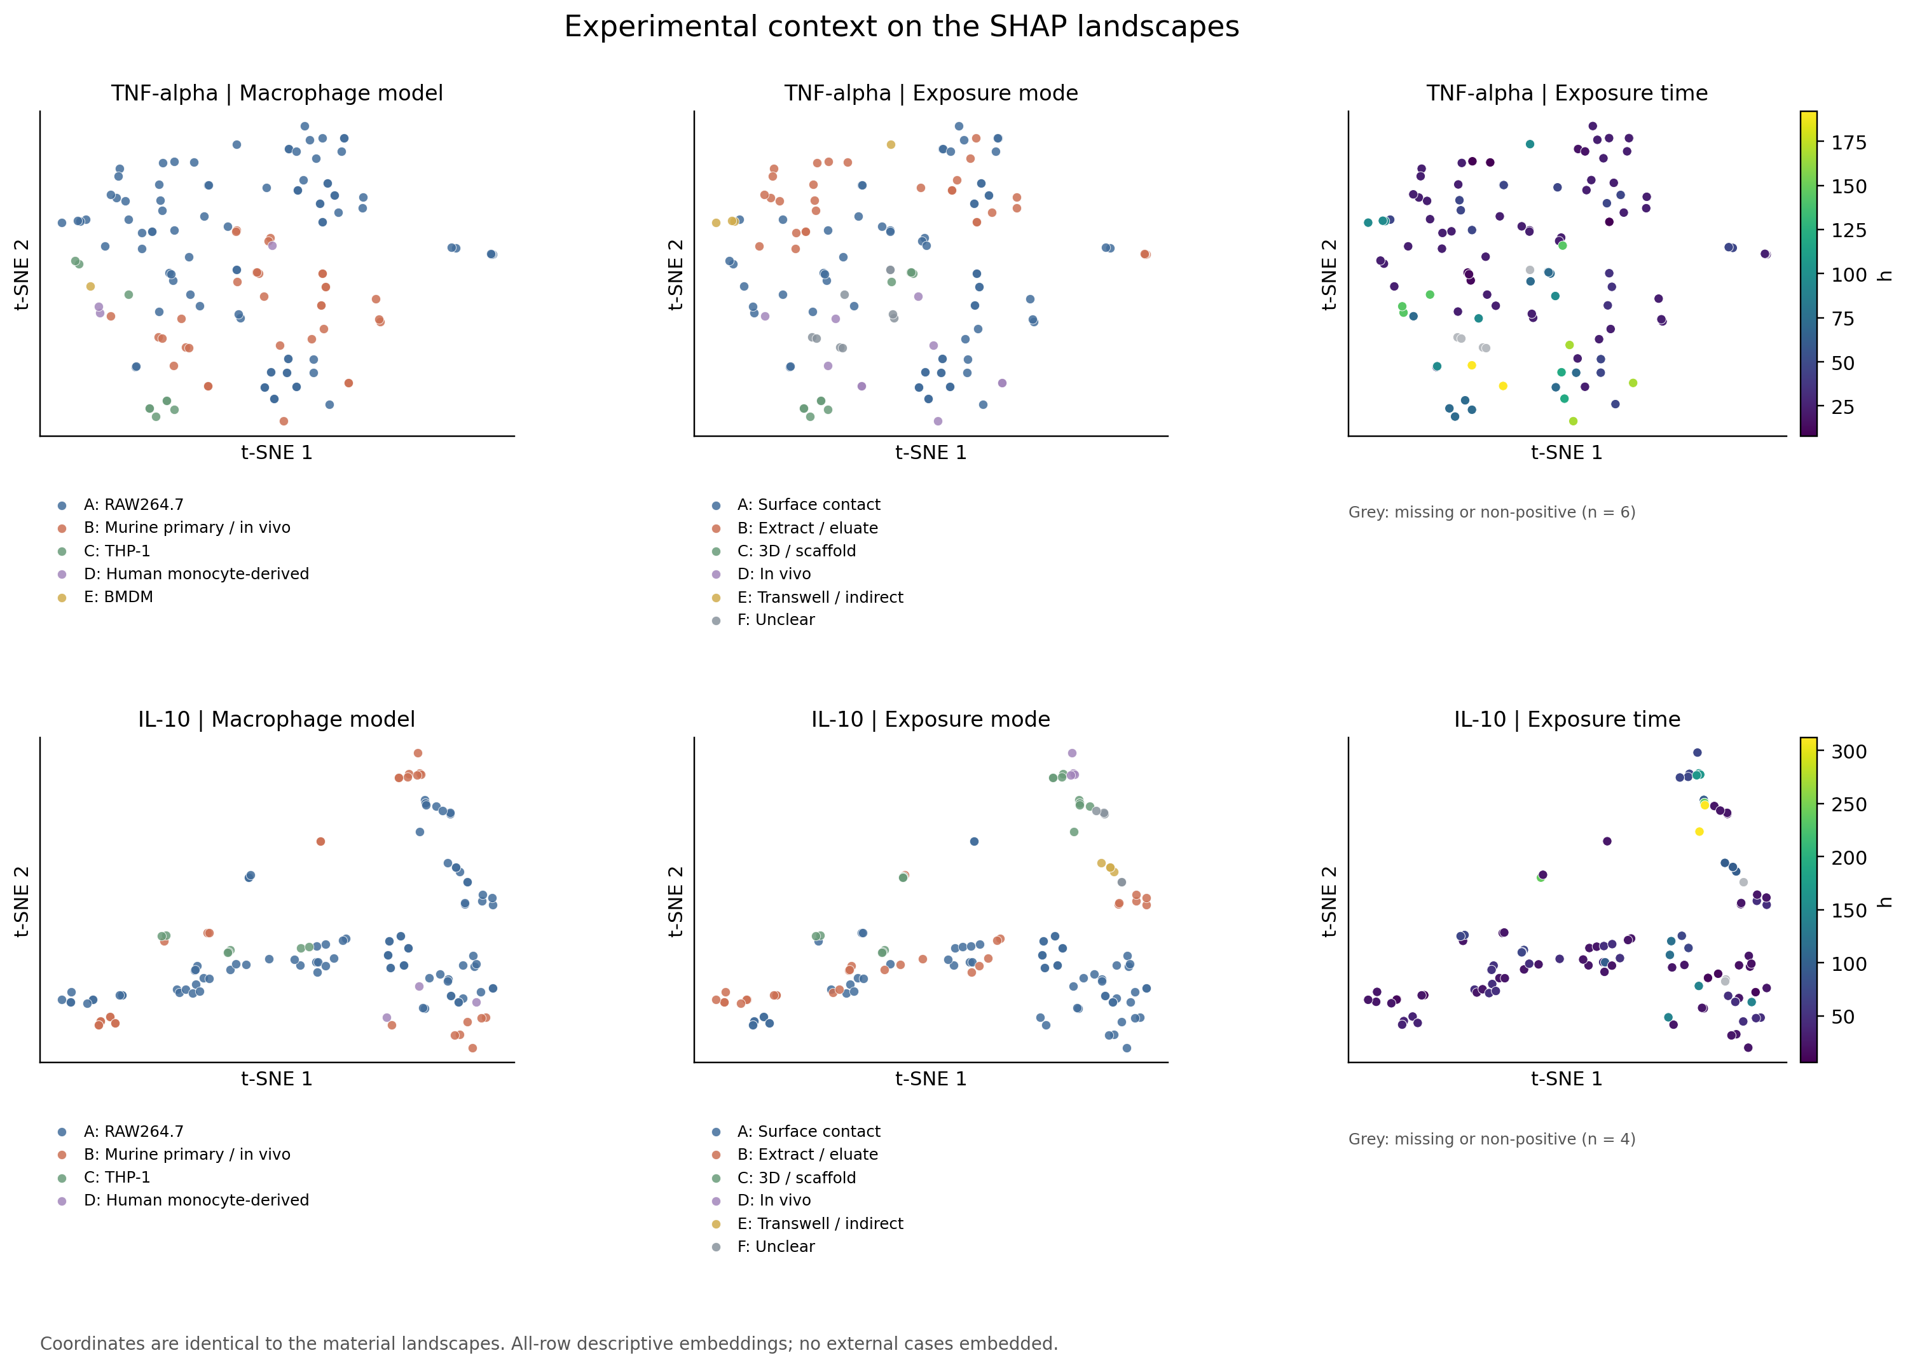
Figure S4. SHAP landscapes coloured by macrophage model, exposure mode and exposure time (h), from left to right. The upper row shows TNF-α and the lower row IL-10. Coordinates correspond to Figures S2–S3; missing exposure-time values are shown in grey.

