**Spiral**

advan + disadvan : risk assessment (unskilled risk assessors can push it back to evolutionary)

Not tied to n increments.

Source: <https://www.softwaretestinghelp.com/spiral-model-what-is-sdlc-spiral-model/>

Spiral model is a combination of sequential and prototype model. This model is best used for large projects which involves continuous enhancements. There are specific activities which are done in one iteration (spiral) where the output is a small prototype of the large software. The same activities are then repeated for all the spirals till the entire software is build.

4 phases:

1. Planning
2. Risk analysis
3. Engineering
4. Evaluation

Colour = each sprint

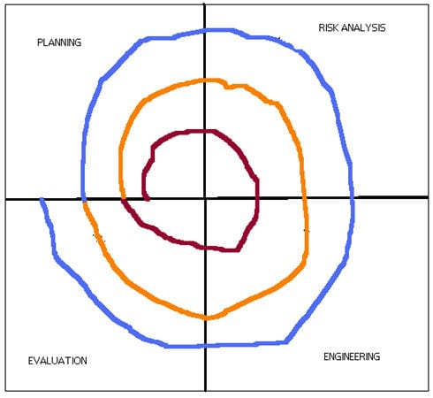

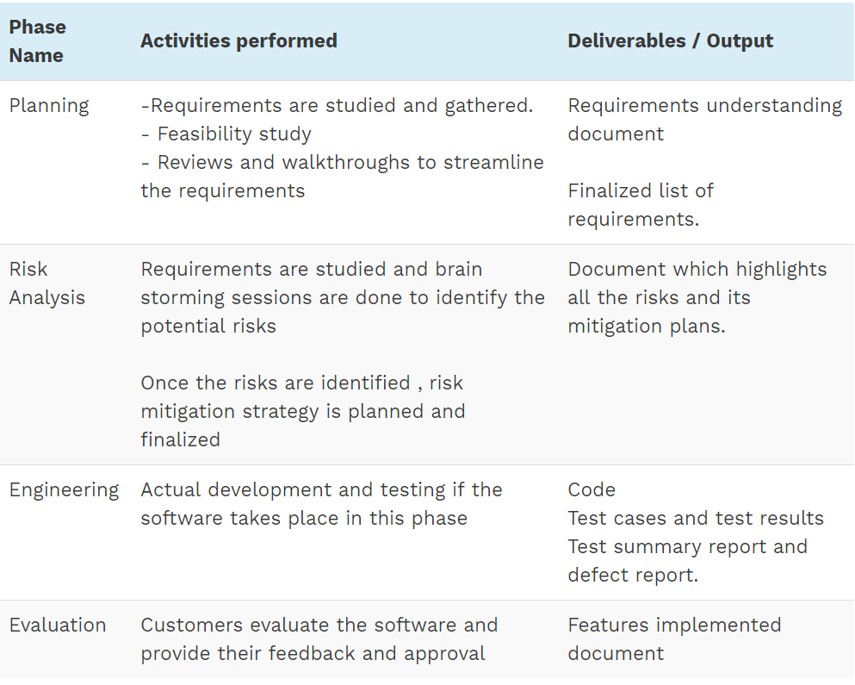

**Useful when:**

* When the project is large.
* Where the software needs continuous risk evaluation.
* Requirements are a bit complicated and require continuous clarification.
* Software requires significant changes.
* Where enough time frame is there to get end user feedback.
* Where releases are required to be frequent

**Advantages:**

* Development is fast
* Larger projects / software are created and handled in a strategic way
* Risk evaluation is proper.
* Control towards all the phases of development.
* More and more features are added in a systematic way.
* Software is produced early.
* Has room for customer feedback and the changes are implemented faster

**Disadvantages:**

* Risk analysis is important phase so requires expert people.
* Is not beneficial for smaller projects.
* Spiral may go infinitely.
* Documentation is more as it has intermediate phases.
* It is costly for smaller projects.