Howard University
College of Engineering and Architecture
Department of Electrical Engineering & Computer Science

Large Scale Programming
Fall 2024

Midterm Exam – Part I
October 17, 2024

Part I: 50 pts. (essay questions)

Instructions:
- Submit completed exam to your github repository under package org.howard.edu.lsp.midterm

Verify that the commit(s) completed successfully

- OPEN BOOK, OPEN NOTES. THERE IS NO COLLABORATION ON THIS EXAM
- Site any and ALL references for anything obtained off the internet.

MORAYO ADEYEMI
@03054141

Question 1. (10 pts.)

You are reviewing the following class in a Fitness Tracking System. The class is intended to manage various aspects of a user’s fitness activities.

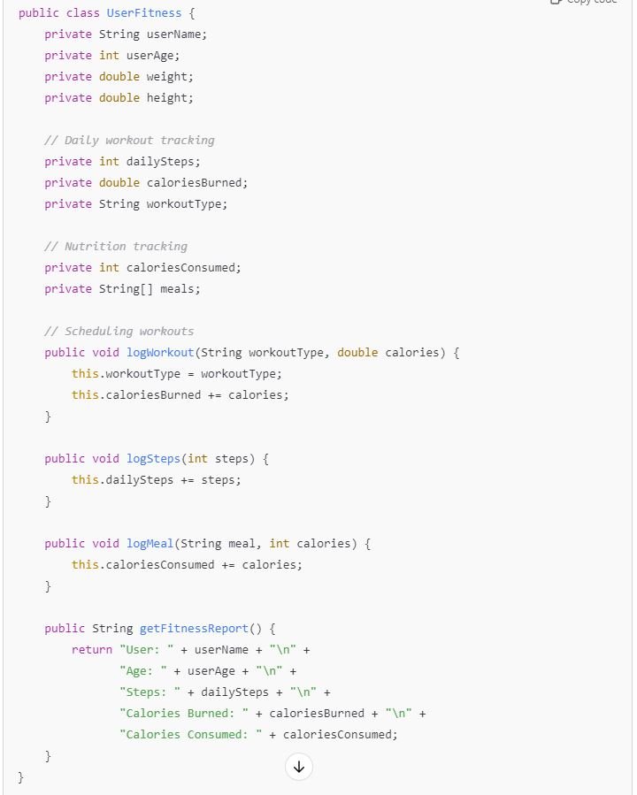

Tasks:
- Analyze the UserFitness class. Explain why this class has low cohesion. (5 pts.)
The UserFitness class has low cohesion because it is responsible for managing too many unrelated tasks. It handles logging workouts, logging steps, tracking meals, and generating fitness reports, all within a single class. Each of these tasks represents a distinct functionality, which means the class is not focused on a single responsibility. This reduces cohesion, as the class is trying to manage multiple aspects of fitness tracking that could be separated into more specific, focused classes.
- Describe, in general, how you would split the UserFitness class into more cohesive classes. Your answer should not be a complete design. (5 pts.)
I would split it by having each method pretty much be its own class logging steps could require a lot more information such as where you’re going maybe the distance of the steps you were going it could be its own class. Logging into could be the type of meal as well as the calories and other facts that you would want to get from the meals so all these classes, each of the methods are currently the class on methods that would like to consume over the whole day then there would be method things like fitness track fitness so I believe that should be its own class and that should lead to more cohesive classes.

Question 2. (5 pts.)
Given the following, answer the below questions.

A university manages its students using a program that has a class Student with subclasses FirstYear, SecondYear, and ThirdYear for year-specific state and behaviors. The program has a List that contains all Students.

Should Student be a class, an abstract class or an interface? Explain your answer

Student should be an abstract class because all students share common responsibilities, such as having a name, student ID, start year, and graduation year. These are instance variables that can be shared between the subclasses, and this is best achieved through abstraction. An abstract class allows for these shared properties to be defined in one place, while also letting each subclass ->> FirstYear, SecondYear, ThirdYear to implement specific behaviors.

- At the end of each year, the third-year students graduate and must be removed. This is done by passing the list to the following method:

void removeThirdYears(List<Students> students) {
for (Student student : students) {
try {
ThirdYear = (ThirdYear) student;
students.remove(thirdyear);
}
}
}

Why is the above method flawed? Hint: Another Arthur Riel heuristic (5 pts.)
The method is flawed because you should not modify a list (or array) while iterating through it. This can cause issues with the iteration process, as removing elements while looping can change the size of the list, which leads to a error because the program will still try to access the data that was in students, but was recently deleted. Also, this method violates the heuristic "H5.2: Derived classes must have knowledge of their base classes by definition, but base classes should not know anything about their derived classes." This is violated because the Student class should not need to know about the specific behaviors or methods of its subclass ThirdYear. By casting Student whichc is the superclass into ThirdYear, you are making the base class aware of its derived class, which goes against this principle. Also, the student class should not know anything so when you do end up removing ThirdYear (it’s lower case so the varible doesn’t exist..) “ThirdYear” isn’t in the students list bcuase students are full of Students.

Question 3. (5 pts.)
Given the following, answer the below questions.

public class BankAccount {
public String accountHolderName;
public String accountNumber;
public double balance;
public double interestRate;

public BankAccount(
String accountHolderName,
String accountNumber,
double initialDeposit,
double interestRate) {
this.accountHolderName = accountHolderName;
this.accountNumber = accountNumber;
this.balance = initialDeposit;
this.interestRate = interestRate;
}

// Exposed implementation for adding interest
public void addInterest() {
double interest = balance * (interestRate / 100);
balance += interest;
}

// Exposed implementation for deposits
public void deposit(double amount) {
balance += amount;
}

// Exposed implementation for withdrawals
public void withdraw(double amount) {
balance -= amount;
}
}

- Is BankAccount well-encapsulated? Why or why not? If so, describe what changes you would make to the class. Otherwise, state nothing. (5 pts.)

I don’t see any encapsulation because there is not one single private instance variable. No, the BankAccount class is not well-encapsulated because none of the instance variables accountHolderName, accountNumber, balance, or interestRate are declared as private. Encapsulation is about restricting direct access to an object's internal state, which is not happening here since all fields are public. To add encapsulation, you should make the accountHolderName, accountNumber, balance, and interestRate variables private. This would prevent external code from directly changing the variables. Because we’re making those instant variables privates, it would need more method so that you can actually access the information.

Question 4. (10 pts.)
Given the following, answer the below questions.

Given:
A car manufacturer uses Java software to track current vehicles being built. The UML diagram below shows an excerpt of the current software structure. You should assume the presence of other appropriate fields and methods

Car
getTrimLevel()
Engine
accelerate()
getFuelLevel()
Base
Sports
Luxury
Electric
Petrol

Each car can be built to one of three trim levels: Base, Luxury or Sport. They can also be configured with an electric or petrol engine. At various points in the manufacturing process the customer can choose to change the trim level.

Task:
- Explain in detail why the current structure does not support this. (5 pts.)

The structure does not support this because changing the trim level is only in the car class so you would only need to be either the car or one of it sub classes to be able to access that getTrimLevel method. So if an electric or pedal engine, wanted to get the trim levels, it would not be able to do so directly because the engine is not in the same hierarchy.

- Describe how to refactor the structure to allow trim-level change for a car to dynamically change. Hint: How would you modify Car to use composition to solve the problem? (5 pts.)

You can dynamically change the trim level of a car by using composition, which allows objects to contain other objects without relying on inheritance. In this case, instead of using inheritance to create separate subclasses for each trim level (Base, Sport, Luxury), you can use composition by adding a trimLevel attribute within the Car class. This allows you to modify the trimLevel dynamically through a setter method like setTrimLevel(), enabling the trim to change without recreating the object. Composition is a better solution than inheritance because it avoids a rigid class hierarchy and allows the car to hold different attributes (like engine and trim level) independently. In this design, the Car class can have an Engine object (either Electric or Petrol) and still allow the trim level to change dynamically without needing to create separate subclasses for each trim and engine combination.

Question 5. (5 pts.)
Suppose you are about to code a particular class and find that you have written another class with nearly the functionality that you now are developing. This means that the two classes in large parts contain the same code, but in smaller parts have different code. Explain in detail why this may be a problem and how to solve it. Give your answer in terms of Arthur Riel’s design heuristics.
If two classes have the same code that means that you’re just making it harder to edit things along the way if there’s two things that are trying to do the same exact thing. This violets “Heuristic 2.8: A class should capture one and only one key abstraction.” This violates it because technically there is two classes that have one key abstraction, which can get really messy when you’re trying to actually edit the code later because we talked about in class how if your software engineer you’re not the only one that’s working on the code, other people are working on it so you wanted it to be very easyly read by others. Some fixes are that you could try to use inheritance to have like a class that is a super class, and the two classes that are similar could be subclasses and have their own unique methods.

Question 6. (5 pts.)
Suppose we need to store instances of the classes Car and BankAccount in a database. To obtain low coupling it may seem as if the functionality to save an instance should be in precisely those classes, since they have the information that shall be saved. Why is it unwise to place the database calls there?
It’s not wise to put a database call in there because it makes it harder for you to make changes inside of the classes after you added to a database and it makes it dependent on the user rather than it being dependent on its own public interface. It also goes against the principle of low coupling because technically then you are really attached to that database, and it makes everything so much harder when it comes to actually accessing and using the database for the Car and BankAccount classes.

Question 7. (5 pts.)
Given a set of requirements, what conditions must be met to make it appropriate to create a new class hierarchy using inheritance? Neither superclass nor subclass exist before, the question is about designing a new class hierarchy.
To have a class be in hierarchy it’s very important for it to have someone of similar methods which are its behaviors. If it has similar behaviors then you should probably have it as a superclass and the behaviors are different should be in the sub classes. Also, if there is a “ is a “ type of relationship between the classes then you should definitely have some hierarchy. I always think of it like if a cat was a subclass of an animal because a cat is an animal. In the presentations, there was like an example where the animal class can have a sound behavior where animals make some type of sound. But a cat would make a specific cat sound and that would use inheritance. But it’s just really important to make sure that you use a higher key. There are similarities between the classes, but they have their key diffrences.

Question 8. (2.5 pts.)
Describe the difference between inheritance and composition why would you choose one over the other.

Inheritance uses "is-a" relationship and it has subclasses thatinherits properties and behaviors from its superclass. It’s used when a class is a specialized version of another class. Also menaing that the super class has methods that the sub classes would automatically need but the sub classes can have more methods that the super doesn’t. You you inhertictance when there is a clear hiercay in the classes. Composition uses a "has-a" relationship, where one class contains an instance of another class. So instead of internating you just make an object of the anoytehr class so youc an access it methods. Compositon is better for when class aren’t in the same tree family but you need some attruvete from it.
**taken from your presenatation

Question 9. (2.5 pts.)
Explain the meaning of cohesion and describe whether low or high cohesion is better.

Cohesion is how much the class is specified to a single task. High cohesion is the better one because that would mean that the class is very specified on the test that is supposed to do so meaning the methods in it are very much related. Wow glow cohesion are meth classes that do no, have a single reason to be there. It has so many different things going on in it that the method are all over the place.

