# Activity Screenshots

## Part 1

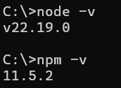

NodeJS and NPM versions, displayed in the Windows terminal.



Running the NodeJS application in the Visual Studio Code terminal.

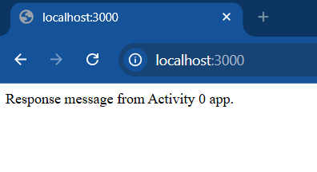

The Express application’s response, as seen in the browser.

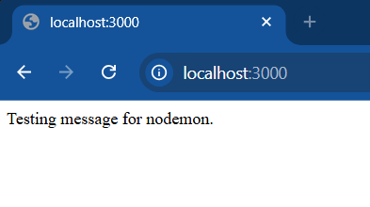

The changed response string displayed in the browser after nodemon restarted the application.

## Part 2

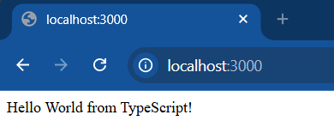

The TypeScript application running, with the server response as seen in the browser.

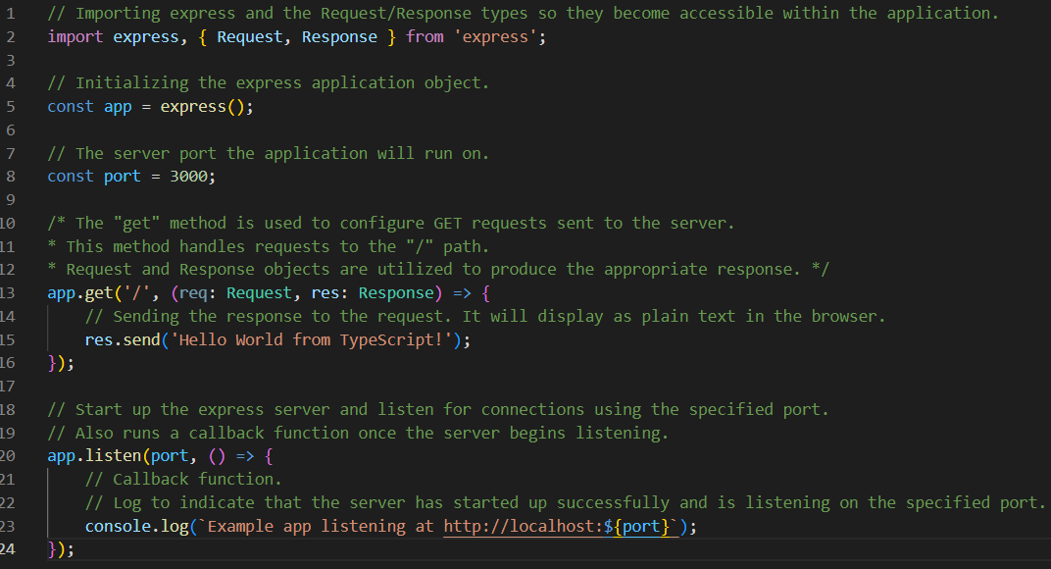

The commented TypeScript code.