How to usefully utilize memory and storage keywords in solidity

In Solidity, two keywords are sometimes cause of missunderstandigns, but, well understood, they can be very usefull. Those keywords are memory and storage. I arrive to this lesson when i was dealing with some linter warning. I will simplify the code i was working on, to reproduce the warning. It was something like:

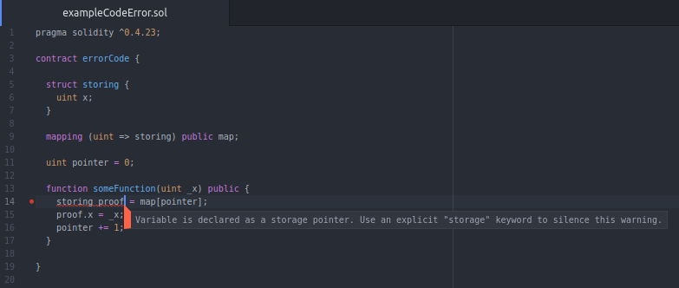
To quickly solve it, i simply follow the instructions in the warning and add “storage” keword to the proof variable initialization, as follows:

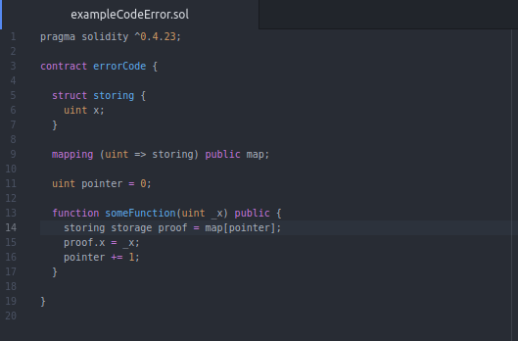
The warning disapaears, so i go on with my work.

Later, i was triying to finnally undertand the difference between storage and memory. I faced with the FAQ of solidity docs. So, to put and abstract of this, There are three ways to store info in the EVM:
- Storage: Is where all the contract state variables reside. Every contract has its own storage and it is persistent between function calls and quite expensive to use.
- Memory: this is used to hold temporary values. It is erased between (external) function calls and is cheaper to use.
- Stack: is used to hold small local variables. It is almost free to use, but can only hold a limited amount of values.

Then i faced with this post, which proposses two ways to solve my original problem. So i went back to my original problem. Was my initial solution to avoid the warning the best?

