電通二乙微處理器實驗 實驗結報

實驗名稱 | LAB-02
組別 |  | 組員 | 賴冠宇

- 實驗目的
LinkIt 7697 D1 – D8 分別接到 LED，實作跑馬燈展示。
- 實驗步驟
LED 向左及向右執行花色展示 2. 執行自定花色展示: 所有LED亮滅兩次 -> 左移八次 -> 所有LED亮滅兩次 -> 右移八次
- 程式碼
const byte LEDs[] = {2,3,4,5,6,7,10,9};
const byte total = sizeof(LEDs);
byte index = 0;
void setup()
{
for (byte i=0;i<total;i++)
{
pinMode(LEDs[i], OUTPUT);
}
}
void loop()
{
for(byte i=0;i<total;i++)
{
digitalWrite(LEDs[i], HIGH);
delay (500);
digitalWrite(LEDs[i], LOW);
}
for(byte i=total-1;i>=0;i--)
{
digitalWrite(LEDs[i], HIGH);
delay (500);
digitalWrite(LEDs[i], LOW);
}
}

const byte LEDs[] = {2,3,4,5,6,7,10,9};
const byte total = sizeof(LEDs);
byte index = 0;
void setup()
{
for (byte i=0;i<total;i++)
{
pinMode(LEDs[i], OUTPUT);
}
}
void loop()
{

for(byte i=0;i<2;i++)
{
digitalWrite(LEDs[0], HIGH);
digitalWrite(LEDs[1], HIGH);
digitalWrite(LEDs[2], HIGH);
digitalWrite(LEDs[3], HIGH);
digitalWrite(LEDs[4], HIGH);
digitalWrite(LEDs[5], HIGH);
digitalWrite(LEDs[6], HIGH);
digitalWrite(LEDs[7], HIGH);
digitalWrite(LEDs[0], LOW);
digitalWrite(LEDs[1], LOW);
digitalWrite(LEDs[2], LOW);
digitalWrite(LEDs[3], LOW);
digitalWrite(LEDs[4], LOW);
digitalWrite(LEDs[5], LOW);
digitalWrite(LEDs[6], LOW);
digitalWrite(LEDs[7], LOW);
delay(500);
}
for(byte a=0;a<8;a++)
{
for(byte b=0;b<total;b++)
{
digitalWrite(LEDs[b], HIGH);
delay (100);
digitalWrite(LEDs[b], LOW);
}
}
for(byte i=0;i<2;i++)
{
digitalWrite(LEDs[0], HIGH);
digitalWrite(LEDs[1], HIGH);
digitalWrite(LEDs[2], HIGH);
digitalWrite(LEDs[3], HIGH);
digitalWrite(LEDs[4], HIGH);
digitalWrite(LEDs[5], HIGH);
digitalWrite(LEDs[6], HIGH);
digitalWrite(LEDs[7], HIGH);
digitalWrite(LEDs[0], LOW);
digitalWrite(LEDs[1], LOW);
digitalWrite(LEDs[2], LOW);
digitalWrite(LEDs[3], LOW);
digitalWrite(LEDs[4], LOW);
digitalWrite(LEDs[5], LOW);
digitalWrite(LEDs[6], LOW);
digitalWrite(LEDs[7], LOW);
delay(500);
}
for(int c=0;c<8;c++)
{
for(int i=7;i>=0;i--)
{
digitalWrite(LEDs[i], HIGH);
delay (100);
digitalWrite(LEDs[i], LOW);
}
}

}

const byte leds[]={10,11,12,13,14,15,16,17};
const byte NUM=sizeof(leds);
int i;
int count;
int t;
void setup()
{
for(int i=0;i<NUM;i++)
{
pinMode(leds[i],OUTPUT);

}
pinMode(6,INPUT);
}

void loop()
{
t = digitalRead(6);
if( t== HIGH)
{
for(i=0;i<NUM;i++)
{
digitalWrite(leds[i],HIGH);
delay(100);
digitalWrite(leds[i],LOW);
}
for(i=NUM-1;i>=0;i--)
{
digitalWrite(leds[i],HIGH);
delay(100);
digitalWrite(leds[i],LOW);
}

}
else
{
for(i=0;i<2;i++)
{
digitalWrite(10,HIGH);
digitalWrite(11,HIGH);
digitalWrite(12,HIGH);
digitalWrite(13,HIGH);
digitalWrite(14,HIGH);
digitalWrite(15,HIGH);
digitalWrite(16,HIGH);
digitalWrite(17,HIGH);
delay(400);
digitalWrite(10,LOW);
digitalWrite(11,LOW);
digitalWrite(12,LOW);
digitalWrite(13,LOW);
digitalWrite(14,LOW);
digitalWrite(15,LOW);
digitalWrite(16,LOW);
digitalWrite(17,LOW);
delay(400);
}
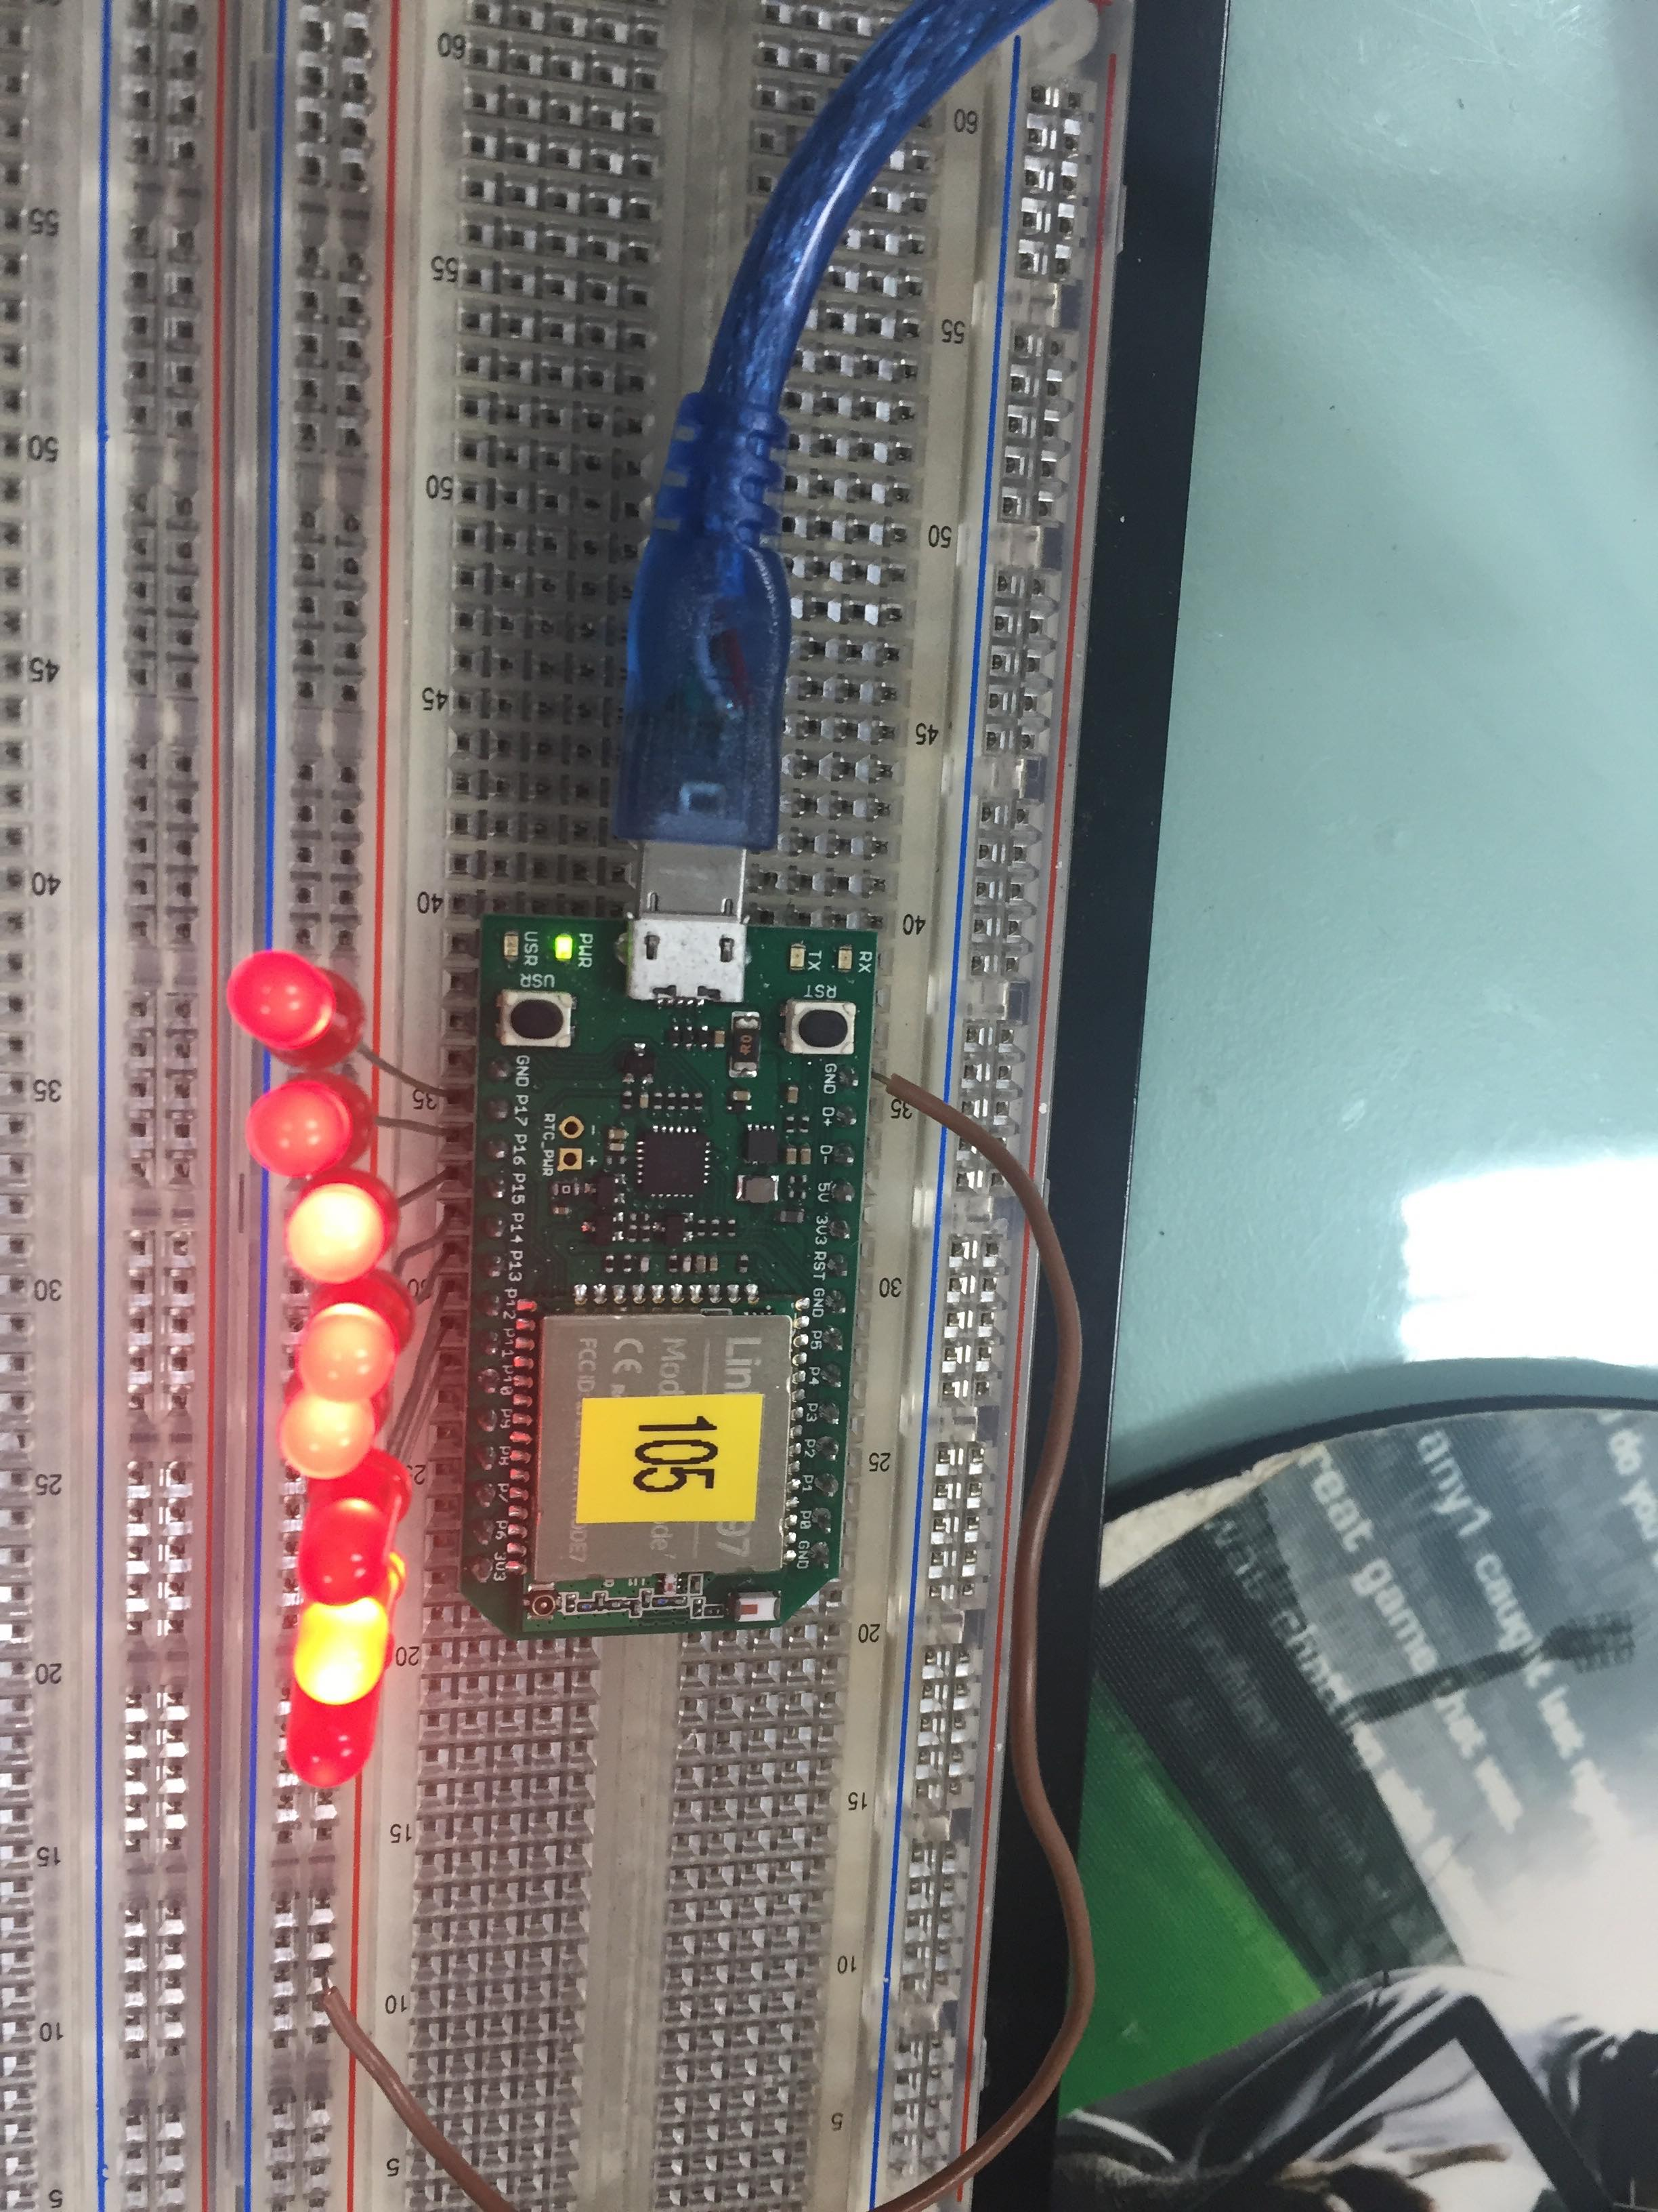
}
}

- 實驗結果及分析
原來DELAY這麼重要，多了DELAY燈就會亮了

- 心得討論
這次有些地方想了很久，原來差一點小東西就差這麼多。
- 修正電路圖
- 修正程式碼

