week3_2.R

danie

2021-06-24

library(readr)  
library(readxl)  
library(dplyr)

##   
## Attaching package: 'dplyr'

## The following objects are masked from 'package:stats':  
##   
## filter, lag

## The following objects are masked from 'package:base':  
##   
## intersect, setdiff, setequal, union

library(tidyr)  
library(ggplot2)  
library(Hmisc)

## Loading required package: lattice

## Loading required package: survival

## Loading required package: Formula

##   
## Attaching package: 'Hmisc'

## The following objects are masked from 'package:dplyr':  
##   
## src, summarize

## The following objects are masked from 'package:base':  
##   
## format.pval, units

library(PerformanceAnalytics)

## Loading required package: xts

## Loading required package: zoo

##   
## Attaching package: 'zoo'

## The following objects are masked from 'package:base':  
##   
## as.Date, as.Date.numeric

##   
## Attaching package: 'xts'

## The following objects are masked from 'package:dplyr':  
##   
## first, last

##   
## Attaching package: 'PerformanceAnalytics'

## The following object is masked from 'package:graphics':  
##   
## legend

library(treemap)  
library(areaplot)  
  
unemployment <- read_csv("C:/Users/danie/OneDrive/DSC-640/week3_4/unemployement-rate-1948-2010.csv")

##   
## -- Column specification --------------------------------------------------------  
## cols(  
## `Series id` = col_character(),  
## Year = col_double(),  
## Period = col_character(),  
## Value = col_double()  
## )

us_postage <- read_excel("C:/Users/danie/OneDrive/DSC-640/week3_4/us-postage.xlsm")  
world_population <- read_excel("C:/Users/danie/OneDrive/DSC-640/week3_4/world-population.xlsm")  
  
# Label for tree map  
us_postage["label"] <- paste(us_postage$Year, ":", us_postage$Price)  
us_postage["label"]

## # A tibble: 10 x 1  
## label   
## <chr>   
## 1 1991 : 0.29  
## 2 1995 : 0.32  
## 3 1999 : 0.33  
## 4 2001 : 0.34  
## 5 2002 : 0.37  
## 6 2006 : 0.39  
## 7 2007 : 0.41  
## 8 2008 : 0.42  
## 9 2009 : 0.44  
## 10 2010 : 0.44

us_postage

## # A tibble: 10 x 3  
## Year Price label   
## <dbl> <dbl> <chr>   
## 1 1991 0.29 1991 : 0.29  
## 2 1995 0.32 1995 : 0.32  
## 3 1999 0.33 1999 : 0.33  
## 4 2001 0.34 2001 : 0.34  
## 5 2002 0.37 2002 : 0.37  
## 6 2006 0.39 2006 : 0.39  
## 7 2007 0.41 2007 : 0.41  
## 8 2008 0.42 2008 : 0.42  
## 9 2009 0.44 2009 : 0.44  
## 10 2010 0.44 2010 : 0.44

# Creating Tree Map  
treemap(us_postage,index = c("label") ,vSize ="Price",title = "Price vs Year")

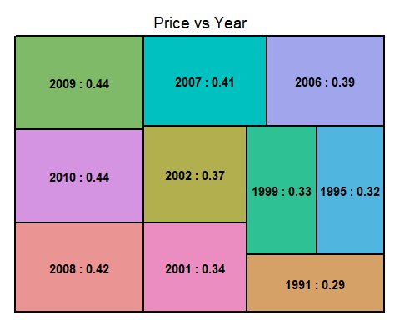

# create area map  
ggplot(world_population, aes(x=Year, y=Population))+geom_area(fill='#F9c19918',alpha=2)

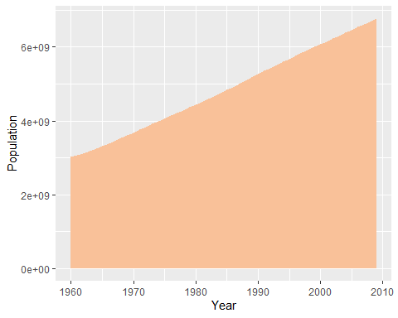

# Stacked area chart  
ggplot(unemployment, aes(x=Year, y=Value, fill=Period )) +   
 geom_area()

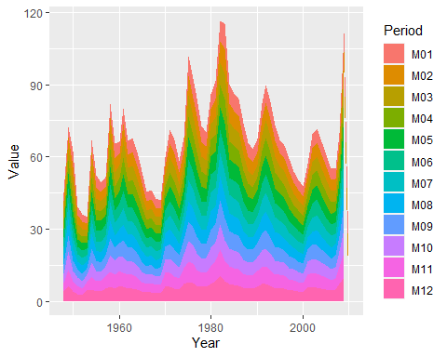

# Step Chart  
ggplot(unemployment, aes(Year,Value)) + geom_step() + #Ploting  
 scale_y_continuous(name= "Year") +  
 scale_x_continuous(name= "Value")

