Planes

Travel Fast and Safe

 

Planes are safer than car!

The accidents data prove the safety record.

One Year in a car is deadlier than more than 20 years of flying!

Both planes and cars accidents are decreasing at a linear rate.

Just in North Carolina, accidents are in the thousands in one year!

The bottom chart shows DMV data of car crash in a major city.

Accidents of cars are exponentially bigger than plane accidents.

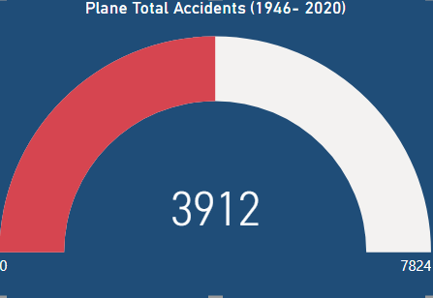 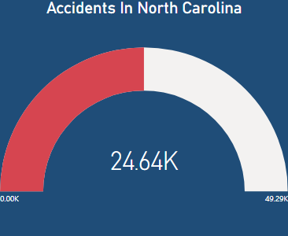

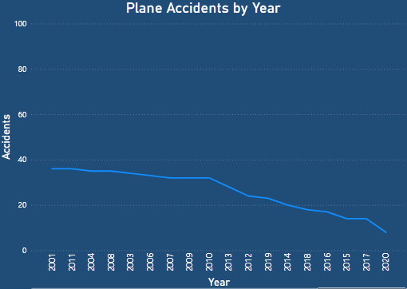 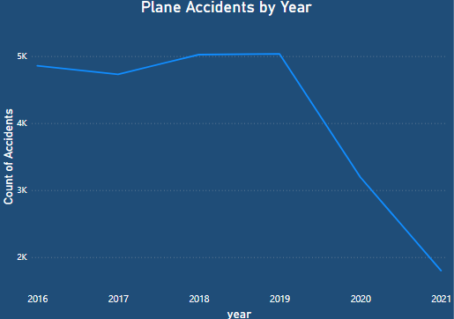

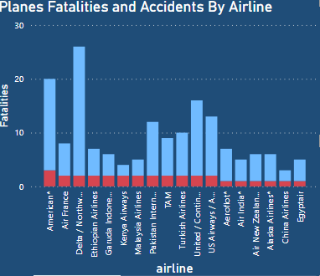 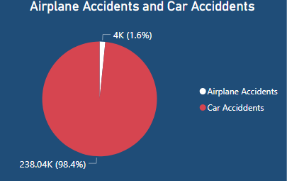 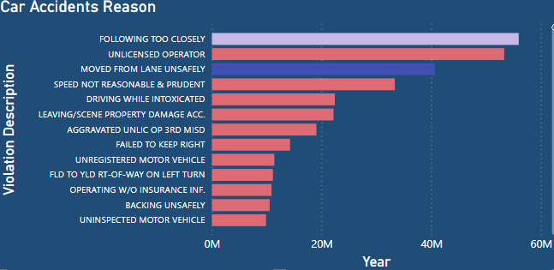

 #1F4D78 