Team Members: Ted Paulsen and Daniel Machlab

Professor Beichel

Embedded Systems

Lab 2 Report

1. **Introduction**

The goal of this lab was to create a counter that could count up, count down, and reset. The number increment or decrement on the counter is to be activated by a pushbutton press of less than one second. Change of modes—increment or decrement mode—is to be activated by a pushbutton press between one and two seconds. A counter reset to zero is to be activated by a pushbutton press of more than two seconds.

1. **Schematic**

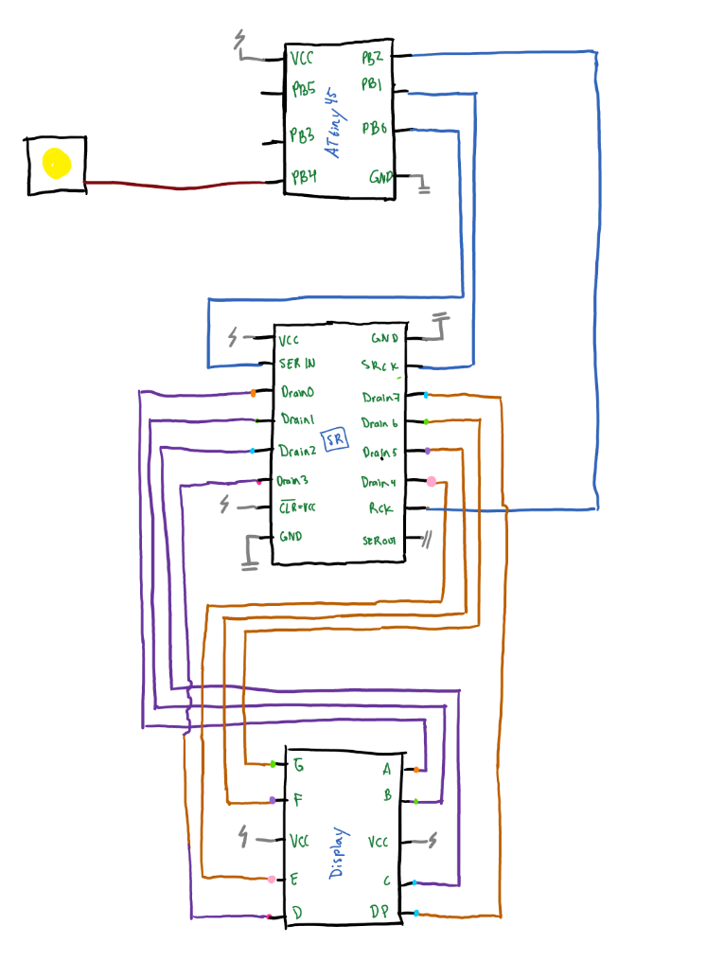

Figure 1: Circuit as implemented

Figure 1 shows the circuit design as it was implemented. PB0, PB1, and PB2 are all configured as outputs for SER_IN, SRCK, and RCK respectively. PB4 is configured as in input from the pushbutton. When the pushbutton is pressed, the voltage transitions to low.

1. **Discussion**

…

Our project consisted of two basic design phases: hardware and software. First, we worked on hardware. Using out class notes as reference we were able to successfully implement hardware debouncing, wire the correct shift register pins the ATtiny, and connect the display to the shift register (Fig. 1). Second we began working on software—the more difficult part of the project because neither of us have experience with assembly.

1. **Conclusion**

From this lab we have really learned the basics of assembly. At the beginning of the lab, we started with hardware. Initially we had no clue were to start with wiring our breadboard, but after a short time we were able to figure out what direction we needed to go in. Eventually we fully understood what was going on and finished the wiring. This same story happened with software. Initially were clueless, but slowly we progressed and learned more until the lab was finished. Now, we both have a firm understanding of both hardware and software used in the lab.