Lab 3 Report

Embedded Systems

Daniel Machlab, Ted Paulsen

03/02/2018

**Introduction**

The goal of this lab was to use a rotary pulse generator RPG and an ATTiny45 microcontroller to provide a way to change the duty cycle of a 3.9 kHz square wave. We used timer routines to generate delays based upon user input from the RPG.

**Schematic**

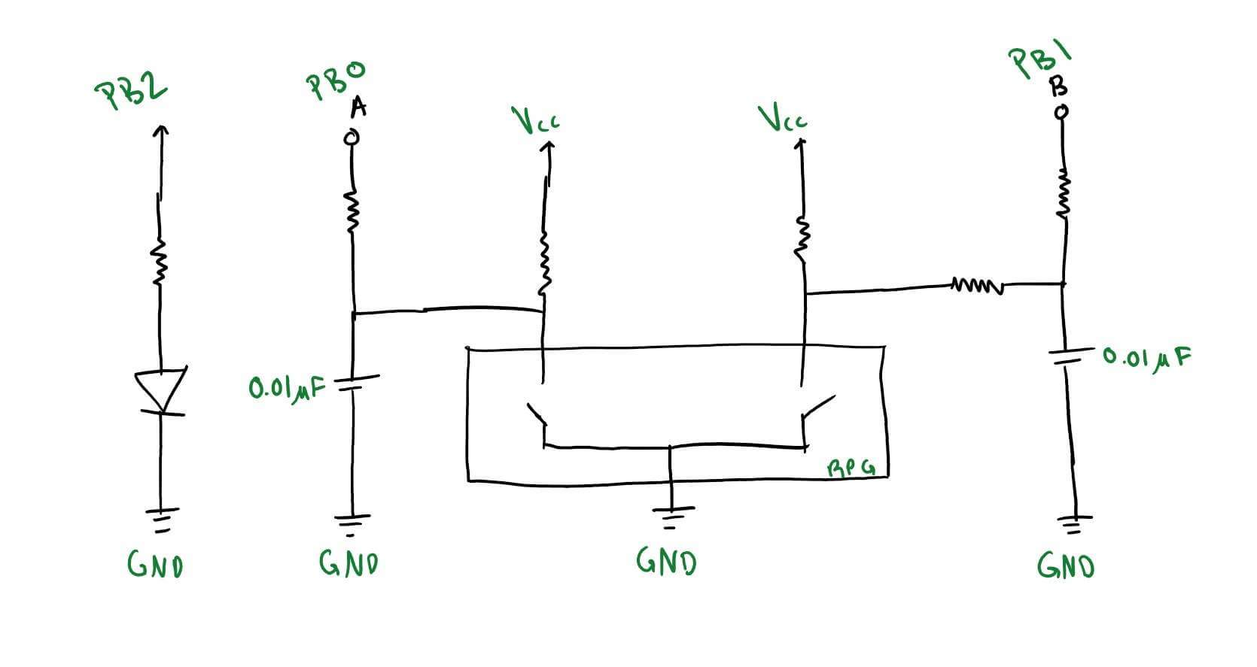

*Figure 1: Wiring schematic showing RPG connections to the microcontroller and output from microcontroller (PB2).*

Figure 1 above shows how we implemented the RPG and microcontroller. We modeled our implementation after the suggested diagram in the RPG data sheet. Capacitors are used to debounce the RPG signals.

**Discussion**

Our first milestone for lab 3 was to determine when the RPG was being turned and whether it was going clockwise or counterclockwise. We did this by constantly reading the value of PINB into a register named prev(for previous), delaying, and then reading the value of PINB into a register named curr(for current). If prev and curr were not equal, then the RPG was turned. We XORed the first bit of prev with the zeroth bit of curr and the zeroth bit of prev with the first bit of curr. If the result was 01, then the RPG was turned clockwise. If the result was 10, then the RPG was turned counter-clockwise.

Our second milestone for lab 3 was to change the duty cycle by turning the RPG. We confirmed the output of our system by connecting the output signal (PB2) to an oscilloscope. The RPG output signal has a frequency of 3.9 kHz and the duty cycle

Duty Cycle = Time on / Period

ranges from 0.3 to 0.7. This equates to 78 to 180 microseconds of on-time. When a turn from one detent to the next is recognized, the on-time is adjusted by 1.5 microseconds. This is 0.76% of the total wave period.

We thought about the timer problem in the following way. Since the duty cycle is always between 0.30 and 0.70. The first 30% of the wave is always on and the last 30% of the wave is always off. We have a routine called delay_30_percent which delays for 30% of the wave which is 78 microseconds. This delay routine is called at the beginning of the period and at the 70% mark. The middle 40% of the wave is variable based on the input from the RPG. We have two delay routines which combine to 40% of the wave. When the RPG is turned clockwise, the first of these delay routines is made longer and the second is made shorter. This ensures that the total delay remains 40% of the total wave.

**Conclusion**

From this lab we gained knowledge about timer routines and learned more about how to calculate timer offsets, timer pre-scalars. We learned more about the ATTiny45 and its assembly language. We are more experienced in writing assembly code and have learned more good practices in writing subroutines. Over the last two labs we have developed a good way to handle user events by using a sort of listener routine.

**Appendix A: Source Code**

;; Lab 3

;; Ted Paulsen, Daniel Machlab

;; Embedded Systems

; cbi is input sbi is output

cbi DDRB, 0 ; input - from A

cbi DDRB, 1 ; input - from B

sbi DDRB, 2 ; output - clockwise (A side) LED

; SETUP WORK

.def curr = R20 ; R20 is the current rpg reading

.def prev = R21 ; R21 is the previous rpg reading

.def count_temp = R19

.def tmp1 = R23

.def tmp2 = R24

.def count_30 = R25

.def count_rpg = R22

.def count_rpg_2 = R16

//.def temp_var = R29

ldi count_30, 0xA3 ; preload count_30 to 160

ldi count_rpg, 140 ; preload count_rpg to 140

ldi count_temp, 1

ldi count_rpg, 240

rcall timer_config

; load both prev and curr with same initial readings

in curr, PINB ; load inputs into prev

andi curr, 0b00000011 ; mask out all signals but A & B

mov prev, curr ; copy contents of curr into prev

rcall delay ; delay a lil bit

rpg_listener:

;rcall lightoff

in prev, PINB

andi prev, 0b00000011

rcall lighton

rcall delay_30_percent ; delay for 77 us

rcall delay_rpg_p1 //108us ; delay for 103 us

rcall lightoff

rcall delay_rpg_p2 //3 us

rcall delay_30_percent

;rcall delay

in curr, PINB

andi curr, 0b00000011

cp prev, curr

brne rpg_handler

rjmp rpg_listener

; This is the infinite loop which reads new inputs

; and handles the changes

rpg_handler:

;rcall lighton

;rcall read_input

;rcall delay

rcall test_rpg

; check if AB == 00

cpi R17, 0b00000000 ; sets Z flag if R17 is 0

breq stationary ; branch if Z flag set, else continue

; check if AB == 01

cpi R17, 0b00000001 ; sets Z flag if the result of the dec operation is 0

breq counterclockwise; originally clockwise ; branch if Z flag set, else continue

; check if AB == 10

cpi R17, 0b00000010 ; sets Z flag if the result of the dec operation is 0

breq clockwise; originally counterclockwise ; branch if Z flag set, else continue

; check if AB == 11

cpi R17, 0b00000011 ; sets Z flag if the result of the dec operation is 0

breq stationary ; branch if Z flag set, else continue

rjmp rpg_handler ; finally, continue the loop

lighton:

sbi PORTB, 2

ret

lightoff:

cbi PORTB, 2

ret

; subroutine which transfers curr into prev

; and then loads new reading into curr

;read_input:

; mov prev, curr ; copy current readings into prev

; in curr, PINB ; load new readings

; andi curr, 0b00000011 ; mask out only signals A & B

; ret

test_rpg:

cpi curr, 0b00000000 ; if curr is 00, immediately xor with prev

breq exor_prev

cpi curr, 0b00000011 ; if curr is 11, immediately xor with prev

breq exor_prev

mov R17, curr

ldi R18, 0b00000011

eor R17, R18 ; if curr had 10, R17 will be loaded with 01

exor_prev:

eor R17, prev

ret

; subroutine to handle when the rpg is stationary

; currently it turns off both LEDs

stationary:

rjmp rpg_listener

; subroutine to hande when rpg is turning clockwise

clockwise:

cpi count_rpg, 130

breq rpg_listener

subi count_rpg, 1

rjmp rpg_listener

; subroutine to hande when rpg is turning counter-clockwise

counterclockwise:

ldi count_temp, 1

cpi count_rpg, 255

breq rpg_listener

add count_rpg, count_temp

rjmp rpg_listener

; a delay routine

delay:

ldi r26, 2

t4: ldi r27, 25

t5: ldi r28, 50

t6: dec r28

nop

brne t6

dec r27

nop

brne t5

dec R26

brne t4

ret

timer_config:

ldi R30, 0x02

out 0x33, R30

ret

delay_30_percent:

; Stop timer

in tmp1, TCCR0B ; Save configuration

ldi tmp2, 0x00 ; Stop timer 0

out TCCR0B, tmp2 ;

; Clear timer overflow flag

in tmp2, TIFR ; tmp <-- TIFR

sbr tmp2, 1<<TOV0 ; clear TOV0, write logic 1

out TIFR, tmp2 ; write config back to TIFR

; Set initial counter offset and start

out TCNT0, count_30 ; load counter

out TCCR0B, tmp1 ; restart timer

wait_30:

in tmp2, TIFR ; tmp <-- TIFR

sbrs tmp2, TOV0 ; check overflow flag

rjmp wait_30

ret

delay_rpg_p1:

; Stop timer

in tmp1, TCCR0B ; Save configuration

ldi tmp2, 0x00 ; Stop timer 0

out TCCR0B, tmp2 ;

; Clear timer overflow flag

in tmp2, TIFR ; tmp <-- TIFR

sbr tmp2, 1<<TOV0 ; clear TOV0, write logic 1

out TIFR, tmp2 ; write config back to TIFR

; Set initial counter offset and start

out TCNT0, count_rpg ; load counter

out TCCR0B, tmp1 ; restart timer

wait_p1:

in tmp2, TIFR ; tmp <-- TIFR

sbrs tmp2, TOV0 ; check overflow flag

rjmp wait_p1

ret

delay_rpg_p2:

; Stop timer

in tmp1, TCCR0B ; Save configuration

ldi tmp2, 0x00 ; Stop timer 0

out TCCR0B, tmp2 ;

; Clear timer overflow flag

in tmp2, TIFR ; tmp <-- TIFR

sbr tmp2, 1<<TOV0 ; clear TOV0, write logic 1

out TIFR, tmp2 ; write config back to TIFR

; Set initial counter offset and start

mov count_temp, count_rpg

ldi count_rpg_2, 255

subi count_temp, 130

sub count_rpg_2, count_temp

out TCNT0, count_rpg_2 ; load counter

out TCCR0B, tmp1 ; restart timer

wait_p2:

in tmp2, TIFR ; tmp <-- TIFR

sbrs tmp2, TOV0 ; check overflow flag

rjmp wait_p2

ret