**Group Members:** Ted Paulsen, Daniel Machlab, Joshua Wootonn

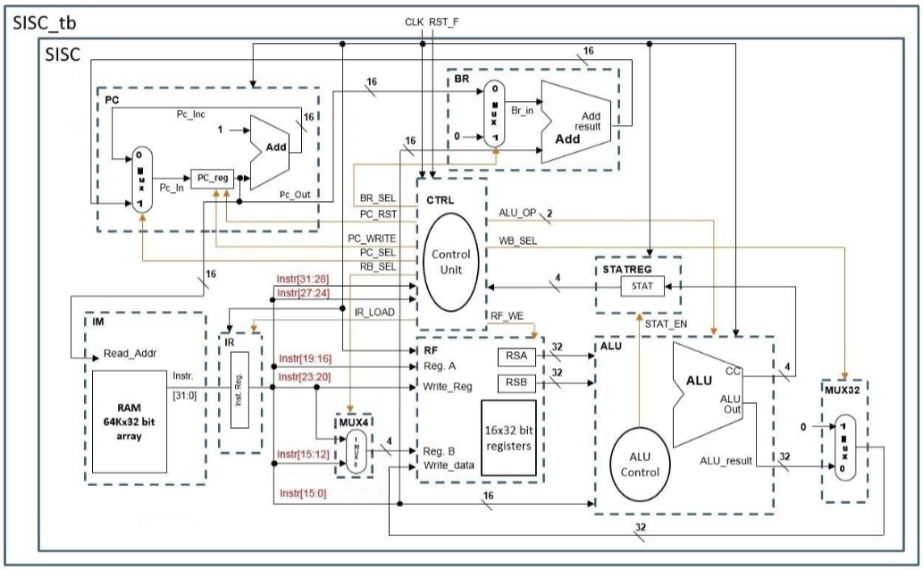

**Project Description:** Part 2 adds a program counter, instruction memory and branch execution. The program counter module together with the instruction memory determine which instruction is to be executed. The branch execution module and the pc_sel signal determine if the program counter is incremented or branched to a different part of the program. The CTRL module drives control signals for all other modules in the SISC CPU design.