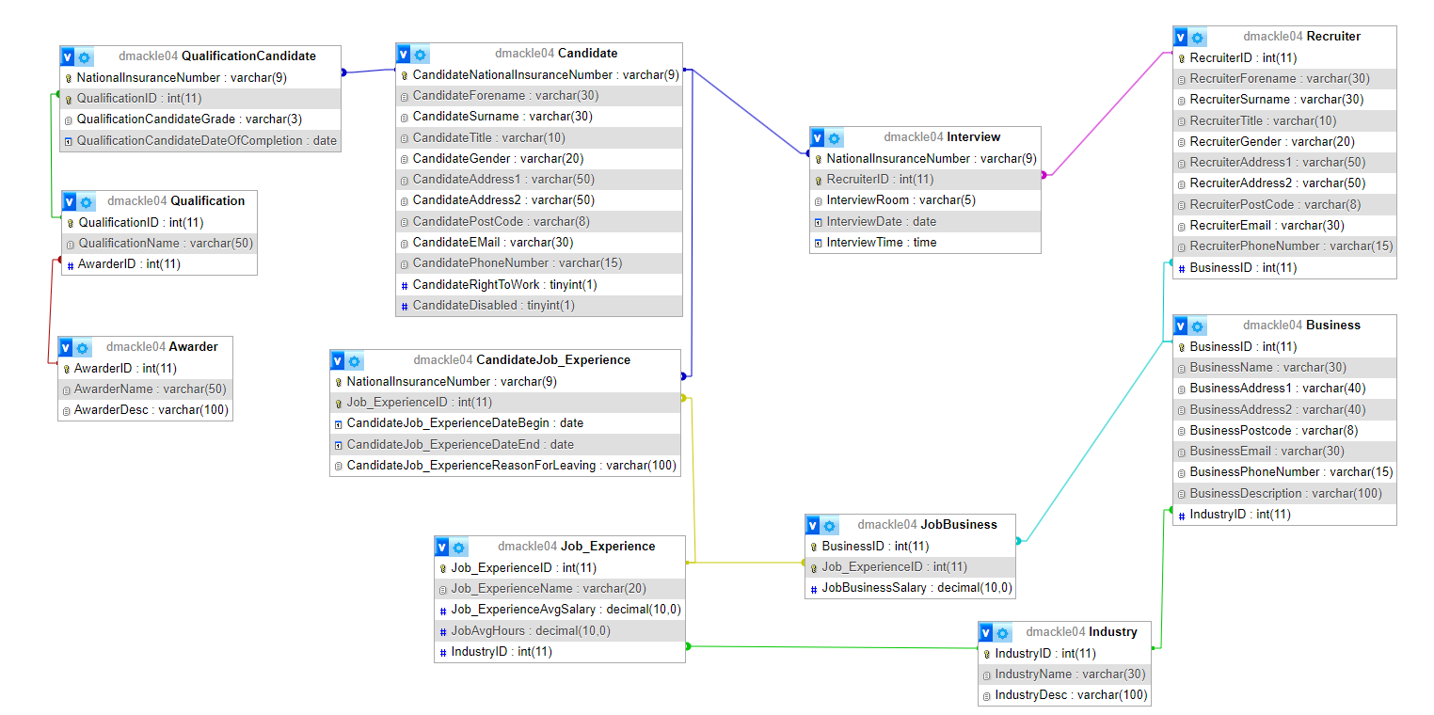Entity-Relation Diagram & Description

This Entity-Relation Diagram represents a database of a recruitment agency, specific to the functionalities of Candidates finding Interviews, Businesses finding fitting Candidates, and the filtering of candidates (by grades, prior jobs) and businesses (by Industry, wage).

# Awarder

Used to ensure the validity of Qualifications.

Contains only a name and a brief description of the awarder of a Qualification.

The primary key is an auto-incrementing surrogate key.

Has no foreign keys.

# Business

Used to hold information about a business, giving easy access to contact information.

Contains the location, name and contact details of a company partnered with the recruitment agency. Each business must have at least one recruiter. Holds address, Business Name, Front Office Phone Number etc.

The primary key is an auto-incrementing surrogate key.

Has one foreign key, corresponding to the Industry the Business falls under.

# Candidate

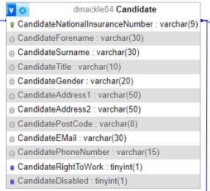

Used to add, display and manage job-seekers in the recruitment agency. Details could be used by Recruiters to filter Candidates for Interviews.

Contains the personal details and contact information of a job-seeker entered into the database. Holds Address, Email, Name etc.

The Primary Key is a Natural Key, the Candidate’s National Insurance Number.

Has no foreign keys.

# CandidateJob_Experience

Used to link prior jobs to their Candidate, and to hold data about the circumstances of the certain job.

Contains the start and end date of the Candidate’s Job Experience, alongside why they left.

This is a linking table, with foreign keys corresponding to the Candidate and their prior Job_Experience. Together, these foreign keys make the primary key.

# Industry

Used to group Job_Experiences and Businesses by Industry.

Contains only a name and a brief description of an Industry.

The primary key is an auto-incrementing surrogate key.

Has no foreign keys.

# Interview

Used to hold the information of an interview. Can be used to make sure there are no room overlaps, and to allow the candidate and recruiter to know the time of the interview.

Contains the time and location of the interview, alongside foreign keys corresponding to the Recruiter and the Candidate who will participate in the interview.

The primary key is an auto-incrementing surrogate key.

This is a linking table, with foreign keys corresponding to the Candidate and the Recruiter. Together, these foreign keys make the primary key.

# JobBusiness

Used to link prior jobs to their business, and to hold data about the circumstances of the certain job.

Contains the salary that a Candidate’s past job gave.

This is a linking table, with foreign keys corresponding to the Job and the Business the Job worked for. Together, these foreign keys make the primary key.

# 

# Job_Experience

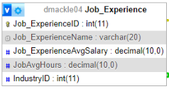

Used to represent a type of past job and the skills it gives. Useful for interviews.

Contains relevant details corresponding to a Candidate’s past experience in a working environment. Contains links to the job and its Industry. Holds the name of the job, and a foreign key corresponding to the Industry.

The primary key is an auto-incrementing surrogate key.

Has one foreign key, corresponding to the Industry the past job’s Business falls under.

# 

# Qualification

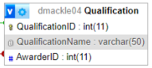

Used to represent a type of qualification which Candidates have achieved. Useful for Interviews.

Contains the name of the qualification, alongside a foreign key linking to the details of the awarder.

The primary key is an auto-incrementing surrogate key.

Has one foreign key, corresponding to the Awarder who gave the Candidate the Qualification.

# 

# QualificationCandidate

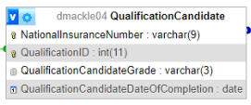

Used to link a candidate to the qualifications they have achieved. This table holds the grade for one such qualification.

Contains the Grade and Date of Completion of the Qualification which a Candidate has achieved.

This is a linking table, with foreign keys corresponding to the Candidate and the Qualification they achieved. Together, these foreign keys make the primary key.

# Recruiter

Used to add, display and manage recruiters who run Interviews on Candidates.

Contains the personal details and contact information of the recruiter who performs interviews on candidates. Holds Address, Email, Name etc.

The primary key is an auto-incrementing surrogate key.

Has one foreign key, corresponding to the Business the Recruiter works for.

# 