Chapter 1

Pag 11

1.1 Getting Started

Notice that \n represents only a single character. An escape sequence like \n provides a
general and extensible mechanism for representing hard-to-type or invisible characters.
Among the others that C provides are \t for tab, \b for backspace, \" for the double quote
and \\ for the backslash itself. There is a complete list in Section 2.3.

Pag 12

1.2 Variables and Arithmetic Expressions

The type int means that the variables listed are integers; by contrast with float, which
means floating point, i.e., numbers that may have a fractional part. The range of both int and
float depends on the machine you are using; 16-bits ints, which lie between -32768 and

Pag 13

+32767, are common, as are 32-bit ints. A float number is typically a 32-bit quantity, with
at least six significant digits and magnitude generally between about 10^-38 and 10^38.

C provides several other data types besides int and float, including:

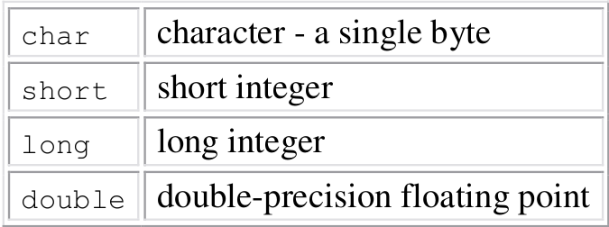

The size of these objects is also machine-dependent. There are also arrays, structures and
unions of these basic types, pointers to them, and functions that return them, all of which we
will meet in due course.

In either case, we will always indent the statements controlled by the while by one tab stop
(which we have shown as four spaces) so you can see at a glance which statements are inside
the loop. The indentation emphasizes the logical structure of the program. Although C
compilers do not care about how a program looks, proper indentation and spacing are critical
in making programs easy for people to read. We recommend writing only one statement per
line, and using blanks around operators to clarify grouping. The position of braces is less
important, although people hold passionate beliefs. We have chosen one of several popular
styles. Pick a style that suits you, then use it consistently.

Pag 14

celsius = 5 * (fahr-32) / 9;
The reason for multiplying by 5 and dividing by 9 instead of just multiplying by 5/9 is that in
C, as in many other languages, integer division truncates: any fractional part is discarded.
Since 5 and 9 are integers. 5/9 would be truncated to zero and so all the Celsius temperatures
would be reported as zero.

By the way, printf is not part of the C language; there is no input or output defined in C
itself. printf is just a useful function from the standard library of functions that are normally
accessible to C programs. The behaviour of printf is defined in the ANSI standard, however,
so its properties should be the same with any compiler and library that conforms to the
standard.

Pag 16

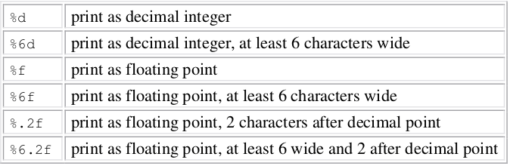
If i got a list of numbers such as:
1
2
23
123
2131
and ask for %6d for example, the output will be:
1
2
23
123
2131

Among others, printf also recognizes %o for octal, %x for hexadecimal, %c for character, %s
for character string and %% for itself.

Dec | Hex | Oct | Bin
0  1  2  3  4  5  6  7  8  9  10  11  12  13  14  15 | 0  1  2  3  4  5  6  7  8  9  A  B  C  D  E  F | 000  001  002  003  004  005  006  007  010  011  012  013  014  015  016  017 | 00000000  00000001  00000010  00000011  00000100  00000101  00000110  00000111  00001000  00001001  00001010  00001011  00001100  00001101  00001110  00001111

Pag 17

A final observation before we leave temperature conversion forever. It's bad practice to bury
``magic numbers'' like 300 and 20 in a program; they convey little information to someone
who might have to read the program later, and they are hard to change in a systematic way.
One way to deal with magic numbers is to give them meaningful names. A #define line
defines a symbolic name or symbolic constant to be a particular string of characters:

#define name replacement list

Thereafter, any occurrence of name (not in quotes and not part of another name) will be
replaced by the corresponding replacement text. The name has the same form as a variable
name: a sequence of letters and digits that begins with a letter. The replacement text can be
any sequence of characters; it is not limited to numbers.

The quantities LOWER, UPPER and STEP are symbolic constants, not variables, so they do not
appear in declarations. Symbolic constant names are conventionally written in upper case so
they can ber readily distinguished from lower case variable names. Notice that there is no
semicolon at the end of a #define line.

