Chapter 1

Pag 11

Notice that \n represents only a single character. An escape sequence like \n provides a
general and extensible mechanism for representing hard-to-type or invisible characters.
Among the others that C provides are \t for tab, \b for backspace, \" for the double quote
and \\ for the backslash itself. There is a complete list in Section 2.3.

Pag 12

The type int means that the variables listed are integers; by contrast with float, which
means floating point, i.e., numbers that may have a fractional part. The range of both int and
float depends on the machine you are using; 16-bits ints, which lie between -32768 and

Pag 13

+32767, are common, as are 32-bit ints. A float number is typically a 32-bit quantity, with
at least six significant digits and magnitude generally between about 10^-38 and 10^38.

C provides several other data types besides int and float, including:

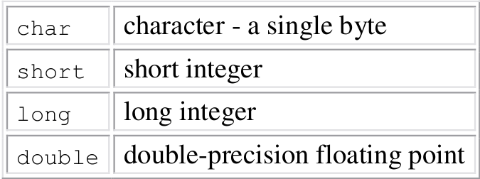

The size of these objects is also machine-dependent. There are also arrays, structures and
unions of these basic types, pointers to them, and functions that return them, all of which we
will meet in due course.

In either case, we will always indent the statements controlled by the while by one tab stop
(which we have shown as four spaces) so you can see at a glance which statements are inside
the loop. The indentation emphasizes the logical structure of the program. Although C
compilers do not care about how a program looks, proper indentation and spacing are critical
in making programs easy for people to read. We recommend writing only one statement per
line, and using blanks around operators to clarify grouping. The position of braces is less
important, although people hold passionate beliefs. We have chosen one of several popular
styles. Pick a style that suits you, then use it consistently.

Pag 14

celsius = 5 * (fahr-32) / 9;
The reason for multiplying by 5 and dividing by 9 instead of just multiplying by 5/9 is that in
C, as in many other languages, integer division truncates: any fractional part is discarded.
Since 5 and 9 are integers. 5/9 would be truncated to zero and so all the Celsius temperatures
would be reported as zero.

By the way, printf is not part of the C language; there is no input or output defined in C
itself. printf is just a useful function from the standard library of functions that are normally
accessible to C programs. The behaviour of printf is defined in the ANSI standard, however,
so its properties should be the same with any compiler and library that conforms to the
standard.

Pag 16

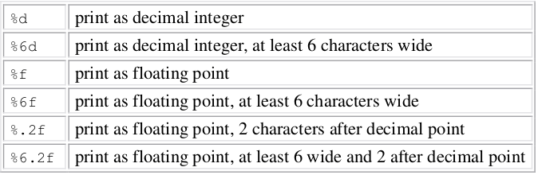
If i got a list of numbers such as:
1
2
23
123
2131
and ask for %6d for example, the output will be:
1
2
23
123
2131

Among others, printf also recognizes %o for octal, %x for hexadecimal, %c for character, %s
for character string and %% for itself.

Dec | Hex | Oct | Bin
0  1  2  3  4  5  6  7  8  9  10  11  12  13  14  15 | 0  1  2  3  4  5  6  7  8  9  A  B  C  D  E  F | 000  001  002  003  004  005  006  007  010  011  012  013  014  015  016  017 | 00000000  00000001  00000010  00000011  00000100  00000101  00000110  00000111  00001000  00001001  00001010  00001011  00001100  00001101  00001110  00001111

Pag 17

A final observation before we leave temperature conversion forever. It's bad practice to bury
``magic numbers'' like 300 and 20 in a program; they convey little information to someone
who might have to read the program later, and they are hard to change in a systematic way.
One way to deal with magic numbers is to give them meaningful names. A #define line
defines a symbolic name or symbolic constant to be a particular string of characters:

#define name replacement list

Thereafter, any occurrence of name (not in quotes and not part of another name) will be
replaced by the corresponding replacement text. The name has the same form as a variable
name: a sequence of letters and digits that begins with a letter. The replacement text can be
any sequence of characters; it is not limited to numbers.

The quantities LOWER, UPPER and STEP are symbolic constants, not variables, so they do not
appear in declarations. Symbolic constant names are conventionally written in upper case so
they can ber readily distinguished from lower case variable names. Notice that there is no
semicolon at the end of a #define line.

Página 19

The parentheses around the assignment, within the condition are necessary. The precedence of != is higher than that of =, which means that in the absence of parentheses the relational test != would be done before the assignment =.

Página 20

The statement
++nc;
presents a new operator, ++, which means increment by one. You could instead write nc = nc + 1 but ++nc is more concise and often more efficient. There is a corresponding operator -- to decrement by 1. The operators ++ and -- can be either prefix operators (++nc) or postfix operators (nc++); these two forms have different values in expressions, as will be shown in Chapter 2, but ++nc and nc++ both increment nc. For the moment we will stick to the prefix form.
The character counting program accumulates its count in a long variable instead of an int. long integers are at least 32 bits. Although on some machines, int and long are the same size, on others an int is 16 bits, with a maximum value of 32767, and it would take relatively little input to overflow an int counter. The conversion specification %ld tells printf that the corresponding argument is a long integer.
It may be possible to cope with even bigger numbers by using a double (double precision float). We will also use a for statement instead of a while, to illustrate another way to write the loop.
printf uses %f for both float and double; %.0f suppresses the printing of the decimal point and the fraction part, which is zero.
for (nc = 0; gechar() != EOF; ++nc)
;

The body of this for loop is empty, because all the work is done in the test and increment parts. But the grammatical rules of C require that a for statement have a body. The isolated semicolon, called a null statement, is there to satisfy that requirement. We put it on a separate line to make it visible.

Pag 21

A character written between single quotes represents an integer value equal to the numerical value of the character in the machine's character set. This is called a character constant, although it is just another way to write a small integer. So, for example, 'A' is a character constant; in the ASCII character set its value is 65, the internal representation of the character A. Of course, 'A' is to be preferred over 65: its meaning is obvious, and it is independent of a particular character set.
The escape sequences used in string constants are also legal in character constants, so '\n' stands for the value of the newline character, which is 10 in ASCII. You should note carefully that '\n' is a single character, and in expressions is just an integer; on the other hand, '\n' is a string constant that happens to contain only one character. The topic of strings versus characters is discussed further in Chapter 2.
Pag 23

One and only one of the two statements associated with an if-else is performed. If the expression is true, statement1 is executed; if not, statement2 is executed. Each statement can be a single statement or several in braces. In the word count program, the one after the else is an if that controls two statements in braces.

Pag 24
The declaration
int ndigit[10];
declares ndigit to be an array of 10 integers. Array subscripts always start at zero (i for example) in C, so the elements are ndigit[0], ndigit[1], ..., ndigit[9]. This is reflected in the for loops that initialize and print the array.
A subscript can be any integer expression, which includes integer variables like i, and integer constants.
This works only if '0', '1', ..., '9' have consecutive increasing values. Fortunately, this is true for all character sets.
By definition, chars are just small integers, so char variables and constants are identical to ints in arithmetic expressions. This is natural and convenient; for example c-'0' is an integer expression with a value between 0 and 9 corresponding to the character '0' to '9' stored in c, and thus a valid subscript for the array ndigit.

Pag 26
Function definitions can appear in any order, and in one source file or several, although no function can be split between files. If the source program appears in several files, you may have to say more to compile and load it than if it all appears in one, but that is an operating system matter, not a language attribute. For the moment, we will assume that both functions are in the same file, so whatever you have learned about running C programs will still work.
int power(int base, int n)
declares the parameter types and names, and the type of the result that the function returns. The names used by power for its parameters are local to power, and are not visible to any other function: other routines can use the same names without conflict. This is also true of the variables i and p: the i in power is unrelated to the i in main.

Pag 27
We will generally use parameter for a variable named in the parenthesized list in a function. The terms formal argument and actual argument are sometimes used for the same distinction.
You may have noticed that there is a return statement at the end of main. Since main is a function like any other, it may return a value to its caller, which is in effect the environment in which the program was executed. Typically, a return value of zero implies normal termination; non-zero values signal unusual or erroneous termination conditions. In the interests of simplicity, we have omitted return statements from our main functions up to this point, but we will include them hereafter, as a reminder that programs should return status to their environment.
The declaration
int power(int base, int n);
just before main says that power is a function that expects two int arguments and returns an int. This declaration, which is called a function prototype, has to agree with the definition and uses of power. It is an error if the definition of a function or any uses of it do not agree with its prototype.
parameter names need not agree. Indeed, parameter names are optional in a function prototype, so for the prototype we could have written
int power(int, int);
Well-chosen names are good documentation however, so we will often use them.

Pag 29
One aspect of C functions may be unfamiliar to programmers who are used to some other languages, particulary Fortran. In C, all function arguments are passed ``by value.'' This means that the called function is given the values of its arguments in temporary variables rather than the originals. This leads to some different properties than are seen with ``call by reference'' languages like Fortran or with var parameters in Pascal, in which the called routine has access to the original argument, not a local copy.
The story is different for arrays. When the name of an array is used as an argument, the value passed to the function is the location or address of the beginning of the array - there is no copying of array elements. By subscripting this value, the function can access and alter any argument of the array. This is the topic of the next section.

Pag 31
getline puts the character '\0' (the null character, whose value is zero) at the end of the array it is creating, to mark the end of the string of characters. This conversion is also used by the C language: when a string constant like
"hello\n"
appears in a C program, it is stored as an array of characters containing the characters in the string and terminated with a '\0' to mark the end.
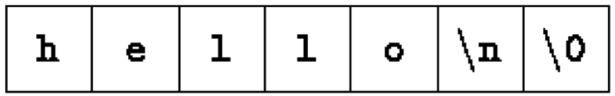
The %s format specification in printf expects the corresponding argument to be a string represented in this form. copy also relies on the fact that its input argument is terminated with a '\0', and copies this character into the output.
Pag 32
The variables in main, such as line, longest, etc., are private or local to main. Because they are declared within main, no other function can have direct access to them. The same is true of the variables in other functions; for example, the variable i in getline is unrelated to the i in copy. Each local variable in a function comes into existence only when the function is called, and disappears when the function is exited. This is why such variables are usually known as automatic variables, following terminology in other languages. We will use the term automatic henceforth to refer to these local variables. (Chapter 4 discusses the static storage class, in which local variables do retain their values between calls.)
As an alternative to automatic variables, it is possible to define variables that are external to all functions, that is, variables that can be accessed by name by any function. (This mechanism is rather like Fortran COMMON or Pascal variables declared in the outermost block.) Because external variables are globally accessible, they can be used instead of argument lists to communicate data between functions. Furthermore, because external variables remain in existence permanently, rather than appearing and disappearing as functions are called and exited, they retain their values even after the functions that set them have returned.
An external variable must be defined, exactly once, outside of any function; this sets aside storage for it. The variable must also be declared in each function that wants to access it; this states the type of the variable. The declaration may be an explicit extern statement or may be implicit from context. To make the discussion concrete, let us rewrite the longest-line program with line, longest, and max as external variables. This requires changing the calls, declarations, and bodies of all three functions.
Pag 33
The external variables in main, getline and copy are defined by the first lines of the example above, which state their type and cause storage to be allocated for them. Syntactically, external definitions are just like definitions of local variables, but since they occur outside of functions, the variables are external. Before a function can use an external variable, the name of the variable must be made known to the function; the declaration is the same as before except for the added keyword extern.
In certain circumstances, the extern declaration can be omitted. If the definition of the external variable occurs in the source file before its use in a particular function, then there is no need for an extern declaration in the function. The extern declarations in main, getline and copy are thus redundant. In fact, common practice is to place definitions of all external variables at the beginning of the source file, and then omit all extern declarations.
int i=4;
/* Global definition */
main() {
i++;
/* Global variable */
func();
printf( "Value of i = %d -- main function\n", i );
}

func() {
int i=10;
/* Local definition */
i++;
/* Local variable */
printf( "Value of i = %d -- func() function\n", i );
}

This will produce following result Value of i = 11 -- func() function Value of i = 5 -- main function

You should note that we are using the words definition and declaration carefully when we refer to external variables in this section.``Definition'' refers to the place where the variable is created or assigned storage; ``declaration'' refers to places where the nature of the variable is stated but no storage is allocated.

Extra Notes
Printf stands for printed formatted

