Chapter 5

Pag 83

The unary operator & gives the address of an object, so the statement
p = &c;
assigns the address of c to the variable p, and p is said to ``point to'' c. The & operator only applies to objects in memory: variables and array elements. It cannot be applied to expressions, constants, or register variables.
The unary operator * is the indirection or dereferencing operator; when applied to a pointer, it accesses the object the pointer points to. Suppose that x and y are integers and ip is a pointer to int. This artificial sequence shows how to declare a pointer and how to use & and *:

Pag 84

double *dp, atof(char *);
says that in an expression *dp and atof(s) have values of double, and that the argument of atof is a pointer to char.
You should also note the implication that a pointer is constrained to point to a particular kind of object: every pointer points to a specific data type. (There is one exception: a ``pointer to void'' is used to hold any type of pointer but cannot be dereferenced itself.

++*ip
and
(*ip)++
The parentheses are necessary in this last example; without them, the expression would increment ip instead of what it points to, because unary operators like * and ++ associate right to left.

Pag 87

In C, there is a strong relationship between pointers and arrays, strong enough that pointers and arrays should be discussed simultaneously. Any operation that can be achieved by array subscripting can also be done with pointers. The pointer version will in general be faster but, at least to the uninitiated, somewhat harder to understand.

Pag 88

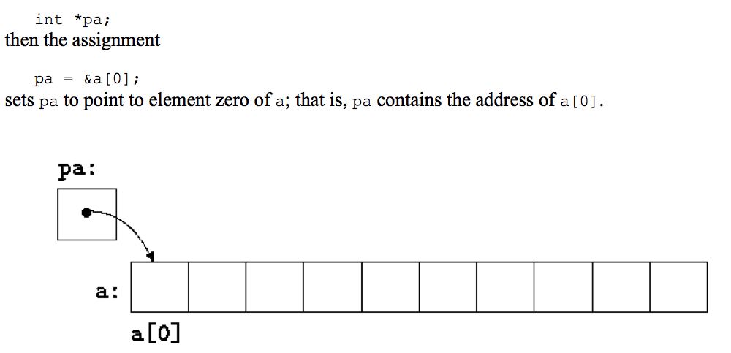
Now the assignment
x = *pa;
will copy the contents of a[0] into x.
If pa points to a particular element of an array, then by definition pa+1 points to the next element, pa+i points i elements after pa, and pa-i points i elements before. Thus, if pa points to a[0],
*(pa+1)
refers to the contents of a[1], pa+i is the address of a[i], and *(pa+i) is the contents of a[i].
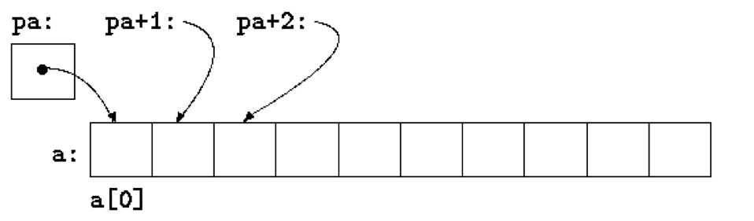

Pag 89

pa = &a[0];
pa and a have identical values. Since the name of an array is a synonym for the location of the initial element, the assignment pa=&a[0] can also be written as
pa = a;
Rather more surprising, at first sight, is the fact that a reference to a[i] can also be written as *(a+i). In evaluating a[i], C converts it to *(a+i) immediately; the two forms are equivalent. Applying the operator & to both parts of this equivalence, it follows that &a[i] and a+i are also identical: a+i is the address of the i-th element beyond a. As the other side of this coin, if pa is a pointer, expressions might use it with a subscript; pa[i] is identical to *(pa+i). In short, an array-and-index expression is equivalent to one written as a pointer and offset.
There is one difference between an array name and a pointer that must be kept in mind. A pointer is a variable, so pa=a and pa++ are legal. But an array name is not a variable; constructions like a=pa and a++ are illegal.
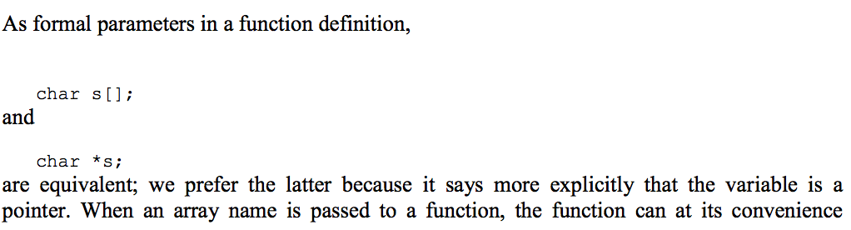

It is possible to pass part of an array to a function, by passing a pointer to the beginning of the subarray. For example, if a is an array,
f(&a[2])
and
f(a+2)

If one is sure that the elements exist, it is also possible to index backwards in an array; p[-1], p[-2], and so on are syntactically legal, and refer to the elements that immediately precede p[0]. Of course, it is illegal to refer to objects that are not within the array bounds.

Pag 92

If not, alloc must return some signal that there is no space left. C guarantees that zero is never a valid address for data, so a return value of zero can be used to signal an abnormal event, in this case no space.
is true if p points to an earlier element of the array than q does. Any pointer can be meaningfully compared for equality or inequality with zero. But the behavior is undefined for arithmetic or comparisons with pointers that do not point to members of the same array. (There is one exception: the address of the first element past the end of an array can be used in pointer arithmetic.)
means the address of the n-th object beyond the one p currently points to. This is true regardless of the kind of object p points to; n is scaled according to the size of the objects p points to, which is determined by the declaration of p. If an int is four bytes, for example, the int will be scaled by four.
Pag 93

Pointer arithmetic is consistent: if we had been dealing with floats, which occupy more storage that chars, and if p were a pointer to float, p++ would advance to the next float. Thus we could write another version of alloc that maintains floats instead of chars, merely by changing char to float throughout alloc and afree. All the pointer manipulations automatically take into account the size of the objects pointed to.
String constants need not be function arguments. If pmessage is declared as char *pmessage;
then the statement
pmessage = "now is the time"; assigns to pmessage a pointer to the character array. This is not a string copy; only pointers are involved. C does not provide any operators for processing an entire string of characters as a unit.
Pag 94

char amessage[] = "now is the time"; /* an array */
char *pmessage = "now is the time"; /* a pointer */

amessage is an array, just big enough to hold the sequence of characters and '\0' that initializes it. Individual characters within the array may be changed but amessage will always refer to the same storage. On the other hand, pmessage is a pointer, initialized to point to a string constant; the pointer may subsequently be modified to point elsewhere, but the result is undefined if you try to modify the string contents.
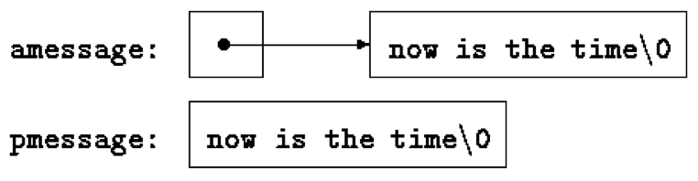
Pag 95

As the final abbreviation, observe that a comparison against '\0' is redundant, since the question is merely whether the expression is zero. So the function would likely be written as
/* strcpy: copy t to s; pointer version 3 */
void strcpy(char *s, char *t)
{
while (*s++ = *t++)
;
}
*--p
decrements p before fetching the character that p points to. In fact, the pair of expressions

*p++ = val; /* push val onto stack */
val = *--p; /* pop top of stack into val */

Pag 100

daytab is the first two-dimensional array we have dealt with. In C, a two-dimensional array is really a one-dimensional array, each of whose elements is an array. Hence subscripts are written as
daytab[i][j] /* [row][col] */
rather than
daytab[i,j] /* WRONG */

If a two-dimensional array is to be passed to a function, the parameter declaration in the function must include the number of columns; the number of rows is irrelevant, since what is passed is, as before, a pointer to an array of rows, where each row is an array of 13 ints. In this particular case, it is a pointer to objects that are arrays of 13 ints. Thus if the array daytab is to be passed to a function f, the declaration of f would be:
f(int daytab[2][13]) { ... }
It could also be
f(int daytab[][13]) { ... }
since the number of rows is irrelevant, or it could be
f(int (*daytab)[13]) { ... }

which says that the parameter is a pointer to an array of 13 integers. The parentheses are necessary since brackets [] have higher precedence than *. Without parentheses, the declaration
int *daytab[13]

Pag 101

int a[10][20];
int *b[10];
then a[3][4] and b[3][4] are both syntactically legal references to a single int. But a is a true two-dimensional array: 200 int-sized locations have been set aside, and the conventional rectangular subscript calculation 20 * row +col is used to find the element a[row,col]. For b, however, the definition only allocates 10 pointers and does not initialize them; initialization must be done explicitly, either statically or with code. Assuming that each element of b does point to a twenty-element array, then there will be 200 ints set aside, plus ten cells for the pointers. The important advantage of the pointer array is that the rows of the array may be of different lengths. That is, each element of b need not point to a twenty-element vector; some may point to two elements, some to fifty, and some to none at all.

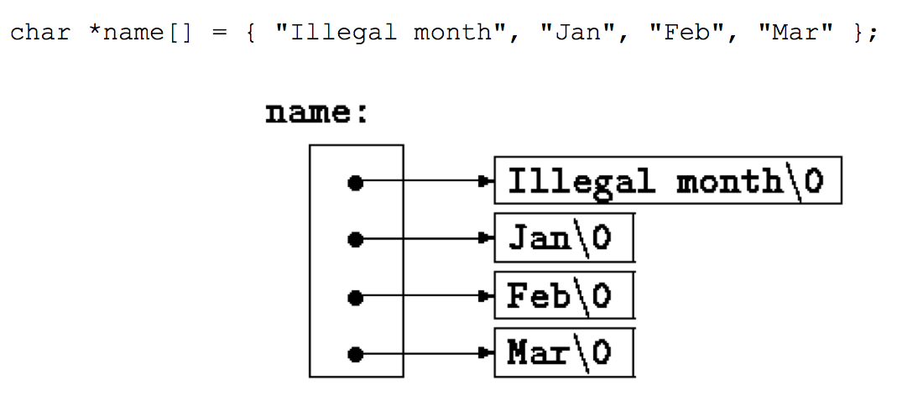

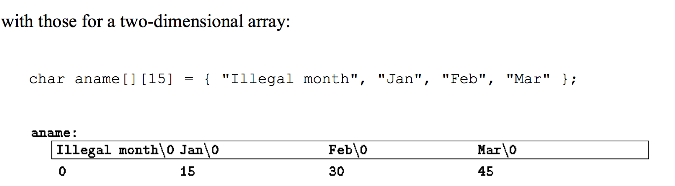

Pag 102

In environments that support C, there is a way to pass command-line arguments or parameters to a program when it begins executing. When main is called, it is called with two arguments. The first (conventionally called argc, for argument count) is the number of command-line arguments the program was invoked with; the second (argv, for argument vector) is a pointer to an array of character strings that contain the arguments, one per string. We customarily use multiple levels of pointers to manipulate these character strings.
The simplest illustration is the program echo, which echoes its command-line arguments on a single line, separated by blanks. That is, the command
echo hello, world
prints the output
hello, world By convention, argv[0] is the name by which the program was invoked, so argc is at least 1. If argc is 1, there are no command-line arguments after the program name. In the example above, argc is 3, and argv[0], argv[1], and argv[2] are "echo", "hello,", and "world" respectively. The first optional argument is argv[1] and the last is argv[argc-1]; additionally, the standard requires that argv[argc] be a null pointer.
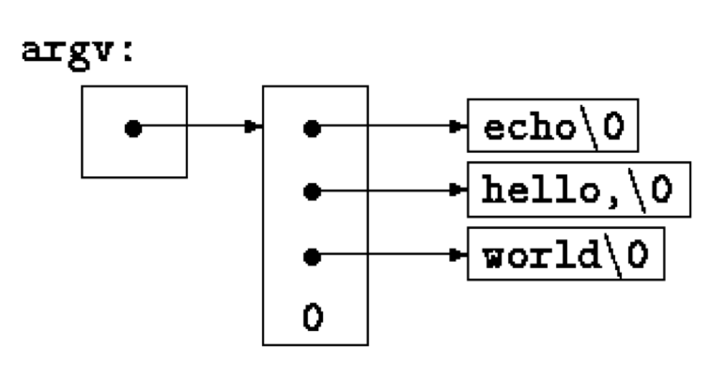

Pag 105

Thus argc should be 1 and *argv should point at the pattern. Notice that *++argv is a pointer to an argument string, so (*++argv)[0] is its first character. (An alternate valid form would be **++argv.)
A void pointer can point to objects of any data type

Pag 107
Any pointer can be cast to void * and back again without loss of information, so we can call qsort by casting arguments to void *.
The declarations should be studied with some care. The fourth parameter of qsort is
int (*comp)(void *, void *) which says that comp is a pointer to a function that has two void * arguments and returns an int.
The use of comp in the line if ((*comp)(v[i], v[left]) < 0)
is consistent with the declaration: comp is a pointer to a function, *comp is the function, and
(*comp)(v[i], v[left])
is the call to it. The parentheses are needed so the components are correctly associated; without them,
int *comp(void *, void *) /* WRONG */ says that comp is a function returning a pointer to an int, which is very different.
Pag 109

C is sometimes castigated for the syntax of its declarations, particularly ones that involve pointers to functions. The syntax is an attempt to make the declaration and the use agree; it works well for simple cases, but it can be confusing for the harder ones, because declarations cannot be read left to right, and because parentheses are over-used. The difference between
int *f(); /* f: function returning pointer to int */
and
}
int (*pf)(); /* pf: pointer to function returning int */
char **argv
argv: pointer to char
int (*daytab)[13]
daytab: pointer to array[13] of int
int *daytab[13]
daytab: array[13] of pointer to int
void *comp()
comp: function returning pointer to void
void (*comp)()
comp: pointer to function returning void
char (*(*x())[])()
x: function returning pointer to array[] of
pointer to function returning char
char (*(*x[3])())[5] x: array[3] of pointer to function returning pointer to array[5] of char

