Import data to sql follow wizard

<https://support.discountasp.net/kb/a1179/how-to-import-a-csv-file-into-a-database-using-sql-server-management-studio.aspx>

remove quote marks from whole DB

<https://support.discountasp.net/kb/a1179/how-to-import-a-csv-file-into-a-database-using-sql-server-management-studio.aspx>

Home Team, Away Team most common result

SELECT TOP 1 [EFL-1888-2017].[dbo].[england].result

FROM [EFL-1888-2017].[dbo].[england] WHERE home='Wigan Athletic' AND visitor='Manchester United'

GROUP BY [EFL-1888-2017].[dbo].[england].result

ORDER BY COUNT(\*) DESC

Python Query in App.py

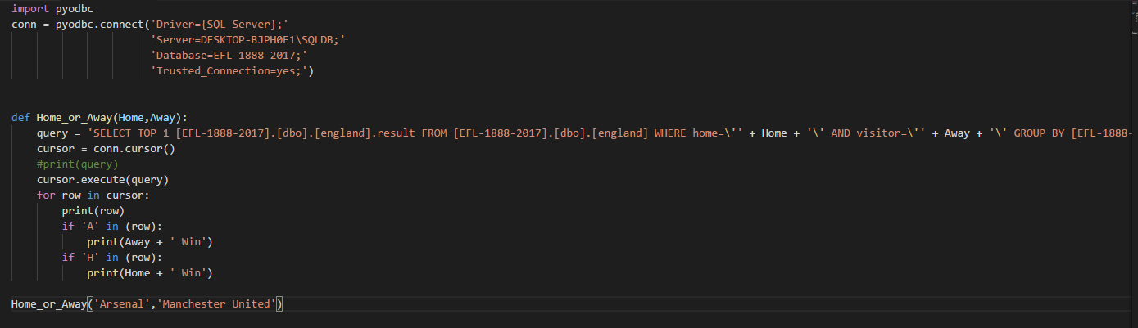

Output

