## Keywords

* Intel – This is an item that the spy can collect to learn the location of the totem.
* Totem – this is the “Key” or “Trophy” that the spy needs to collect in order to win and escape.
* Radio – A distraction component that the spy can use to distract guards

I have included some “high quality” MS Paint diagrams to help describe what goes on in each action.

My project is in Perforce or can be located at the Github link below

Github Repository Link - https://github.com/danielmccluskey/Unity-AI-SpyVsGuard

# Guard Behaviours

## Patrolling

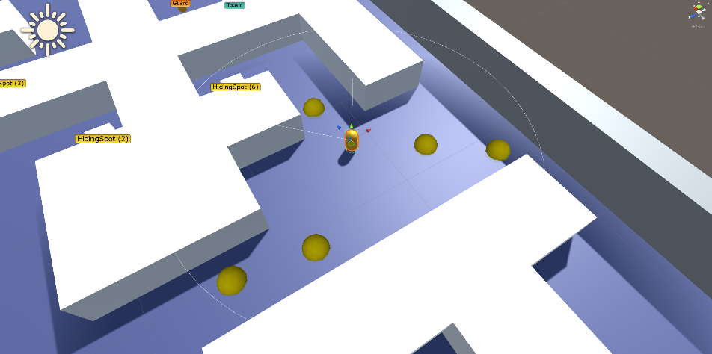When the guard spawns it will randomly select some patrol points to walk around using CS_GuardPatrolManager.cs, it will then try and choose a semi-coherent path to follow between these points by linking each point to the next closest point. These points are represented by yellow gizmo circles, shown when selecting the guard.

## Investigating

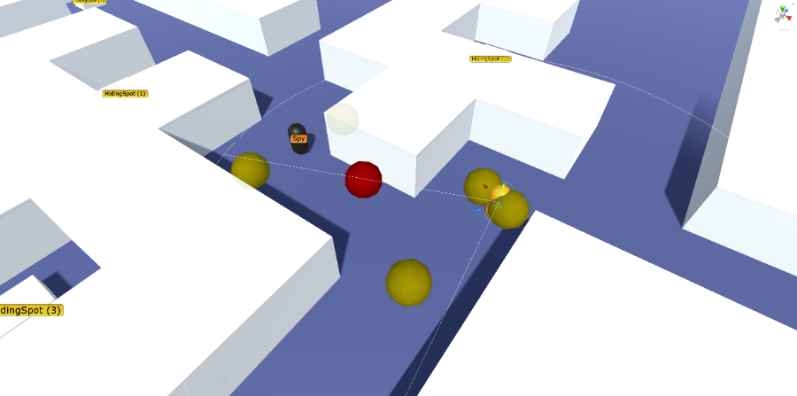The guard can be told to investigate an area, this is exactly the same method and script as Patrolling, it will select a centre point and do a Patrol with a smaller range for a given amount of time. Afterwards, it will return to its original patrol route. The last known location is represented by a red gizmo sphere when the guard is selected, and the investigate points by yellow ones.

## Attacking Player

If the Guard gets line of sight of the spy, it will follow them, in an attempt to attack them. When they lose sight of the player, they then investigate the last known location of the player.

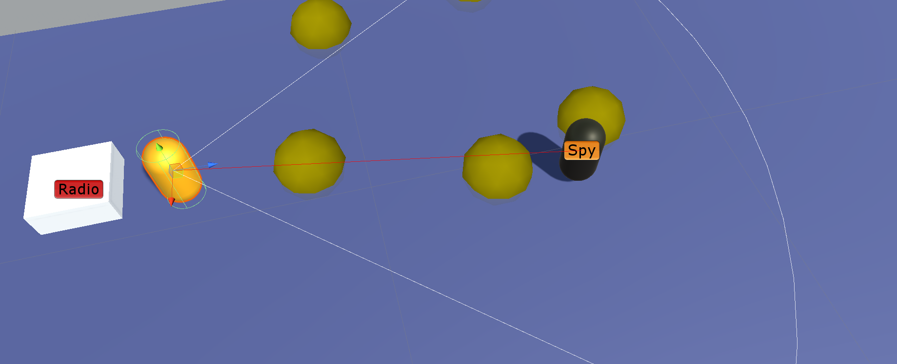

## Guard to Guard Communication

If a guard can see another guard that is following the spy or is alerted, they will join the pursuit of the spy, even if they haven’t seen the spy.

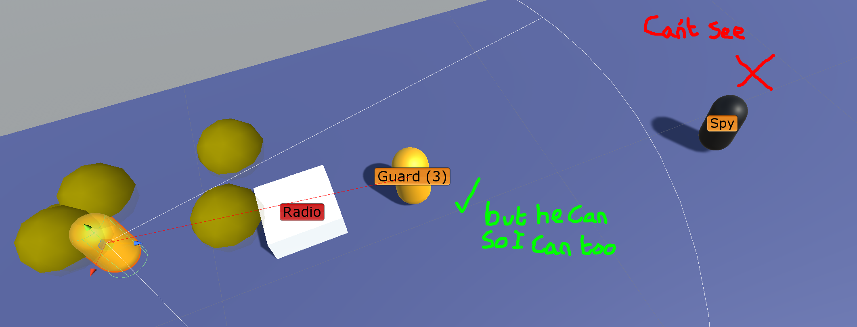

## Turning off Radio

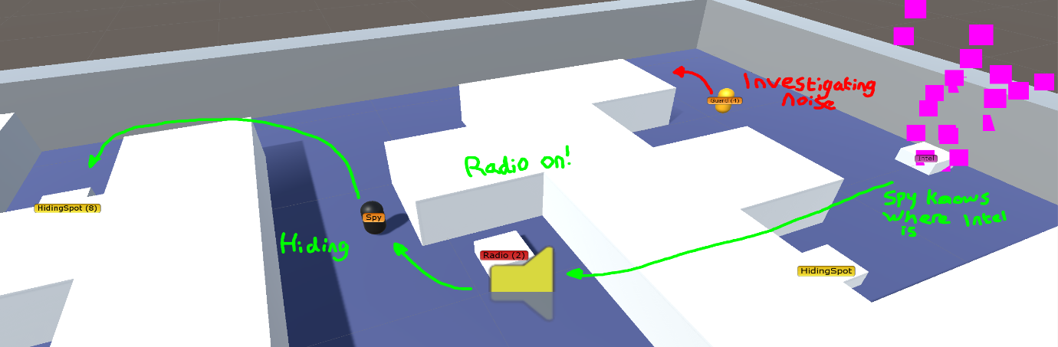If a radio is turned on, guards will go to the source of the noise, turn off the radio and then investigate the area.

## Hiding Spot detection

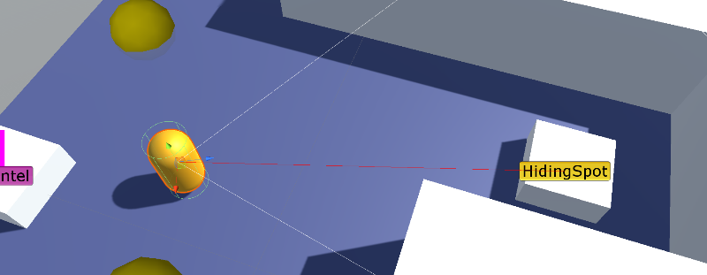If the guard locates a hiding spot, that spot will be disabled for 60 seconds and the player will not be able to hide there.

## Spy Behaviours

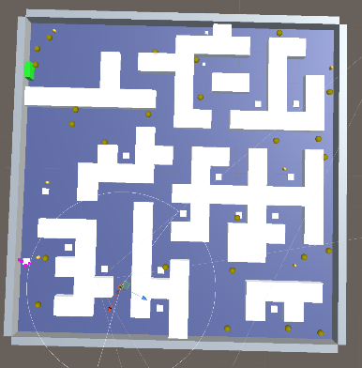The spy has a few duplicated behaviours such as CS_TurnOnRadioIntelAction and CS_TurnOnRadioTotemAction (among others) because of a bug I found with the GOAP world data not resetting very close to the assignment deadline. I recognise that this duplicated code could easily be transcribed into one script, but I could not find the bug in the end.

## Spy Searching

This re-uses the CS_GuardPatrolManager script to create one huge “Patrol” around the map, once the player has visited all points, it will select a set of new search points until a trigger is reached such as finding the totem.

## Spy Avoiding Guard

A small “hacky” way of avoiding guards is implemented. When the player sees a guard, it will calculate its facing direction using the dot product, if it is facing the player, it will send out 3 Ray-cast rays, one each in the left, right and back direction. The ray that shoots for the longest will be chosen as an avoid point. The ray cast method was suggested to me by Callum Pertoldi.

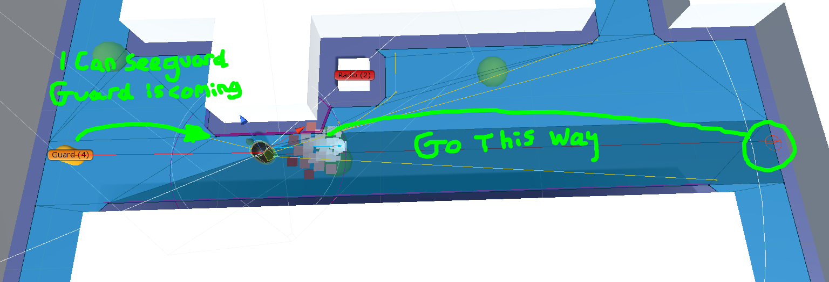

## Spy Avoiding Guard (Experimental)

This is a method I implemented but didn’t have enough time to iron out the bugs. It can be seen in the ExperimentalScene.scene. It takes advantage of the Unity Navmesh system by making the area in front of the guard a ridiculously high cost to traverse for the spy. This would make the spy re-evaluate its path and make it go around the guard, but still has the opportunity to run past the guard if needed.

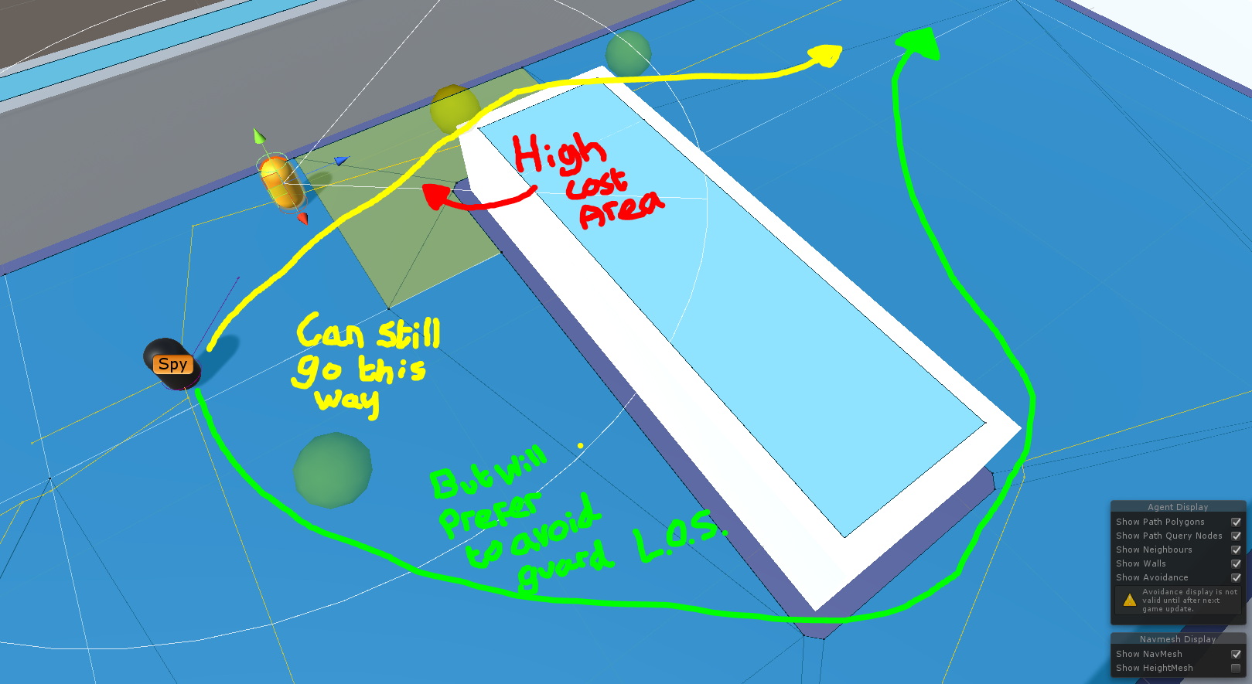

## Spy Turning on Radio (Intel and Totem)

If the player learns the location of either the Intel or the totem, it will check if any enemies are near the target location. If so, it will find the nearest Radio to the location, turn it on, hide for 2 seconds and then go and retrieve the Intel/Totem. There is a bug however where they will only ever do this action once per target.

## Spy Hide

When the spy is touched by a guard or is in extreme proximity they will find the closest Hiding spot by calculating the length of the path to each spot. It will go to it and hide there, if a guard spots the player whilst hiding, it will attempt to find another hiding spot.

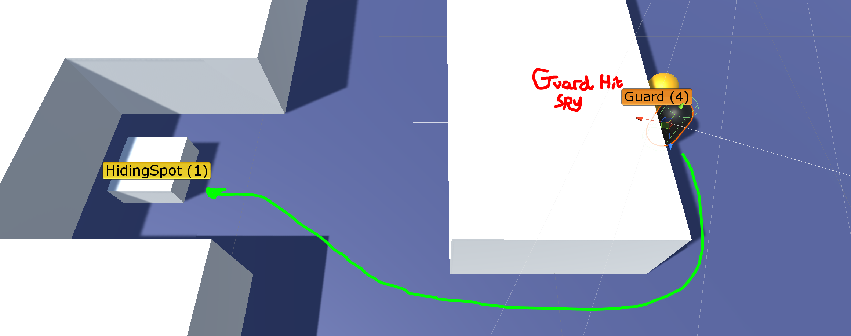

## Spy escape

When the player has the totem, it will escape. It will run straight to the escape point and ignore all guards.

## Spy knowledge

The spy has a simple, but effective way of simulating knowledge. This uses CS_KnowledgeComponent.cs, if the guard sees Intel or a totem, they will access that items knowledge component and set it to “Found”, once they get within range they will set it to “Collected”.

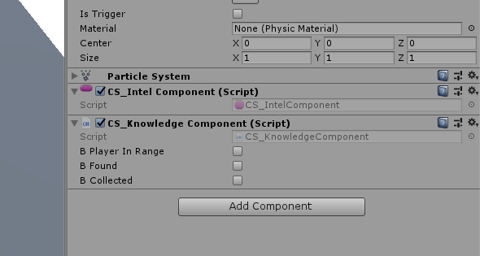

# Other

## FMOD

Sounds in the project are handled by FMOD. The distance at which the sound can be heard is dictated by the sound attenuation set in FMOD studio, this lets you easily tweak how far each individual sound travels.

