ATIC Exercise 10

a)

i) model_car:

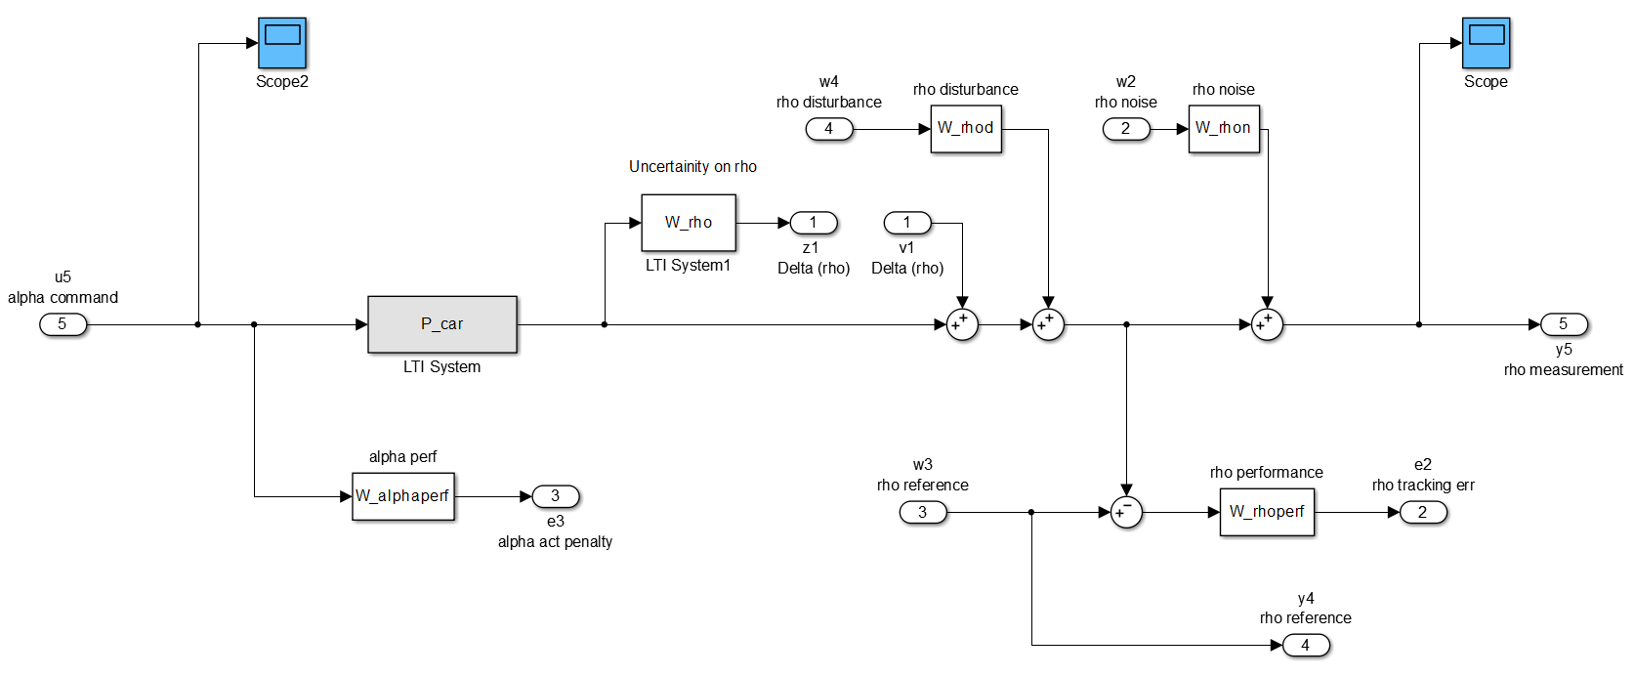

ii)

[A_P,B_P,C_P,D_P] = linmod('model_car');

P = ss(A_P,B_P,C_P,D_P);

P =

a =

x1 x2 x3 x4 x5 x6 x7 x8

x1 0 0 1 0 0 0 0 0

x2 0 0 0 1 0 0 0 0

x3 78.23 -59.38 0 0 0 0 0 0

x4 0 -400 0 -20 0 0 0 0

x5 40.74 0 0 0 -4 0 0 0

x6 -2.546 0 0 0 0 -0.001667 0 -0.02

x7 0 0 0 0 0 0 -1000 0

x8 0 0 0 0 0 0 0 -0.002

b =

u1 u2 u3 u4 u5

x1 0 0 0 0 0

x2 0 0 0 0 0

x3 0 0 0 0 0

x4 0 0 0 0 69.81

x5 0 0 0 0 0

x6 -0.25 0 0.25 0 0

x7 0 0 0 0 128

x8 0 0 0 0.0625 0

c =

x1 x2 x3 x4 x5 x6 x7 x8

y1 20.37 0 0 0 -2 0 0 0

y2 0 0 0 0 0 0.1333 0 0

y3 0 0 0 0 0 0 -125 0

y4 0 0 0 0 0 0 0 0

y5 10.19 0 0 0 0 0 0 0.08

d =

u1 u2 u3 u4 u5

y1 0 0 0 0 0

y2 0 0 0 0 0

y3 0 0 0 0 16

y4 0 0 1 0 0

y5 1 0.01 0 0 0

iii)

[Knom,Gnom,gamma,info] = hinfsyn(Pnomdesign,nmeas,nctrl,...

'METHOD','ric',... % Riccati solution

'DISPLAY','on',... % verbose

'TOLGAM',0.1); % gamma tolerance

Knom =

a =

x1 x2 x3 x4 x5 x6

x1 -18.69 0 1 0 -1.042e-08 0

x2 -2.154e-15 0 0 1 -1.201e-24 0

x3 -87.04 -59.38 0 0 -9.215e-08 0

x4 19.76 -405.8 2.215 -20.2 -0.5922 534.6

x5 0.01322 0 0 0 -0.0005989 0

x6 36.23 -10.6 4.061 -0.3661 -1.086 -19.89

x7 63.38 0 0 0 -0.0001203 0

x7

x1 -0.1468

x2 -1.692e-17

x3 -1.298

x4 0.01302

x5 0.0001038

x6 0.02388

x7 0.4958

b =

u1 u2

x1 0 20.78

x2 0 2.395e-15

x3 0 183.8

x4 0 -7.408e-15

x5 2.832 -2.847

x6 0 0

x7 0 -70.49

c =

x1 x2 x3 x4 x5 x6

y1 0.02499 -0.007314 0.002801 -0.0002525 -0.0007488 0.6759

x7

y1 1.647e-05

d =

u1 u2

y1 0 0

iv)

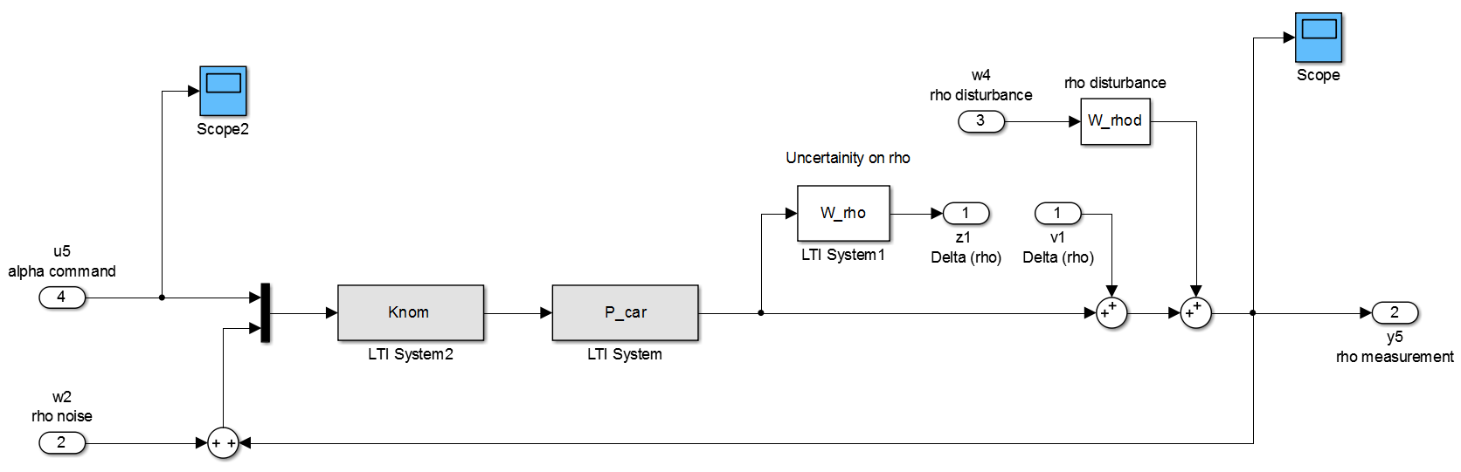

b)

Gamma value achieved: 0.2143

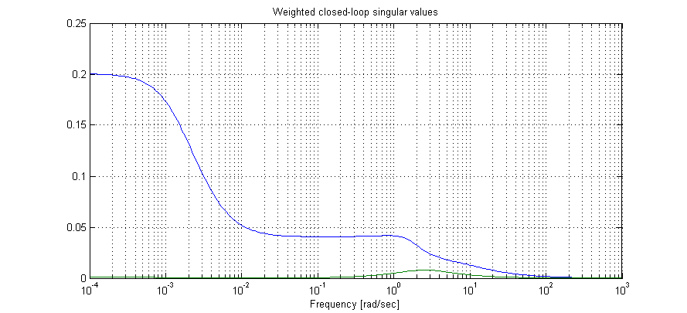

c)

% Find closed loop eigenvalues

G_cl=lft(Pnomdesign,Knom,nctrl,nmeas);

eig(G_cl)

1.0e+03 *

-0.0000 + 0.0000i

-1.0000 + 0.0000i

-0.0089 + 0.0001i

-0.0089 - 0.0001i

-0.0089 + 0.0000i

-0.0088 + 0.0000i

-0.0012 + 0.0012i

-0.0012 - 0.0012i

-0.0005 + 0.0000i

-0.0100 + 0.0173i

-0.0100 - 0.0173i

-0.0100 + 0.0173i

-0.0100 - 0.0173i

-0.0000 + 0.0000i

They all have a negative real part > stable.

d)

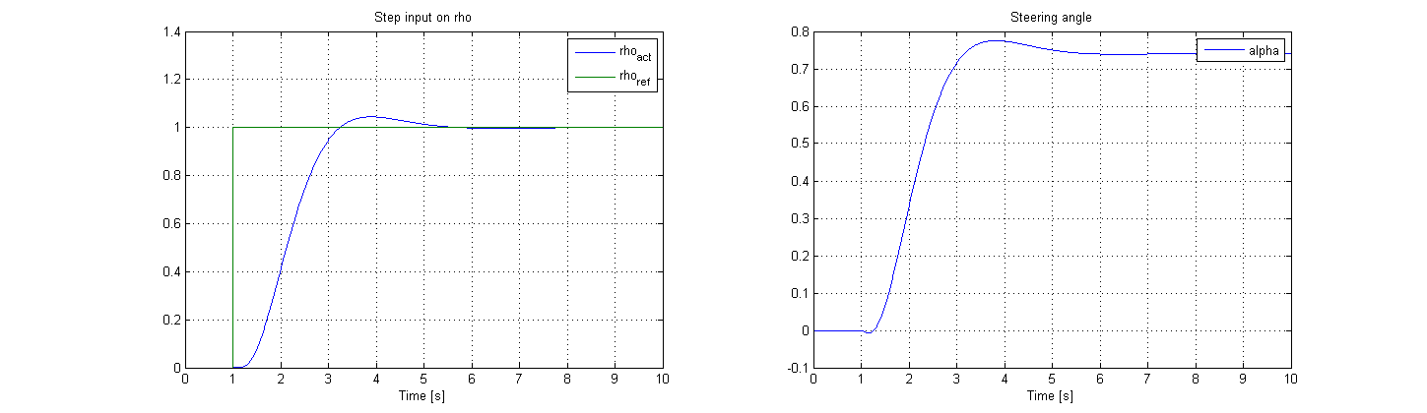

Looking at the steering angle, we can nicely see the non-minimum phase behavior