ATIC Exercise 11

a)

i) model_car:

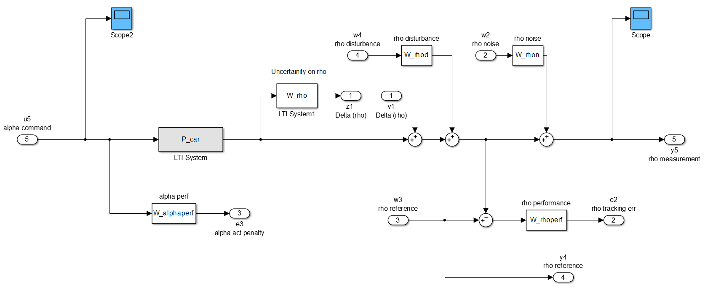

[A_P,B_P,C_P,D_P] = linmod('model_car');

P = ss(A_P,B_P,C_P,D_P);

P =

a =

x1 x2 x3 x4 x5 x6 x7 x8

x1 0 0 1 0 0 0 0 0

x2 0 0 0 1 0 0 0 0

x3 78.23 -59.38 0 0 0 0 0 0

x4 0 -400 0 -20 0 0 0 0

x5 40.74 0 0 0 -4 0 0 0

x6 -2.546 0 0 0 0 -0.001667 0 -0.02

x7 0 0 0 0 0 0 -1000 0

x8 0 0 0 0 0 0 0 -0.002

b =

u1 u2 u3 u4 u5

x1 0 0 0 0 0

x2 0 0 0 0 0

x3 0 0 0 0 0

x4 0 0 0 0 69.81

x5 0 0 0 0 0

x6 -0.25 0 0.25 0 0

x7 0 0 0 0 128

x8 0 0 0 0.0625 0

c =

x1 x2 x3 x4 x5 x6 x7 x8

y1 20.37 0 0 0 -2 0 0 0

y2 0 0 0 0 0 0.1333 0 0

y3 0 0 0 0 0 0 -125 0

y4 0 0 0 0 0 0 0 0

y5 10.19 0 0 0 0 0 0 0.08

d =

u1 u2 u3 u4 u5

y1 0 0 0 0 0

y2 0 0 0 0 0

y3 0 0 0 0 16

y4 0 0 1 0 0

y5 1 0.01 0 0 0

ii)

% ________

% | |

% Delta inputs: z <---| |<--- v: Delta output

% cost/errors: e <---| P |<--- w: exogenous inputs

% measurements: y <---| |<--- u: control actuation

% |_______|

%

% Outputs Inputs

%

% Delta1 (rho) z1 v1

%

% rho tracking err e2 w2 rho noise

% alpha act penalty e3 w3 rho reference

% w4 rho disturbance

%

% rho reference y4 u5 alpha command

% rho measurement y5

Iz = [1:1]';

Ie = [2:3]';

Iy = [4:5]';

Iv = [1:1]';

Iw = [2:4]';

Iu = [5:5]';

A = A_P;

Bw = B_P(:,Iw);

Bu = B_P(:,Iu);

Ce = C_P(Ie,:);

Cy = C_P(Iy,:);

Dew = D_P(Ie,Iw);

Dyw = D_P(Iy,Iw);

Deu = D_P(Ie,Iu);

Dyu = D_P(Iy,Iu);

P_test = ss(A,[Bw,Bu], [Ce;Cy],[Dew, Deu;Dyw,Dyu]);

P_test =

a =

x1 x2 x3 x4 x5 x6 x7 x8

x1 0 0 1 0 0 0 0 0

x2 0 0 0 1 0 0 0 0

x3 78.23 -59.38 0 0 0 0 0 0

x4 0 -400 0 -20 0 0 0 0

x5 40.74 0 0 0 -4 0 0 0

x6 -2.546 0 0 0 0 -0.001667 0 -0.02

x7 0 0 0 0 0 0 -1000 0

x8 0 0 0 0 0 0 0 -0.002

b =

u1 u2 u3 u4

x1 0 0 0 0

x2 0 0 0 0

x3 0 0 0 0

x4 0 0 0 69.81

x5 0 0 0 0

x6 0 0.25 0 0

x7 0 0 0 128

x8 0 0 0.0625 0

c =

x1 x2 x3 x4 x5 x6 x7 x8

y1 0 0 0 0 0 0.1333 0 0

y2 0 0 0 0 0 0 -125 0

y3 0 0 0 0 0 0 0 0

y4 10.19 0 0 0 0 0 0 0.08

d =

u1 u2 u3 u4

y1 0 0 0 0

y2 0 0 0 16

y3 0 1 0 0

y4 0.01 0 0 0

iii)

cvx_begin sdp

cvx_solver sedumi

variable X(n,n) symmetric;

variable Y(n,n) symmetric;

variable W(length(Ie),length(Ie)) symmetric;

variable Ah(n,n);

variable Bh(n,length(Iy));

variable Ch(length(Iu),n);

variable gamma_2lmi

minimize gamma_2lmi;

subject to

trace(W) < gamma_2lmi;

0.5*(...

[W, Ce*X + Deu*Ch, Ce;

X*Ce'+Ch'*Deu', X, eye(n,n);

Ce', eye(n,n),Y]+...

[W, Ce*X + Deu*Ch, Ce;

X*Ce'+Ch'*Deu', X, eye(n,n);

Ce', eye(n,n),Y]') > 0; % 0.5*(X+X') to make it symmetric (rounding errors...)

0.5*(...

[A*X+Bu*Ch+X*A'+Ch'*Bu', A+Ah', Bw;

A'+Ah, Y*A'+A'*Y+Bh*Cy+Cy'*Bh', Y*Bw+Bh*Dyw;

Bw',Bw'*Y+Dyw'*Bh', -eye(length(Iw),length(Iw))]+...

[A*X+Bu*Ch+X*A'+Ch'*Bu', A+Ah', Bw;

A'+Ah, Y*A'+A'*Y+Bh*Cy+Cy'*Bh', Y*Bw+Bh*Dyw;

Bw',Bw'*Y+Dyw'*Bh', -eye(length(Iw),length(Iw))]') < 0;

cvx_end

iv)

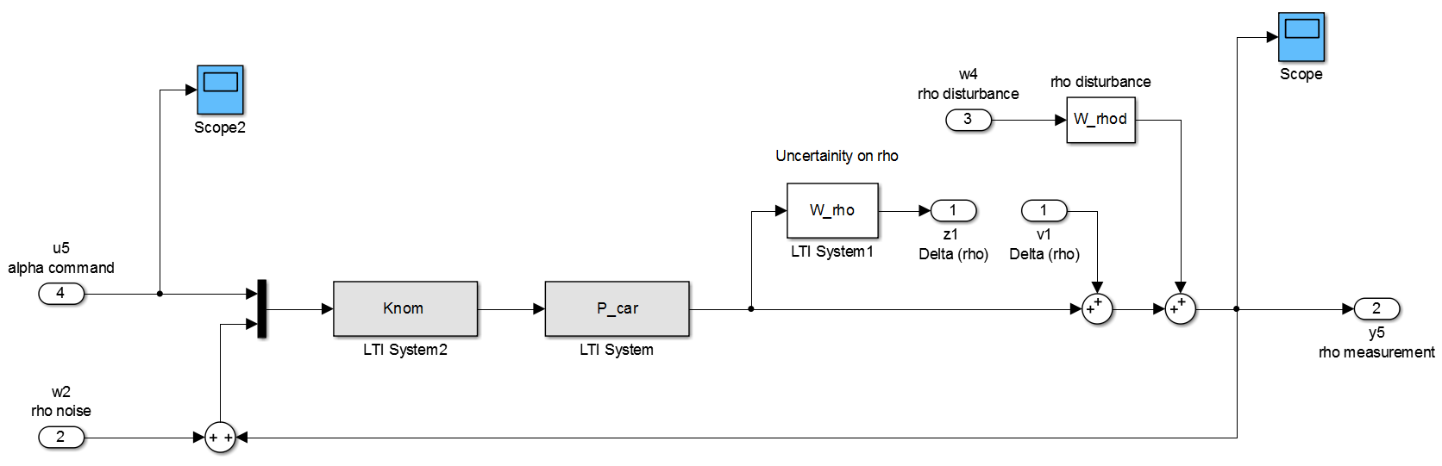

b)

Gamma value achieved: 0.2143

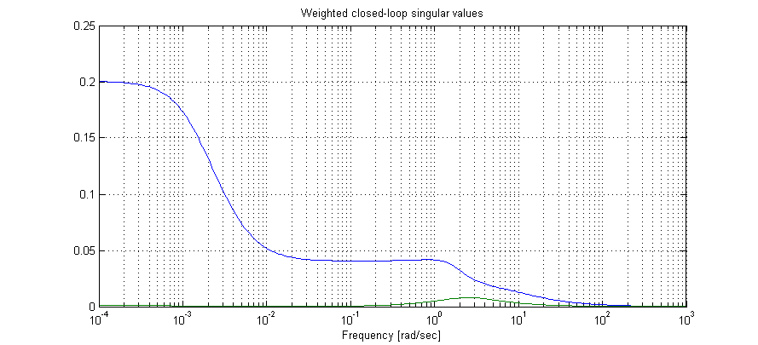

c)

% Find closed loop eigenvalues

G_cl=lft(Pnomdesign,Knom,nctrl,nmeas);

eig(G_cl)

1.0e+03 *

-0.0000 + 0.0000i

-1.0000 + 0.0000i

-0.0089 + 0.0001i

-0.0089 - 0.0001i

-0.0089 + 0.0000i

-0.0088 + 0.0000i

-0.0012 + 0.0012i

-0.0012 - 0.0012i

-0.0005 + 0.0000i

-0.0100 + 0.0173i

-0.0100 - 0.0173i

-0.0100 + 0.0173i

-0.0100 - 0.0173i

-0.0000 + 0.0000i

They all have a negative real part > stable.

d)

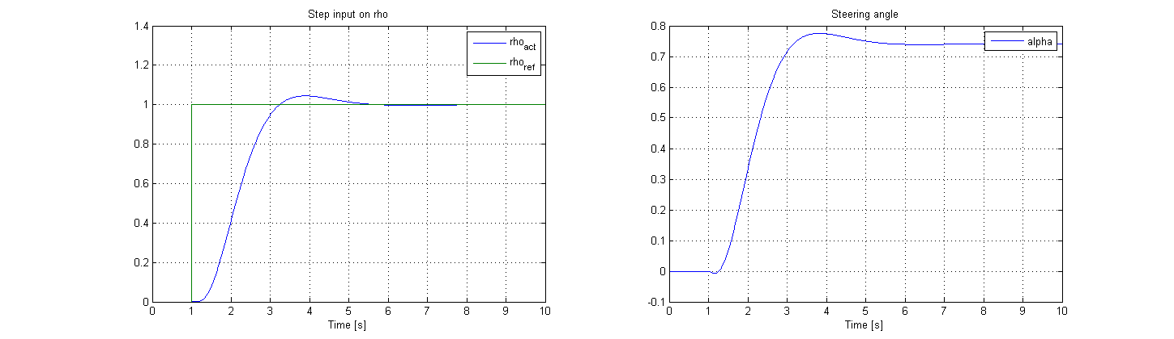

Looking at the steering angle, we can nicely see the non-minimum phase behavior