Anibody

A 2d Canvas-based game engine

*Version: 1.1.8*

Inhaltsverzeichnis

Preface 4

About this document 4

About the methodology 4

Who wants to use Anibody? 4

Idea of the Engine 4

Installation 4

Basic Concept 4

The Game Cycle - here Frame() 5

Documentation 6

Anibody 6

Anibody.* 6

EngineObject 6

ABO 6

Widget 6

DefaultCamera 6

DefaultTerrain 6

ECMAScriptExtension 6

Anibody.debug.* 6

DumbObject 6

Consolero 6

DebugWindow 6

Monitor 6

Anibody.input.* 6

Anibody.nav.* 7

BoxMenu 7

Gallery 7

SlideMenu > Tab 7

Anibody.shapes.* 7

Shape 7

Rectangle 7

Circle 7

Triangle 7

Anibody.ui.* 7

Alert 7

Confirm 7

Prompt 7

MultipleChoice 7

ColorPicker 7

Button 7

InputField 7

Slider 7

Switch 7

Toaster 7

Anibody.util.* 7

PriorityQueue 7

Timer 7

IntervalHandler 7

Counter 7

Flow 7

MultiFlow 7

MediaManager 7

Storage 7

Task > Step 7

Anibody.visual.* 7

ABOPresenter 7

Animation 7

ImageObject 7

ABText 7

CoordinateSystem 7

Highlighting 7

Spline 8

Spotting 8

Sprite 8

Anibody.static.* 8

FAQ 8

Where can I find an example project? 8

# Preface

## About this document

This documentation will cover the Anibody Engine in great detail. Please note, that not all of the components, methods and attributes are described here. This can have one of the following reasons:

1. The feature is not important or deprecated.
2. The feature should only be used internally (often marked by the underscore “_” in front of the name)
3. It was simply forgotten to be added to the document. In that case, a reminder or a short message is more than welcomed.

## About the methodology

In this document, the methodology is a combination of listing the features with further description plus a short excerpt of an example (code snippets), in which the represented feature is being used.

|  |
| --- |
| // It is hoped that by doing so the learning effect will be increased |

Please see: FAQ for further examples. Where can I find an example project?

## Who wants to use Anibody?

Anyone who wants to bring his or her interactive animations or games to live and does not want to start from scratch. Anyone who wants to express them on the web and does not want to discriminate the viewer for what operation system or browser they use.

## Idea of the Engine

It provides the developer a possibility to implement game elements or interactive animations with less writing effort in a short period of time.

It is HTML5-conform and hence cross-browser friendly.

## Installation

|  |
| --- |
| <!-- You do not have to use jquery but if you do than jquery should be included before anibody -->  <script type="text/javascript" src="jqueryXYZ.js"></script>  <script type="text/javascript" src="anibodyXYZ.js"></script> |

## Basic Concept

All game related objects, which are registered for the Anibody engine, are going through the game cycle, when the Frame() method is called.

By default, a Timer calls the Frame() method 25 times per second – also known as FPS ( frames per second).

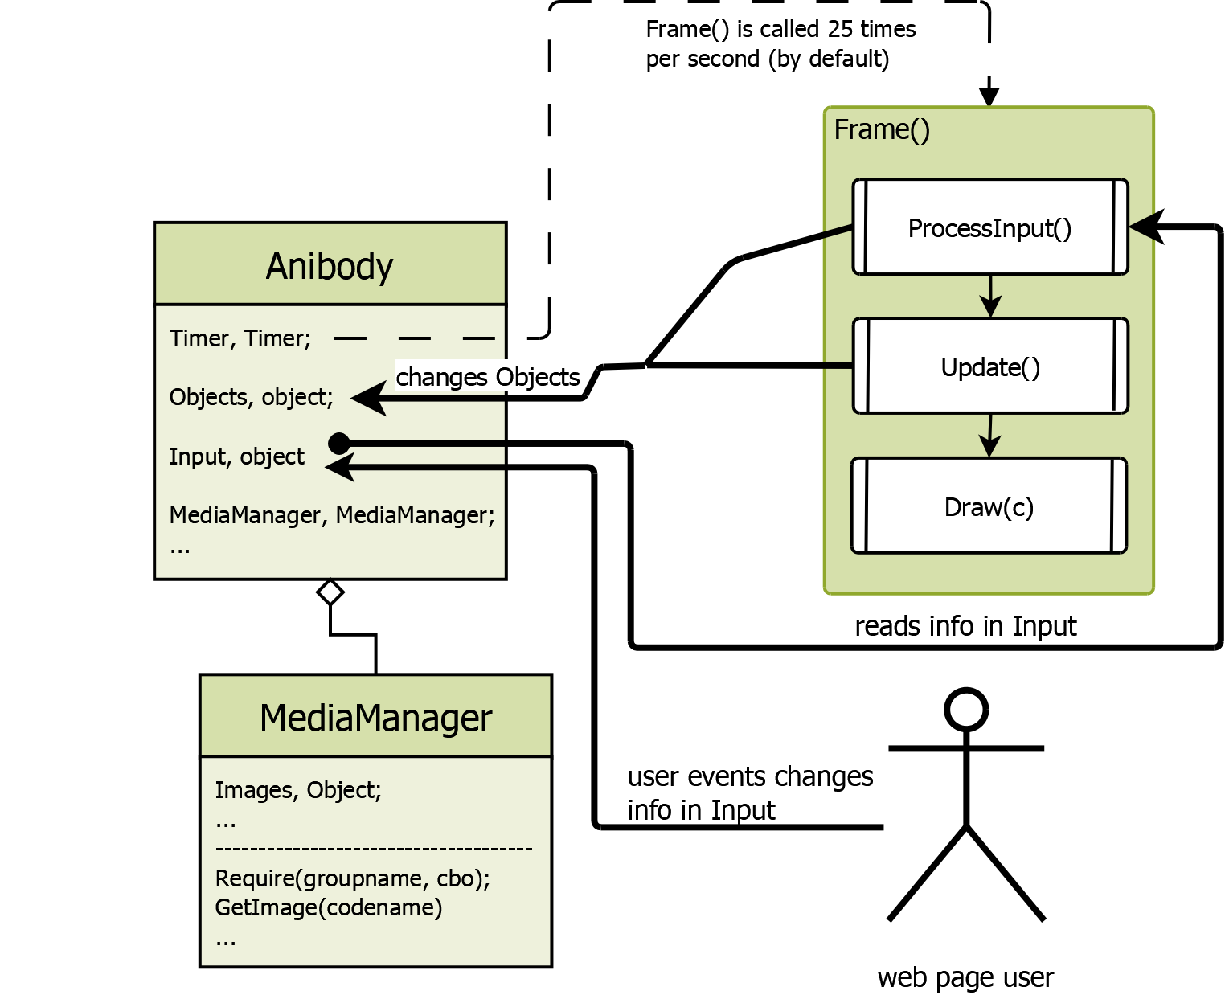

### The Game Cycle - here Frame()

**ProcessInput()**

In this phase of the game cycle, it is usual practice to read the information, which is saved in Anibody.Input, and manipulate the representative object or the environment according to your game logic.

For example: If the W key is pressed then move the representative game object 10 pixel upwards.

|  |
| --- |
| //this.Engine is a reference to the Anibody engine  if (this.Engine.Input.Keys.W.FramesPressed === 1) {  this.Move(0, -10);  } |

**Update()**

In this phase, if it is necessary to your game logic you can check the representative object or the general environment and handle the situation accordingly.

For example: If the mouse is over the graphical representation of this object, switch the cursor of the mouse to the “pointer”.

|  |
| --- |
| if(this.IsMouseOver)  this.Engine.Input.Mouse.Cursor.pointer(); |

Note: *At the end of ProcessInput(), the engine will resolve over which object the mouse is hovering, so now in the Update() you can safely check this.*

**Draw(c)**

In this phase every object with a graphical representation will be drawn on the canvases context (c variable).

# Documentation

## Anibody

This is the main class. This is the engine. By default, it contains a timer, which calls the Frame()-Methode 25 times per second (known as FPS, “frames per second”). Through an option parameter the engine’s timer can be set to a different value or being canceled completely.

## Anibody.*

### EngineObject

### ABO

### Widget

### DefaultCamera

### DefaultTerrain

## ECMAScriptExtension

## Anibody.debug.*

### DumbObject

### Consolero

### DebugWindow

### Monitor

## Anibody.input.*

- not the classes are important but the structure and the meaning of the data here

## Anibody.nav.*

### BoxMenu

### Gallery

### SlideMenu > Tab

## Anibody.shapes.*

### Shape

### Rectangle

### Circle

### Triangle

## Anibody.ui.*

### Alert

### Confirm

### Prompt

### MultipleChoice

### ColorPicker

### Button

### InputField

### Slider

### Switch

### Toaster

## Anibody.util.*

### PriorityQueue

### Timer

### IntervalHandler

### Counter

### Flow

### MultiFlow

### MediaManager

### Storage

### Task > Step

## Anibody.visual.*

### ABOPresenter

### Animation

### ImageObject

### ABText

### CoordinateSystem

### Highlighting

### Spline

### Spotting

### Sprite

## Anibody.static.*

# FAQ

## Where can I find an example project?

The Github repository is a big example. You can clone it and test it on your own server or click the link found in the README.md to test it without any further time to waste.