Computer programming

Final Project

Report

I.E.S. San Vicente
San Vicente del Raspeig (Alicante)
2017/2018

Teachers:
José Ignacio Cabanes / Ignacio Iborra

Student:
XXX

-= Note: all the texts included here are just an example
of the way that the report should look when finished
Each student must replace these texts with
the ones corresponding to their projects =-

1. Introduction
Project name
Feed your baby

Made by
Daniel Miquel Sirera

Short description of the project
This is a program to feed a baby from 0 to 1 year, the user can choose the foods he wants to give his baby considering the allergies and problems with food.
I use Windows Forms

2. Functionality of the project
The program collects the data of a baby entered by the user, with this data will search in a database the food that the baby can eat and organizes it in a calendar of the 7 days of the week.

The selection of food will have the criterion of not over repeating a type of food, with certain exceptions.
It will have an allergy option to eliminate these foods from the menu.

3. Screen prototype
The program screen will look like this:

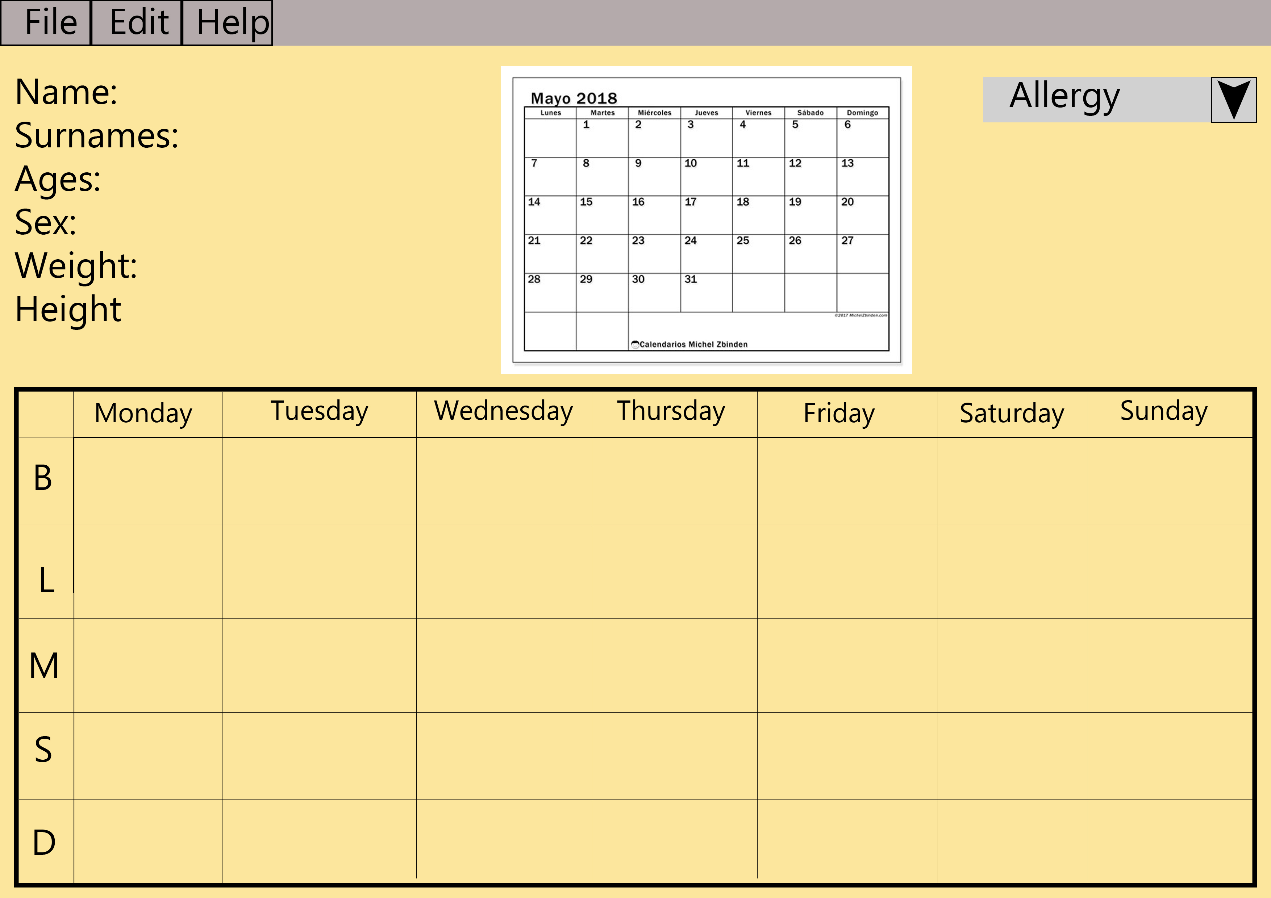

4.Analysis

4a. Requisites
Requisite | Date achieved
The program will allow adding and removing a child with all the data | X
The program will allow modify information of a child | X
The program will allow save and load information of children | X
The program will allow show the children information and diet
The program will allow save the all children progress and can load a specific day for show what did he do that day
The program will allow select a specific diet for a child considering allergies
The intro screen will allow he user can see list of children
The program will allow save a pdf file
The program will allow message between school and home

4b. Basic pseudocode

Program body:
Display welcome screen
Wait for user to press a key
If key = ESC, quit program
If key = 1, start one player game
…

One player game:
Display level selection screen
Wait for user to press a key
If key = ESC, return
…

…

4c. Classes diagram
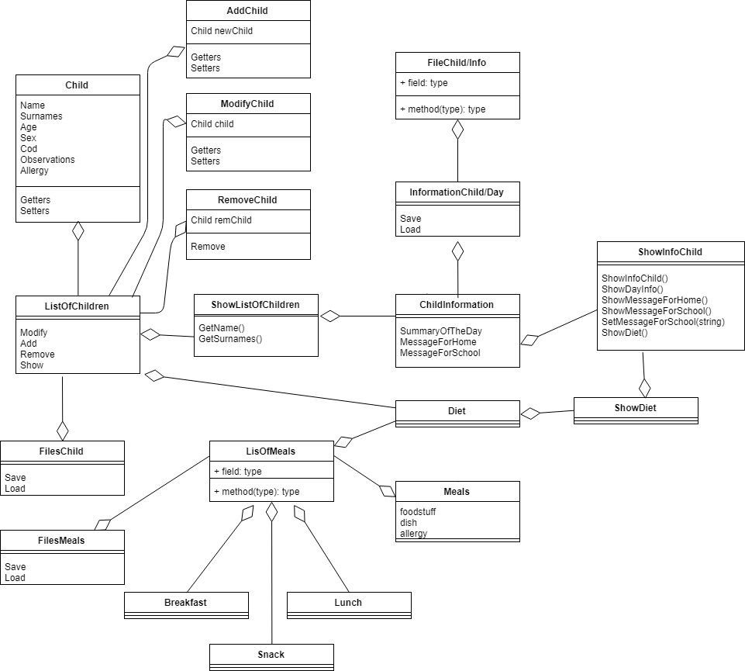

5. Initial planning and expected deliveries

5a. Expected deliveries

- Create files to save children and meals and load that information with a default format.
- Create the child and meals classes, create classes ListOfChild and ListOfMeals to create, save and load the information of files.
- Separate the information according to the corresponding parameter in ListOfChild and ListOfMeals.
- Add and remove a child of ListOfChildren.
- Modify a child of ListOfChildren.
- Cross the data of children's allergies with possible meals
- Choose foods for all children with allergies
- Create ChildInofrmation class to take all information about a child and show
- Show the child’s diet and possibility to change a meal.
- Show the information of child with the passage of messages between the nursery and parents.
- Save the information of every day of the children's progress.
- Load all children’s progress to show.
- Load child information of the specified day.
- Windows Forms, interface for the user.
- Save to pdf with style.

5b. Real deliveries
- Create files and clasess FileChild and FileMeals to save children and meals and load that information with a default format, create class Child and Meal.
- Create classes ListOfChild and ListOfMeals, abstract clas FoodType, and classes Snack, Breakfast, Lunch.
Classes ListOfChild and ListOfMeals already receive children and meals, ListOfChild separate the information and show to screen.
- Separate the information according to the corresponding parameter in ListOfChild and ListOfMeals to be able to work with the information, ListOfMeals show to screen.Can delete children.
- Created methods to removeChild, GetChild with an index, modify Childs and show child in form edit.
- Add,modify and remove child of list(in the absence of allergies at modify and add).
- Cross the data of children's allergies with possible meals and show for one child.
- Choose foods for all children with allergies and start to created classes related with Information of Children of all Days.

6. File formats

6a. Plain files format
The scores table is saved to a text file, which contains the name of a player in one line, and the corresponding score in the following line, and so on, to complete the 10 highest scores, as in this example:

John
125
Peter
116
…

6b. Entity-Relationship Diagram (If needed)
(…)

7. Problems found and solutions
I preferred not to use the SDL library directly, which I found difficult to learn, so I have used the classes "Hardware", "GraphicsElement" and "Font" that we had used previously in class games (...)

Although in the level 3 (hard) I check the next three movements, sometimes the computer makes foolish moves, but always in the first column. I have not found where the bug is, but I think the problem may lie in this portion of code, in which I check each column versus the previous one: (...)

I noticed that if I take the game to another computer which has not the DotNet Framework installed in it, the program closes without any error or warning message (...)

(…)

8. Improvements or restrictions to the starting design
I have had time enough to include the effect of animation when the pieces fall (…)

I have not been able to implement (…) because of (…)

9. Screenshots of the final project
(…)

10. Source code of the final project
(…)

