### Acting with Integrity

Clients, customers, suppliers, investors, retailers, employees, the media, the government, members of the surrounding community, competitors, and even the environment are **stakeholders** in a business; that is, they are individuals and entities affected by the business’s decisions ([Figure 1.2](https://openstax.org/books/business-ethics/pages/1-1-being-a-professional-of-integrity#OSX_Ethics_01_01_Stakeholders)). Stakeholders typically value a leadership team that chooses the ethical way to accomplish the company’s legitimate for-profit goals. For example, Patagonia expresses its commitment to environmentalism via its “1% for the Planet” program, which donates 1 percent of all sales to help save the planet. In part because of this program, Patagonia has become a market leader in outdoor gear.

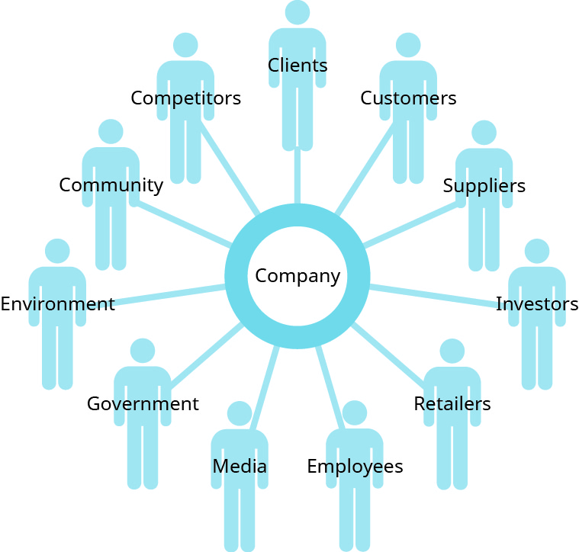

**Figure 1.2** Stakeholders are the individuals and entities affected by a business’s decisions, including clients, customers, suppliers, investors, retailers, employees, the media, the government, members of the surrounding community, the environment, and even competitors. (attribution: Copyright Rice University, OpenStax, under CC BY 4.0 license)

Being successful at work may therefore consist of much more than simply earning money and promotions. It may also mean treating our employees, customers, and clients with honesty and respect. It may come from the sense of pride we feel about engaging in honest transactions, not just because the law demands it but because we demand it of ourselves. It may lie in knowing the profit we make does not come from shortchanging others. Thus, **business ethics** guides the conduct by which companies and their agents abide by the law and respect the rights of their stakeholders, particularly their customers, clients, employees, and the surrounding community and environment. Ethical business conduct permits us to sleep well at night.

### LINK TO LEARNING

Are business ethics an oxymoron? [Read “Why Ethics Matter” to understand](https://openstax.org/l/53oxymoron) just a few of the reasons to have values-driven management.

Nearly all systems of religious belief stress the building blocks of engaging others with respect, empathy, and honesty. These foundational beliefs, in turn, prepare us for the codes of ethical behavior that serve as ideal guides for business and the professions. Still, we need not subscribe to any religious faith to hold that ethical behavior in business is still necessary. Just by virtue of being human, we all share obligations to one another, and principal among these is the requirement that we treat others with fairness and dignity, including in our commercial transactions.

For this reason, we use the words *ethics* and *morals* interchangeably in this book, though some philosophers distinguish between them. We hold that “an ethical person” conveys the same sense as “a moral person,” and we do not regard religious belief as a requirement for acting ethically in business and the professions. Because we are all humans and in the same world, we should extend the same behavior to all. It is the right way to behave, but it also burnishes our own professional reputation as business leaders of integrity.

Integrity—that is, unity between what we say and what we do—is a highly valued trait. But it is more than just consistency of character. Acting with **integrity** means we adhere strongly to a code of ethics, so it implies trustworthiness and incorruptibility. Being a professional of integrity means consistently striving to be the best person you can be in all your interactions with others. It means you practice what you preach, walk the talk, and do what you believe is right based upon reason. Integrity in business brings many advantages, not the least of which is that it is a critical factor in allowing business and society to function properly.

Successful corporate leaders and the companies they represent will take pride in their enterprise if they engage in business with honesty and fair play. To treat customers, clients, employees, and all those affected by a firm with dignity and respect *is* ethical. In addition, laudable business practices serve the long-term interests of corporations. Why? Because customers, clients, employees, and society at large will much more willingly patronize a business and work hard on its behalf if that business is perceived as caring about the community it serves. And what type of firm has long-term customers and employees? One whose track record gives evidence of honest business practice.

### LINK TO LEARNING

In [this interview, Mark Faris, a white-collar criminal convicted of fraud, claims that greed, arrogance, and ambition were motivating factors](https://openstax.org/l/53MarkFaris) in his actions. He also discusses the human ability to rationalize our behavior to justify it to ourselves. Note his proposed solutions: practicing ethical leadership and developing awareness at an individual level via corporate training.

Many people confuse legal and ethical compliance. They are, however, totally different and call for different standards of behavior. The concepts are not interchangeable in any sense of the word. The law is needed to establish and maintain a functioning society. Without it, our society would be in chaos. Compliance with these legal standards is strictly mandatory: If we violate these standards, we are subject to punishment as established by the law. Therefore, **compliance** in terms of business ethics generally refers to the extent to which a company conducts its business operations in accordance with applicable regulations, statutes, and laws. Yet this represents only a baseline minimum. Ethical observance builds on this baseline and reveals the principles of an individual business leader or a specific organization. Ethical acts are generally considered voluntary and personal—often based on our perception of or stand on right and wrong.

Some professions, such as medicine and the law, have traditional codes of ethics. The Hippocratic Oath, for example, is embraced by most professionals in health care today as an appropriate standard always owed to patients by physicians, nurses, and others in the field. This obligation traces its lineage to ancient Greece and the physician Hippocrates. Business is different in not having a mutually shared standard of ethics. This is changing, however, as evidenced by the array of codes of conduct and mission statements many companies have adopted over the past century. These have many points in common, and their shared content may eventually produce a code universally claimed by business practitioners. What central point might constitute such a code? Essentially, a commitment to treat with honesty and integrity customers, clients, employees, and others affiliated with a business.

The law is typically indebted to tradition and precedence, and compelling reasons are needed to support any change. Ethical reasoning often is more topical and reflects the changes in consciousness that individuals and society undergo. Often, ethical thought precedes and sets the stage for changes in the law.

Behaving ethically requires that we meet the mandatory standards of the law, but that is not enough. For example, an action may be legal that we personally consider unacceptable. Companies today need to be focused not only on complying with the letter of the law but also on going above and beyond that basic mandatory requirement to consider their stakeholders and do what is right.

### LINK TO LEARNING

To see [an example of a corporate ethical code](https://openstax.org/l/53J&Jcredo) or mission statement, visit Johnson & Johnson and read “Our Credo” written by former chair Robert Wood Johnson.

*Forbes* provides [an annual list of companies recently deemed the most ethical](https://openstax.org/l/53EthicalBus) according to their standards and research.

### Ends, Means, and Character in Business

How, then, should we behave? Philosophy and science help us answer this question. From philosophy, three different perspectives help us assess whether our decisions are ethical on the basis of reason. These perspectives are called **normative ethical theories** and focus on how people ought to behave; we discuss them in this chapter and in later chapters. In contrast, *descriptive ethical theories* are based on scientific evidence, primarily in the field of psychology, and describe how people tend to behave within a particular context; however, they are not the subject of this book.

The first normative approach is to examine the ends, or *consequences*, a decision produces in order to evaluate whether those ends are ethical. Variations on this approach include utilitarianism, teleology, and consequentialism. For example, **utilitarianism** suggests that an ethical action is one whose consequence achieves the greatest good for the greatest number of people. So if we want to make an ethical decision, we should ask ourselves who is helped and who is harmed by it. Focusing on consequences in this way generally does not require us to take into account the means of achieving that particular end, however. That fact leads us to the second normative theory about what constitutes ethical conduct.

The second approach does examine the *means,* or actions, we use to carry out a business decision. An example of this approach is **deontology**, which essentially suggests that it is the means that lend nobility to the ends. Deontology contends that each of us owes certain duties to others (*deon* is a Greek word for duty or obligation) and that certain universal rules apply to every situation and bind us to these duties. In this view, whether our actions are ethical depends only on whether we adhere to these rules. Thus, the means we use is the primary determinant of ethical conduct. The thinker most closely associated with deontology is the eighteenth-century German philosopher Immanuel Kant ([Figure 1.3](https://openstax.org/books/business-ethics/pages/1-1-being-a-professional-of-integrity#OSX_Ethics_01_01_Kant)).

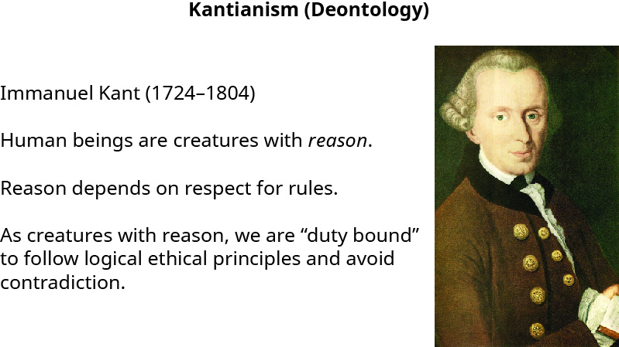

**Figure 1.3** Immanuel Kant was an eighteenth-century philosopher, now associated with deontology, who spent nearly all his professional life teaching at the university in Königsberg (which today is Kaliningrad, the westernmost point in Russia). (credit right: modification of “Kant foto” by “Becker”/Wikimedia Commons, Public Domain)

The third normative approach, typically called **virtue theory**, focuses on the *character* of the decision-maker—a character that reflects the training we receive growing up. In this view, our ethical analysis of a decision is intimately connected with the person we choose to be. It is through the development of habits, the routine actions in which we choose to engage, that we are able to create a character of integrity and make ethical decisions. Put differently, if a two-year-old is taught to take care of and return borrowed toys even though this runs contrary to every instinct they have, they may continue to perfect their ethical behavior so that at age forty, they can be counted on to safeguard the tens of millions of dollars investors have entrusted to their care in brokerages.

Virtue theory has its roots in the Greek philosophical tradition, whose followers sought to learn how to live a flourishing life through study, teaching, and practice. The cardinal virtues to be practiced were courage, self-control, justice, and wisdom. Socrates was often cited as a sage and a role model, whose conduct in life was held in high regard.

### ETHICS ACROSS TIME AND CULTURES

#### Aristotle and the Concept of Phronesis, or Practical Wisdom

*Phrónēsis* (fro-NEE-sis) is a type of practical wisdom that enables us to act virtuously. In “The Big Idea: The Wise Leader,” a *Harvard Business Review* article on leadership and ethical decision-making, Ikujiro Nonaka, a Japanese organizational theorist, and Hirotaka Takeuchi, a professor of Management Practice at Harvard Business School, discuss the gap between the theory and practice of ethics and which characteristics make a wise leader.[1](https://openstax.org/books/business-ethics/pages/1-end-notes#rf-001) The authors conclude that “the use of explicit and tacit knowledge isn’t enough; chief executive officers (CEOs) must also draw on a third, often forgotten kind of knowledge, called practical wisdom. Practical wisdom is tacit knowledge acquired from experience that enables people to make prudent judgments and take actions based on the actual situation, guided by values and morals.”

The concept of practical wisdom dates back to Aristotle, who considered phronesis, which can also be defined as prudence, to be a key intellectual virtue. Phronesis enables people to make ethically sound judgments. According to the authors, phronetic leaders:

* practice moral discernment in every situation, making judgments for the common good that are guided by their individual values and ethics;
* quickly assess situations and envision the consequences of possible actions or responses;
* create a shared sense of purpose among executives and employees and inspire people to work together in pursuit of a common goal;
* engage as many people as possible in conversation and communicate using metaphors, stories, and other figurative language in a way that everyone can understand; and
* encourage practical wisdom in others and support the training of employees at all levels in its use.

In essence, the first question any company should ask itself is: “Do we have a moral purpose?” Having a moral purpose requires focusing on the common good, which precedes the accumulation of profit and results in economic and social benefits. If companies seek the common good, profits generally will follow.