Moose Environment

An innovative shopping solution

Prepared for: SE, Unibz, 2016

Prepared by: Matthias Moroder, Daniel Morandini

5 June 2016

# Final project report

## Problem description

As an electronics hobbyist, you will encounter the challenge of component sourcing at some point. Currently there are two solutions, either to get them from local distributors, possibly receiving them the day after but at high costs, or to buy them from Chinese sellers, at a fraction of the price, but with very slow shipping, which can take from four up to ten or more weeks to be delivered. Because of this, many tend to buy components they may need at some point in advance, that way building up a rather big collection of components, which they probably never ever use.

## Goals

Creating an environment that can actually save people’s money and time, giving th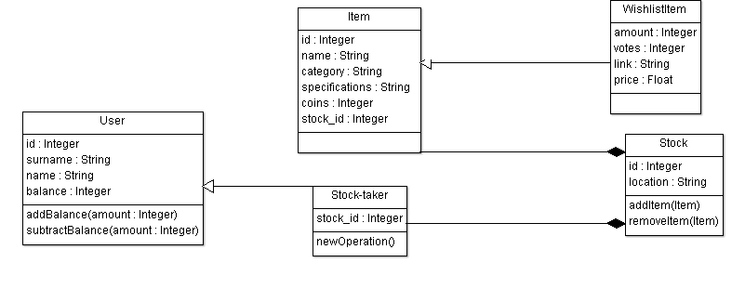em the possibility to take from a stock just what they need and at the lowest price possible.

## Solution

By grouping together multiple people we have the ability to have more components, while reducing the cost per person. Selected people act as stock-takers ordering successfully proposed items and keeping them available for others. The software gives the possibility to look up available components, request them from the respective stock-taker and to propose new items, which are ordered if enough users vote for them. Inside the system all the payment is done by credit points, which an user gets in exchange for real money, which then gets used to order new components.

## Project Outline

Class diagram

sequence d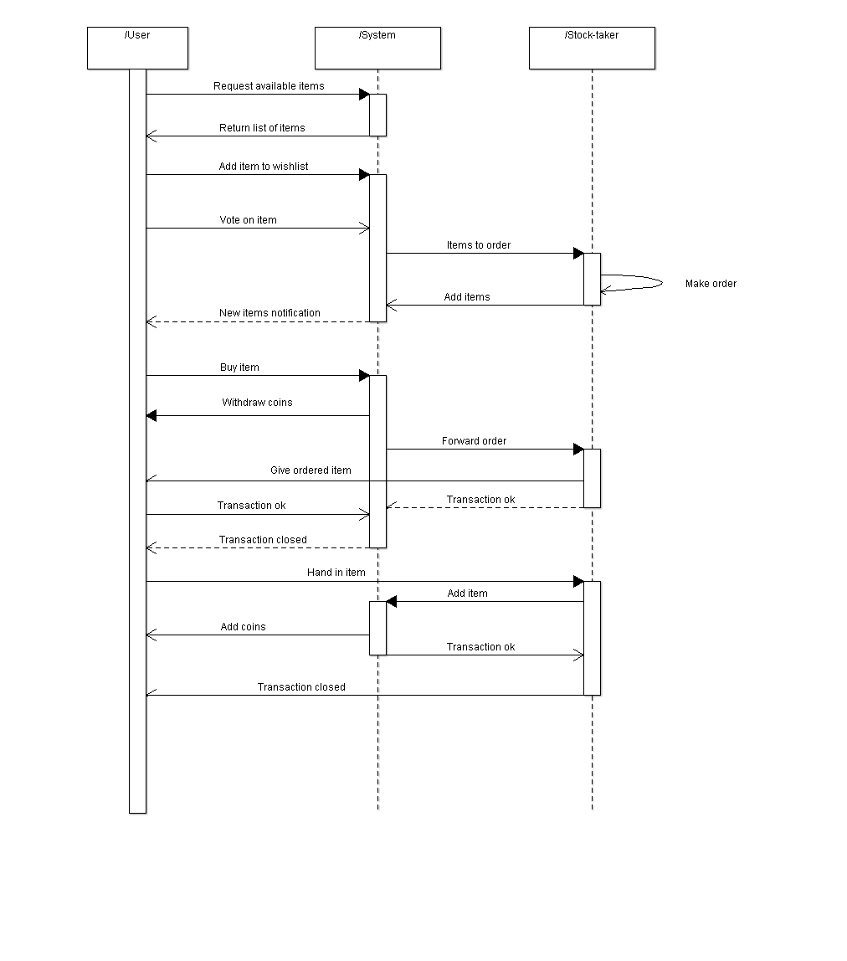iagram

Use case diagram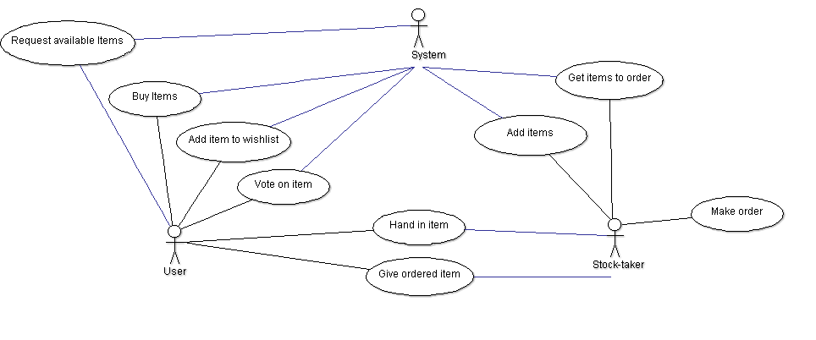

## Instructions

We preinstalled and configured a Raspberry-pi in the faculty ([rpi3-01.unibz.it](http://rpi3-01.unibz.it)) that will host our server during this week, so you just need to run the client application.

During the project we preferred to keep all of our data in the git repository of our project, and in order to simplify our work, we wrote a Wiki for the server Api and other use cases.

We kindly invite you to read it, because we hope that the Wiki will help you in the understanding of the logic and usage of the whole application.

* [Wiki](https://github.com/danielmorandini/moose-env/wiki)
* [Milestone/Issues](https://github.com/danielmorandini/moose-env/milestones)
* [Whole repo](https://github.com/danielmorandini/moose-env)