# Test cases for Blackjack program Aces.

# Scenario 1:

In the first scenario, the player hits and receive and Ace card. The value taken for Ace is 1 instead of 11 because we already had a 15.

Player’s hand: HQ, H5, SA

Card values: (10 + 5 + 1)

Score output: 16

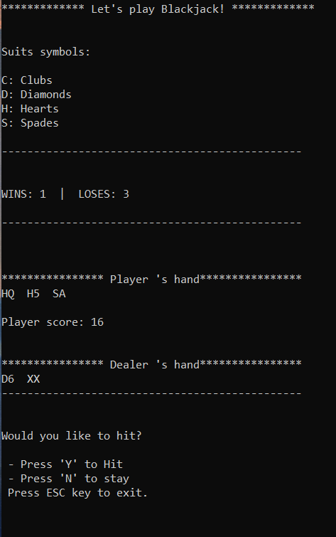

We hit again and receive a King of hearts with a value of ten which ends in a bust for the player.

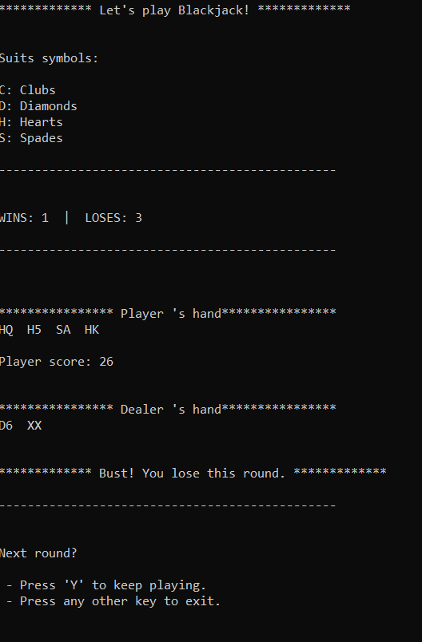

# Scenario 2:

In this scenario, we hit cards until we have two aces. The program calculates with a value of 1.

Player’s hand: SA, H2, S7, C8, HA

Card values: (1 + 2 + 7 + 8 + 1)

Score output: 19

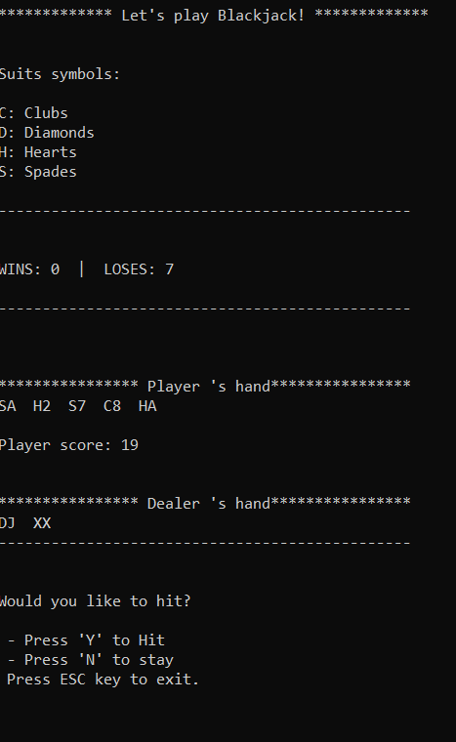

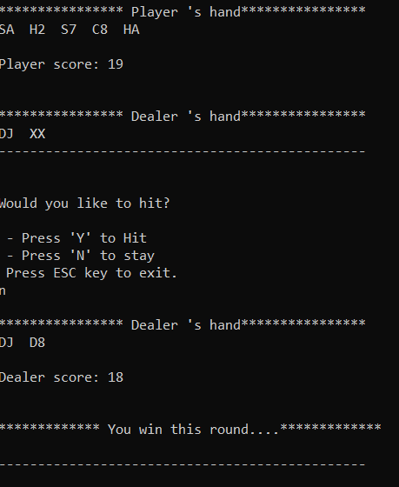

Dealer scored an 18 therefore player wins the round.

# Scenario 3: Blackjack

In this scenario, we have a Blackjack, which means the player receives a total score of 21 in the first deal automatically winning the round.

The program chooses a value of 11 for the Ace card.

**Player’s hand**: SJ, CA

**Card values:** (10 + 11)

**Score output:** 21

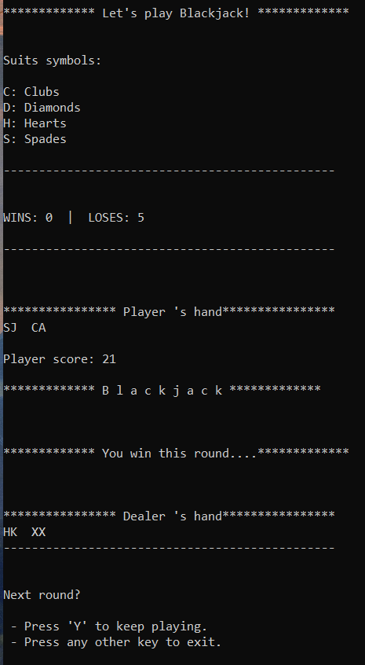

# Scenario 4:

I added a test case in the code to intentionally add 8 cards at the top of the deck BEFORE dealing and in the next order: H8, HA, D8, DA... and so on.

By doing this we test the values for the Ace cards.

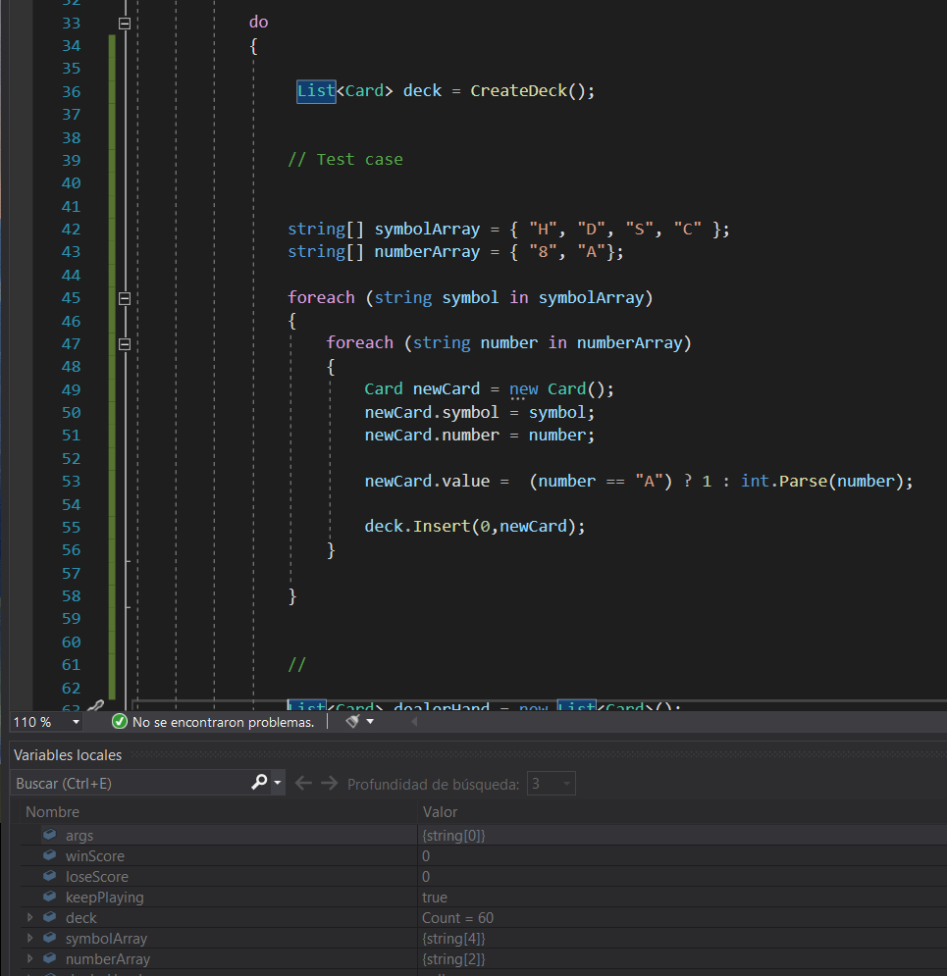

***(Now we have a total of 60 cards in the deck)***

The player receives the first two cards CA, C8 with a score of (11 + 8) = 19 as shown in the next image.

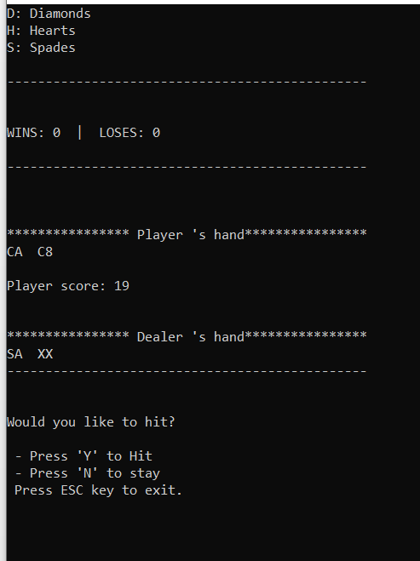

We hit a card in order to receive a secure Ace for the next series having a new score as shown in the next image. The next Ace is counted as 1.

**Player’s hand:** CA, C8, DA

**Card values:** (11 + 8 + 1)

**Score output:** 20

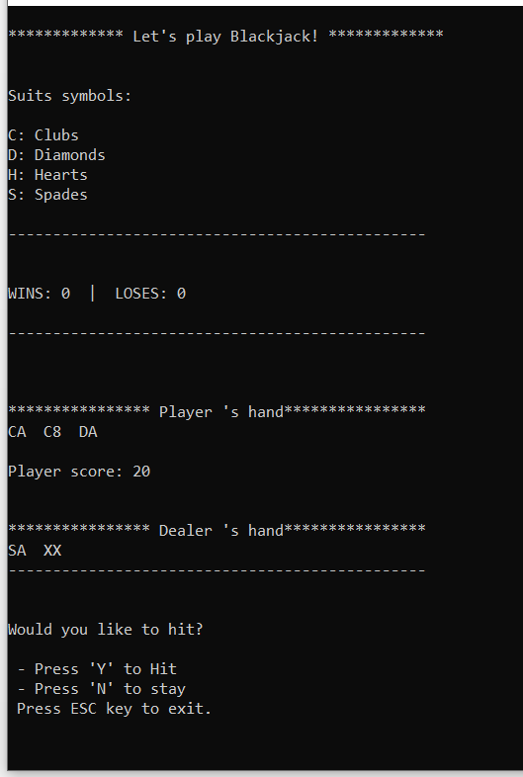

We hit once more to receive a secure 8 card. Now both aces should have a value of 1 each. Having a new score of 18.

**Player’s hand:** CA, C8, DA, D8

**Card values:** (1+ 8 + 1 + 8)

**Score output:** 18

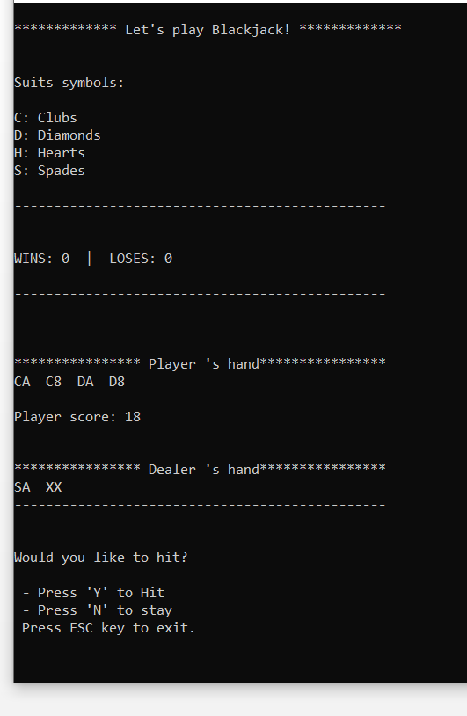

If we hit TWO more times, we will end up in having a bust.

**Player’s hand:** CA, C8, DA, D8, HA, H8

**Card values:** (1+ 8 + 1 + 8 + 1 + 8)

**Score output:** 27

