
Ain Shams University Faculty of Engineering
International Credit Hours Engineering Programs (I-CHEP)

PrimeStay Hotel

Submitted to:
Dr. Mahmoud Ibrahim Khalil Eng. Mazen Tarek Samy
Faculty of Engineering of Ain Shams University

Submitted by:
Daniel Mourad 25P0365
Mario Soliman 25P0226
Hana Ahmed 25P0376
Mohamed Khaled 25P0127
Rawan Mohamed 25P0239

9/5/2026

GitHub Repository:
https://github.com/danielmourad376/Desktop__Hotel__Reservation__System.git

Youtube Link:
https://youtu.be/lFSBCyaPz3o

Executive Summary
For Milestone 2, our engineering team executed a complete paradigm shift, deprecating the legacy console-based interface of Phase 1 to develop a modern, event-driven desktop application. We utilized the JavaFX framework to implement a rigorous Model-View-Controller (MVC) architecture. Beyond the core requirements, we successfully engineered advanced subsystems including an asynchronous concurrency model for real-time UI updates, and an ACID-compliant SQLite relational database for absolute data persistence.
Front-End Architecture & UX Design We abandoned standard, unstyled Java components in favor of a production-grade graphical interface driven by custom FXML layouts and advanced CSS styling.
- The Authentication Gateway: As demonstrated in our system deployment, the entry point features a sophisticated, dark-themed login and registration modal. We utilized StackPane and VBox layouts to create a responsive authentication card. The UI implements modern design principles, including border-radius clipping, and a medium-contrast light grey-on-dark-navy color palette. 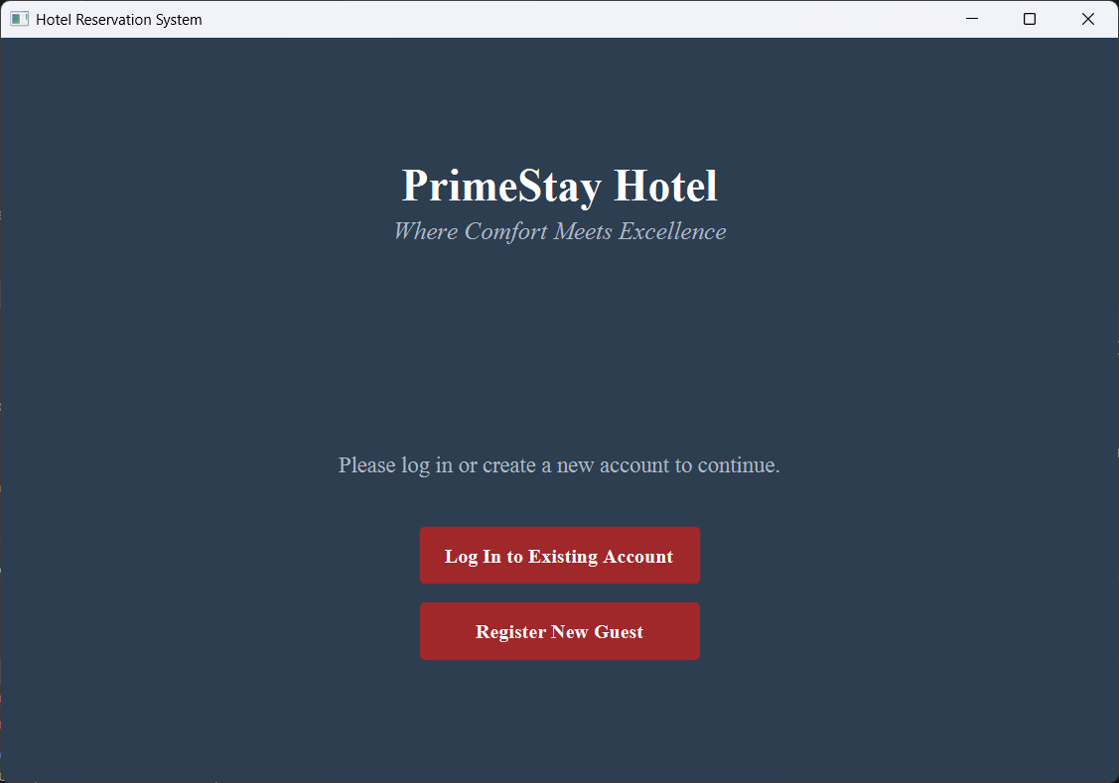
- Dynamic View Routing: Rather than instantiating multiple overlapping windows, our custom SceneManager utilizes the FXMLLoader to seamlessly inject and swap root nodes on a single Stage, ensuring optimal memory management and fluid user experience.
- Input Validation: The registration forms intercept bad data (e.g., mismatched passwords or missing fields) at the controller level, surfacing immediate, non-blocking visual feedback to the user via dynamic error labels rather than relying on console-level exceptions.
Concurrency & UI Synchronization One of the most persistent issues in heavy data applications is the "UI freeze" during background operations. To achieve a highly reactive dashboard, we integrated Java’s Concurrency API and advanced controller routing.
- Asynchronous Data Fetching: To prevent the main JavaFX Application Thread from freezing during heavy I/O database operations, we implemented background Runnable tasks. When a user requests to view available rooms or load massive reservation histories, a secondary thread fetches the data arrays from SQLite.
- Thread-Safe UI Updates: Because the JavaFX scene graph is not thread-safe, direct manipulation from a background thread triggers a fatal NotOnFXThreadException. We engineered around this by wrapping all state-to-UI binding updates inside Platform.runLater(), successfully bridging our background data retrieval with the main application thread.
- Event-Driven UI Synchronization: we have engineered a highly efficient parent-child controller delegation model. Sub-controllers (such as ManageRoomsController and ManageReservationsController) are injected with a reference to the main AdminController. Upon executing a successful database transaction, the child controller immediately forces the parent to recalculate the system statistics. This guarantees the executive dashboard displays real-time metrics with zero thread overhead or latency.
Persistent Relational Data Management To transition from volatile in-memory storage to a production-ready persistent state, we bypassed simple text files and integrated the SQLite JDBC driver.
- Initialization Protocol: Upon execution, our DatabaseHelper connects to a compiled .db binary. It executes bulk SQL SELECT queries, mapping the relational table data directly back into our Java Object models.
- Primary Key Synchronization: To bridge the gap between static Java memory and the relational database, we engineered a custom initialization protocol. During the SQLite load phase, the system intercepts existing Primary Keys (e.g., A4 for a Mini Fridge) and dynamically shifts the static idCounters in our Java classes. This prevents Ghost ID collisions and ensures seamless auto-incrementing when generating new records.
- Real-Time Data Persistence (ACID Compliance): Instead of relying on volatile shutdown hooks, our system implements real-time Object-Relational Mapping (ORM). Whenever an actor manipulates a domain object (e.g., an Admin editing a room or a Guest processing a checkout), the backend service layer simultaneously updates the Java Object in RAM and fires a parameterized JDBC UPDATE, INSERT, or DELETE query directly to the SQLite binary. This guarantees absolute data integrity and zero data loss, even in the event of an unexpected hardware or application crash.
Object-Oriented Domain Logic
- Decoupled Service Layer: We strictly adhered to the MVC design pattern by stripping all database logic out of our domain models (Invoice, Reservation, Room). Instead, database interactions are routed through our Actor classes (Admin, Receptionist, Guest). This ensures that the JavaFX UI Controllers act purely as input/output viewers, delegating all complex validation, financial calculations, and data persistence to the backend models.

