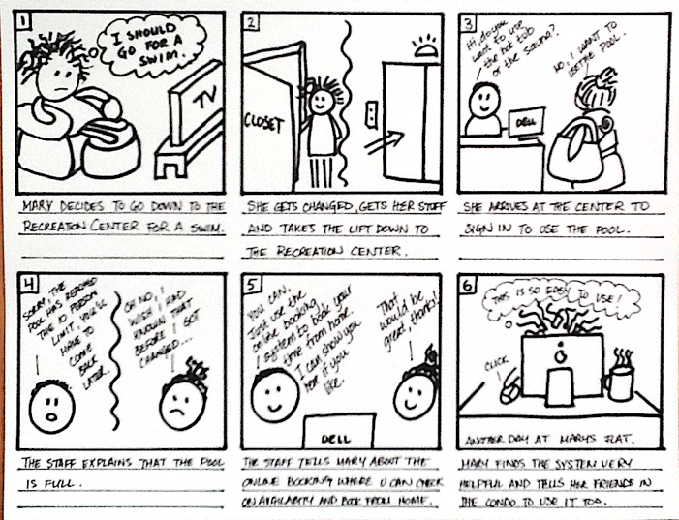

Example: to create an online booking/reservation system for my condo complex. Residents could book and check on booking for equipement or activities in the recreation centre.
1. One storyboard focused on how the user would benefit from the system.
2. My second storyboard focused on how the recreation staff would benefit from the system.
It was the same 'system' but showed how two different users would benefit from using it. Hope this helps a little.

The idea behind the storyboards is not necessarily to show how the interface works, that's what the wireframing and prototyping will do, but to show in what situation and to solve what problem your program would be used.

http://whitelines.se/link/
http://www.storyboardthat.com/





Comparison Axure, Jus In Mind, Balsamiq
http://socialcompare.com/en/comparison/axure-justinmind-1fje08tg

