Data Exploration Project Memo

Daniel Rios, Niko van Stipdonk, Tao Squires, Kohei Murakami, Simon Antony

The data we have chosen is the Salary_Data dataset sourced from Mohith Sai Ram Reddy, J G. Sukumar, and Nikhileswar Sambang. It consists of 6 columns, representing various pieces of data for individuals. These columns are as follows: Age, Gender, Education Level, Job Title, Years of Experience, and Salary. The sample size of the data is 6705 individuals, an ample amount to remove the effect of any outliers. Some possible inaccuracies in our data that we noticed is that the data set consists of a higher percentage of college educated people than the average American.

Using this data, we plan to understand the job market of today and understand the various factors that play into a successful career. As current students we are highly interested in which variables are the most important for us and our classmates to focus on. Our story is this: how can we best plan our education to align with our career goals in the current job market?

We started by asking a simple question: does a higher level of education advance your career? To answer this, we began by examining the average salary for each level of education: PhD, Master’s, Bachelor’s, and High School. As we can see in the graph, there is a positive correlation between the level of education and salary. With each successive increase in level of education, the relevant average salary also increases.

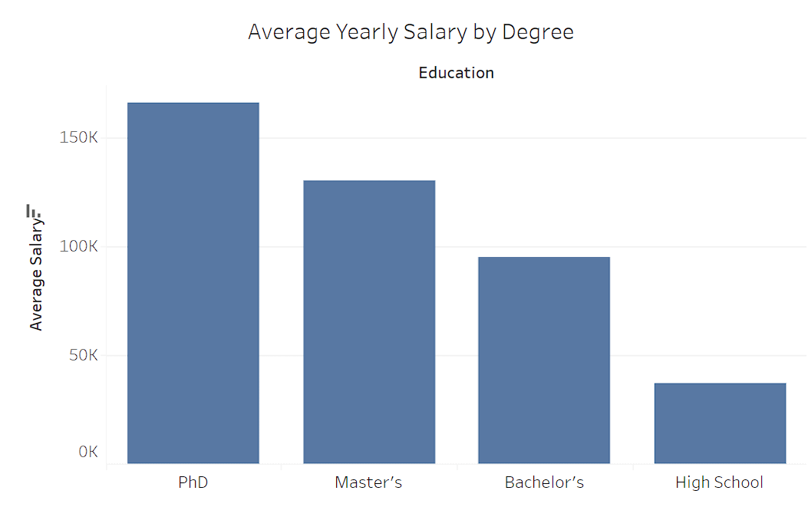

We then compared this data to the average American’s salary, to gain a better understanding of the proportion of above/below average earners among each education level. We can clearly see in the graph that there is a strong increase in above-average income earners as one gains a higher level of education, reinforcing the conception that more education is correlated with a higher salary.

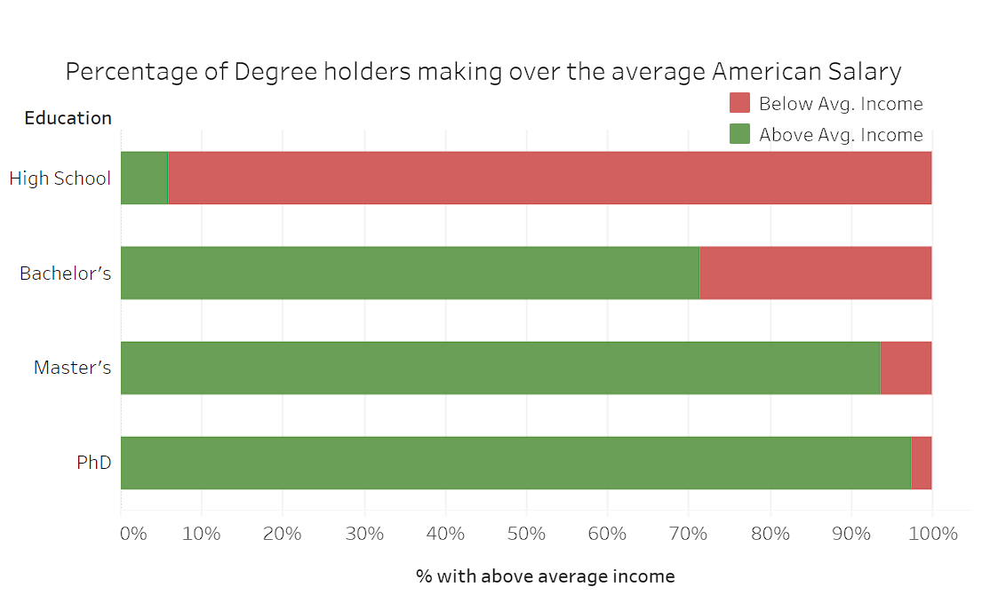

We shifted our focus to a different measurement than salary: job role/level, to further investigate the trends observed. The next visualization we made is intended to show the distribution of job levels by degree. The five job levels we specified are Executive, Director, Senior/Manager, Mid-Level, and Junior/Associate. We then made a horizontal plot that shows the types of job levels present in each level of education. When looking at the graph, it is clear to see that the higher levels of education are correlated with higher job levels. As well as, at least in this data set, only individuals with master’s or PhD degrees have a chance at achieving an executive job level. Therefore, there seems to be a barrier to entry for those with only high school diplomas to achieve Director or Executive level jobs. We can also see that a master’s degree is the most flexible and has the highest opportunity of any level of education. Some statistics we were able to draw from this visualization were that bachelor’s degree holders are 40% more likely to progress past an Associate / Junior level role, Master’s degree holders are 33% more likely to Land a Senior/Manager role, and PhD degree holders are 11% more likely to land an executive role.

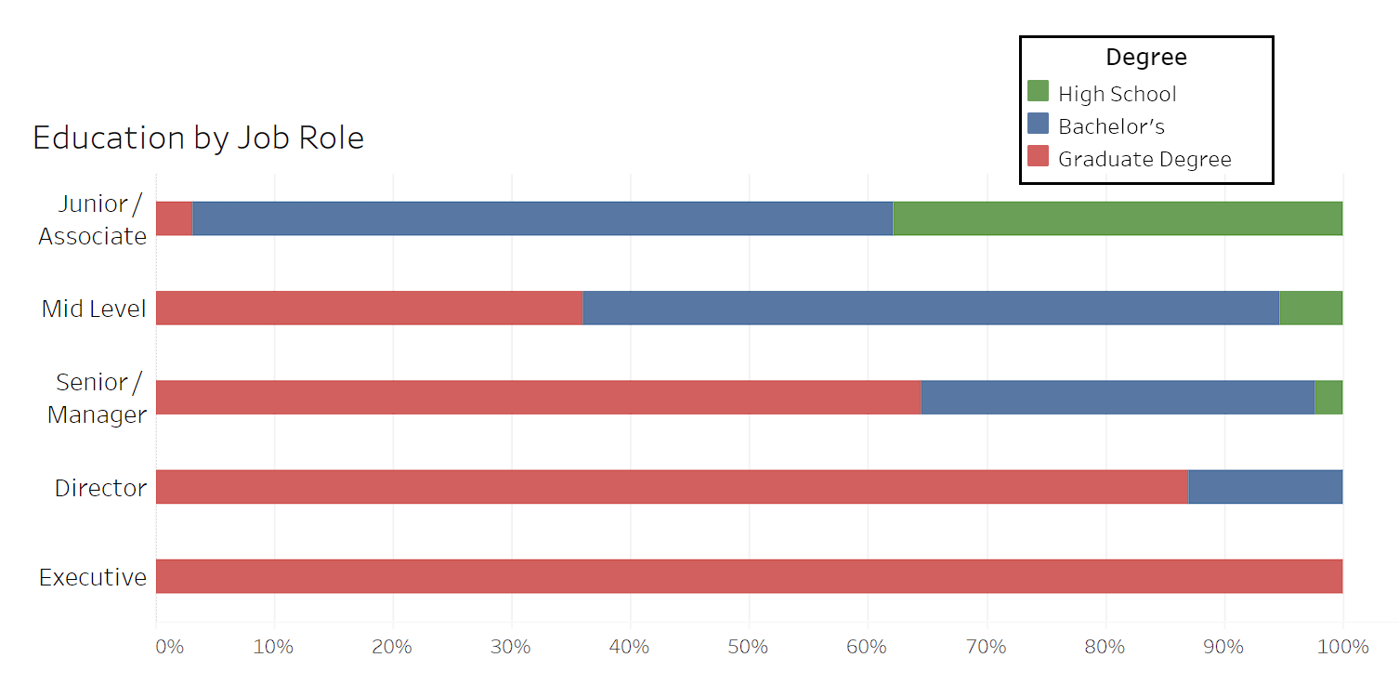

Next, we wanted to explore one of the biggest factors in predicting a salary. How a salary changes over experience, and how this is affected by the type of degree held. Does salary progress faster with a better degree? Or do they increase at a similar rate? The next visualization we graphed shows the relationship between salary and age for each level of education. One clear takeaway from this graph is that as an individual’s level of education rises, so does the floor and ceiling of their salary. As along the entire age range, higher levels of education make more than the lower levels.

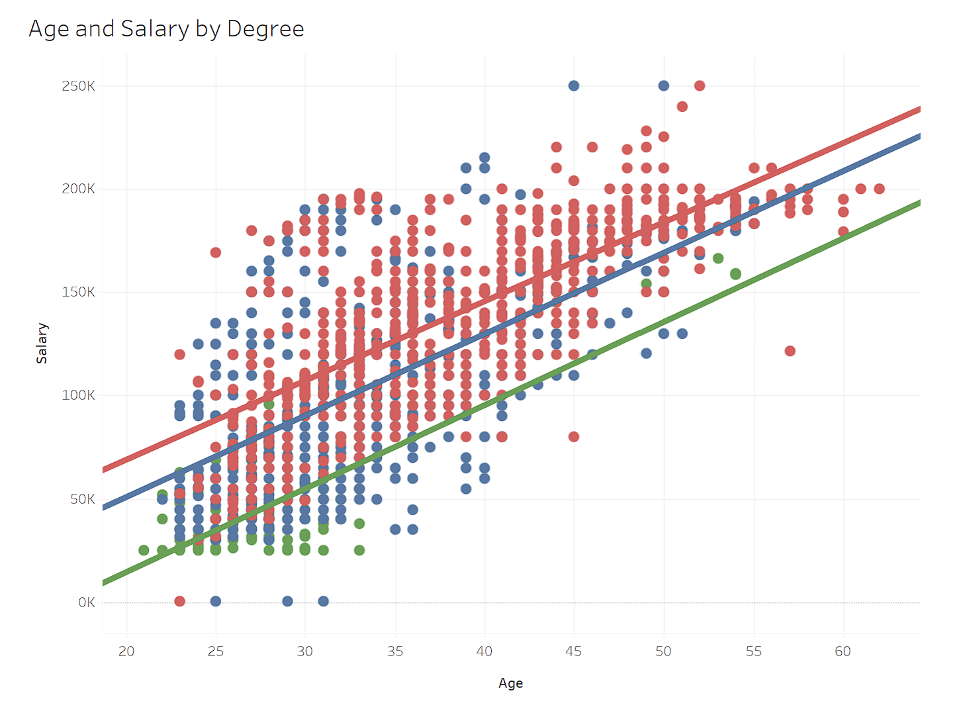

We were able to generate some statistics from our work with the data. The first set focuses on the subsequent increases in average annual salary from a High School Diploma for each respective education level.

* Having a bachelor’s degree increases average annual salary by $58,400.
* Having a master’s degree increases average annual salary by $93,400.
* Having a PhD increases average annual salary by $129,000.

The next set of statistics we created centered around the opportunity costs of the degrees. For example, it takes an average of 4 years to complete a bachelor’s degree and an average total cost of $103,000. But with average salary increase of $58,000, it will only take around 1.5 to 2 years to break even (with no further costs). Secondly, it usually takes 2 years to complete a Master's, with an average total cost of $62,650. With the benefit of an increased $35,000 average annual salary, it would take about 1.5 to 2 years to break even.

We wanted to shift our focus to Industry based research to see if the trends we’ve observed vary or hold true across different industries. In this next graph, we compared Education and Job Title, then displayed the average salary for each pair. Colored darker for a higher salary, we can see that as we would expect, higher levels of education make more money. However, we can see that for fields such as finance/accounting those with only a bachelor’s earn the most, with the average salary decreasing at higher education levels. We placed this next to a second graph that displays the Average Job Role based on Education Level and Job. Each section is colored, corresponding to a degree of seniority, with the darkest blue representing the highest level of position. We can see that the highest concentration of senior positions exists within the PhD and Master’s level of Education. Our findings mostly mirror what we’ve found previously. This graph does have many blank spots due to a lack of data, thus an expanded data sample may show different results.

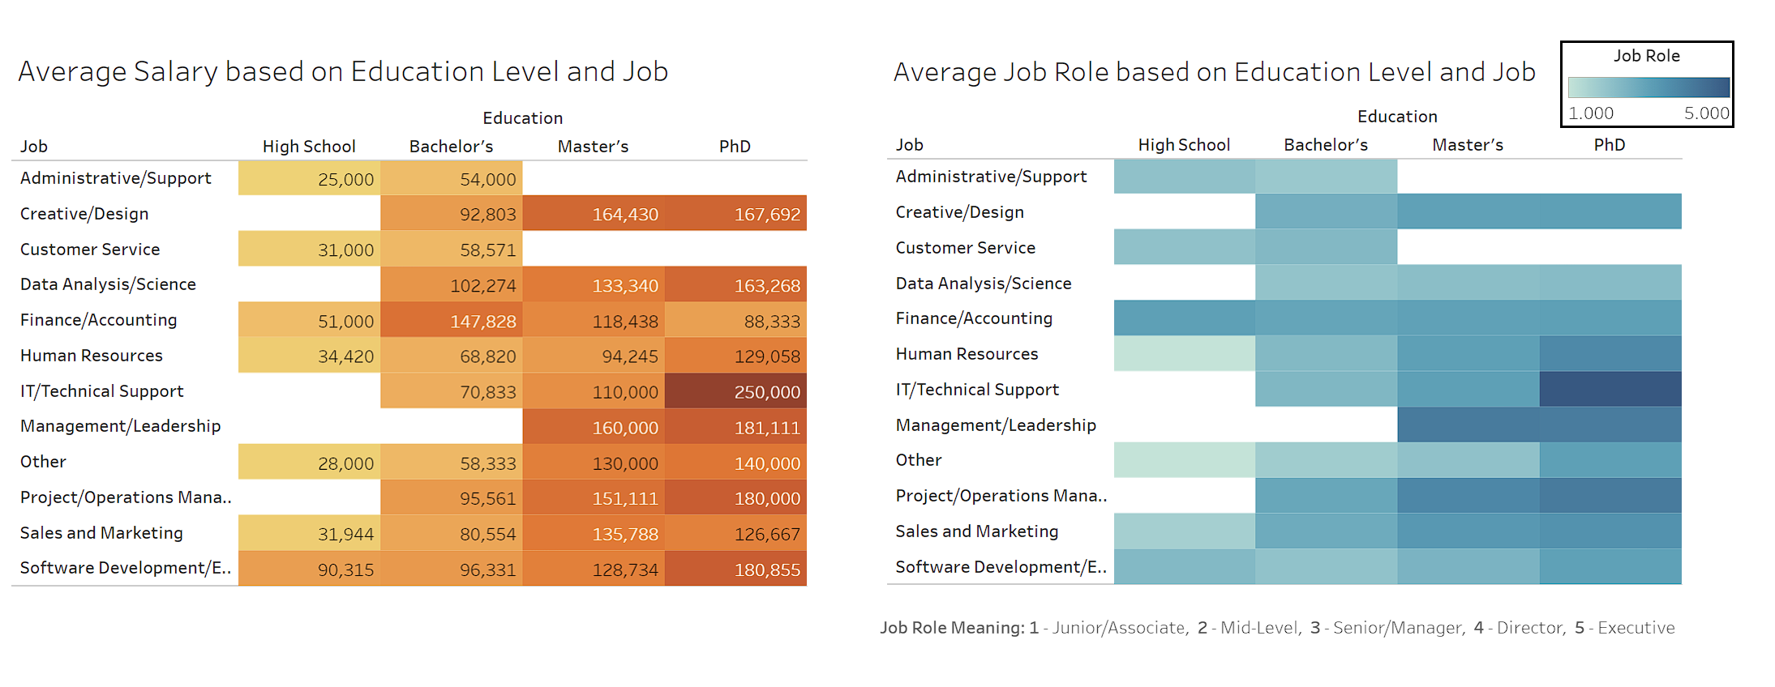

With the previous graph we saw not all industries have the same level of progression across degrees (ex. Finance/Accounting), so it’d be interesting to instead look if there’s higher progression within degrees. We narrowed down the 3 industries with the most notable trends to observe how a bachelor’s degree holding individual’s salary varys with years of experience. Here we can see that for both creative/design and finance/accounting industry jobs, there is a steep increase in salary as years of experience increase. However, the administrative/support industry has the shallowest relationship among all the industries, showing that it is the slowest growing.

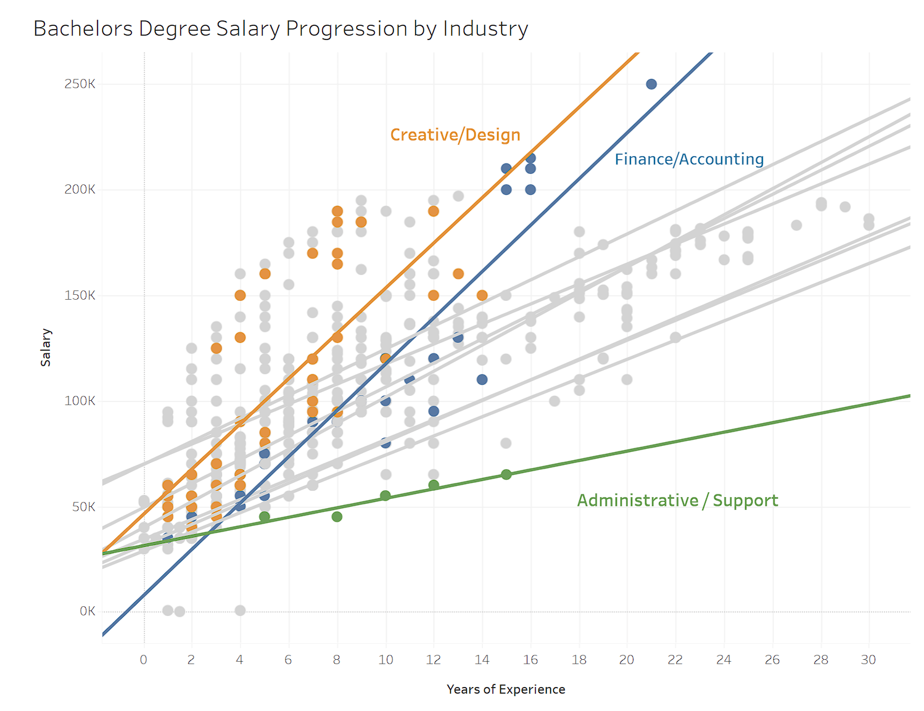

To pair this graph’s findings, we looked into the top 3 industries for immediate bachelor’s degree earners. This graph shows the average bachelor’s degree holder’s salary in their first 3 years of experience across these industries. We can see here that in comparison to the previous graph, only one industry is consistent: Creative/Design. Therefore, we can note that while an industry like Data Analysis/Science does have the highest average salary straight out of university, it does not have the highest growth rate and instead sits comfortably with most other industries.

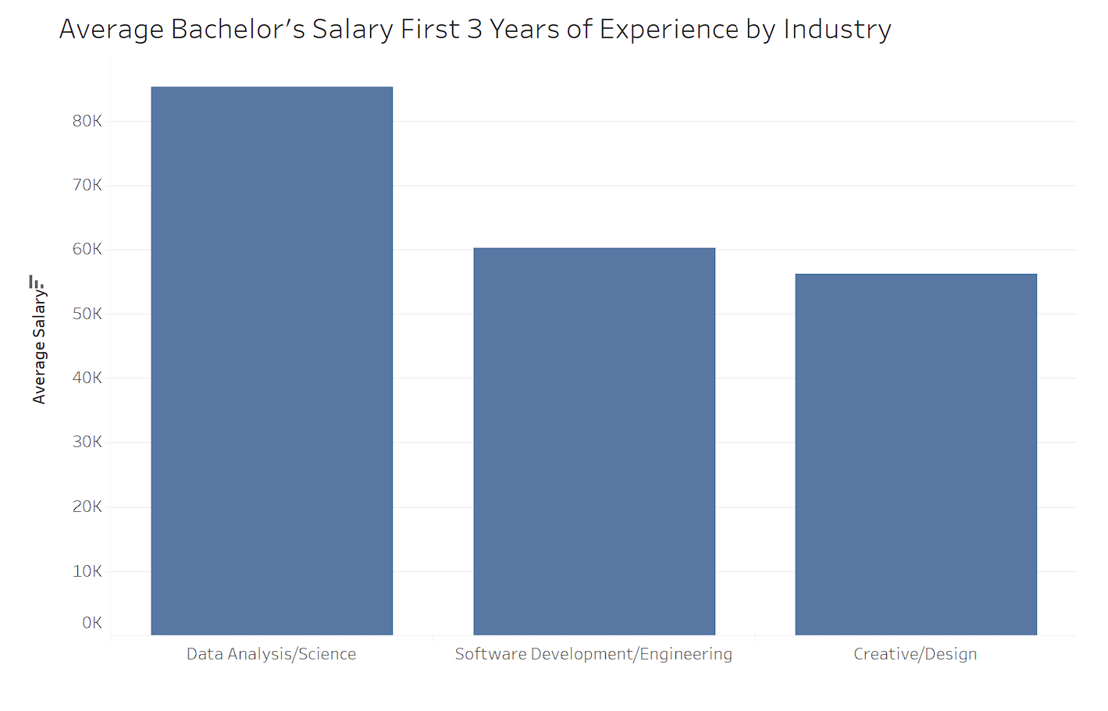

Finally, for our last visualization, we wanted to explore if there are any disparities between male and female individuals, specifically their level of education and salary. Here we can see that women are generally misrepresented in higher education and compensated less. However, in the highlighted section, we can see that while more women hold master’s level degrees, they make on average less than their male counterparts. It is important to note however that this data may be skewed in the number of females it surveyed, as they is not entirely representative of the actual nationwide data available.

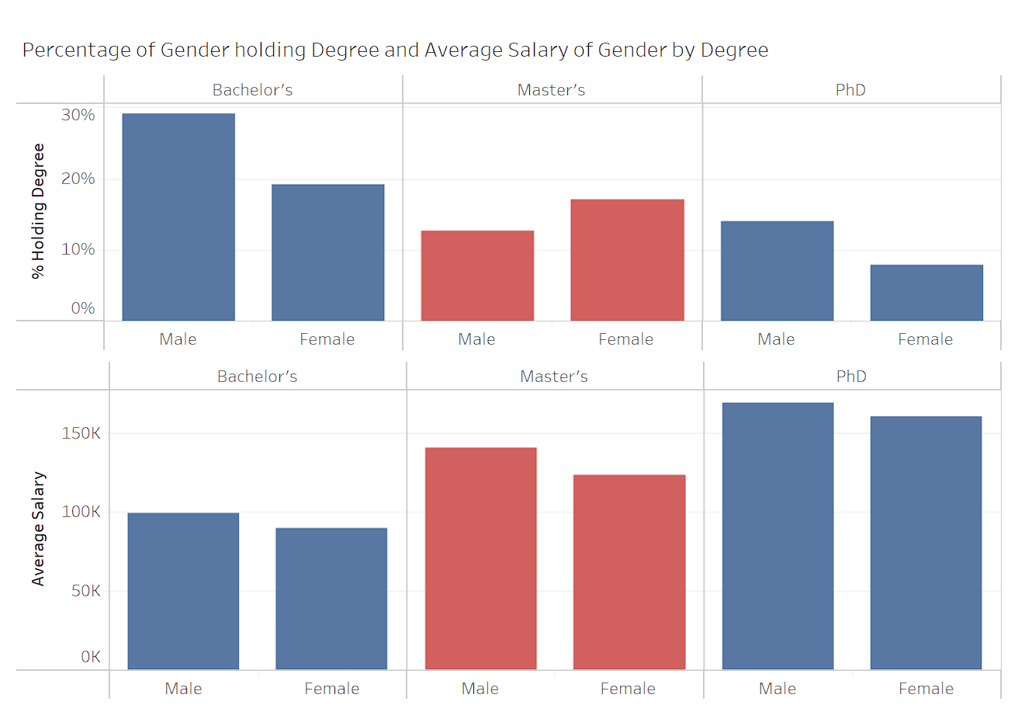

Overall, the biggest takeaways we found from this investigation are as follows:

* That as expected, a higher level of education will average in a higher salary.
* That the highest job levels are comprised almost entirely of master’s and PhD graduates.
* Between each level of education there is a predictable floor and ceiling of possible salary amounts and job levels.
* Women are statistically under-represented and under-compensated across every degree.