
Technical Coding Research Innovation, Navi Mumbai,
Maharashtra, India-410206

BREAST CANCER DETECTION

A Case-Study Submitted for the requirement of
Technical Coding Research Innovation

For the Internship Project work done during
DEEP LEARNING USING COMPUTER VISION INTERNSHIP PROGRAM

by
DANIEL SIVAPRASAD (TCRIK01R24)

Date:
Grade:

Rutuja Doiphode
CO-FOUNDER &CEO
TCR innovation.

Breast Cancer Detection via Breast Cancer Image Classification
Daniel Sivaprasad
Master of Computer Application
Viva Institute of Technology
Mumbai, India
musafirdaniel@gmail.com

Abstract - Breast cancer is considered to be one of the leading causes of death among women aged 20-59 worldwide. Early detection and treatment may allow patients to receive appropriate treatment and thus reduce the risk of breast cancer. Studies show that most experienced physicians can diagnose cancer with 79% accuracy while 91% accurate diagnosis is obtained using machine learning techniques. In this paper, we present the most recent models of breast cancer screening and classification models based on machine learning by analyzing them in the form of comparative research. Also, in this paper, sets of public data to be used and popular and to be listed in the latest activity to facilitate any new tests and comparisons. Challenge dataset of histology images of breast cancer and achieve a high classification accuracy of 72%. Experimental results show that our method can achieve quite promising performance and outperform state-of-the-art methods in the coming days.
Index Terms - Breast cancer image classification, deep convolutional neural network, multi-network features, low-rank learning, ensemble support vector machine.
I. Introduction
Breast cancer is the most common type of cancer and the main leading cause of cancer death among women worldwide [1]. The cancer cell grows with the unusual growth of cells, which attack the surrounding tissues in the human body. There are two categories of tumors, the most dangerous and the most dangerous, and in the absence of a tumor in the breast it is considered normal. Benign tumor cells are cancer-free cells that grow only locally and cannot spread by invasion. While malignant tumors are cancerous cells and have the ability to replicate uncontrollably, they spread to various parts of the body and invade surrounding tissues. Breast cancer is one of the most common cancers and a serious public health problem for women worldwide. According to a report by the International Agency for Research on Cancer (IARC) released by the World Health Organization (WHO) in 2012, an estimated 8.2 million people died of cancer, which by 2030 is expected to be higher. increase to 27 million .Thus, timely and accurate detection, early detection, and effective prevention requirements are important requirements to reduce the mortality rate of women.

Abnormalities such as bulk, small numbers, and areas of asymmetry and deformities within the breast may indicate the presence of breast cancer. Among these exceptions, the masses are the most representative and common species. However, the masses can be easily hidden by the accumulation of breast tissue, making it difficult to see. In addition, some breast tissue is morphologically similar to morphology, and as a result they do not look as good as masses. The invisible mass is a false negative, which delays the patient's diagnosis until the next examination. Therefore, this task is considered a daily challenge for radioologists as there is a large number of time-consuming mammograms that test the visual acuity of each mammogram.

Abnormalities such as bulk, small numbers, and areas of asymmetry and deformities within the breast may indicate the presence of breast cancer. Among these exceptions, the masses are the most representative and common species. However, the masses can be easily hidden by the accumulation of breast tissue, making it difficult to see. In addition, some breast tissue is morphologically similar to morphology, and as a result they do not look as good as masses. The invisible mass is a false negative, which delays the patient's diagnosis until the next examination. Therefore, this task is considered a daily challenge for radioologists as there is a large number of time-consuming mammograms that test the visual acuity of each mammogram. Therefore, there is a discrepancy between sensitivity and specificity that has been identified during the present mass analysis. Through the use of secondary studies, either by specialists or by Computer-Aided Diagnosis (CAD) programs, the absolute accuracy and precision of bulk detection, classification, and classification can be improved and false positive and negative cases. reduced.

Few subjects include a fully integrated system that integrates all stages of acquisition, classification, and classification. In fact, the variability in density between surrounding tissues in

terms of texture, shape, size, and location in mammograms, makes the task of finding the challenge more challenging [7,8]. negative ratings in mass segregation are a major challenge due to the strong correlation between the presence of masses and their inconsistencies in composition, size, and location with low variability and abstract boundaries [9 - 12]. Unfortunately, these methods still lack efficiency in the management of spontaneous mass fragmentation, because simple hand-made or automated features based on prior knowledge cannot cope with complex shapes, as well as the diffusion of different mass concentrations of surrounding tissue [9]. Otherwise the feature removal and manualization is very time consuming.The manual release and selection feature makes it difficult to define as well-intentioned features. Recently, a few studies based on in-depth learning models have provided an excellent alternative to other conventional classification methods, by automatically extracting the in-depth features of high-level classification directly from the input raw data to avoid manual character issues.
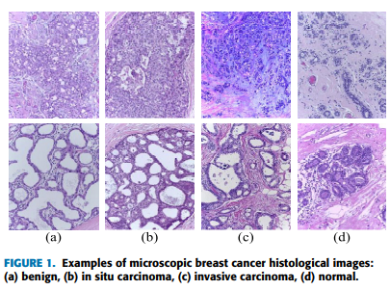

Convolutional Neural Network (CNNs) contains a number of convolu-tional layers that can produce features that represent a variety of image conditions without feature engineering. That is why CNN has become a widely used method of image translation services in many domains such as breast cancer screening and classification. Following CNN's success in standardized discovery activities, a few studies have used the benefits of deepCNNs to overcome the barriers to standardized weight gain models.

The primary purpose of mammography is to detect early signs of cancer and to identify the mammary glands in the images. Mammograms are considered to be the most important tool for doctors not only to diagnose breast cancer, but also to diagnose, diagnose, and monitor people with breast cancer. Mammography tests are performed in two steps. First, the breast is pressed between two small flat plates. Then, a low-

resolution X-ray is applied directly to the breast and detected by a two-dimensional (2D) panel detector.
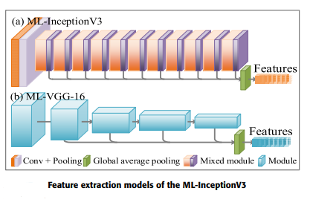

II. Methodology

A. Notations

In this paper, uppercase boldface letters represent matrices, lowercase boldface letters represent vectors, and ordinary italics represent scalars. For the matrix X = [ x_{i,j} ], its i-th row and j-th column are denoted as x^{i} and x_{j}.
The Frobenius norms l1, l2, l2,1, and lF -norm of a matrix X are denoted as ||X||₁ = Σ_{i}|x^{i}|,||x^{i}||₂ = √ x²_{i,j ,} ||x^{i}||_{2,1 =} Σ_{i}||x^{i}||₂ = Σ_{i√} Σ_{j}x²_{i,j}
respectively. Moreover, X^{T}, Tr(X), rank(X), and X ⁻¹ denoted as the transpose, trace, rank, and inverse operators of X, respectively.

B. Figure Extraction Model

In this section, we briefly introduce the image preprocessing and describe how to extract the multi-network features using the four pre-trained DCNNs, and perform the feature encoding.

C. Doll Feature Selection Method
Full features are extracted by utilizing different DCNNs and different convolutional layers in the same DCNN. However, these features can cause information redundancy and overfitting and reduce the classification accuracy of breast cancer histological images. Therefore, we propose a DOLL feature selection method.

D. Optimization
This Section describes the optimization process, which determines optimal parameters (e.g., Z, b1, b2, A1, and A2). Specifically, we iteratively conduct the following two steps until satisfying predefined conditions. (1) Update Z with fixed b1, b2, A1 and A2. (2) Update b1, b2, A1 and A2 with fixed Z

E. Train E-SVM Classifiers
As shown in Fig below we train the classifiers via fused features and voting strategy to conduct the breast cancer classification. Specifically, the dual-network features are first fused to train SVM classifiers, as shown in Fig. below (a). E-SVM classifier is trained by voting strategy as shown in Fig. below (b). For the features of each dual-network, we can train two SVMs and vote on their predicted score.
We train an E-SVM classifier with high precision and strong robustness by considering the fused features of dual-network and voting strategy for the predicted score of two dual-networks as depicted in Fig. below (c). In our experiments, three E-SVM classifiers are trained. The reason why we only train three E-SVM classifiers is that the features of training each E-SVM classifier must be derived from different DCNNs rather than sharing the features of the same DCNN (e.g., D-R and D-MV shares the features of DenseNet-121), which avoids introducing redundant features.
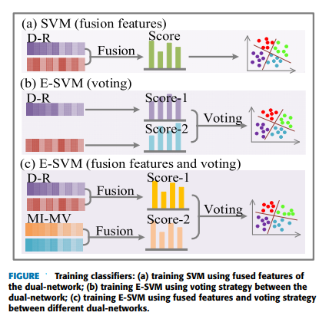

III. Comparative study for the used evaluation metrics and datasets
There have been effective advances in research in each specific area of ​​uncommon discovery, classification, and classification. The Mass detection initiative is considered to be an important step in the process of identifying potential regions for cancer in order to further evaluate the Computer-Aided Diagnosis (CAD) program. Breast weight differentiation also plays an important role in accurately removing the discriminatory features of certain large regions, while excluding surrounding tissues.
This section introduces the metrics used to evaluate the breastfeeding and diagnostic system and how to obtain each metric purpose. Then, a comparison between the most recent preferred methods for breast cancer screening and classification based on the data correction performed for each item. Finally, a comparative analysis is proposed to show the acquisition and classification models used and their performance.
III. Conclusion
In this paper, we compare among the latest models proposed for the detection and classification of breast cancer to reduce the mortality rate caused by breast cancer. We have compiled from a recently published work, public database. Differences are discussed between these data sets from many points such as size, input views, classrooms and image format. It is assumed that the most commonly used and widely used website is CBIS-DDSM which is an improved version from DDSM. It is thought that YOLO and RetinaNet new models have recently been used and are considered much simpler than conventional CNN networks and achieve better results and more accurate performance of bulk detection and negative classification. Also, models that use a balanced number in the model classes will find them, are accurate and gain much better accuracy than non-standard data models.
References
1. Boyle, P., Levin, B., et al .: World Cancer Report 2008. IARC Press, InternationalAgency for Research on Cancer (2008)
2. Al-antari, MA, Al-masni, MA, Park, SU, Park, JH, Metwally, MK, Kadah, YM, Han, SM, Kim, T.-S .: Computer-assisted breast cancer screening program -mammogram digital with a deep belief network. J. Med. Biol. English.38 (3), 443–456 (2017)
3. Al-masni, M., Al-antari, M., Park, J., Gi, G., Kim, T., Rivera, P., Valarezo, E., Han, S.-M., Kim, T .-S .: Detection and separation of abnormal breasts in digital mammograms via a convolutional neural network. At: 39th Annual International Conference of IEEE Engineering in Medicine and Biology Society (EMBC 2017), Jeju Island, South Korea, pp. 1230–1236 (2017)
4. Al-masni, MA, Al-antari, M., Park, J.-MP, Gi, G., Kim, T.-YK, Rivera, P., Valarezo, E., Choi, M.-T., Han, S.-M., Kim, T.-S .: Simultaneous acquisition and classification of bulk breasts into digital mammograms with a YOLO-based in-depth reading program. Computer. Biomed Systems Methods. 157, 85–94 (2018)
5. Al-antari, M.A., Al-masni, M.A., Park, S.U., Park, J.H., Kadah, Y.M., Han, S.M., Kim, T.S .: Automatic computer-assisted diagnosis of breast cancer in digital mammo-grams with a deep belief network. At: Global Conference on Engineering and AppliedScience (GCEAS), Japan, pp. 1306–1314 (2016)
6. Al-antari, M.A., Al-masni, M.A., Kadah, Y.M .: Hybrid computer-assisted breast cancer diagnostic model from digital mammograms. J. Sci. Eng. 04 (2), 114–126 (2017)

