NET 365

Lab #4 – IPv6 Lab

**ANSWERS DOCUMENT**

Due Thursday, May 27th, 2021 by 11:59 pm

**Your Name:**

You should read the Lab #4 Assignment Document before reading this one. You can type your answers into this document or create a separate one. When complete, save answers file as PDF and submit for your Lab #4 assignment on D2L.

**IP Subnet Design**

Enter the Subnet information for all lab subnets into Table #1 below.

**Table #1: IPv6 Subnet Design**

**Deliverables** (128, 64, 32, 16, 8, 4, 2, 1)

**Let <SN> = 40 (32 + 8)**

|  |  |  |  |  |
| --- | --- | --- | --- | --- |
| **Subnet Name** | **Subnet Network Address** | **Prefix Length**  **(/n)** | **First IPv6 Address** | **Last IPv6 Address** |
| Subnet A | **2001:B9:CC:E1::** | **64** | 2001:B9:CC:E1::1 | 2001:B9:CC:E1:FFFF:FFFF:FFFF:FFFF |
| Subnet B | **2001:B9:CC:E2::** | **64** | 2001:B9:CC:E2::1 | 2001:B9:CC:E2:FFFF:FFFF:FFFF:FFFF |
| Subnet C | **2001:B9:CC:E3::** | **64** | 2001:B9:CC:E3::1 | 2001:B9:CC:E3:FFFF:FFFF:FFFF:FFFF |
| Subnet D | **2001:B9:CC:E4::** | **64** | 2001:B9:CC:E4::1 | 2001:B9:CC:E4:FFFF:FFFF:FFFF:FFFF |
| Subnet E | **2001:B9:CC:E5::** | **64** | 2001:B9:CC:E5::1 | 2001:B9:CC:E5:FFFF:FFFF:FFFF:FFFF |
| Link 1 | **2001:B9:CC:FF::** | **126** | 2001:B9:CC:FF::1 | 2001:B9:CC:FF::3 |
| Link 2 | **2001:B9:CC:FF::4** | **126** | 2001:B9:CC:FF::5 | 2001:B9:CC:FF::3 |

**IPv6 Address Plan**

Now, based on your IPv6 Subnet Design above and the network diagram, assign a specific IPv6 global address to each interface and enter it into the table below.

**Table #2: IP Address Plan**

|  |  |  |
| --- | --- | --- |
| **Device** | **Interface** | **IPv6 Global Address** |
| R1 | Fa0/0 | **2001:B9:CC:E1::1** |
| R1 | Fa0/1 | **2001:B9:CC:E5::2** |
| R1 | S0/2/0 | **2001:B9:CC:FF::3** |
| R2 | S0/2/0 | **2001:B9:CC:FF::** |
| R2 | Fa0/0 | **2001:B9:CC:E3::1** |
| R2 | Loopback1 | **2001:B9:CC:E2::1** |
| R3 | Fa0/0 | **2001:B9:CC:E4::1** |
| R3 | Fa0/1 | **2001:B9:CC:E3::2** |
| R3 | S0/2/0 | **2001:B9:CC:FF::** |
| R4 | Fa0/0 | **2001:B9:CC:E5::1** |
| R4 | S0/2/0 | **2001:B9:CC:FF::3** |
| Host #1 |  | **2001:B9:CC:E1::40** |
| Host #2 |  | **2001:B9:CC:E4::40:40** |

**Lab Implementation**

Now, follow directions in the Lab #4 Assignment document to implement the lab network. Answer questions in each part below only when instructed to do so in the assignment document.

# **Part 3.1 Questions:**

1. On Host #1, **ping** to Host #2.

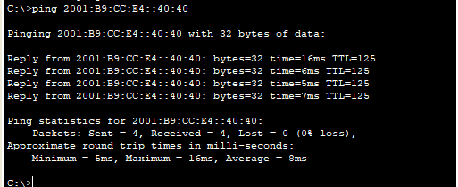

1. On Host #1, **tracert** to Host #2.

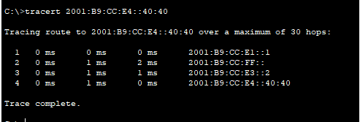

1. On Host #1, **tracert** to 2001:B9:CC:E2::1.

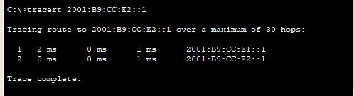

1. Link-Local IPv6 address of R4 interface Fa0/0.

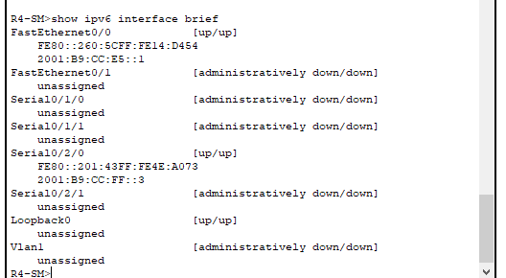

* 1. Was the Interface ID part of this Link-Local IPv6 address determined via the EUI-64 method?

**Yes,**

How do you know?

**Presence of “FFFE” inserted in between the two pieces to make 64 bit value.**

1. On Router R1, execute **show ipv6 protocol**.

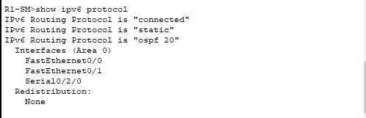

1. On Router R2, execute **show ipv6 protocol**.

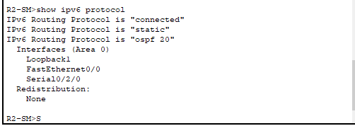

1. On Router R1, execute **show ipv6 route**

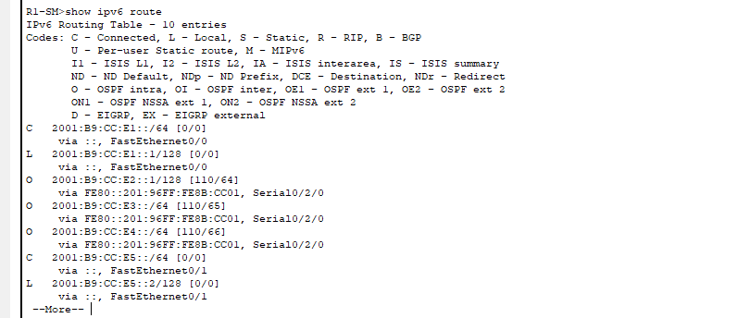

* 1. How many routes are there to Subnet D in the routing table?

**1**

Why?

**Only one ipv6 address is present in the network**

1. On Router R2, execute **show ipv6 route**

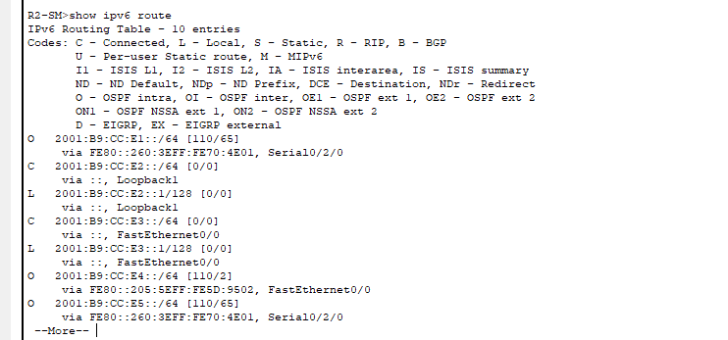

# **Part 3.2 Questions:**

1. On Host #1, **ping** to Host #2.

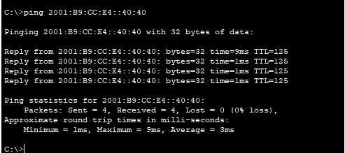

1. On Host #1, **tracert** to Host #2.

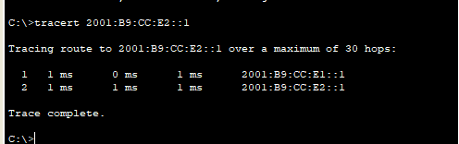

1. On Router R3, execute **show interface s0/2/0**

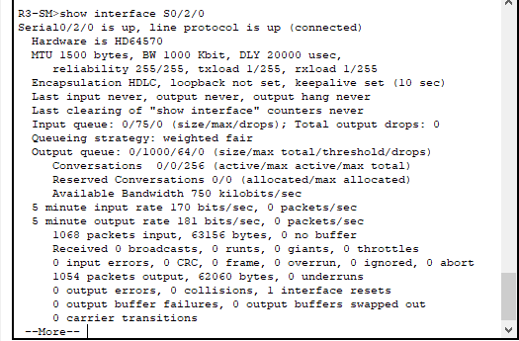

1. On Router R3, execute **show ipv6 ospf neighbor**

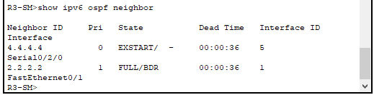

1. Which router (R2 or R3) is the Designated Router for Subnet C?

**R2**

1. On Router R1, execute **show ipv6 route**

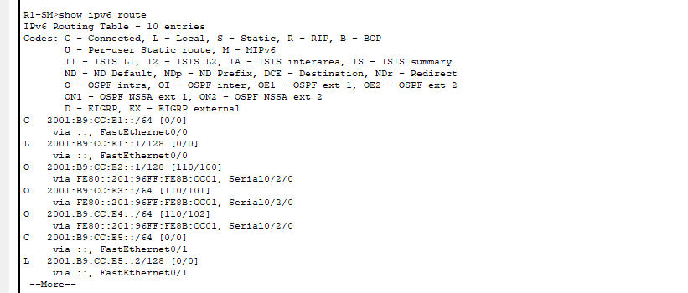

1. How many routes are there to Subnet D in the routing table?

**Once**

1. There are 2 paths a packet could take from Host #1 to R2 – either a 2-hop path (Host #1 🡪 R1 🡪 R2) or a 4-hop path (Host #1 🡪 R1 🡪 R4 🡪 R3 🡪 R2).
2. On Host #1, **tracert** to **2001:B9:CC:E2::1**.

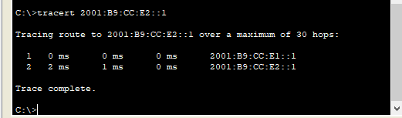

1. This tracert should show packets taking the longer path (through all 4 routers). Why are packets being routed over the longer path?

**Since most of the packets have been configured to follow the shortest path (OSPF), the packets will queue leading to delays forcing the others to follow the longer path**

1. Do a **show ipv6 route** on all 4 routers.

