NET 365

Lab #1 – OSPF Lab

**ANSWERS DOCUMENT**

Due Thursday, April 22nd, 2021 by 11:59 pm

**Your Name:**

You should read the Lab #1 Assignment Document before reading this one. You can type your answers into this document or create a separate one. When complete, save the completed Answers file as PDF and submit for your Lab #1 assignment on D2L, along with your Packet Tracer PKT file.

**IP Subnet Design**

Enter the Subnet information for all lab subnets into Table #1 below. The “Valid Host IP” addresses are assignable IP addresses.

**Table #1: IP Subnet Design**

**Deliverables** (128, 64, 32, 16, 8, 4, 2, 1)

**Let <SN> = 40 (32 + 8)**

|  |  |  |  |  |
| --- | --- | --- | --- | --- |
| **Subnet Name** | **Subnet ID (network address and /n)** | **Size**  **= 2[32-n]** | **First Valid Host IP** | **Last Valid Host IP** |
| LA Subnet | 22.22.40.0/24 | 256 | 22.22.40.1 | 22.22.40.254 |
| NY Subnet | 172.11.5.16/28 | 16 | 172.11.5.17 | 172.11.5.30 |
| F-Link | 122.40.0.4/30 | 4 | 122.40.0.5 | 122.40.0.6 |
| G-Link | 122.40.0.8/30 | 4 | 122.40.0.9 | 122.40.0.10 |
| S-Link 1 | 200.0.0.4/30 | 4 | 200.0.0.5 | 200.0.0.6 |
| S-Link 2 | 200.0.0.8/30 | 4 | 200.0.0.9 | 200.0.0.10 |

**IP Address Plan**

Now, based on your IP Subnet Design above and the network diagram, assign a specific IP address and subnet mask to each interface and enter it into the table below.

**Table #2: IP Address Plan**

|  |  |  |  |
| --- | --- | --- | --- |
| **Device** | **Interface** | **IP Address** | **Mask** |
| R1 | Fa0/0 | 22.1.1.2 | 255.255.255.255 |
| R1 | Fa0/1 | 22.1.1.3 | 255.255.255.255 |
| R1 | S0/1/0 | 22.1.1.254 | 255.255.255.255 |
| R2 | S0/1/0 | 22.2.2.4 | 255.255.255.255 |
| R2 | Fa0/0 | 22.2.2.3 | 255.255.255.255 |
| R2 | Gi0/2/0 | 22.2.2.254 | 255.255.255.255 |
| R3 | Gi0/2/0 | 22.3.3.254 | 255.255.255.255 |
| R3 | S0/1/0 | 22.3.3.4 | 255.255.255.255 |
| R4 | Fa0/0 | 2.4.4.5 | 255.255.255.255 |
| R4 | S0/1/0 | 2.4.4.254 | 255.255.255.255 |
| LA Host |  | 22.22.40.40 | 255.255.255.0 |
| NY Host |  | 172.11.5.18 | 255.255.255.240 |

**Lab Implementation**

Now, follow directions in the Lab #1 Assignment document to implement the lab network. Answer questions in each part below only when instructed to do so in the Assignment document.

# Part 3.1 Questions:

1. On LA Host, **ping** to NY Host.

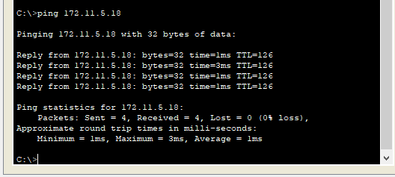

1. On LA Host, **tracert** to NY Host.

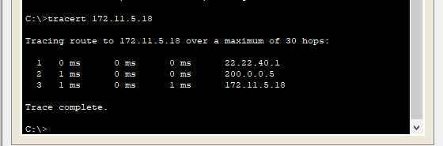

* 1. Does this packet follow the 3-hop path (across S-Link 1) or the 5-hop path (across S-Link 2)?

**It follows 3-hop path across S-link 1**

1. On R1, execute **show ip route**.

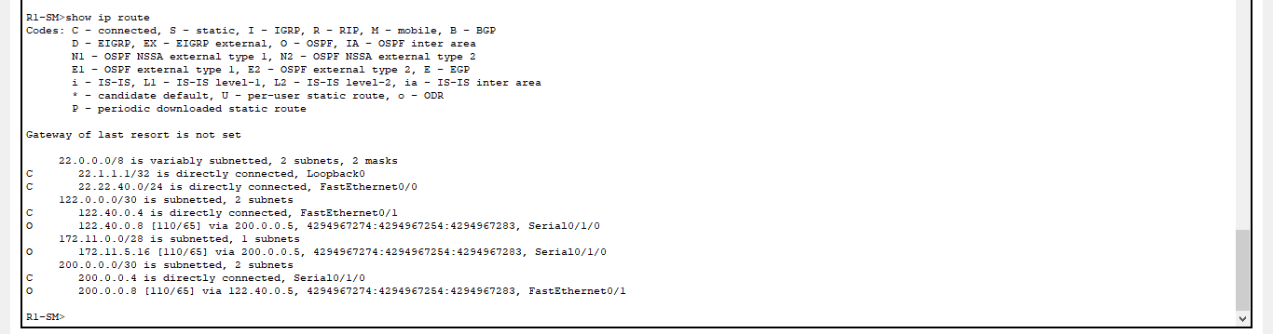

1. Do you see 10 IP subnets (LA Subnet, NY Subnet, all 4 Links, and all 4 Loopback0s) in this routing table? (If not, go back and troubleshoot).

**Yes**

1. How many routes are shown to destination 22.3.3.3/32? Why is here more than 1 route to this destination?

**Because the packet should calculate the shortest path by following different paths**

1. On Router R1, execute **traceroute 22.3.3.3**.

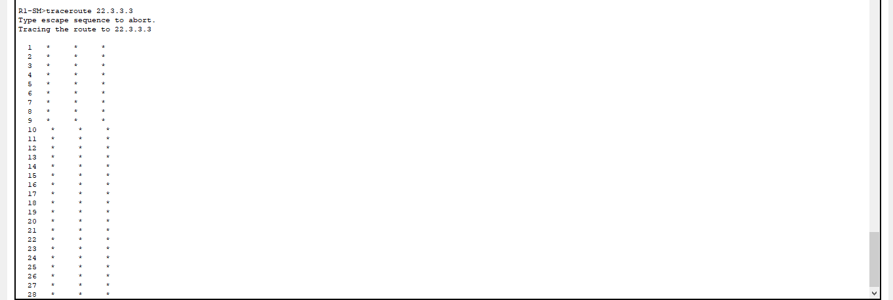.

1. On Router R1, execute **show ip protocol**.

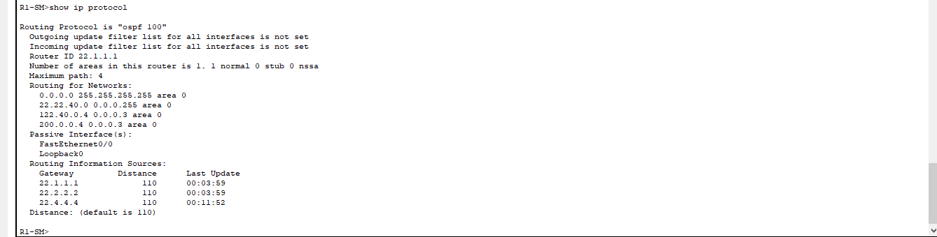

1. On Router R1, execute **show ip ospf neighbor**.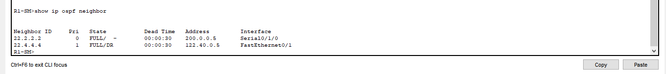 Which router (R1 or R4) is the **designated router** for the F-Link subnet?

**R4**

1. Using the **show ip ospf interface <int-name>** command, where <int-name> is an interface name, tell me the OSPF cost of each of these links:

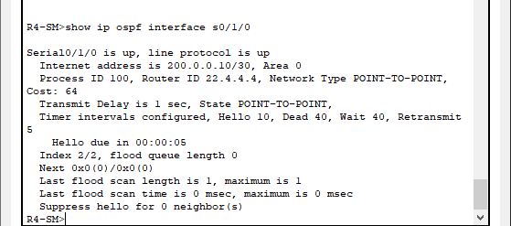

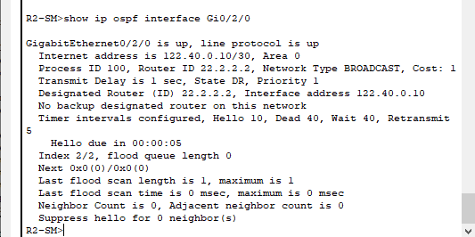

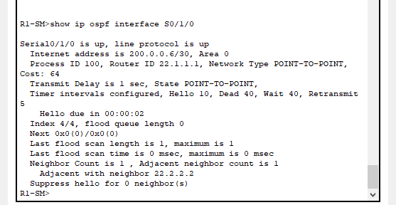

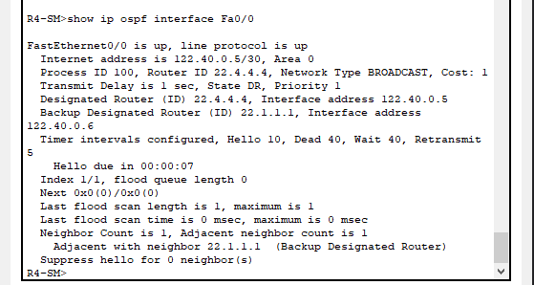

1. OSPF Cost of F-Link = **1*2=2**
2. OSPF Cost of S-Link 1 = **64*2=128**
3. OSPF Cost of G-Link = **1*2=2**
4. OSPF Cost of S-Link 2 = **64*2=128**

Now, go back to Lab #1 Assignment and perform Step #6 of the Network Implementation and Testing before continuing with Part 3.2.

**Part 3.2 Questions:**

1. On LA Host, **tracert** to NY Host.

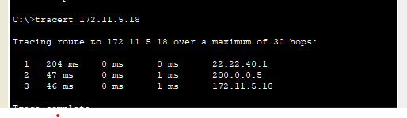

1. Does this packet follow the 3-hop path (across S-Link 1) or the 5-hop path (across S-Link 2)? Why?

**Yes, 3 hops; because it is the shortest path**

1. On R1, execute **show ip route**.
2. What changes do you see in the R1 routing table, compared with your screenshot for #3 above?

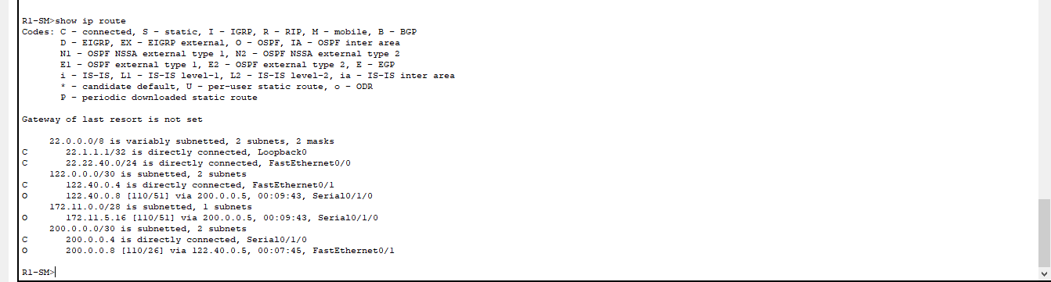

**The value: [110/66] and [110/51]**

1. How many routes are shown to destination 22.3.3.3/32?

**2 routes**

1. On Router R1, execute **traceroute 22.3.3.3**.

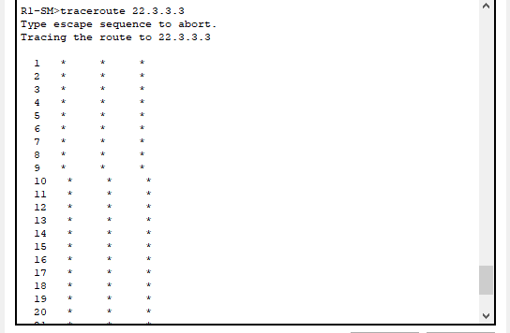

1. Using the **show ip ospf interface <int-name>** command, where <int-name> is an interface name, tell me the OSPF cost of each of these links:

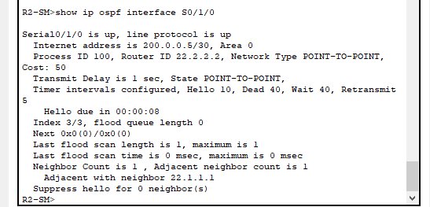

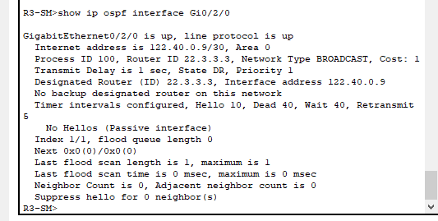

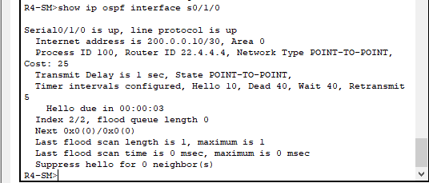

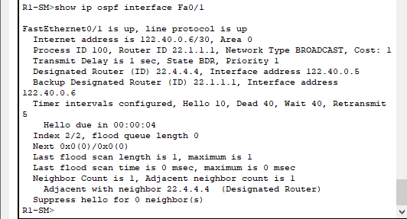

1. OSPF Cost of F-Link = **1*2=2**
2. OSPF Cost of S-Link 1 = **50*2=2**
3. OSPF Cost of G-Link = **1*2=2**
4. OSPF Cost of S-Link 2 = **25*2=50**

*** Now, on each of the 4 routers, go into OSPF router configuration mode (**router ospf 100**) and execute **auto-cost reference-bandwidth 1000** to change the Reference Bandwidth for calculating OSPF link costs to 1000 Mbps (so Link costs are now calculated as 1,000,000,000 / BW)

1. On R1, execute **show ip route**.

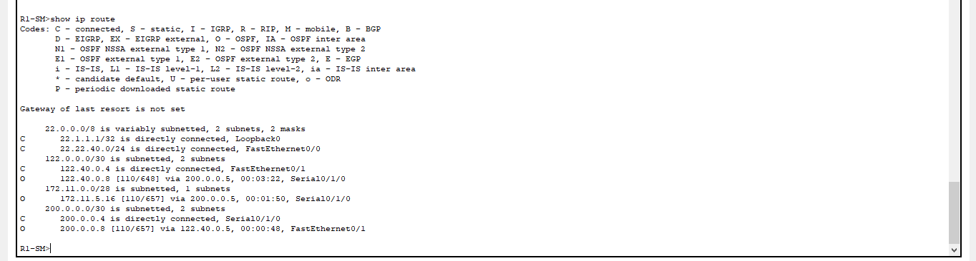

1. What changes do you see in the R1 routing table, compared with your screenshot for #9 above?

**The value: [110/51] and [110/648]**

1. Using the **show ip ospf interface <int-name>** command, where <int-name> is an interface name, tell me the OSPF cost of each of these links:

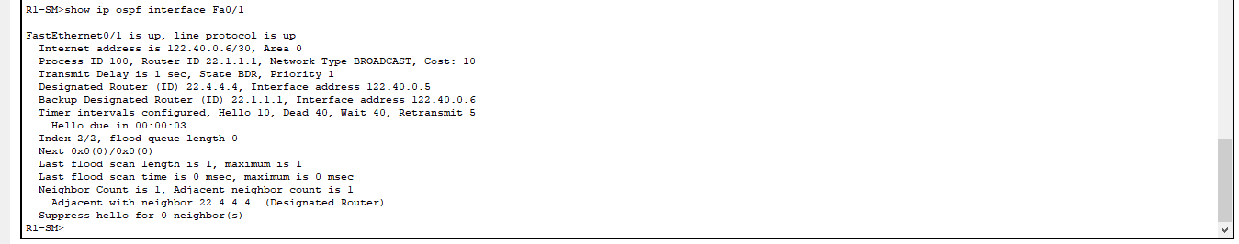

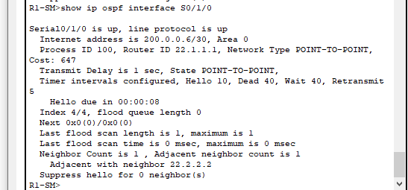

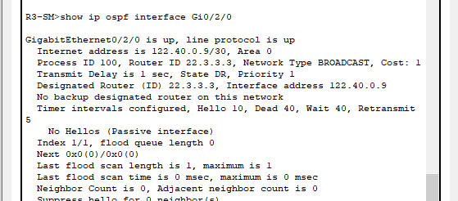

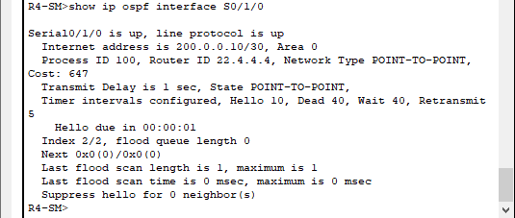

1. OSPF Cost of F-Link = **2*10**
2. OSPF Cost of S-Link 1 = **2*647=1294**
3. OSPF Cost of G-Link = **2*1=2**
4. OSPF Cost of S-Link 2 = **2*647=1294**

**NB: Formula:**

1. **Calculate the first IP address in the subset**

**Add:** convert address into bits

**Mask:** subnet mask

**ANDing = (Add & Mask)**

**First Usable IP = +1**

1. **Calculate the last IP address in the subset**

**Add:** convert address into bits (Jerman-Blažič et al., 2014).

**Mask:** subnet mask

**ORing = (Add & complement Mask)**

**Last usable IP = -1**