NET 365

Lab #5 – BGP Lab

**ANSWERS DOCUMENT**

Due Tuesday, June 8th, 2021 by 11:59 pm

**Your Name:**

You should read the Lab #5 Assignment Document before reading this one. You can type your answers into this document or create a separate one. When complete, save answers file as PDF and submit for your Lab #5 assignment on D2L.

**Part 1: IP Subnet Design**

Enter the IPv4 Subnet information for all lab subnets into Table #1a below.

**Deliverables** (128, 64, 32, 16, 8, 4, 2, 1)

**Let <SN> = 40 (32 + 8)**

**Table #1a: IPv4 Subnet Design**

|  |  |  |  |  |  |
| --- | --- | --- | --- | --- | --- |
| **Subnet Name** | **Subnet Network Address** | **Prefix Length**  **(/n)** | **Size**  **= 2[32-n]** | **First Valid Host IP** | **Last Valid Host IP** |
| Subnet A | **40.1.1.1** | **32** | **1** | **40.1.1.2** | **40.1.1.0** |
| Subnet B | **40.2.2.2** | **32** | **1** | **40.2.2.3** | **40.2.2.1** |
| Subnet C | **111.40.2.0** | **24** | **256** | **111.40.2.1** | **111.40.2.254** |
| Subnet D | **222.40.2.0** | **24** | **256** | **222.40.2.1** | **222.40.2.254** |
| E-Link 1 | **101.40.1.0** | **30** | **4** | **101.40.1.1** | **101.40.1.2** |
| E-Link 2 | **202.40.1.0** | **30** | **4** | **202.40.1.1** | **202.40.1.2** |
| Link 1 | **100.0.0.0** | **30** | **4** | **100.0.0.1** | **100.0.0.2** |
| Link 2 | **100.0.0.4** | **30** | **4** | **100.0.0.5** | **100.0.0.6** |
| Link 3 | **100.0.0.8** | **30** | **4** | **100.0.0.9** | **100.0.0.10** |

**Part #2: IP Address Plan**

Now, based on your IP Subnet Design above and the Addressing Requirements in the assignment, assign a specific IP address to each interface and enter it into the table below.

**Table #2a: IPv4 Address Plan**

|  |  |  |  |
| --- | --- | --- | --- |
| **Device** | **Interface** | **IPv4 Address** | **Mask** |
| R1 | Loopback1 | **40.1.1.1** | **255.255.255.255** |
| R1 | Loopback2 | **40.2.2.2** | **255.255.255.255** |
| R1 | S0/2/0 | **100.0.0.10** | **255.255.255.252** |
| R1 | S0/2/1 | **100.0.0.2** | **255.255.255.252** |
| R2 | S0/2/0 | **100.0.0.5** | **255.255.255.252** |
| R2 | S0/2/1 | **100.0.0.1** | **255.255.255.252** |
| R2 | Fa0/0 | **202.40.1.1** | **255.255.255.252** |
| R2 | Loopback0 | **133.2.2.2** | **255.255.255.255** |
| R3 | Fa0/0 | **101.40.1.1** | **255.255.255.0** |
| R3 | S0/2/1 | **100.0.0.6** | **255.255.255.252** |
| R3 | S0/2/0 | **100.0.0.9** | **255.255.255.252** |
| R3 | Loopback0 | **133.3.3.3** | **255.255.255.255** |
| R4 | Fa0/0 | **222.40.2.1** | **255.255.255.0** |
| R4 | Fa0/1 | **202.40.1.2** | **255.255.255.252** |
| R4 | Loopback0 | **133.4.4.4** | **255.255.255.255** |
| R5 | Fa0/0 | **111.40.2.1** | **255.255.255.0** |
| R5 | Fa0/1 | **101.40.1.2** | **255.255.255.252** |
| R5 | Loopback0 | **133.5.5.5** | **255.255.255.255** |
| Host #1 |  | **222.40.2.10** | **255.255.255.0** |
| Host #2 |  | **111.40.2.10** | **255.255.255.0** |

**Part 3: Lab Implementation**

Now, follow directions in the Lab #5 Assignment document to implement the lab network. Answer questions in each part below only when instructed to do so in the assignment document.

# **Part #3.1 Results:**

1. On Host #1, execute **tracert** **133.2.2.2**

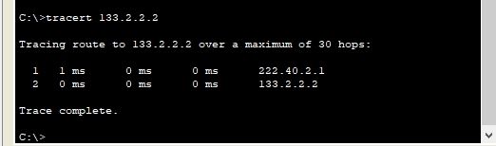

1. On Router R3, execute **show ip protocol**

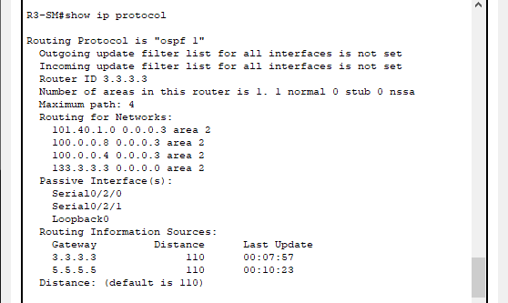

1. On Router R3, execute **show ip ospf neighbor**

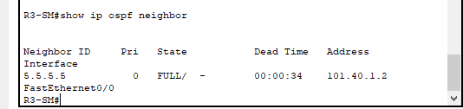

* 1. Which router (R3 or R5) is the designated router (DR) on E-Link 1?

**R5**

1. On Router R3, execute **show ip route**

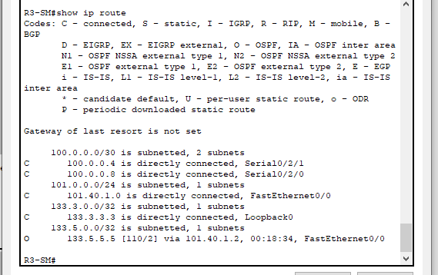

1. On Router R2, execute **show ip protocol**

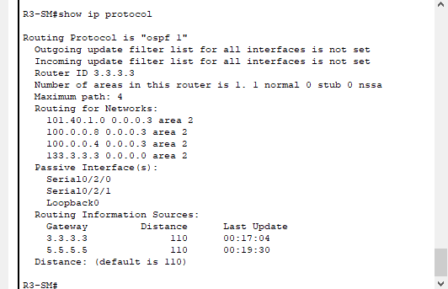

1. On Host #2, execute **tracert 133.3.3.3**

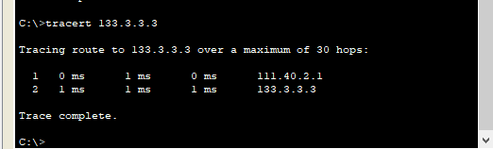

# **Part #3.2 Results:**

1. On router R1, execute **show ip bgp**

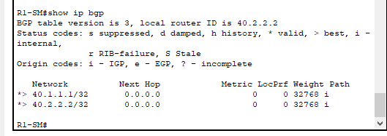

1. On router R1, execute **show ip bgp summary**

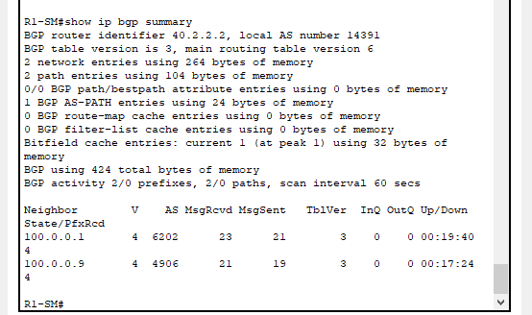

1. On router R2, execute **show ip bgp**

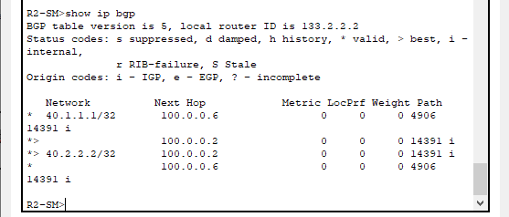

1. On Router R2, execute **show ip protocol**

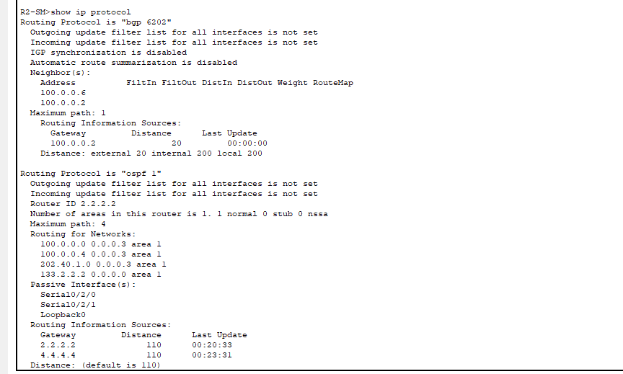

# **Part #3.3 Results:**

1. On router R1, execute **show ip bgp**

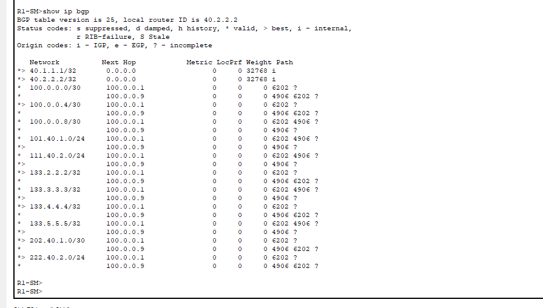

1. On Host #1, execute **tracert** to Host #2

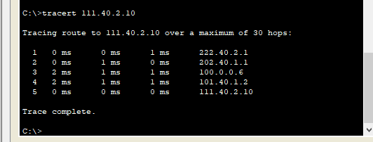

1. On Host #1, execute **tracert to <SN>.1.1.1**

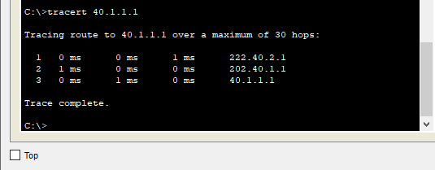

1. On Host #2, execute **tracert to <SN>.2.2.2**

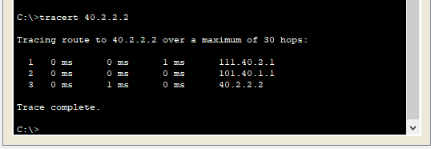

1. On Router R4, execute **show ip route**

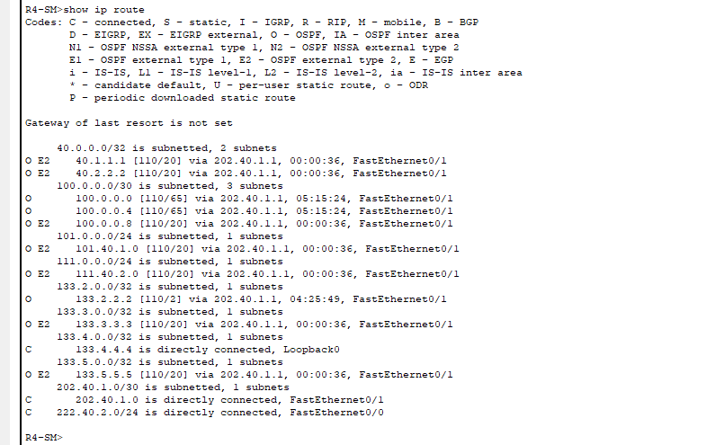

* 1. Does the R4 routing table contain all subnets from all Autonomous Systems?

**Yes – 13 subnets**

1. On Router R1, execute **show ip route**

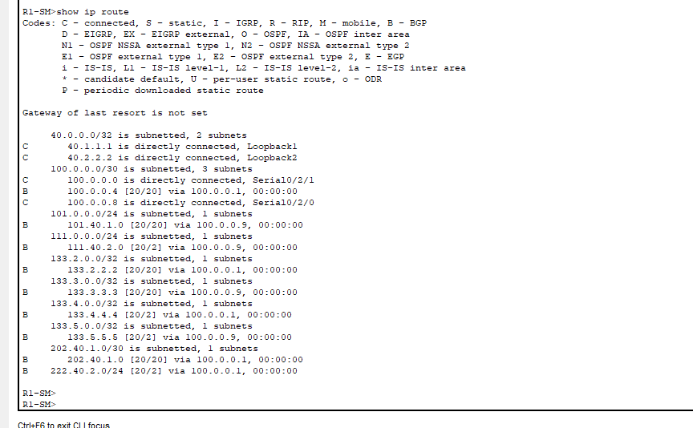

1. Does the R1 routing table contain all subnets from all Autonomous Systems?

**Yes**

* *** Now, on router R2,**shut down interface S0/2/1** ***

1. On router R2, execute **show ip interface brief**

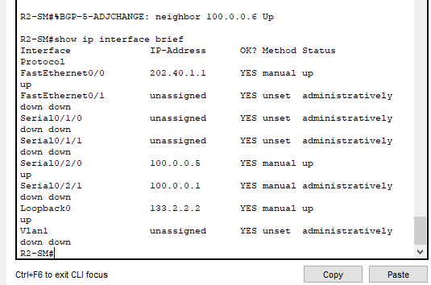

1. On router R1, execute **show ip bgp**

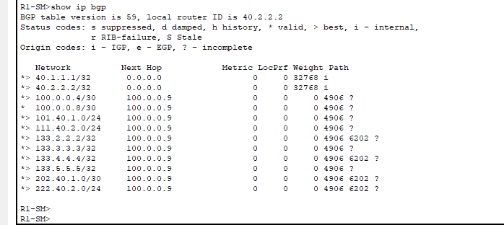

1. On Host #1, execute **tracert to <SN>.1.1.1**

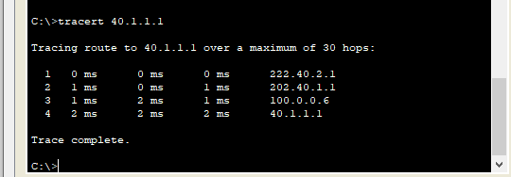

1. On Router R1, execute **show ip route**

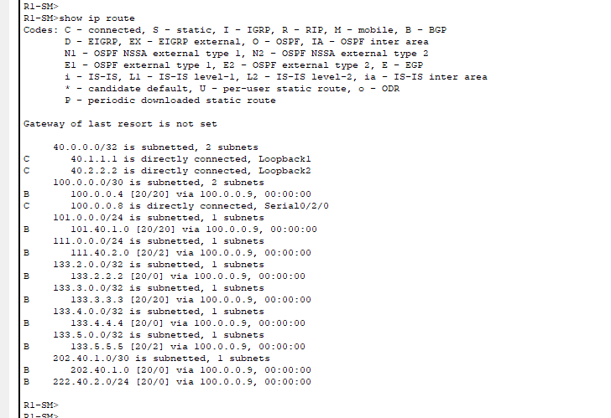

Convert this file to PDF format, review the resulting file to ensure that all answers and screenshots are readable. You will submit two files on D2L:

* + These Answers in PDF format
  + Your Packet Tracer .pkt file

That’s it for Lab #5!!

**NB: Formula:**

1. **Calculate the first IP address in the subset**

**Add:** convert address into bits

**Mask:** subnet mask

**ANDing = (Add & Mask)**

**First Usable IP = +1**

1. **Calculate the last IP address in the subset**

**Add:** convert address into bits (Jerman-Blažič et al., 2014).

**Mask:** subnet mask

**ORing = (Add & complement Mask)**

**Last usable IP = -1**