Ice Floe Validation Dataset: Version History
2024: Initial sampling and dataset development
Initial sampling and image analysis began in Spring 2024. Sampling regions were defined using equal-area boxes. An initial set of samples were drawn from 2003-2022, using v4 of the NSIDC CDR, and used for Simon Hatcher’s batchelor’s thesis in engineering to test methods for validating the Ice Floe Tracker algorithm. During the analysis, we noted three issues in the approach: (1) some regions, such as Hudson Bay, contained large ocean areas outside the intended region (Fig. 1); (2) overlapping region boundaries resulted in ambiguous region membership for samples; (3) cases where the sample came from narrow channels which were smaller than the coastal buffer used in Ice Floe Tracker. In addition, we identified cases where the MODIS data was corrupted or missing, necessitating drawing more samples.
To address problem (1) and (2), we refined the region definitions to match the definitions from the International Hydrological Organization. We discarded samples which no longer belonged to any region. Then, we developed a sampling procedure to draw new samples such that all Marginal Ice Zone (MIZ) areas in the new sample had uniform likelihood of selection. The procedure is as follows. Consider a region $X$ and a new, overlapping region $Y$. We posses a sample of $n_{X}$ points from region $X$ and wish to form a sample of equal size from $Y$. Given a random sample of $m$points from $Y$, we can separate them into $m_{Y∩X}$ points from $Y∩X$ (i.e., the points in $X$ that are also in $Y$ ), and $m_{Y\backslash X}$ points that are in the region of $Y$ but not in $X$. With a sufficiently large $m$, we can determine the proportion $p$ of the original points to keep:
$p= \frac{m_{Y∩X }}{m}$
Based on these calculations, we randomly selected points to keep from the original sample and drew additional samples as needed.
To address problem (3), we computed the ocean area remaining after landmask buffering and rejected samples with too little ocean coverage.
Manual labeling and metadata categorization continued over the next year.
2025: Addressing sea ice concentration errors, finishing v0.1 floe labels
In Spring 2025, we identified an issue with late-summer samples: erroneous high sea ice concentration in coastal waters in the NSIDC sea ice concentration dataset (Meier et al. 2021). To address this, we accessed MASIE data for comparison. This data first became available in 2006, so we restricted the samples to 2006 and onward. In addition, we allowed the end year for samples to 2023. The MASIE dataset enabled us to flag where there were large discrepancies between estimated sea ice fraction in the NSIDC dataset and the MASIE ice extent. However, the ice extent in MASIE still didn’t match perfectly with visual analysis. We drew additional samples to match the shifted time window, and continued working on manual floe labeling.
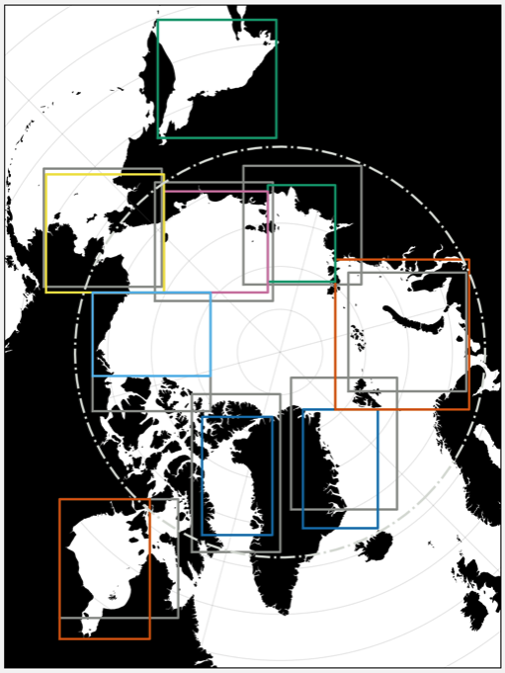
Figure 1: Original (gray) and updated (colors) region boundaries for the random sampling approach. The dash-dotted line shows the Arctic Circle.

- labeling, quicklook images, continuing landfast ice labeling, testing ideas for labeling other surface types
2026: Incorporation of the dataset into the IFT testing pipeline
During

During Fall 2026, we performed a major overhaul of the dataset to address the need for a rigorous set of point samples for calibrating the Ice Floe Tracker classifier function. In addition, we found it necessary to expand the sample to include 500 km by 500 km images. These images were drawn as a superset of the 100 km images, starting from identifying the region centered at the original 100 km sample, then adjusting the location to stay within the bounding boxes for the regions as necessary.
The NSIDC Climate Data Record of Sea Ice was updated to Version 6. Re-running the sea ice fraction analysis, we found that the end date for the Sea of Okhostk occurs earlier in the season (June 9th, rather than June 22nd). This date is earlier than the dates for two of the samples: cases 171 and 173.
The MASIE sea ice extent proved not to be as useful as anticipated.
- Organization for 500 km cases
- Addition of ASI images

References
Hatcher, S. (2024) “Error quantification in the Ice Floe Tracker algorithm.” Honors Batchelor’s Thesis, School of Engineering, Brown University

Meier, W. N., Fetterer, F., Windnagel, A. K., & Stewart, S. (2021). NOAA / NSIDC Climate Data Record of Passive Microwave Sea Ice Concentration, Version 4. National Snow and Ice Data Center. https://doi.org/10.7265/efmz-2t65

