*[Journal of Geophysical Research: Atmospheres ]*

Supporting Information for

Air-Ice-Ocean Coupling During a Strong Mid-Winter Cyclone Part 1: Coupled Dynamic Interactions in Observations and a Model

D. M. Watkins1, P. O. G. Persson2, T. Stanton3, A. Solomon2, J. K. Hutchings4 J. Haapala5, G. Svensson6

1Center for Fluid Mechanics, Brown University, Providence, RI, USA. 2Cooperative Institute for Research in Environmental Sciences, University of Colorado, Boulder CO and NOAA/Physical Sciences Laboratory, Boulder CO, USA. 3Moss Landing Marine Laboratories and Naval Postgraduate School, CA, USA. 4College of Earth Ocean and Atmospheric Sciences, Oregon State University, Corvallis, OR, USA. 5Finnish Meteorological Institute, Helsinki, Finnland. 6Stockholm University, Stockholm, Sweden

**Contents of this file**

Text S1 to S2

Figures S1 to S2

Table S1

**Introduction**

The supplemental text and figures provide information on the 30 January storm for comparison with the 31 January-1 February storm that is the main focus of the article. Text S1 describes Figure S1, which includes the buoy velocity components and wind speed map for comparison with Figure 8. Text S2 describes Figure S2, which shows the deformation in the Distributed Network for comparison with Figure 10. Table S1 lists the reference buoys used at multi-sensor sites.

Text S1.

The 30 January storm (C1) shows a similar pattern of differential motion across the extended DN as described for C2, though to a lesser extent (Figure S1); maximum drift speeds are between 10-20 cm/s. We note that no cold-sector LLJ is visible in the sounding data for C1, (Figure 5a), and the sea level pressure fields from ERA5 (Figure 2) indicate that SLP reached maximum depth after the storm had moved past the MOSAiC array. Therefore, it is likely that if a cold-sector LLJ developed during C1, it developed after the storm had left the MOSAiC site.

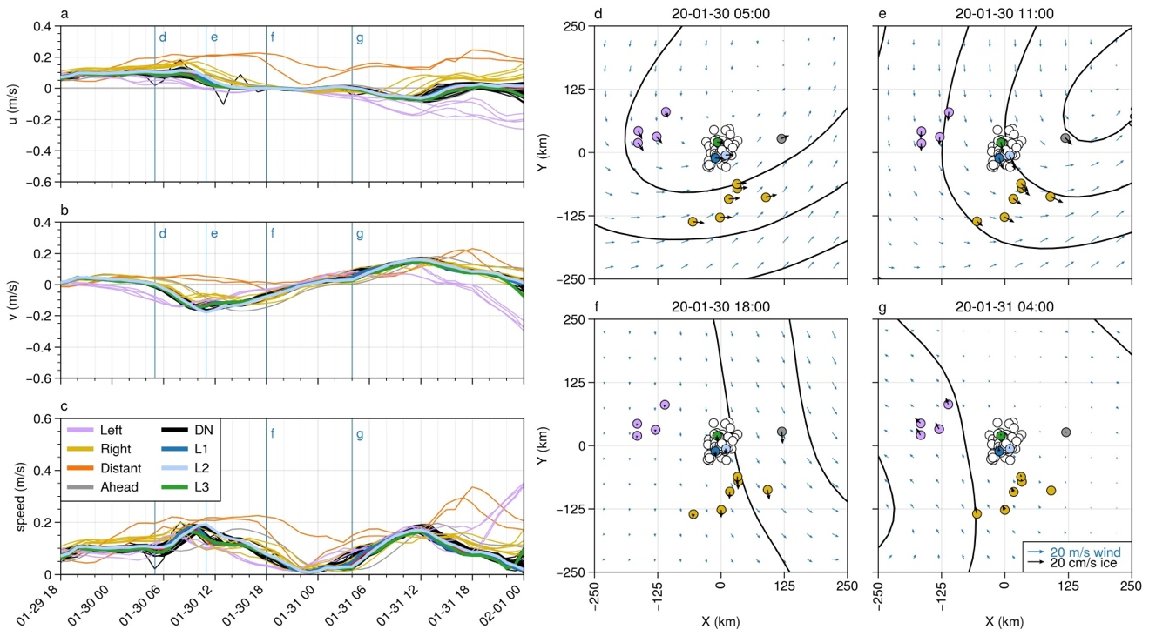

Figure S1. Left: Buoy velocity components (a, b) and magnitude (c) for the period from 18 UTC on Jan. 29 to 0 UTC on Feb 1. The top and middle panels show the u and v velocity components relative to the north polar stereographic projection, thus corresponding to the x and y axis, respectively, in the panels on the right. For the period shown here, the positive y direction is approximately northward. Right: Snapshots of buoy motion (thick black arrows) superimposed on the ERA5 sea level pressure isobars (black contours, 4 hPa spacing) and near-surface (10 m) wind fields (blue arrows) at times corresponding to vertical lines in the velocity time series to the left.

Text S2.

As with the 1 February storm, the largest deformation response during C1 occurs at close to the time of the passage of the front (Figure S2). For the weaker cyclone, the full DN shows no significant divergence, while still showing a local maximum in maximum shear strain rate, and shows the same vorticity pattern with cyclonic vorticity during the approach of the front and anticyclonic vorticity thereafter. Deformation is localized. Here, the L-site triangle shows positive divergence while polygon DN 4 straddles a north-south oriented shear zone near L2 and shows convergence. We note in Figure S2d that there is evidence that the shear zone near L3 activated (weakly) during this storm; it is possible that the ice in the shear zone was weakened by the first storm enabling a stronger deformation response during the second storm.

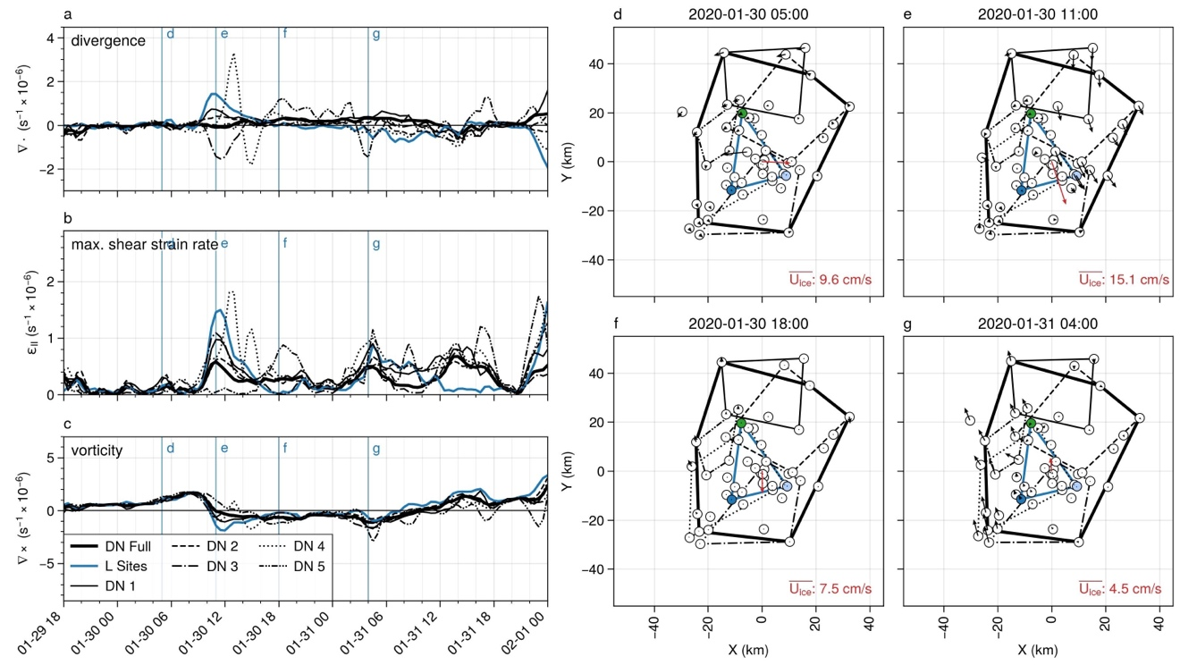

Figure S2. Strain rate components (a-c) and velocity anomalies (d-g) of the Distributed Network for the Jan 30 cyclone. Polygons used for the deformation calculations are shown in panels d-g. The polygons were selected manually; note that the buoy in the upper left was not included in the “DN Full” array due to periods of missing data. Velocity anomalies in panels d-g were computed relative to the ensemble average velocity, which is shown as the red arrow at the center of each panel.

|  |  |
| --- | --- |
| Site | Sensor ID |
| CO1 | 2019T66 |
| L1 | 2019T67 |
| L2 | 2019T65 |
| L3 | 2019S94 |
| M1 | 2019O1 |
| M2 | 2019V2 |
| M3 | 2019O3 |
| M4 | 2019O4 |
| M5 | 2019O5 |
| M6 | 2019O6 |
| M8 | 2019T69 |
| **Table S1** | |

Table S1. Representative buoys for multi-sensor sites