Grocery Store Helper

Ahmad Nizam

CS 449

Table of Contents

Vision Statement………………………………………………………………3

Requirements…………………………………………………………………..4

Sprint 1…………………………………………………………………………….6

Sprint 2…………………………………………………………………………….8

Sprint 3…………………………………………………………………………….10

Sprint 4…………………………………………………………………………….12

Sprint 5…………………………………………………………………………….14

Sprint 6…………………………………………………………………………….16

Design………………………………………………………………………………17

Coding Standards……………………………………………………………..18

**Vision Statement**

For the average person who goes grocery shopping, the Grocery Helper is an application for organization that helps a user keep track of their checklist, reward cards and past spending. Unlike other organizational applications, our product allows user watch their spending and see what they bought in the past.

**Requirements**

Users:

User A, an organized person.

User B, a person who has too many cards in their wallet

User C, a person watches their spending.

|  |  |
| --- | --- |
| **Actor** | **Goal** |
| User A | Making a grocery list |
|  | Clicks on a tab, called “List” |
|  | Adds grocery list |
|  |  |
| User B | Add rewards card |
|  | Clicks on tab, called “Rewards card” |
|  | Click on “+” |
|  | Camera opens |
|  | User takes picture |
|  | Picture of rewards care is saved and displayed under the tab |
|  |  |
| User C | Adds how much the user spent and on day |
|  | Clicks on tab, called “Receipts” |
|  | Selects date to they went shopping |
|  | Adds how much they spent |
|  | User clicks save |
|  |  |

Stories:

As User A, I want to be able to create a grocery list for my trip to the grocery store.

As User B, I want to be able to save my rewards card on my phone and have easy excess to it.

As User C, I want to be able to save my grocery store receipts from my trips to the grocery store for my reference.

Product Backlog:

|  |  |  |  |  |
| --- | --- | --- | --- | --- |
| **Story ID** | **Story** | **Story Points** | **Priority** | **Status** |
| S1 | Allow user to create a grocery checklist |  | 1 |  |
| S2 | Allow user to save a reward card for a store |  | 2 |  |
| S3 | Allow user to save and date how much they spent on a grocery trip |  | 3 |  |

SPRINT 1 PLAN

|  |  |  |  |
| --- | --- | --- | --- |
| **Story ID** | **Story / Task** | **Estimated**  **Hours** | **Actual**  **Hours** |
|  | Create design of the app | 5 | 3 |
|  | Create tabs for each feature | 2 | 4 |
|  | Create buttons | 2 | 1 |
|  | Get working camera for the app | 6 | - |
|  | Test buttons and tabs | 4 | 1 |
|  | Create toast for each button to insure working buttons | 3 | 2 |

Screenshots:

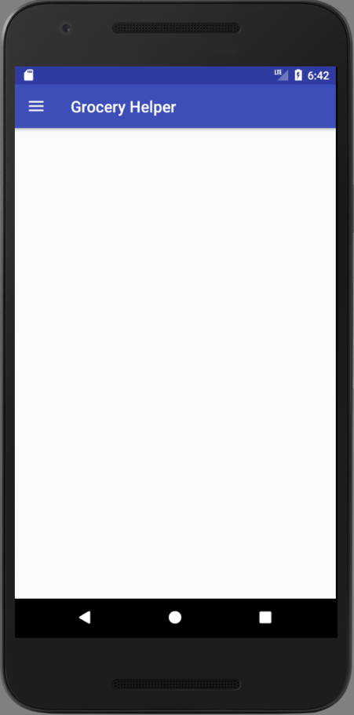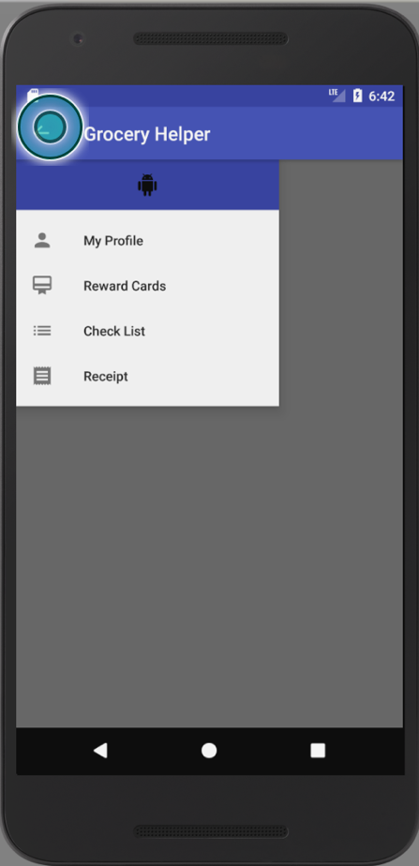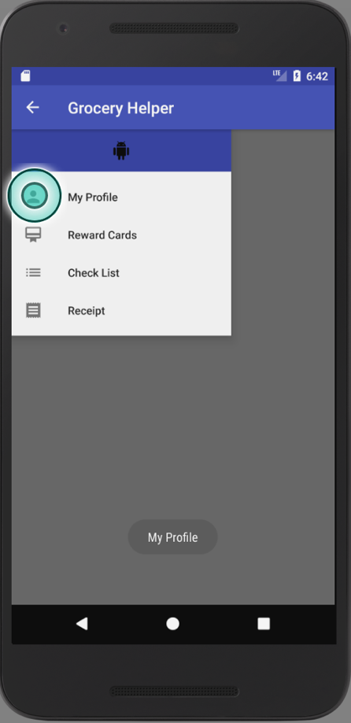

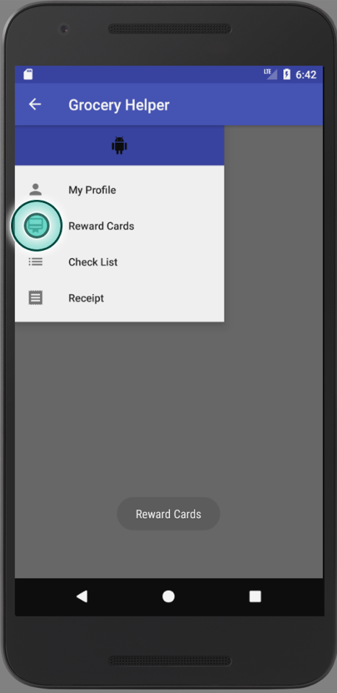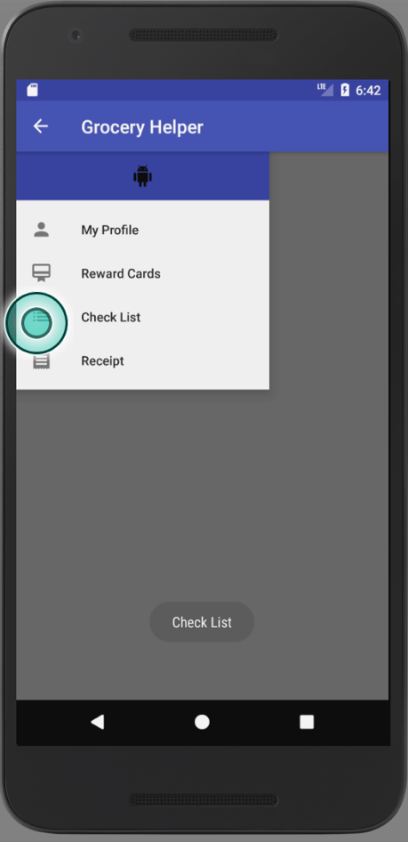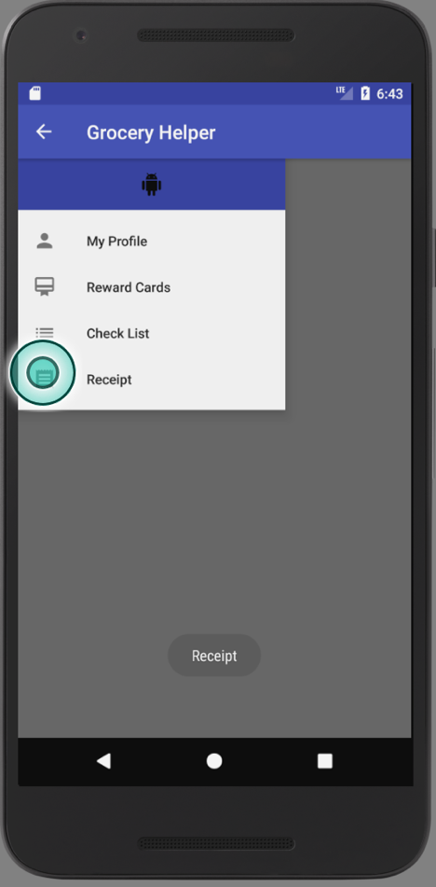

Review:

Retrospective:

For this iteration, I planned on finishing the design of the app and get toast for each of the buttons to test and see if they work. Next, was to get an actual camera interface to work and store photos on the application but that was more difficult than thought of. I would say that I planned too much for the first iteration and should of planned better. I will have to move this camera interface of the application to the next iteration.

Project Velocity: 11

SPRINT 2 PLAN

|  |  |  |  |
| --- | --- | --- | --- |
| **Story ID** | **Story / Task** | **Estimated**  **Hours** | **Actual**  **Hours** |
|  | Create check list feature | 3 | - |
|  | Test check list | 1 | - |
|  | Continue working camera for app | 4 | 5 |
|  | Test camera | 1 | 1 |
|  | Convert picture of barcode to pdf | 4 | - |
|  |  |  |  |

Screenshots:

  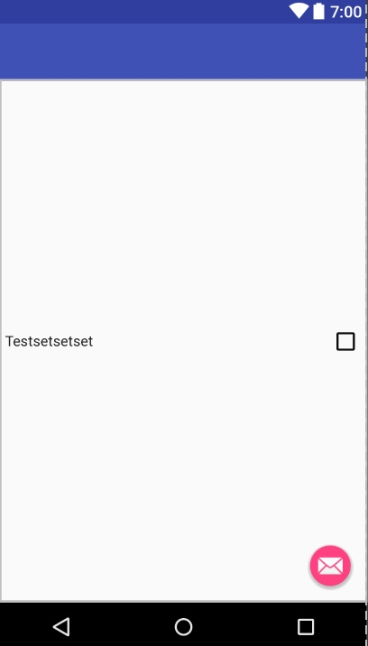

Review:

Retrospective:

For this iteration, I planned on finishing the camera interface and get a checklist started. I ran into a lot of trouble with the camera interface as I did not know where the photo was stored after the photo was taken in the photo storage to be used and displayed. But I eventually figured it out and got it reproduce on the screen. I started the checklist but had a biking accident that caused my arm to be in sling. I plan on finished the checklist next iteration.

Project Velocity: 6

Sprint 3 Plan

|  |  |  |  |
| --- | --- | --- | --- |
| **Story ID** | **Story / Task** | **Estimated**  **Hours** | **Actual**  **Hours** |
|  | Create check list feature | 5 | 4 |
|  | Test check list | 1 | - |
|  | Convert picture of barcode to pdf | 5 | - |
|  | Design a menu for the front page of the application | 3 | 2 |
|  |  |  |  |

Screenshots:

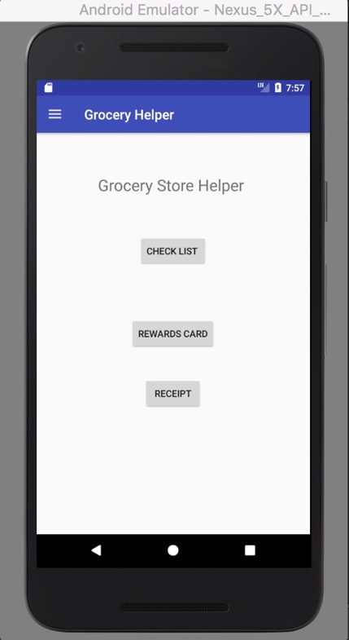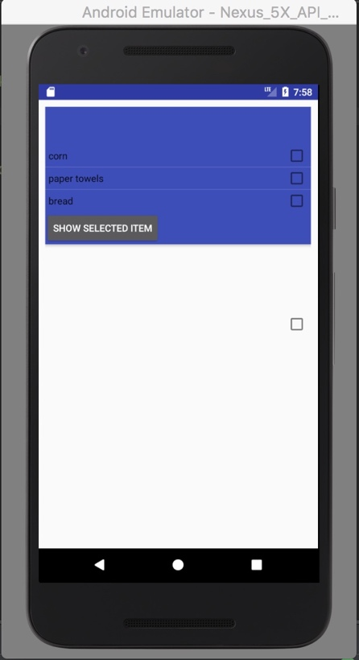

Review:

Retrospective:

For this iteration, I planned on finishing my checklist feature, design my main menu and try to convert my barcode pictures to pdf. I finished the checklist design but still needed user input. The design of the menu was completed. The hardest part and the part that I am still researching is the conversion of an image to pdf in java. Overall good progress on the project, even with one hand typing.

Project Velocity: 6

Sprint 4 Plan

|  |  |  |  |
| --- | --- | --- | --- |
| **Story ID** | **Story / Task** | **Estimated**  **Hours** | **Actual**  **Hours** |
|  | Finish check list feature | 3 | 3 |
|  | Test check list | 1 | 1 |
|  | Convert picture of barcode to pdf | 5 | - |
|  | Start receipt feature | 3 | 2 |
|  | Add calendar feature to receipt | 3 | 2 |

Screenshots:

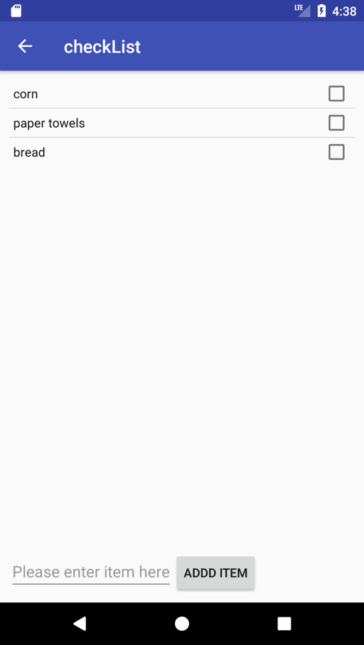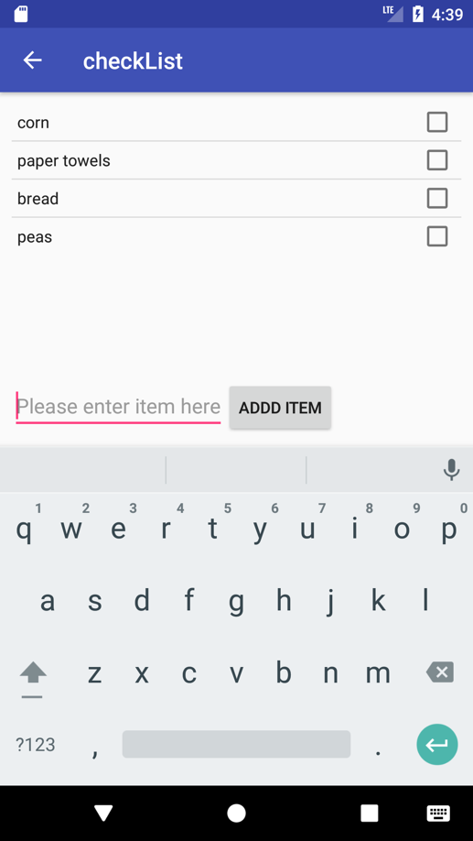

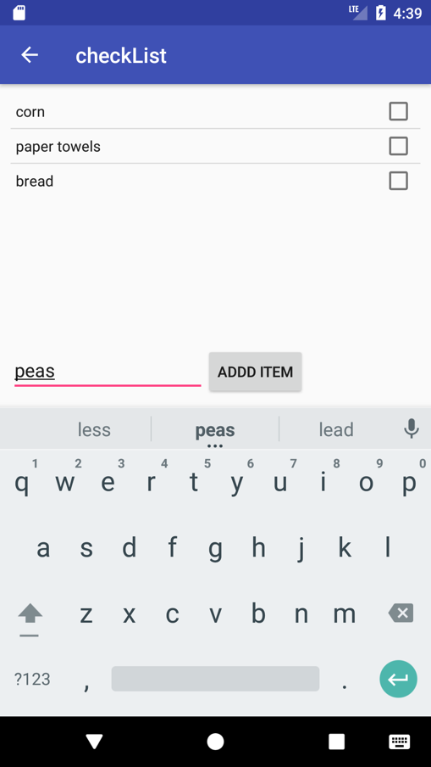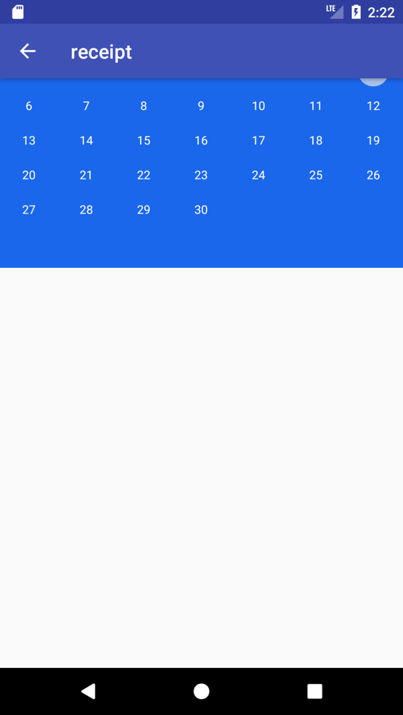

Review:

Retrospective:

For the iteration, I finished up the checklist feature with the user input. That took rather long as I had to figure out how to dynamically add to a list. One problem that came up during my iteration was the receipt feature and had to complete change the idea I had for the feature itself. Overall the iteration went okay. I plan on finishing the receipt feature in the next iteration and plan of including SQL-lite for saving data.

Project Velocity: 8

Sprint Plan 5:

|  |  |  |  |
| --- | --- | --- | --- |
| **Story ID** | **Story / Task** | **Estimated**  **Hours** | **Actual**  **Hours** |
|  | Finish receipt feature | 5 | 5 |
|  | Test receipt feature | 1 | 1 |
|  | Fix camera feature for saving cards | 2 | - |
|  | Start SQL-lite database | 3 | 7 |

Screenshots:

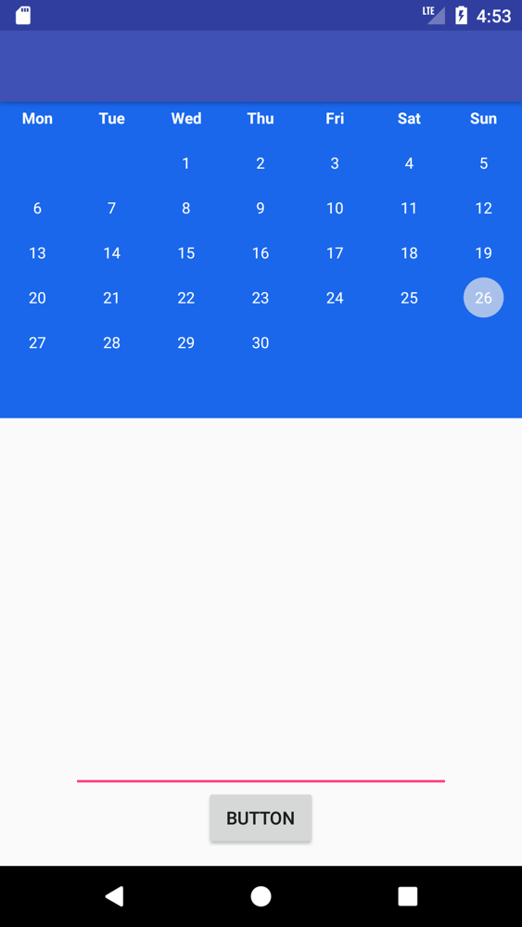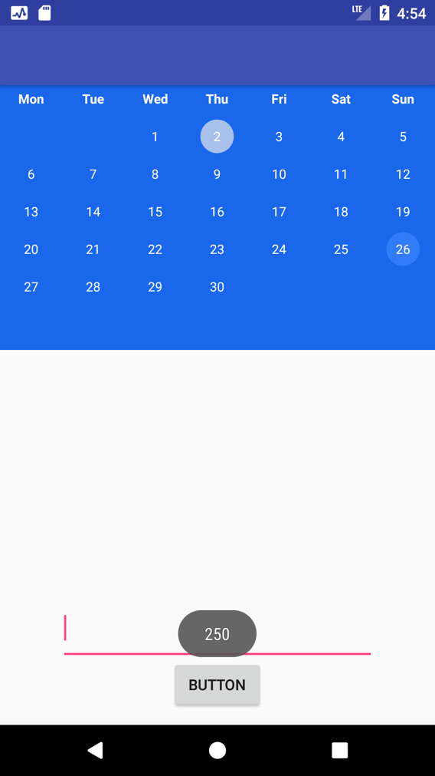

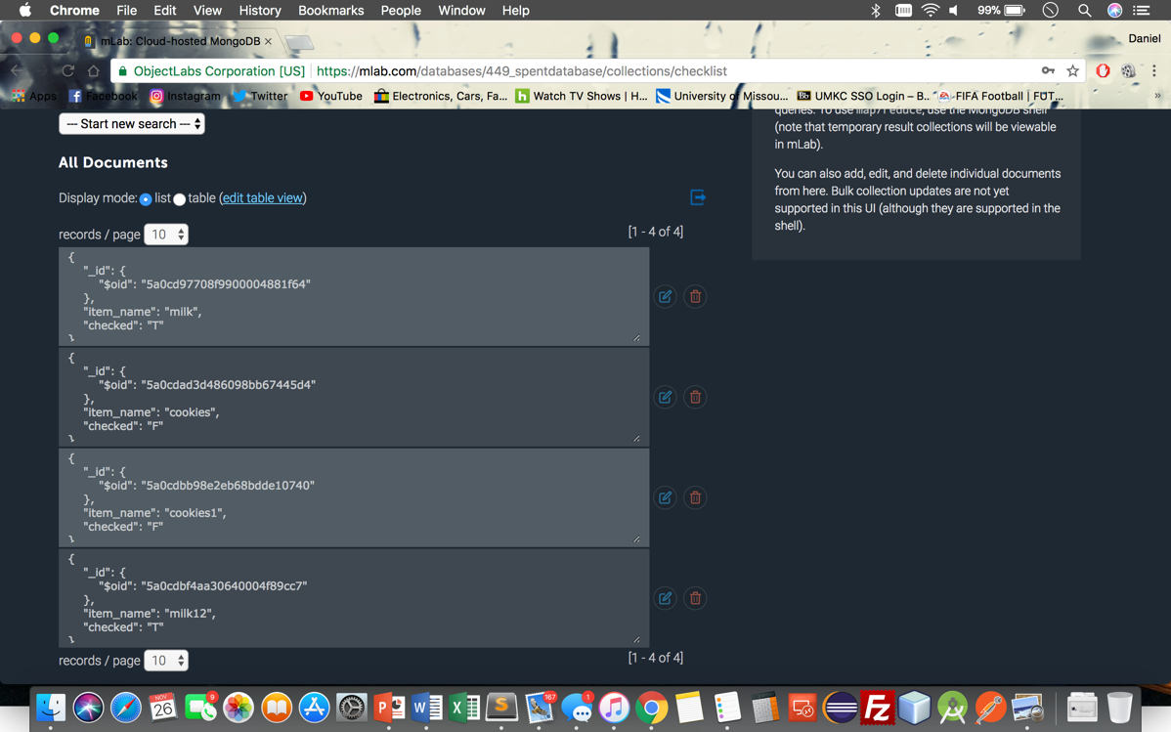

Review:

Retrospective:

For this iteration I was able to get a lot done. It took while to figure out but I got the backend of the application done. It was quite confusing and required a lot of time. I was able to figure it out by using different database management systems to connect to each other. I also figured out the calendar section of the application and got it works and connecting the database. Also got the checklist to connect to the database. For the last sprint I plan to clean up the code and fix some features as the camera feature doesn’t save photos.

Project velocity: 13

Sprint Plan 6:

|  |  |  |
| --- | --- | --- |
| **Story / Task** | **Estimated**  **Hours** | **Actual**  **Hours** |
| Refactor/clean up application | 10 | 10 |
| Test overall application | 5 | - |
| Fix camera feature for saving cards | 2 | - |
| Finish database | 4 | 4 |

Screenshot:

Retrospective:

For this last iteration I cleaned up the code to the best of my ability without getting confused. The overall project was a nice learned process for sprints and the agile method. It was rather difficult at first to learn android programming but I eventually learned it, somewhat. I did not get all the features that I wanted to get done because of confusion and the difficulty of trying to figure out the camera and how to use it and save photos.

Project velocity:

Design:

Coding Standards: