
<Noam Efrat - noame920@gmail.com - 307903054 - 0523235344>
<Daniel Nachshoni - danielnahshoni@gmail.com - 303111744 - 0528383980>
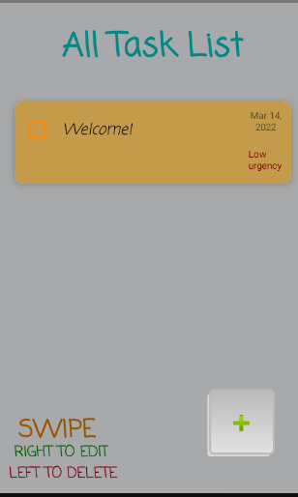
We’ve been sharing both design and the implementation of activities. Noam mostly touched the bundle sphere, and Daniel the SQL. We both contributed together to the UI.
Our system functions as a Tasklist which provides the ability to add and edit tasks while having the option to rate their importance, setting a date for the task.
When entering the Main Activity, the user will find his tasks to appear vertically, one underneath the other, where the latest task will appear at the toppest oval.
User will be able to see next to it the date and how important is the task.
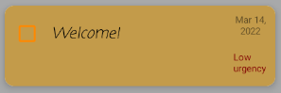

In case the task is no longer relevant, the user has the following options:
a. Click the ‘checkbox’ button to maintain the appearance of the task, yet to know it has been fulfilled.
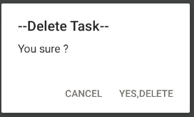
b. Swipe left to erase the task.
A window verifying the user wants to erase completely the task from the list.

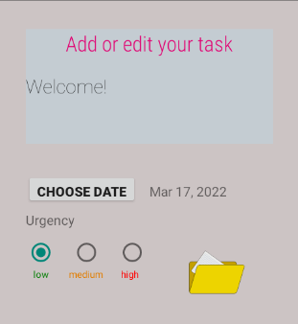
c. Swipe right to edit the task. A window requesting the new information will pop-up. This will lead us to the ‘AddTask’ activity.


The window from clause ‘c’ is the same one of the ‘Add New Task’ option, which is presented to the user by the following button:The technology is available for 92% out of the overall devices, and has been emulated on a ‘Nexus One API 30’ device.
When it comes to our architecture, we have been following the idea of seperating our UI from the Data models.
The data is being saved on a SQLite database, which allows saving of previous tasks. This is associated with the ‘DataBaseSQLite’ folder, containing ‘MyDBhelper’ and ‘SQLdbManager’ files.

Database structure:
TASK_ID | TASKS_STATUS | TASK | DATE | URGENCY

<Noam & Daniel>

