Crownfield Eye Hospital
  - Individual report — database implementation, security and testing
CPU4103 Introduction to Database | Dumitru-Daniel Nedelescu | Student ID: G1423264 | 6 November 2026

1. Introduction
This report explains my work on a MySQL database prototype for the fictional Crownfield Eye Hospital. The database stores patients, appointments, clinicians, clinics, diagnoses, prescriptions and follow-up information in separate tables. My main responsibility as Student A was implementation, security and testing. I checked the database structure and sample records, tested transactions and an audit trigger, and configured user roles. The ER diagrams and other shared database materials were developed as part of the team project. This report describes the work I checked and the evidence I saved from MySQL Workbench.

2. Analysis and design
The five unnormalised source rows contain four unique patients, because OP001, Amina Yusuf, appears for two appointments. Relying on Patient ID as a visit key would merge unrelated encounters. The row for OP001 also lists 'Latanoprost | Timolol' in one medicine cell, while another row gives 'None'. Such mixed representations obstruct searches and produce repeating groups. Similarly, '6 weeks | High' combines interval and priority, making validation unreliable. Repeated clinician/specialty names create update anomalies if specialty wording changes and insertion anomalies if a new clinician has not yet handled a visit. Deleting the last visit could inadvertently discard permanent patient or clinic details (Global Banking School, 2025).
The conceptual model makes Patient, Clinician and Clinic independent entities linked through Appointment. A patient may have zero or many appointments, but each appointment requires precisely one patient, clinician and clinic. Each clinician references one primary specialty, which can be shared among many clinicians. Separate Diagnoses and Medicines catalogues avoid rewriting clinical labels in every visit. AppointmentDiagnoses and PrescriptionItems resolve many-to-many associations, and PrescriptionItems also stores the dose, route, frequency and duration for each medication. FollowUpPlans is optional and unique by appointment, allowing zero or one plan. Treatment junctions are extra synthetic entities because the appendix lacks procedure-level treatment fields.
A deliberate modelling choice is to use separate surrogate numeric identifiers for appointments and the main clinical reference records while preserving patient identifiers such as OP001. This prevents a patient’s repeated attendance from being mistaken for one encounter. Clinic and clinician details are stored once and referenced by foreign key, so changing the spelling of a clinic name does not require updating every booking. I would check the diagram by following each mandatory relationship from Appointments to its three parents and then following optional records toward diagnoses, prescriptions and follow-ups. A relationship diagram is only correct when its optionality matches both the business rules and the SQL NULL/UNIQUE constraints.
In unnormalised form, medicine names are grouped inside a single visit row. First normal form (1NF) requires atomic medicine entries and a distinct AppointmentID, rather than patient identity as the encounter key. A provisional 1NF relation with (AppointmentID, MedicineID) has partial dependencies: date, clinician and patient depend only on AppointmentID, while medicine description depends only on MedicineID. Second normal form (2NF) separates these attributes into master and transactional tables. Third normal form (3NF) removes transitive dependencies such as AppointmentID → PatientID → full_name/postcode and ClinicianID → SpecialtyID → specialty_name. The resulting design reduces duplication and makes patient contact corrections possible in one place (Global Banking School, 2026).
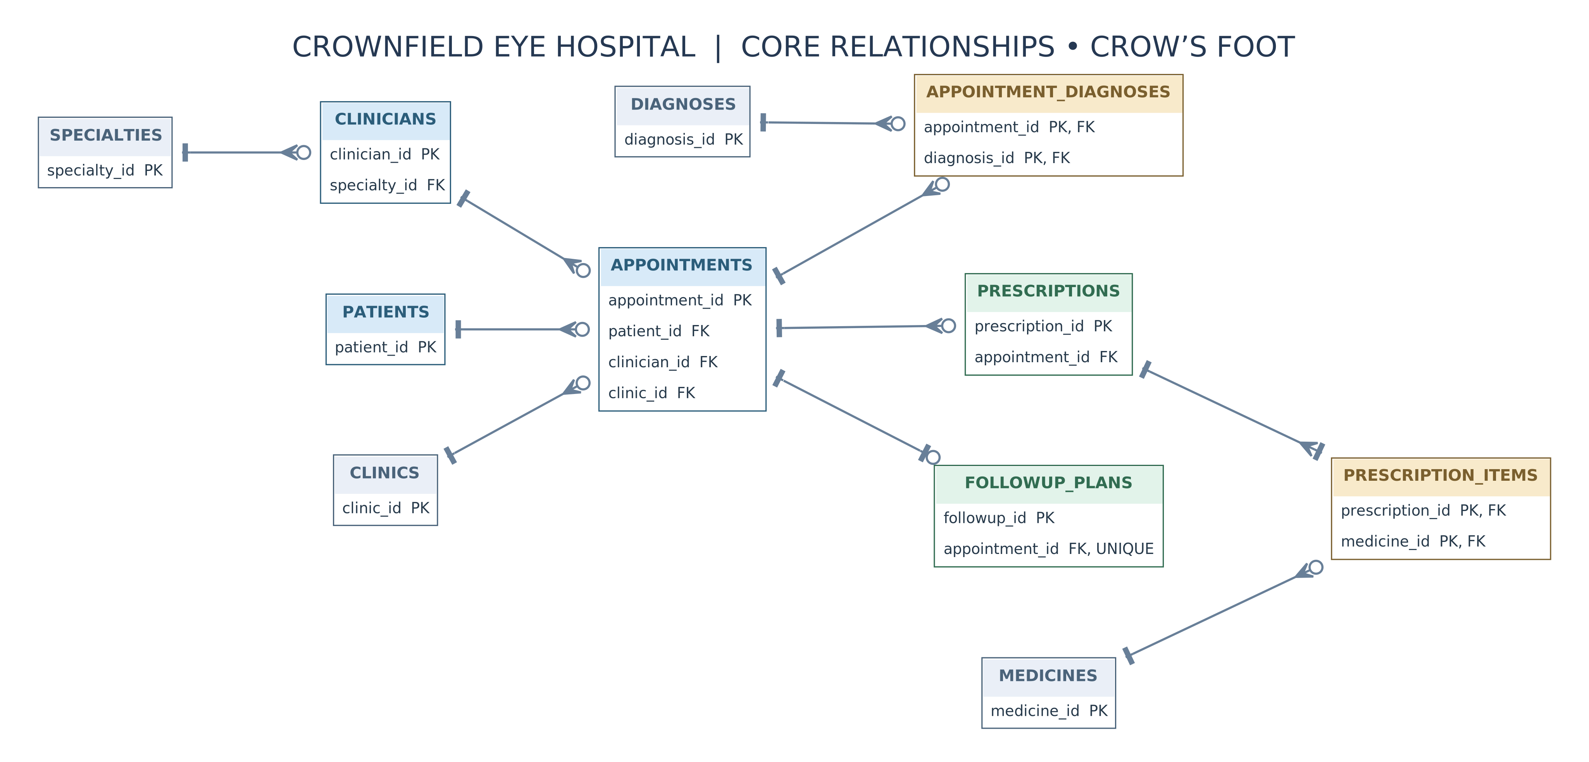
Figure 1. Core relationships using Crow’s Foot notation (full logical ERD appears on the final landscape page).
Database table list
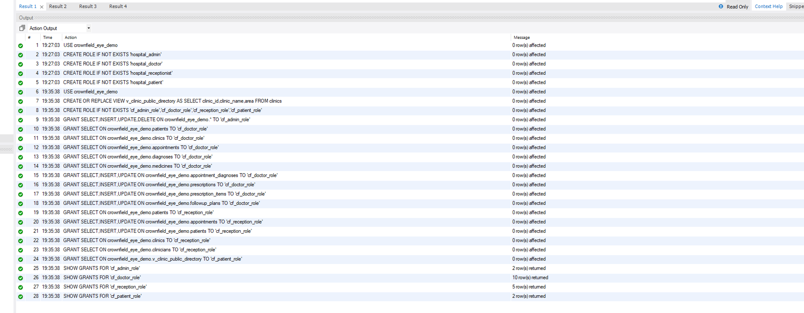
MySQL Workbench evidence — screenshot image(20261106-193743)

3. Implementation and testing
I checked the database in MySQL Workbench using the crownfield_eye_demo schema. The test data included 16 patients, 13 clinics, 15 clinicians and 20 appointments. I checked for missing required values, duplicate IDs, invalid appointment statuses, invalid appointment dates and times, overlapping scheduled appointments, and orphan records in the relationships I tested. These checks did not return problems. I also tested an appointment status change using ROLLBACK, which restored the original status, and COMMIT. The audit trigger recorded the status changes. I did not complete every possible negative test, so these results only describe the checks I carried out.
The sample data contains patients with more than one appointment and patients with no bookings. This makes it useful for testing different types of SQL queries. I kept screenshots of the database checks and transaction results. The screenshots should show the SQL statement and the result together, so the evidence can be understood without running the database again.
Database data counts
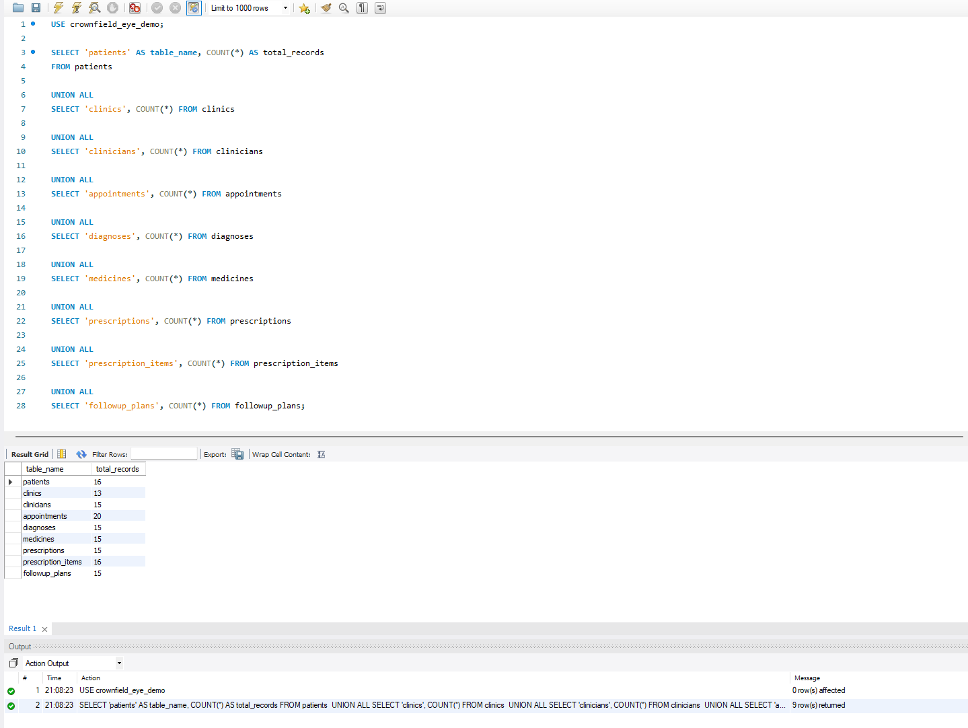
MySQL Workbench evidence — screenshot image(20261106-210854)

Validation and transaction checks
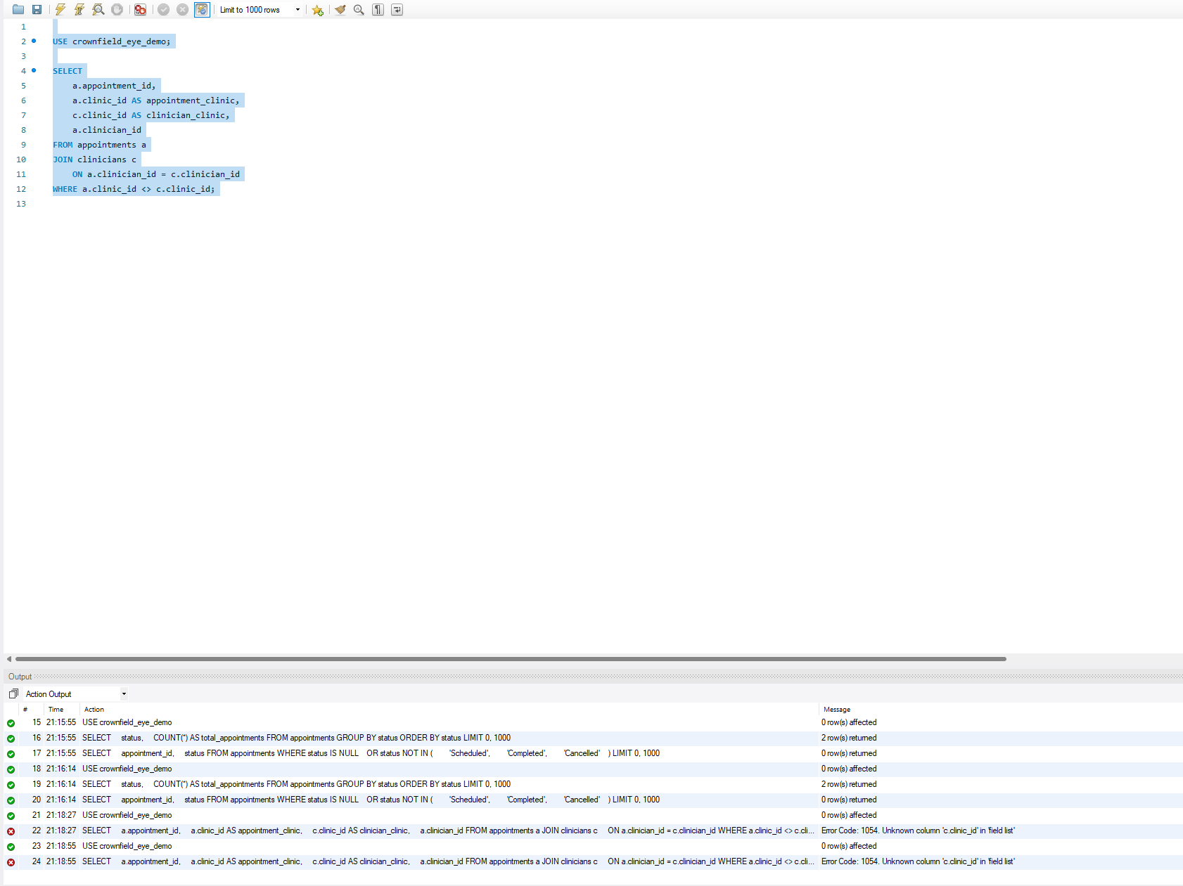
MySQL Workbench evidence — screenshot image(20261106-211917)
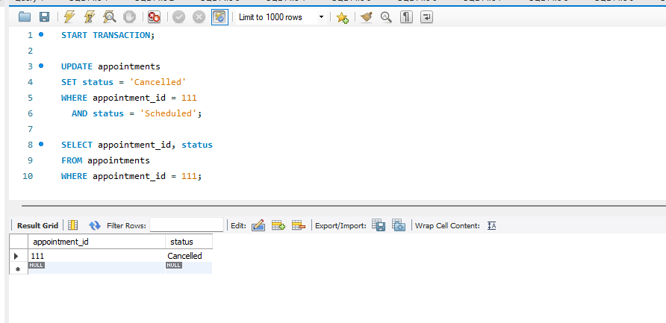
MySQL Workbench evidence — screenshot image(20261106-204418)

4. Individual SQL — six required features
The following six SQL features are described as part of the project. The matching screenshots should be inserted from my saved MySQL Workbench evidence. I have not included any result that I cannot verify from a screenshot.

Q1. Patient appointment frequency — GROUP BY / HAVING
Q1 groups patient appointments and retains only patients with more than one, using GROUP BY and HAVING. Its purpose is to identify repeat service use without confusing appointment rows with unique patients.
Q1: Patient appointment frequency
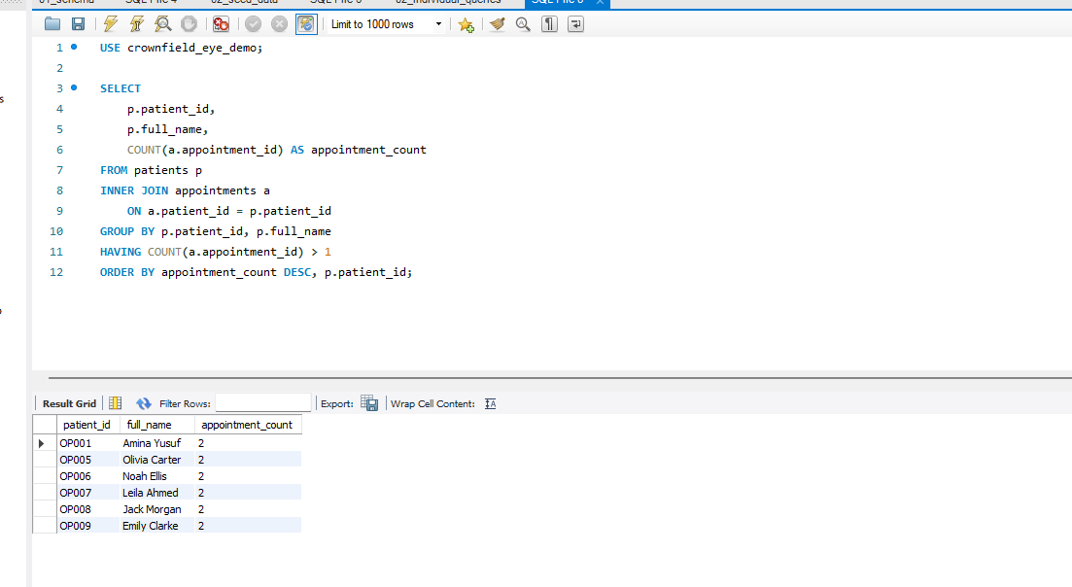
MySQL Workbench evidence — screenshot image(4)

Q2. Patient/clinician/clinic visits — INNER JOIN
Q2 joins appointments, patients, clinicians and clinics with INNER JOIN. Each returned line provides a clinically understandable encounter context; rows without required foreign-key parents cannot appear because the schema prevents them.
Q2: Patient, clinician and clinic joins
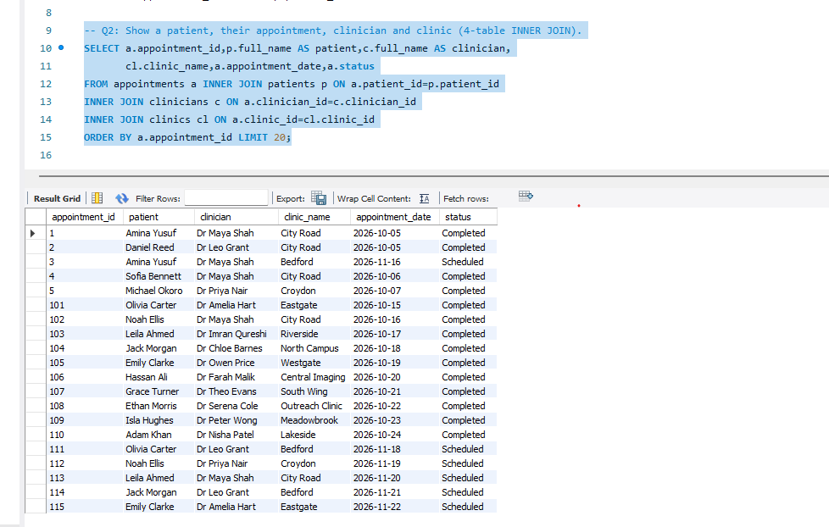
MySQL Workbench evidence — screenshot image(5)

Q3. Patients without bookings — LEFT JOIN
Q3 starts from patients and LEFT JOINs appointments, selecting null appointment identifiers. It deliberately shows registered patients with no visits, which an INNER JOIN would hide.
Q3: Patients without appointments
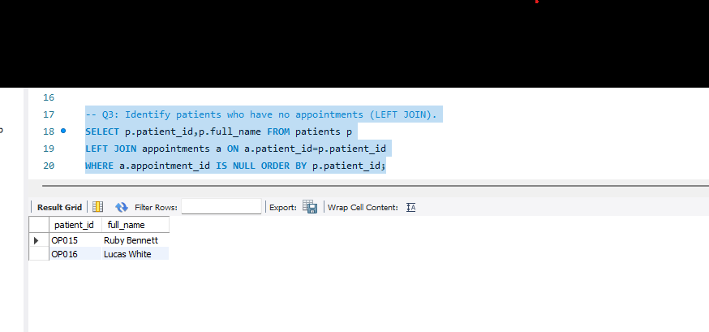
MySQL Workbench evidence — screenshot image(6)

Q4. Higher-than-average visits — CTE
Q4 uses a common table expression to calculate counts including zero-booking patients, then compares them with their overall average. It identifies patients whose visit frequency is unusually high within this small synthetic sample.
Q4: Higher-than-average visits
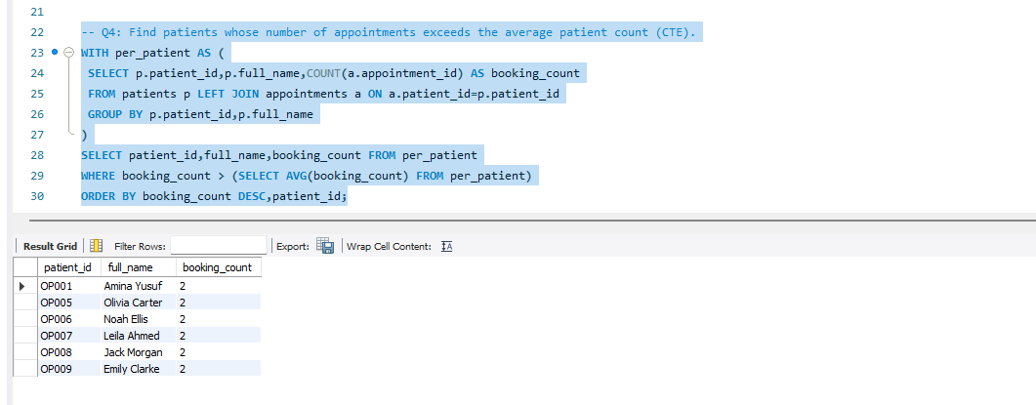
MySQL Workbench evidence — screenshot image(7)

Q5. Patient appointment lookup — stored procedure
Q5 implements sp_s1_patient_appointments with a patient-ID input parameter. It retrieves visit dates, clinicians, clinic locations and statuses without embedding a fixed patient ID in the procedure definition.
Q5: Patient appointment procedure
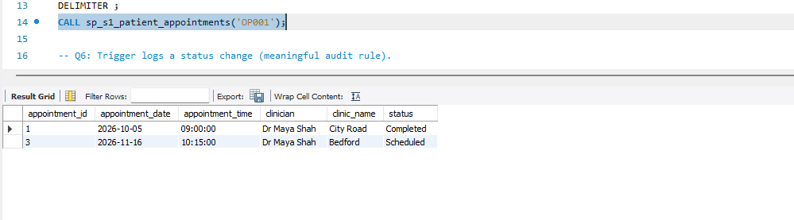
MySQL Workbench evidence — screenshot image(20261106-190331)

Q6. Appointment change log — trigger
Q6 uses an AFTER UPDATE trigger to record appointment status changes in appointment_status_audit. I tested appointment 111 by changing its status and checking the audit table. I also used ROLLBACK to restore a change and tested a committed change. The audit table showed the status transitions.
Q6: Appointment status audit trigger
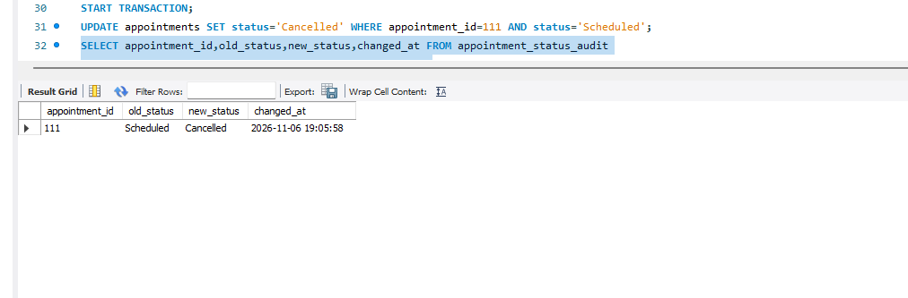
MySQL Workbench evidence — screenshot image(20261106-190805)
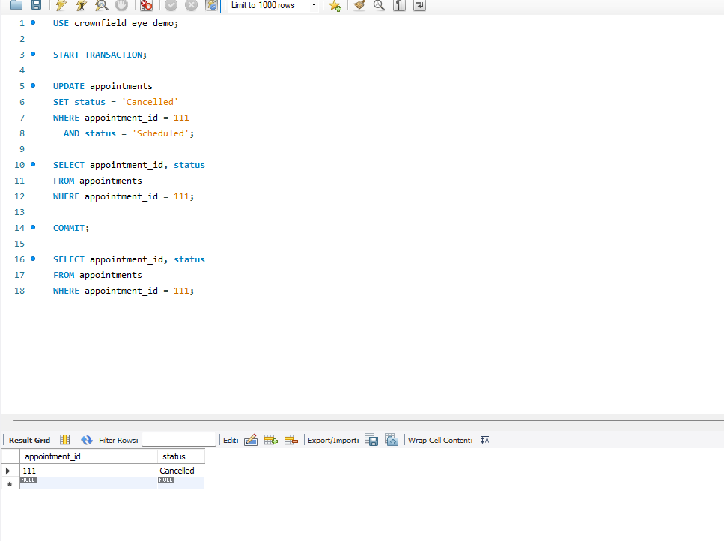
MySQL Workbench evidence — screenshot image(20261106-204926)

The six features cover different retrieval and validation techniques. A GROUP BY can produce correct totals only if the grouping level reflects the question: counting appointment rows by patient avoids inadvertently counting prescription items as additional visits. A four-table join is intentionally built through key relationships, not by matching repeated names. The CTE first includes patients with zero appointments; this affects the average and should be justified when the result is interpreted. The procedure parameter should be tested with one existing patient and one nonexistent ID to show both normal and empty-result behaviour. Finally, the audit trigger should be tested with both a real status change and an update that leaves status unchanged; only the first should create an audit event.

5. Security and transactions
I configured four MySQL roles: administrator, doctor, receptionist and patient. I checked the GRANT statements and confirmed that the roles were assigned to the matching hospital user accounts. I also checked their default roles. The patient role has SELECT access to the public clinic directory view, not the full patients table. The doctor and receptionist roles have different permissions based on their tasks. I did not complete the final access-denied test while signed in as hospital_patient, so I cannot claim that this restriction was tested through that account.
The SHOW GRANTS results are evidence of how the permissions were configured. They do not, by themselves, prove what happens when each user logs in. I also checked transaction behaviour with COMMIT and ROLLBACK and reviewed the audit records created by the trigger. The project discusses encryption and prepared statements as useful security techniques, but I have not included a claim that I personally verified those demonstrations unless a matching screenshot is available.
Role grants and role assignment
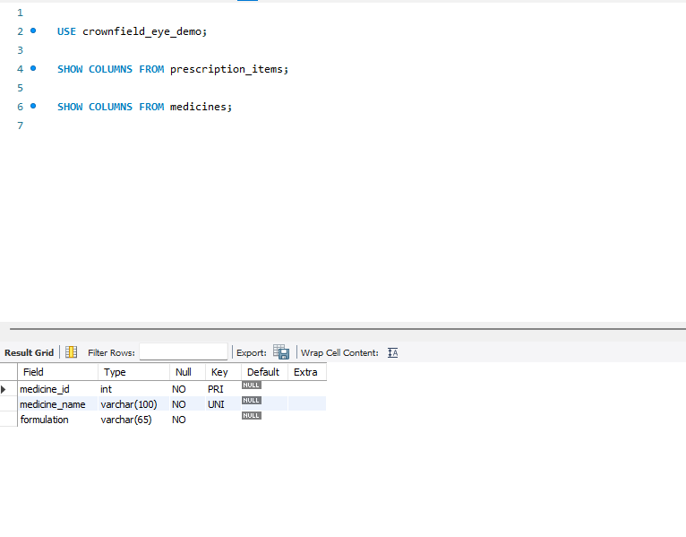
MySQL Workbench evidence — screenshot image(20261106-212617)
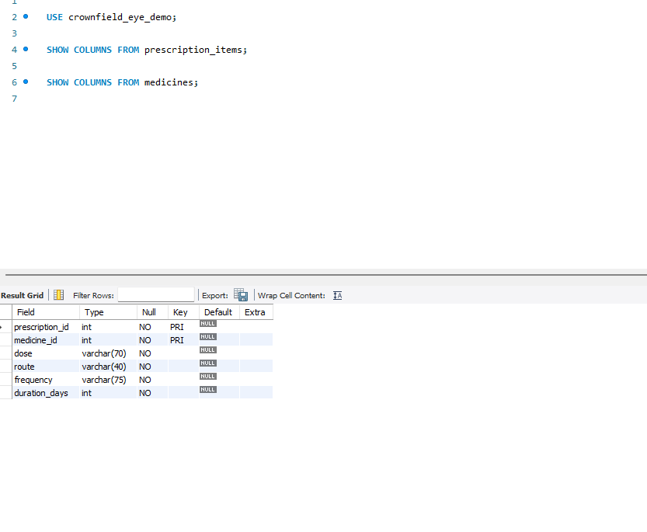
MySQL Workbench evidence — screenshot image(20261106-212650)
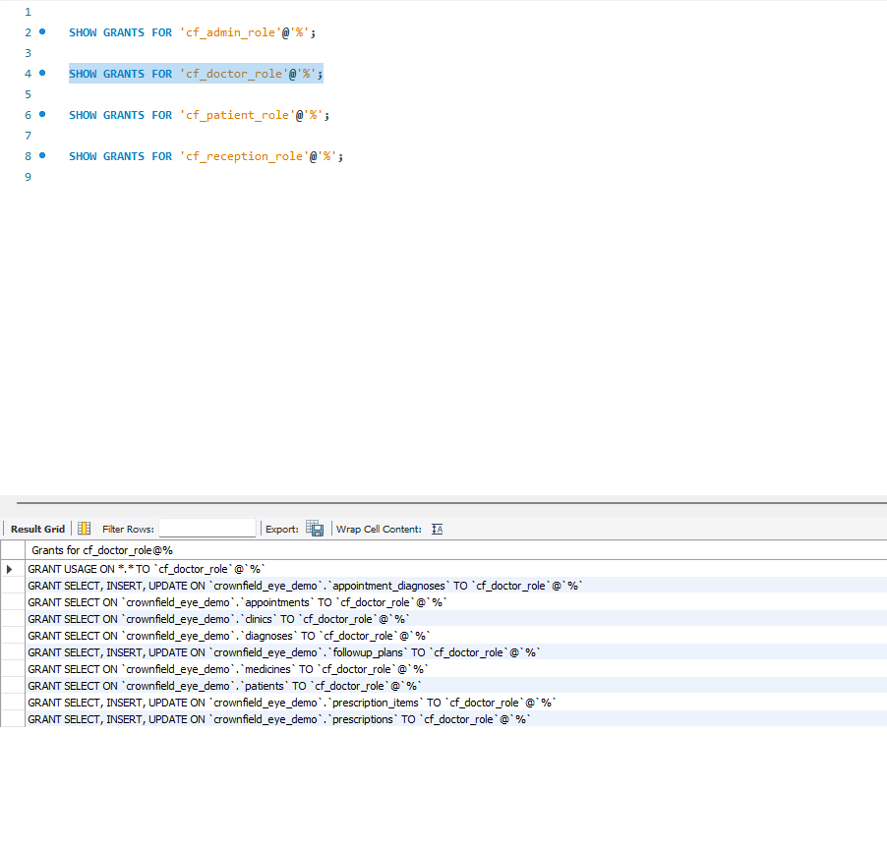
MySQL Workbench evidence — screenshot image(20261106-213252)

COMMIT and ROLLBACK tests
MySQL Workbench evidence — screenshot image(20261106-204418)
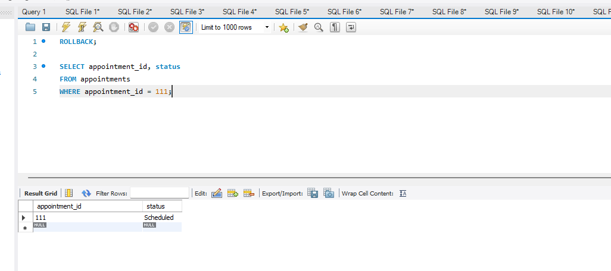
MySQL Workbench evidence — screenshot image(20261106-204502)

6. Evaluation and reflection
This project helped me understand how a database can separate patient details from appointments and use foreign keys to keep information connected. One problem I met in MySQL Workbench was that I tried to test patient permissions while I was still connected as root. The query worked because root had wider access. I realised this was not a valid patient-role test, so I did not record it as a pass. I also learned to check which account is active before testing permissions. The database is a learning prototype, not a complete hospital system. For example, table permissions alone do not limit each patient to their own record, and the audit trigger only records appointment status changes.

7. References and use of AI tools
Global Banking School (2025) CPU4:103 Introduction to Database: Summative Assessment Guide, Crownfield Eye Hospital scenario, June 2025 cohort. Assessment brief supplied to students.
Global Banking School (2026) Introduction to Databases, CPU4103-20C: Weeks 1–5 student lecture materials. Internal teaching slides.
Oracle (n.d.) MySQL 8.0 Reference Manual. Available at: https://dev.mysql.com/doc/refman/8.0/en/ (Accessed: 5 November 2026).

Appendix — Full logical ER diagram (Crow’s Foot notation)
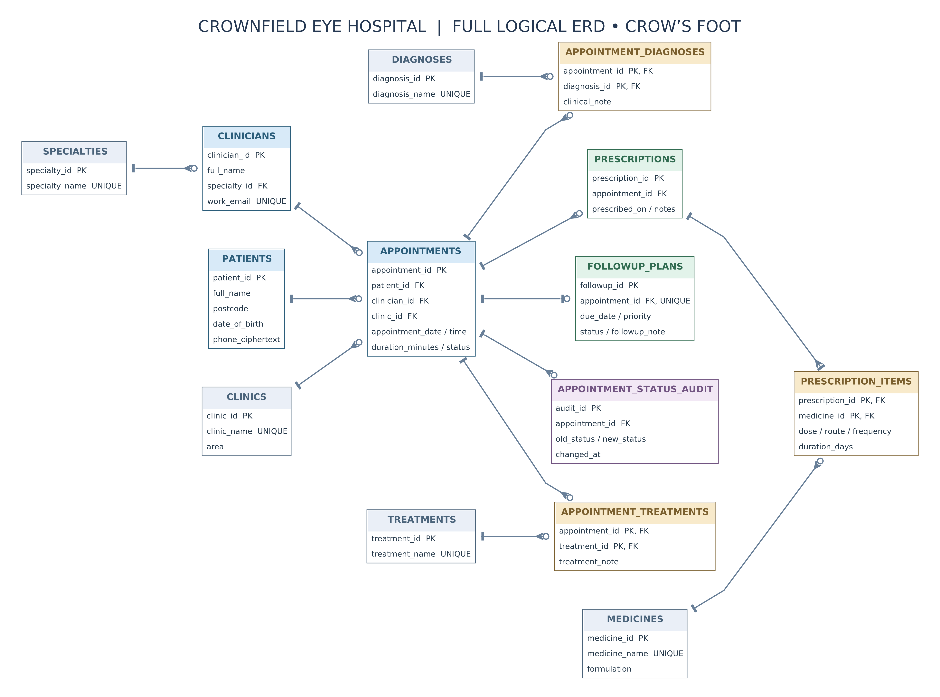
Crow’s Foot legend: | = exactly one · ○< = zero to many · |< = one to many · ○| = zero or one. All tables and foreign keys reflect 01_schema.sql.
Note: the business rule requiring at least one prescription item must be enforced by the application or transaction; a foreign key alone does not ensure a parent has a child.
AI tool acknowledgement: I used OpenAI ChatGPT to help plan the structure of this report, organise the sections and improve the clarity of my English. I reviewed the content and used my own MySQL Workbench work and screenshots as evidence.

