It will also have its own distinctive theme, based on saving endangered species. Think of investing in different conservation schemes, developing different aspects of these, raising funds for these or devoting resources to them. Rather than use cash for your transactions, you might want to think about allocating some other resource – people, equipment, know-how, time-and-effort. It’s your job to think through and apply the ‘metaphor’ you want to use in your game.

Resources (Ʀ) are the games currency , the resource squares will either give or take away from a players resources like chance, chest or tax squares in a normal monopoly board

(1) Pass GO

(2) IUCN

(3) Resource square

(4) World Animal Protection

(5) International Animal rescue

(6) The wildlife trust

(7) Resource square

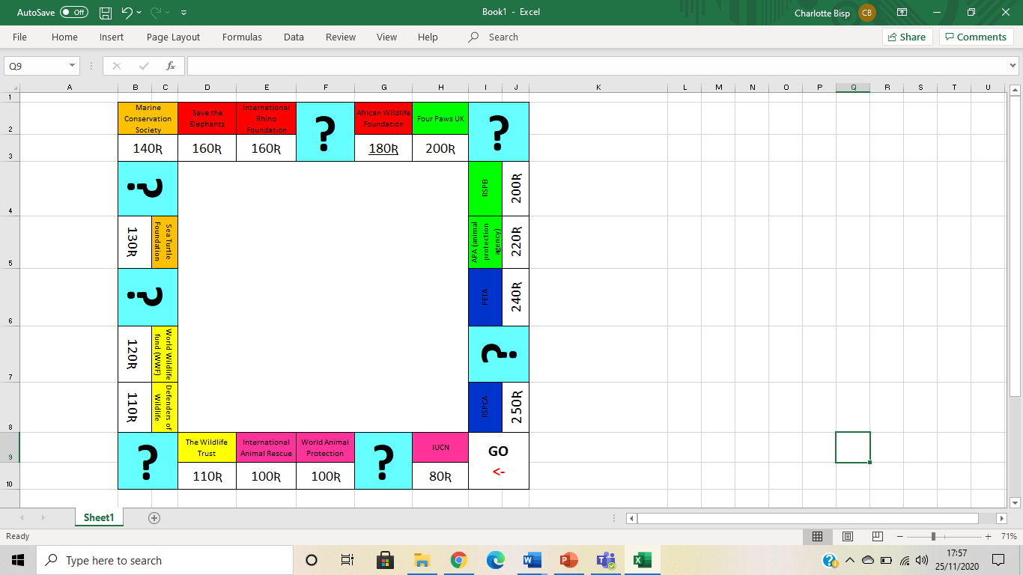(8) Defenders of wildlife

(9) World Wildlife fund (WWF)

(10) Resource square

(11) Sea turtle foundation

(12) Resource square

(13) Marine conservation society

(14) Save the elephants

(15) International Rhino foundation

(16) Resource square

(17) African wildlife foundation

(18) Four Paws uk

(19) Resource square

(20) RSPB

(21) Apa (animal protection agency)

(22) Peta

(23) Resource square

(24) Rspca

|  |  |  |  |  |  |
| --- | --- | --- | --- | --- | --- |
| Square 1  Pass go | Square 2  Colour Pink  “IUCN” | Square 3  Resource Sq. | Square 4  Colour Pink  “WAP” | Square 5  Colour Pink  “IAR” | Square 6  Colour Yellow  “Wildlife Trust” |
| Collect 200 Ʀ | Sq costs 80Ʀ  Dev cost 150Ʀ  Maj costs 50Ʀ |  | Sq costs 100Ʀ  Dev cost 150Ʀ  Maj costs 50Ʀ | Sq costs 100 Ʀ  Dev cost 160Ʀ  Maj costs 50Ʀ | Sq costs 110Ʀ Dev cost 170Ʀ  Maj costs 50Ʀ |

|  |  |  |  |  |  |
| --- | --- | --- | --- | --- | --- |
| Square 7  Resource Sq. | Square 8  Colour Yellow  “DoW” | Square 9  Colour Yellow  “WWF” | Square 10  Resource Sq. | Square 11  Colour Orange  “Sea Turtle F” | Square 12  Resource Sq. |
|  | Sq costs 120Ʀ  Dev cost 180Ʀ  Maj costs 50Ʀ | Sq costs 120Ʀ  Dev cost 180Ʀ  Maj costs 50Ʀ |  | Sq costs 130 Ʀ  Dev cost 190Ʀ  Maj costs 100Ʀ |  |

|  |  |  |  |  |  |
| --- | --- | --- | --- | --- | --- |
| Square 13  Colour Orange  “Marine” | Square 14  Colour Red  “Elephants” | Square 15  Colour Red  “Rhino” | Square 16  Resource Sq. | Square 17  Colour Red  “AWF” | Square 18  Colour Green  “Four Paws” |
| Sq costs 140Ʀ  Dev cost 200Ʀ  Maj costs 100Ʀ | Sq costs 150Ʀ  Dev cost 210Ʀ  Maj costs 100Ʀ | Sq costs 150Ʀ  Dev cost 210Ʀ  Maj costs 100Ʀ |  | Sq costs 160 Ʀ  Dev cost 220Ʀ  Maj costs 100Ʀ | Sq costs 170 Ʀ  Dev cost 230Ʀ  Maj costs 150Ʀ |

|  |  |  |  |  |  |
| --- | --- | --- | --- | --- | --- |
| Square 7  Resource Sq. | Square 8  Colour Green  “RSPB” | Square 9  Colour Green  “APA” | Square 10  Colour Blue  “PETA” | Square 11  Resource Sq. | Square 12  Colour Blue  “RSPCA” |
|  | Sq costs 170Ʀ  Dev cost 240Ʀ  Maj costs 150Ʀ | Sq costs 180Ʀ  Dev cost 250Ʀ  Maj costs 150Ʀ | Sq costs 200 Ʀ  Dev cost 280Ʀ  Maj costs 150Ʀ |  | Sq costs 220 Ʀ  Dev cost 300Ʀ  Maj costs 150Ʀ |

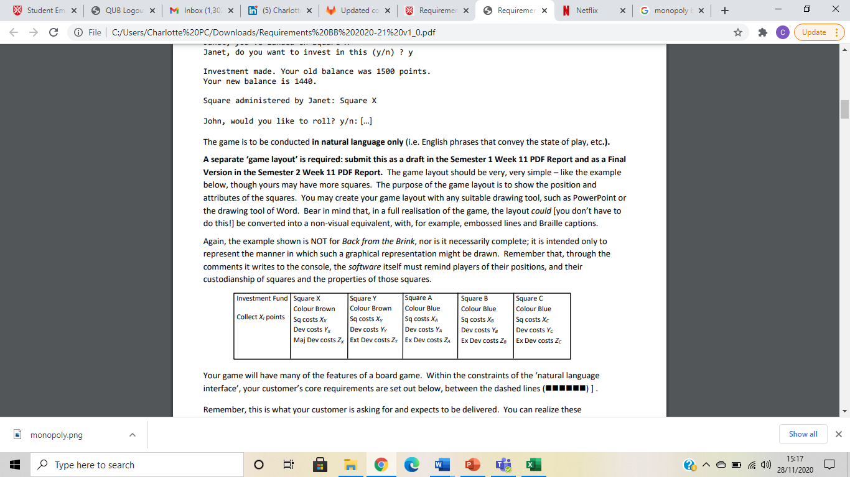

Not sure what Ext Dev costs are lol