|  |  |  |
| --- | --- | --- |
| **Animal Organisations Area**  (2) IUCN  (4) World Animal Protection  (5) International Animal rescue | **Wildlife Organisations**  (6) The Wildlife Trust  (8) Defenders of wildlife  (9) World Wildlife fund (WWF) | **Aquatic Conservation Area**  (11) Sea turtle foundation  (13) Marine conservation society |
| **Safari Conservation Area**  (14) Save the elephants  (15) International Rhino foundation  (17) African wildlife foundation | **Domestic Pets Conservation Area**  (18) Four Paws UK  (20) RSPB  (21) APA (animal protection agency) | **Animal Protection Area**  (22) PETA  (24) RSPCA |

**Action Areas**

**Note: ? represent ‘Added-Value Feature’ Squares**

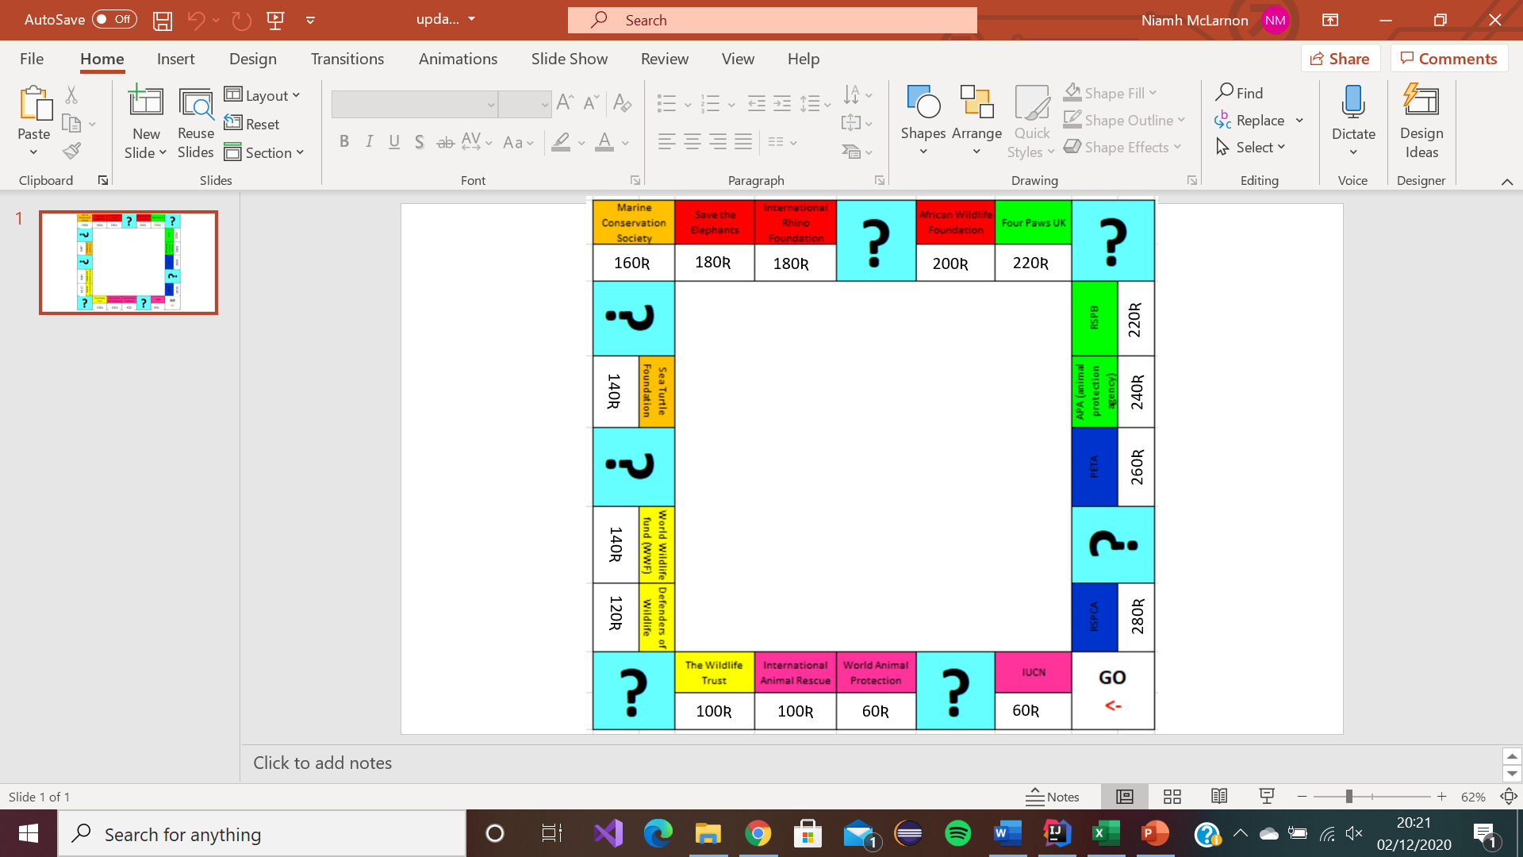

|  |  |  |  |  |  |
| --- | --- | --- | --- | --- | --- |
| Square 1  Pass go | Square 2  Colour Pink  “IUCN” | Square 3  Resource Sq. | Square 4  Colour Pink  “WAP” | Square 5  Colour Pink  “IAR” | Square 6  Colour Yellow  “Wildlife Trust” |
| Collect 200 Ʀ | Purchase cost 60R  Step Cost 30R  Contribution Costs:  2R  1Step(10R), 2Step(30R),  3Step(90R)  Maj Step cost 250R | Collect 10R | Purchase cost 60R  Step Cost 30R  Contribution Costs:  4R  1Step(20R), 2Step(60R),  3Step(180R)  Maj Step cost 450R | Purchase cost 100R  Step Cost 50R  Contribution Costs:  6R  1Step(30R), 2Step(90R),  3Step(270R)  Maj Step cost 550R | Purchase cost 100R  Step Cost 50R  Contribution Costs:  6R  1Step(30R), 2Step(90R),  3Step(270R)  Maj Step cost 550R |

|  |  |  |  |  |  |
| --- | --- | --- | --- | --- | --- |
| Square 7  Resource Sq. | Square 8  Colour Yellow  “DoW” | Square 9  Colour Yellow  “WWF” | Square 10  Resource Sq. | Square 11  Colour Orange  “Sea Turtle F” | Square 12  Resource Sq. |
| Collect 50R | Purchase cost 120R  Step Cost 60R  Contribution Costs:  8R  1Step(40R), 2Step(100R),  3Step(3000R)  Maj Step cost 600R | Purchase cost 140R  Step Cost 70R  Contribution Costs:  10R  1Step(50R), 2Step(150R),  3Step(450R)  Maj Step cost  750R | Collect 100R | Purchase cost 140R  Step Cost 70R  Contribution Costs:  10R  1Step(50R), 2Step(150R),  3Step(4500R)  Maj Step cost 750R | Collect 170R |

|  |  |  |  |  |  |
| --- | --- | --- | --- | --- | --- |
| Square 13  Colour Orange  “Marine” | Square 14  Colour Red  “Elephants” | Square 15  Colour Red  “Rhino” | Square 16  Resource Sq. | Square 17  Colour Red  “AWF” | Square 18  Colour Green  “Four Paws” |
| Purchase cost 160R  Step Cost 80R  Contribution Costs:  12R  1Step(60R), 2Step(180R),  3Step(500R)  Maj Step cost 900R | Purchase cost 180R  Step Cost 90R  Contribution Costs:  14R  1Step(70R), 2Step(200R),  3Step(550R)  Maj Step cost 950R | Purchase cost 180R  Step Cost 90R  Contribution Costs:  14R  1Step(70R), 2Step(200R),  3Step(550R)  Maj Step cost 950R | Collect 200R | Purchase cost 200R  Step Cost 100R  Contribution Costs:  16R  1Step(80R), 2Step(220R),  3Step(600R)  Maj Step cost 1000R | Purchase cost 220R  Step Cost 110R  Contribution Costs:  18R  1Step(90R), 2Step(250R),  3Step(700R)  Maj Step cost 1050R |

|  |  |  |  |  |  |
| --- | --- | --- | --- | --- | --- |
| Square 19  Resource Sq. | Square 20  Colour Green  “RSPB” | Square 21  Colour Green  “APA” | Square 22  Colour Blue  “PETA” | Square 23  Resource Sq. | Square 24  Colour Blue  “RSPCA” |
| Collect 250R | Purchase cost 220R  Step Cost 120R  Contribution Costs:  18R  1Step(90R), 2Step(250R),  3Step(700R)  Maj Step cost 1050R | Purchase cost 240R  Step Cost 120R  Contribution Costs:  20R  1Step(100R), 2Step(300R),  3Step(750R)  Maj Step cost 1100R | Purchase cost 260R  Step Cost 130R  Contribution Costs:  22R  1Step(110R), 2Step(330R),  3Step(800R)  Maj Step cost 1150R | Collect 300R | Purchase cost 280R  Step Cost 140R  Contribution Costs:  24R  1Step(120R), 2Step(360R),  3Step(850R)  Maj Step cost 1200R |