# Database Queries in SQL

**By Daniel Oppong Ampah**

## Project description

Through SQL queries in MariaDB, I am able to filter needed data.

## Writing Queries to Identify Employees

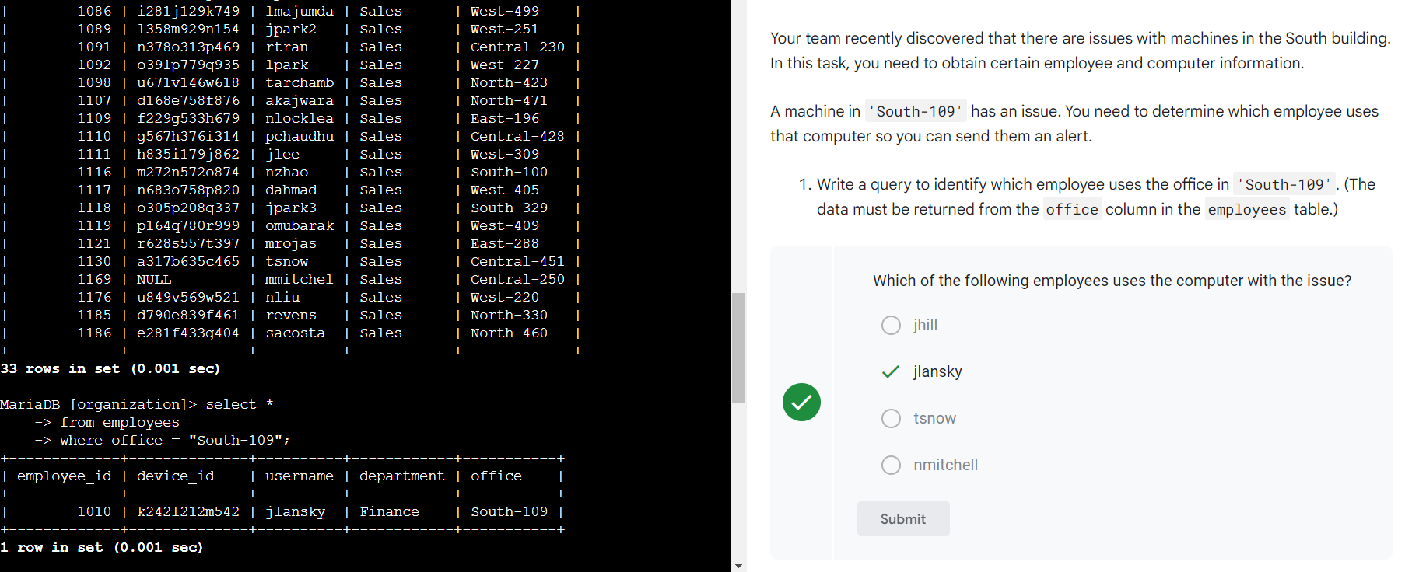

## Modifying Queries to Return Information on Employees

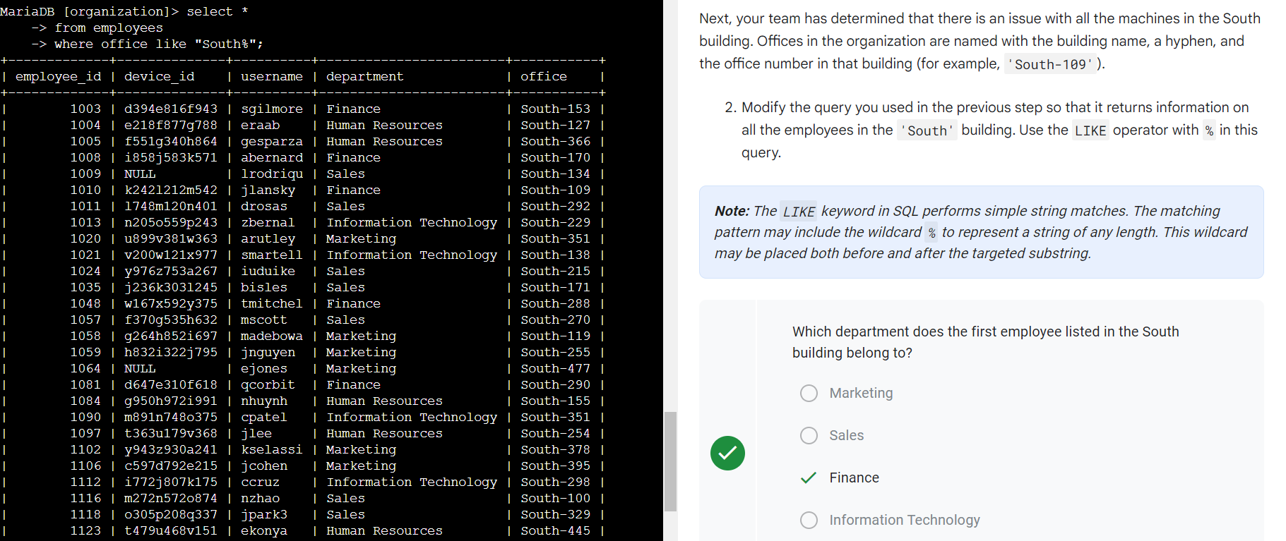

Completed this activity and practiced applying

* the WHERE keyword
* the BETWEEN and AND operators, and
* operators for working with numeric or date and time data types (for example, =, >, >=)

to filter data from a table.

