# File permissions in Linux

**By Daniel Oppong Ampah**

## Project description

Through Linux commands, I am changing/editing file permissions on both visible and hidden files.

## Check file and directory details

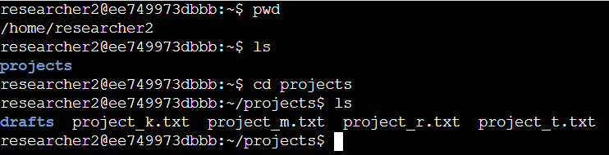

## Describe the permissions string

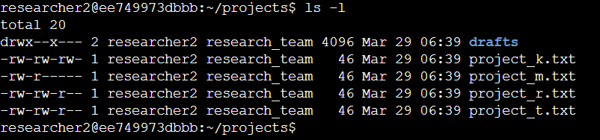

d – describes a directory.  
“-“ – describes a file.

r – read, w – write and x – execute.

2nd to 4th rwx characters = user’s permissions.

5th to 7th rwx characters = group’s permissions.

8th to 10th rwx characters = others’ permissions.

## Change file permissions

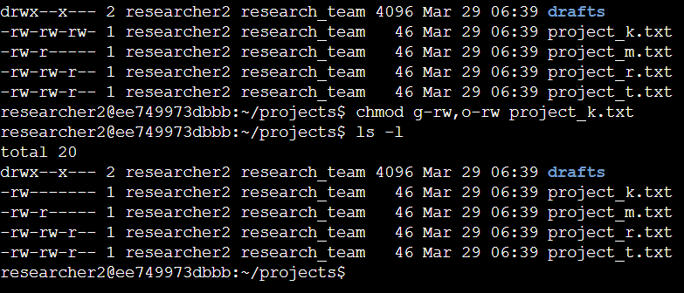

We can see from here that now, group and others’ read and write permission or access to the project_k.txt has been removed.

## Change file permissions on a hidden file

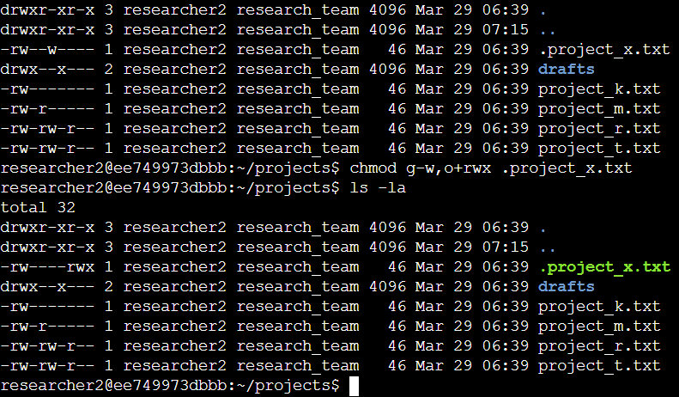

Group’s write permission or access to the hidden file “.project_x.txt” has been removed. Others’ read, write and execute permission or access to the hidden file “.project_x.txt” has been added.

## Change directory permissions

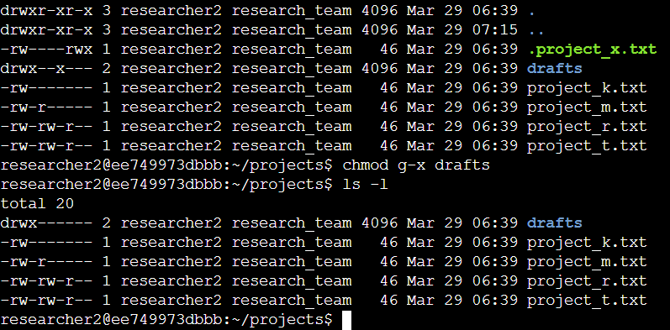

Here, the drafts directory execute permission has been removed.

## Summary

Through simple Linux commands, we are able to easily control who can and cannot access files in the company’s system.