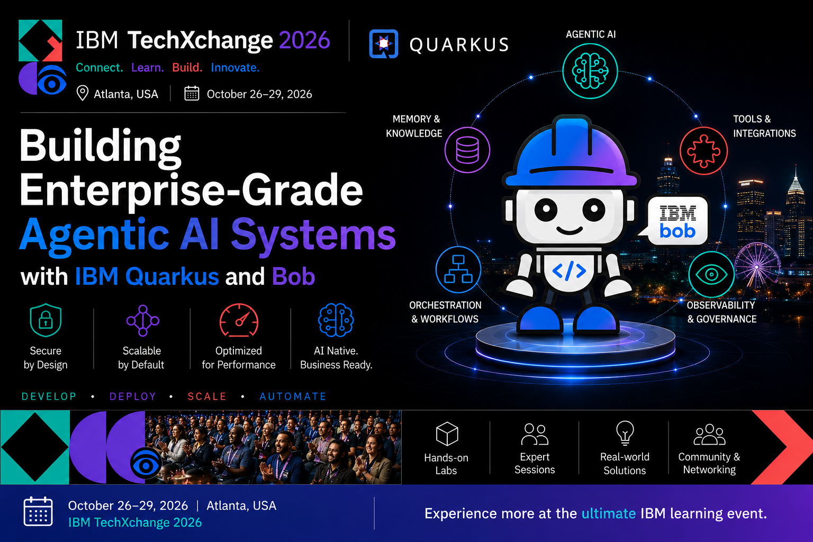

LAB-1219

Building Enterprise-Grade Agentic AI Systems
with IBM Enterprise Build of Quarkus and Bob
IBM TechXchange 2026 · Hands-On Lab · 90 minutes

Lab Guide: bit.ly/lab-1219

The Scenario: Apex Systems
Apex Systems is a mid-size enterprise IT services company managing infrastructure across data centers and cloud regions. The NOC (Network Operations Center) receives free-text incident reports from monitoring tools, tickets, and on-call engineers — but today those reports live in chat threads, email chains, and tribal knowledge.

Last quarter's post-mortem told the story:
- Two P1 outages (auth failure, API gateway) lasted 4+ hours because manual triage classified them as P3 — $150k combined revenue loss
- A payment-gateway incident was routed to the networking team instead of payments, burning 20 engineer-hours before correction
- NOC analysts cannot explain why an incident was routed or whether escalation was appropriate — no audit trail exists
Leadership mandate: automate incident triage and routing with AI agents — without losing enterprise control.

Why Agentic AI (Not "Just a Chatbot")
Chatbot | Agent
Answers questions | Takes actions
One LLM call | Multi-step reasoning + tool calls
No side effects | Mutates state (e.g., IncidentStatus → TRIAGING)
Stateless | Shares context via AgenticScope across workflow
Single model | Composed specialists (triage, diagnostic, impact)

Apex Systems needs systems that reason over messy natural-language incident reports, act by calling enterprise tools, collaborate across specialized roles, pause for humans on high-stakes outcomes, and scale across teams via open protocols.

What You Will Build
A production-shaped agentic incident management platform on IBM Enterprise Build of Quarkus — from a single agent to a full supervisor orchestration with human oversight and distributed services.

Learning Path: 8 Exercises, 8 Capabilities
Exercise | Persona | Problem | Pattern
1 — Agent + Tool | Sam — NOC analyst | Free-text reports pile up; triage is manual | @Agent + @ToolBox
2 — Policy as Prompt | Chris — Ops lead | Diagnostic decisions need policy, not code | @SystemMessage as policy
3 — Parallel Agents | Chris — Ops lead | Three analyses must run concurrently | @ParallelMapperAgent
4 — Supervisor | Priya — IT service mgr | Critical incidents need adaptive escalation | @SupervisorAgent
5 — AI Governance | Jordan — Platform engineer | Must ship governed code; copilots hallucinate | AGENTS.md + IBM Bob
6 — Human Gate + Tracing | Alex — Compliance officer | P1 incidents need approval + audit trail | @HumanInTheLoop + OTel
7 — Remote Agents (A2A) | Riley — SRE lead | Impact assessment is a separate team | @A2AClientAgent
8 — Quality Loop (Bonus) | Jordan — Platform engineer | Post-incident reports need refinement | loopBuilder() + Quarkus Flow

Exercises 1–4 are hands-on code-along. Exercise 5 uses IBM Bob for governance. Exercises 6–7 run pre-built solutions to explore HITL and A2A. Exercise 8 (bonus) builds a programmatic quality loop.

The IBM Stack
Layer | Component | Role
Runtime | IBM Enterprise Build of Quarkus | Build-time agent validation, fast startup
AI Extension | Quarkus LangChain4j | Declarative agents, workflows, A2A
Dev Tooling | IBM Bob | SDLC partner: plan → code → test → secure
Context | AGENTS.md | Targeted Bob context — avoids token-bloat scans

Prerequisites
- Java 25+
- Maven 3.9+ (or use ./mvnw in each exercise)
- IBM Bob (bob.ibm.com) — sign in before the lab starts
- LLM API key — provided in the room (OPENAI_API_KEY)
- Free ports 8080 and 8888
- Docker or Podman — for Quarkus Dev Services (PostgreSQL, LGTM)

Get Started
Clone the repository and start your first exercise:
git clone https://github.com/danieloh30/techxchange-2026-quarkus-bob-lab.git
cd techxchange-2026-quarkus-bob-lab
export OPENAI_API_KEY=sk-your-lab-key-here
cd lab
./mvnw quarkus:dev
Open http://localhost:8080 — you should see the Incident Dashboard with 8 seeded incidents. No agent behavior yet: that's Exercise 1.

Full lab guide and all exercises:
bit.ly/lab-1219

